4.3: Logic

4.3.1: Tests performed

These are the results of tests performed with valid data. The animation and graph data are completely based on strength and number of moles of catalyst.

Animation

|  |  |  |  |
| --- | --- | --- | --- |
| Test number | Description | Result | Cross-reference |
| 1 | Comparing good catalyst at 25 and 75 moles | Pass | Video 1 |
| 2 | Comparing poor catalyst at  25 and 75 moles | Pass | Video 2 |
| 3 | Comparing unused catalyst at 25 and 75 moles | Pass | Video 3 |
| 4 | Comparing inhibitor catalyst at 25 and 75 moles | Pass | Video 4 |
| 5 | Comparing time taken by animation with each catalyst at 50 moles | Pass | Video 5 |

Graphs

|  |  |  |  |
| --- | --- | --- | --- |
| Test number | Description | Result | Cross-reference |
| 6 | Comparing good catalyst at 25 and 75 moles | Pass | Figure 4.3.1 |
| 7 | Comparing poor catalyst at 25 and 75 moles | Pass | Figure 4.3.2 |
| 8 | Comparing unused catalyst at 25 and 75 moles | Pass | Figure 4.3.3 |
| 9 | Comparing inhibitor catalyst at 25 and 75 moles | Pass | Figure 4.3.4 |
| 10 | Good catalyst  Poor catalyst  No catalyst  Inhibitor catalyst | Pass | Figure 4.3.5 |
| 11 | Testing if graph plots alongside animation | Pass | Video 6 |

Calculations

|  |  |  |  |
| --- | --- | --- | --- |
| Test number | Description | Result | Cross-reference |
| 12 | Showing working for Kc | Partial fail | Figure 4.3.6 |
| 13a) | Current reaction has lower temperature than reaction being compared (endothermic reaction) | Pass | Figure 4.3.7 |
| 13b) | Current reaction has lower temperature than reaction being compared (exothermic reaction) | Pass | Figure 4.3.8 |
| 14a) | Current reaction has higher temperature than reaction being compared (endothermic reaction) | Pass | Figure 4.3.9 |
| 14b) | Current reaction has higher temperature than reaction being compared (exothermic reaction) | Pass | Figure 4.3.10 |
| 15a) | Current reaction has same temperature as reaction being compared (endothermic reaction) | Pass | Figure 4.3.11 |
| 15b) | Current reaction has same temperature as reaction being compared (exothermic reaction) | Pass | Figure 4.3.12 |

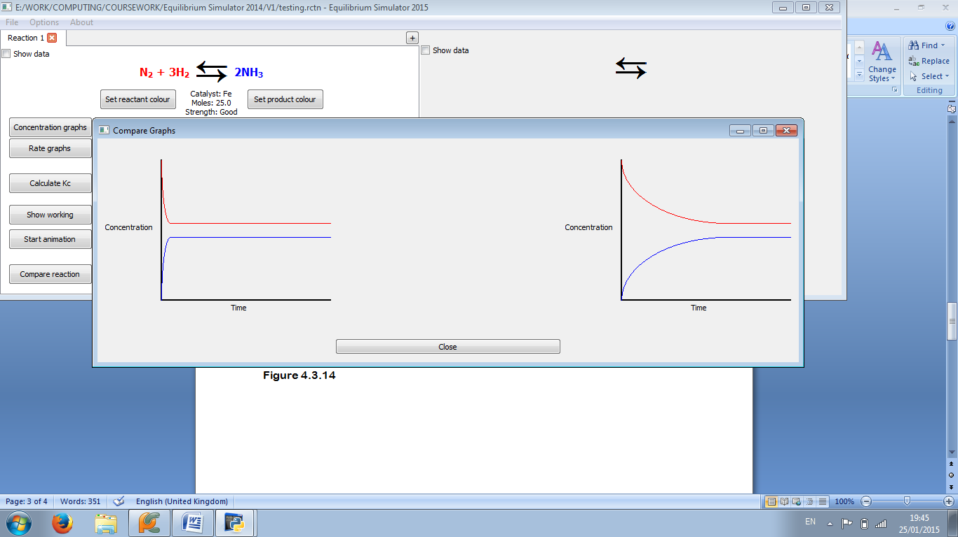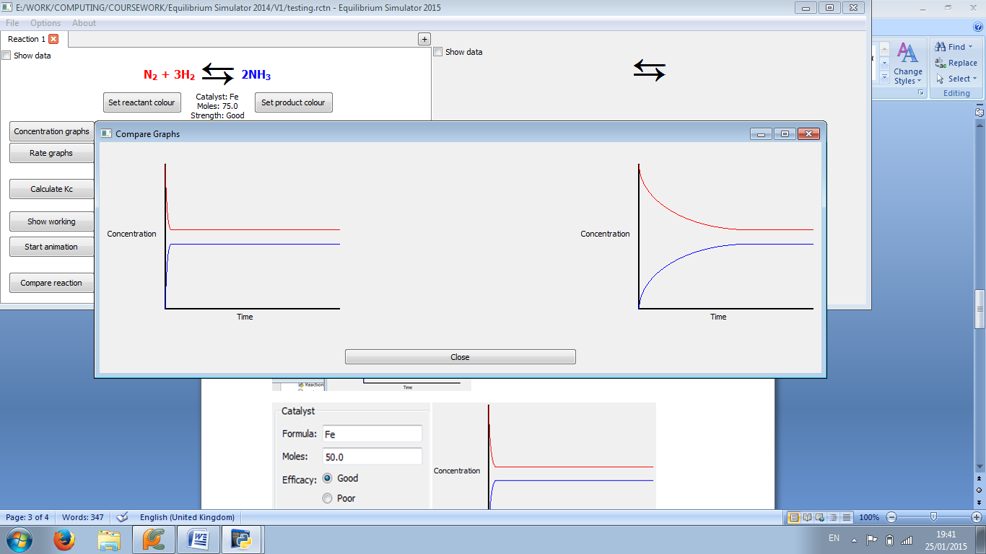

Figure 4.3.1: The graph is steeper at 75 moles (right) than at 25 (left)

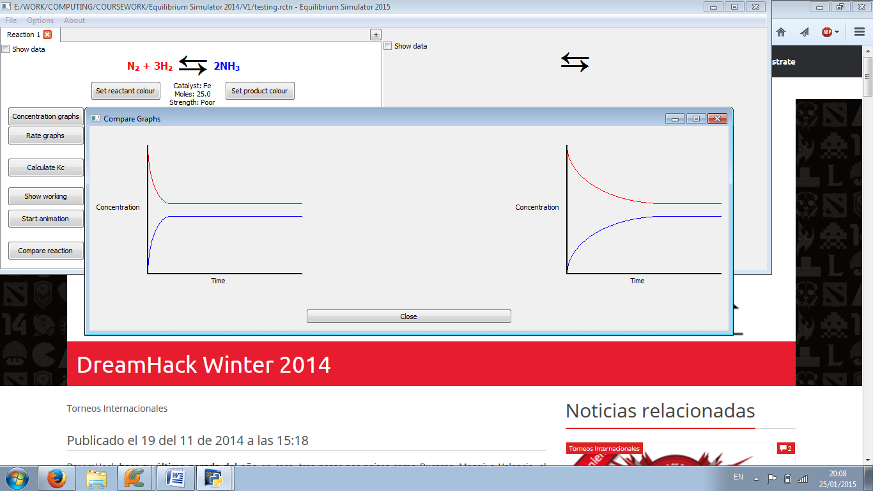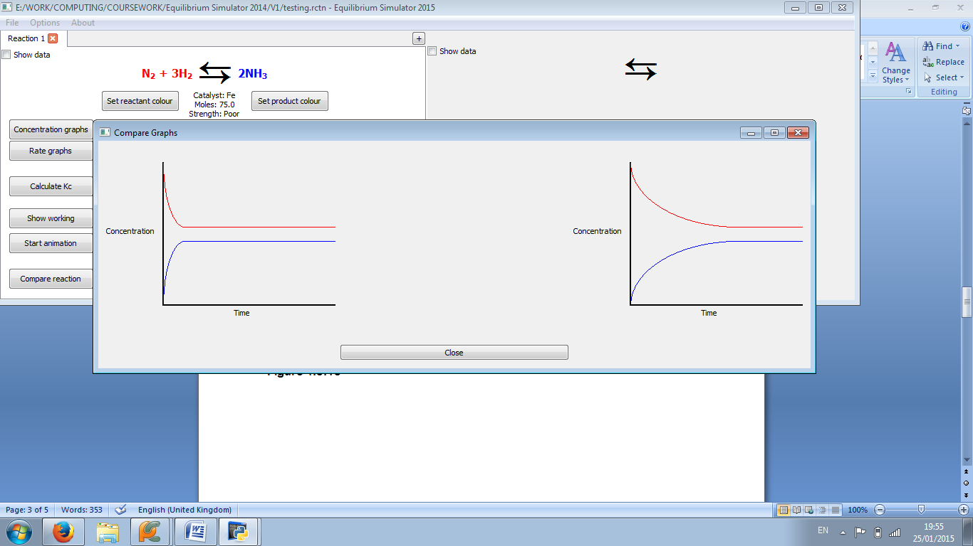

Figure 4.3.2: The graph is steeper at 75 moles (right) than at 25 (left)

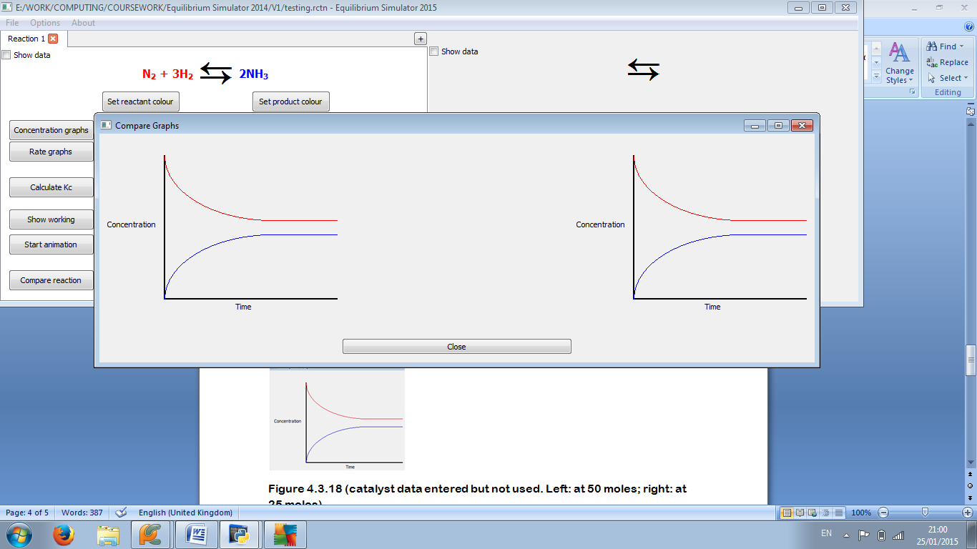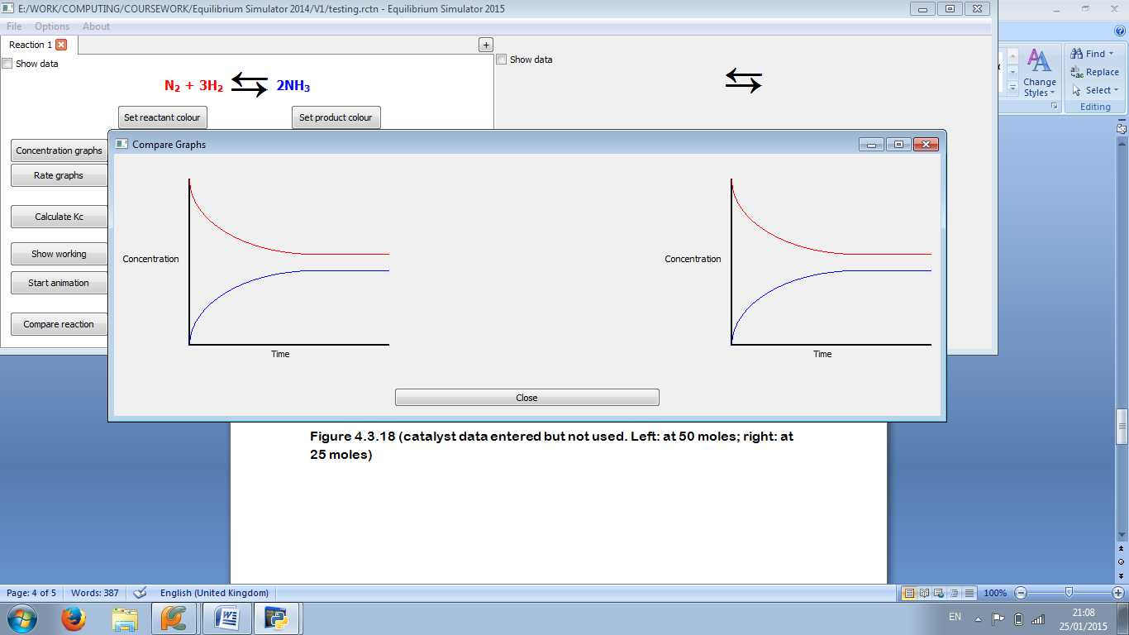

Figure 4.3.3: The two graphs are identical. (Catalyst data entered but not used. Left: at 25 moles; right: at 75 moles)

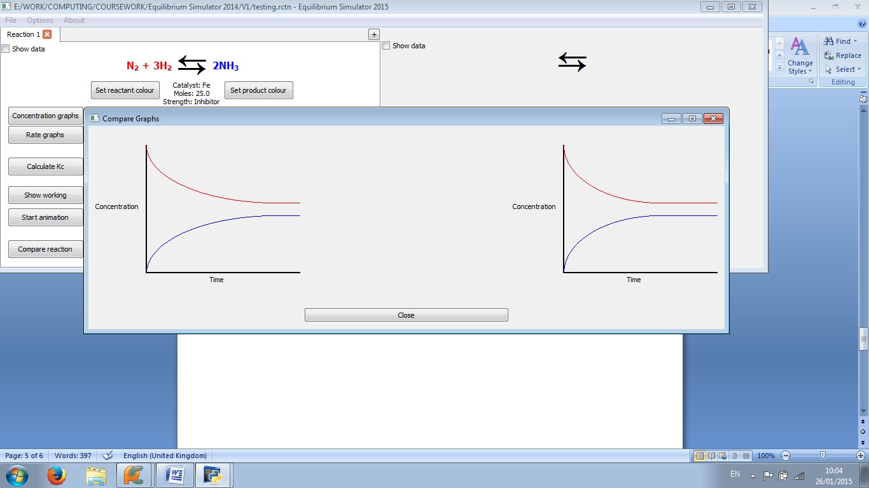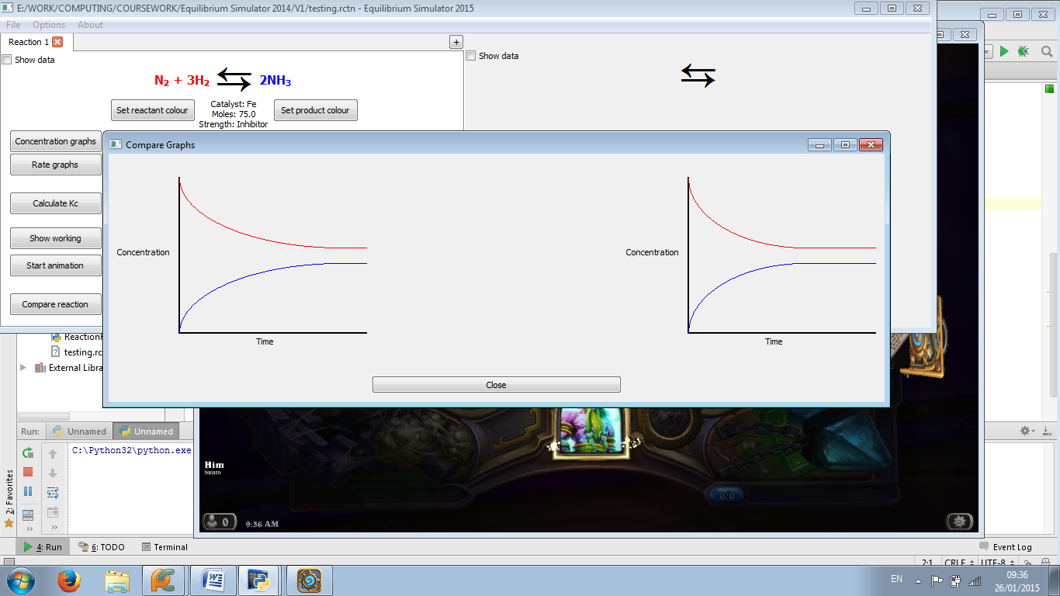

Figure 4.3.4: The graph is steeper at 25 moles (left) than at 75 (right)

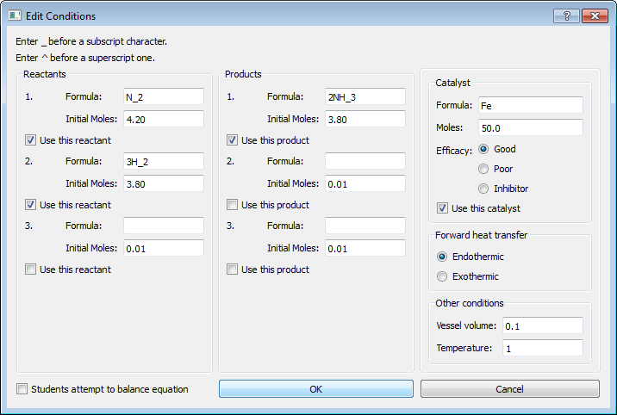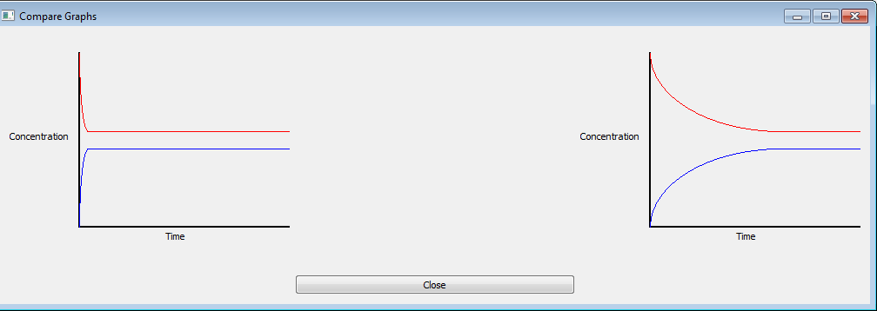  
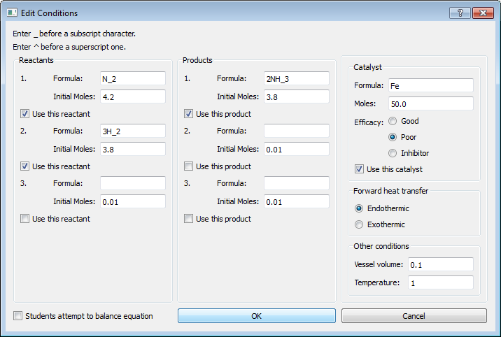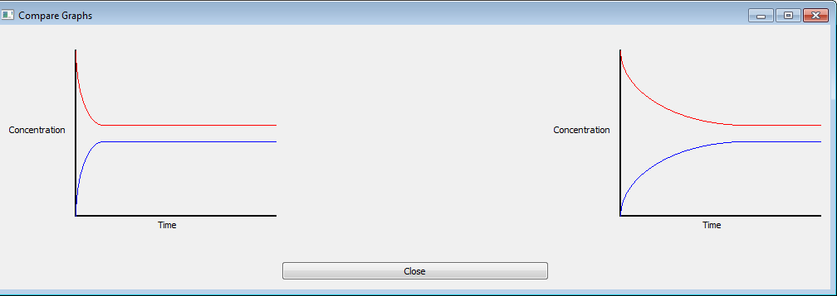  
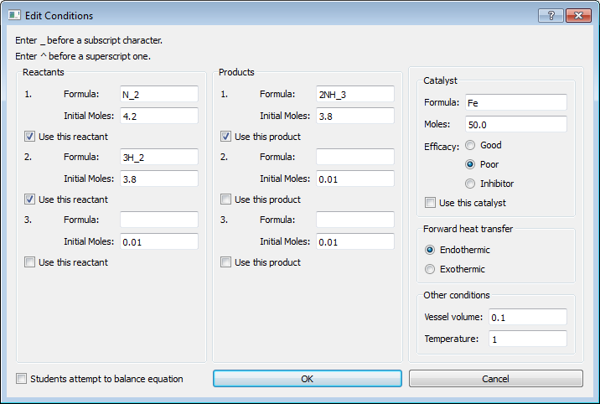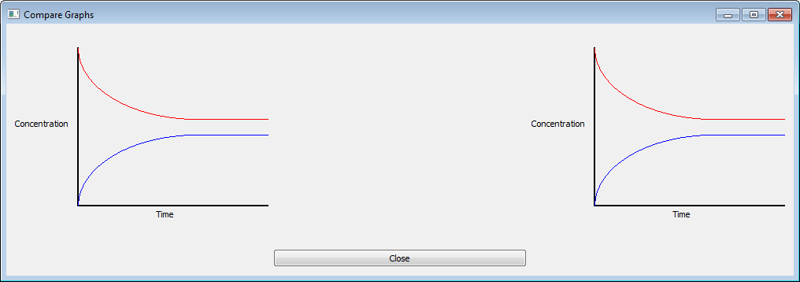  
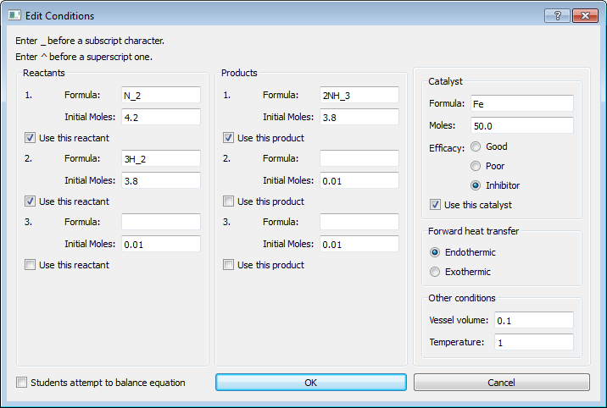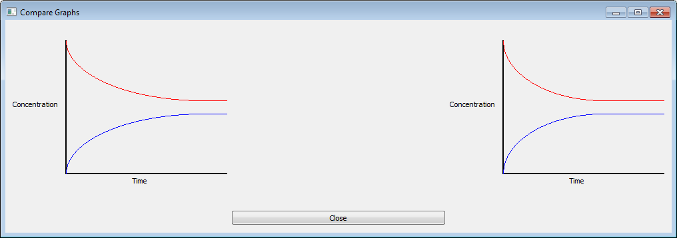

Figure 4.3.5: A clear decrease in steepness of the curve can be seen from good (top) to inhibitor (bottom) strength

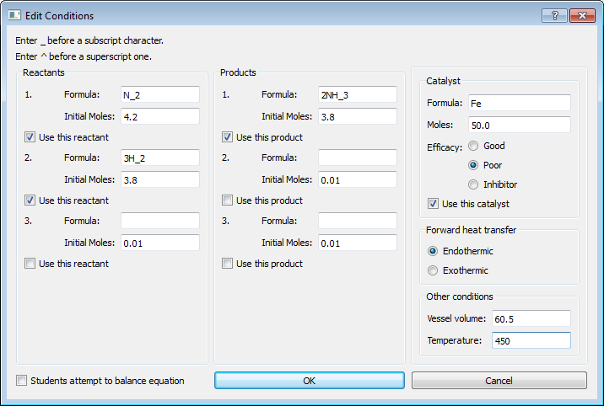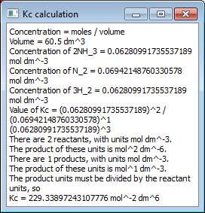

Figure 4.3.6: Popup box appears (right) showing correct working and calculation, except for units of Kc, which are initially miscalculated but not in the final answer

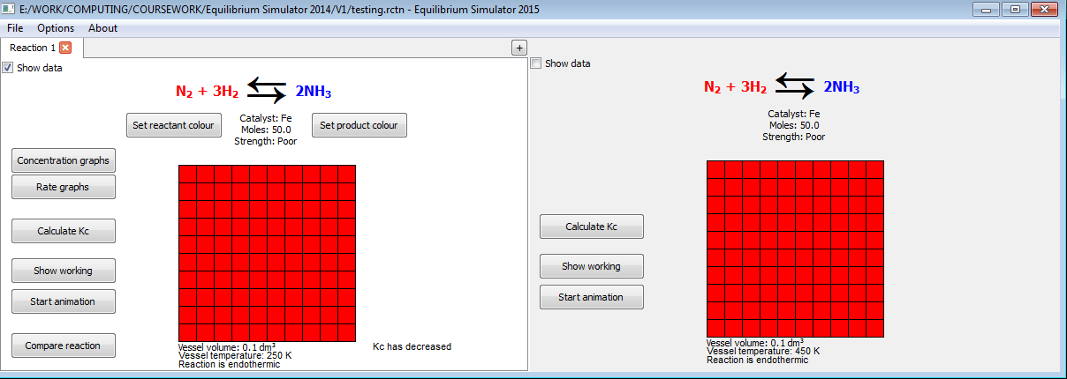

Figure 4.3.7: Text appears (left-hand side), explaining that Kc has decreased

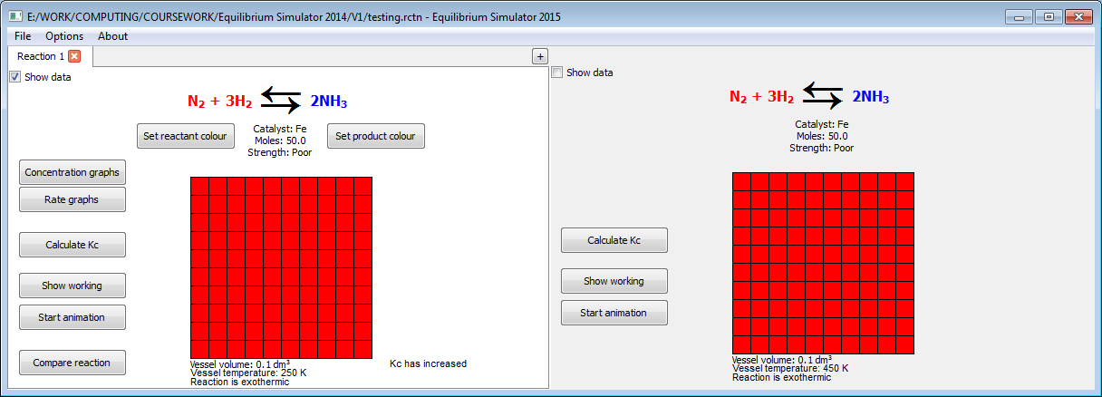

Figure 4.3.8: Text appears (left-hand side), explaining that Kc has decreased

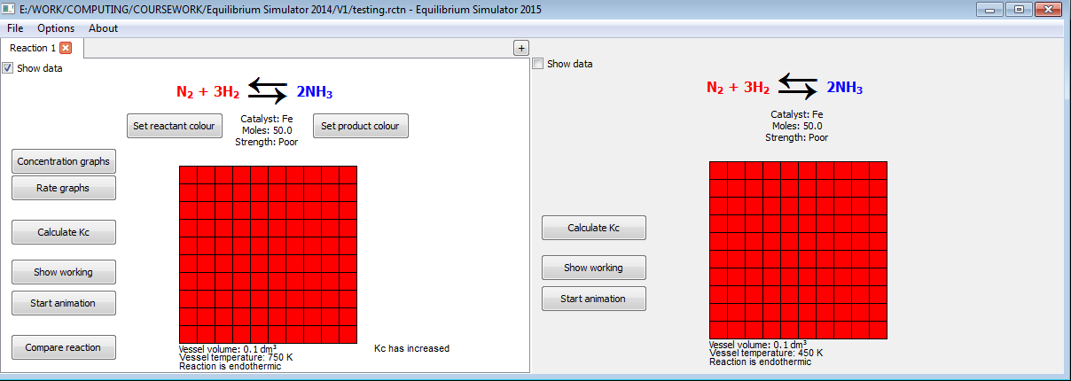

Figure 4.3.9: Text appears (left-hand side), explaining that Kc has increased

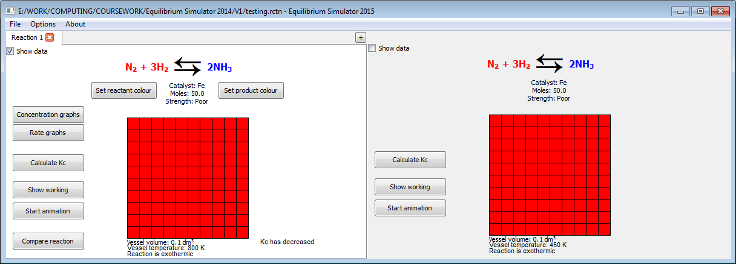

Figure 4.3.10: Text appears (left-hand side), explaining that Kc has decreased

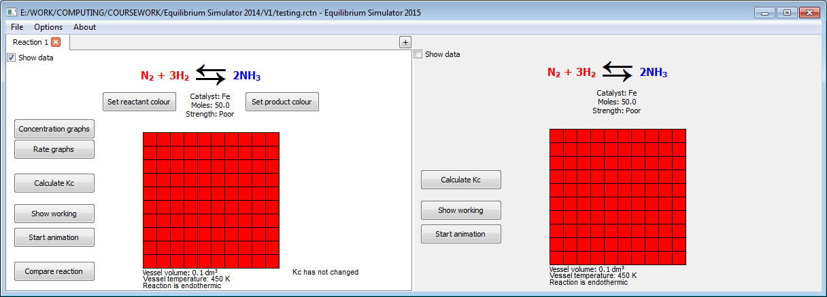

Figure 4.3.11: Text appears (left-hand side), explaining that Kc has not changed

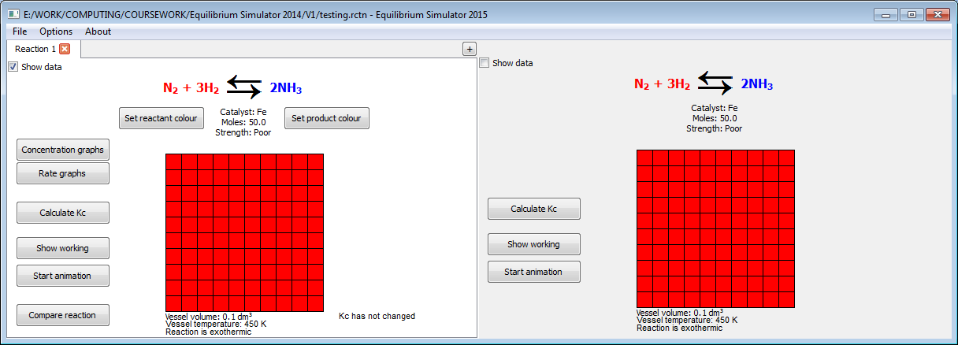

Figure 4.3.12: Text appears (left-hand side), explaining that Kc has not changed

4.3.2: Failed tests

Source code involved in test 11:

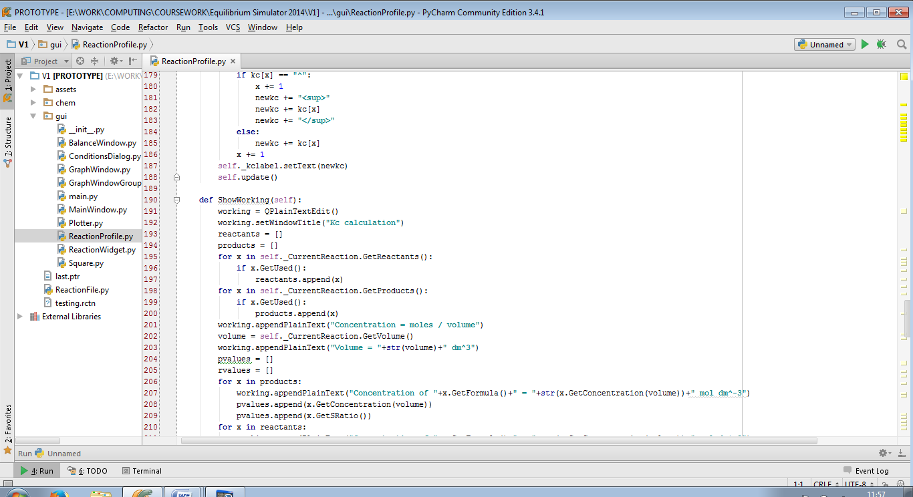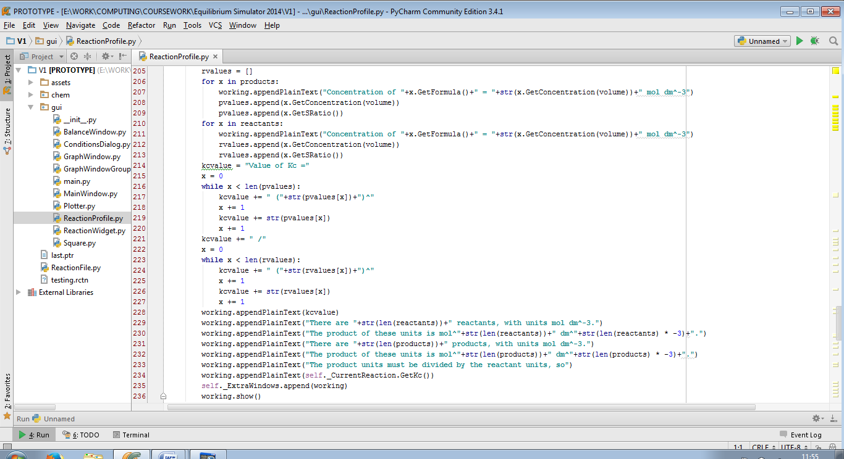

The code passed overall as it came to a final value which is actually more precise than the value calculated before testing. However, there is an error in some of the working produced: the powers involved in the concentration are calculated from an incorrect algorithm (lines 229-232).

Amended source code:

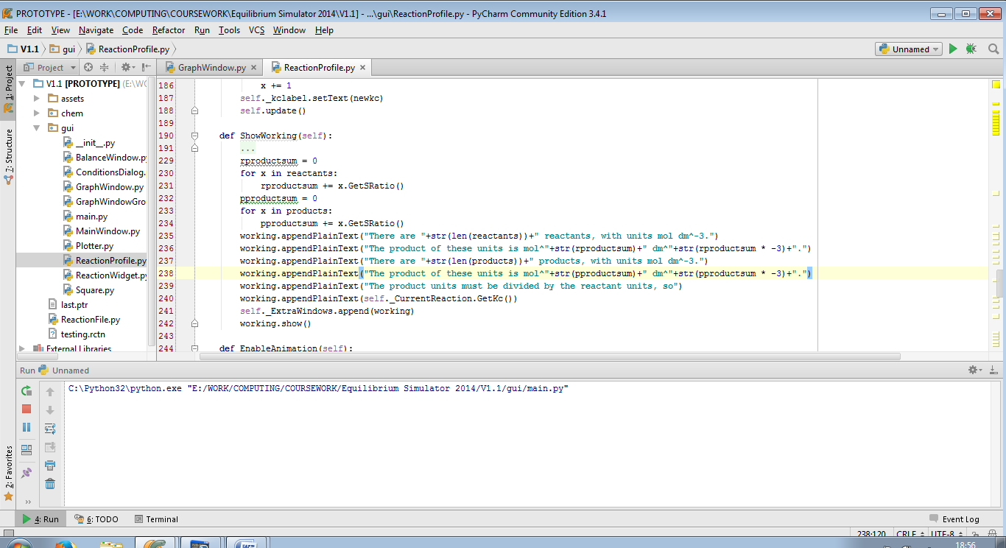

The code now fully passes test 11:

|  |  |  |  |
| --- | --- | --- | --- |
| 11 | On clicking “OK” in “Invalid Data” dialog | Pass | Figure 4.3.13 |

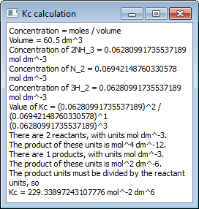

Figure 4.3.13: A popup box appears (right), showing all working correctly