4: Testing

4.1: Validation

4.1.1: Tests performed

Validation does not need to be performed in all areas where users enter input, because in many cases the user can only enter pre-selected values which are known to be valid, using widgets such as drop-down menus, checkboxes or radio buttons. No validation is programmed for entering file names for saving and opening, as the program’s framework does this already. However, validation needs to be performed in the conditions dialog, as this is the only other area of the application which gives users opportunities to enter whatever data they want.

All text boxes for entering the name of a chemical are created the same way and use the same validation algorithm. Also, all text boxes for entering the number of moles of a chemical are created the same way and use the same validation algorithm. This is why only the test results for reactant 1 are provided.

Validation is only carried out on the reactants, products or catalyst which the user selects to use in the reaction, so that the user is not forced to unnecessarily enter valid data for all available chemicals if the user does not want to use some of them.

When each input area is tested, all other input areas are given valid data to make the result more clear.

Two regex expressions were used for validation:

* R1, for chemical formulae:   
  [2-9]?(\(([A-Z][a-z]?(_[0-9])*)+\)(_[0-9])*|[A-Z][a-z]?(_[0-9])*)+((\^[0-9])*\^(\+|-))?
* R2, for decimal numbers: [0-9]?[0-9]\.[0-9][0-9]?

Key to test types: N = normal; E = erroneous; B = boundary

|  |  |  |  |
| --- | --- | --- | --- |
| Test number | Test type; input data | Result | Cross-reference |
| 1 | N; “2NaCl” | Pass | Figure 4.1.1 |
| 2 | E; “2N@C&” | Pass | Figure 4.1.2 |
| 3 | E; “” | Pass | Figure 4.1.3 |
| 4 | B; “H” | Pass | Figure 4.1.4 |
| 5 | B; “CH_3COO(CH_2)_4C_1_0H_2_1” | Pass | Figure 4.1.5 |
| 6 | N; “24.53” | Pass | Figure 4.1.6 |
| 7 | E; “101.42” | Pass | Figure 4.1.7 |
| 8 | E; “-4.24” | Pass | Figure 4.1.8 |
| 9 | E; “” | Pass | Figure 4.1.9 |
| 10 | E; “6” | Pass | Figure 4.1.10 |
| 11 | E; “4. | Pass | Figure 4.1.11 |
| 12 | E; “3.14159” | Pass | Figure 4.1.12 |
| 13 | E; “sixteen” | Pass | Figure 4.1.13 |
| 14 | B; “99.99” | Pass | Figure 4.1.14 |
| 15 | B; “0.01” | Pass | Figure 4.1.15 |
| 16 | N; “13.37” | Pass | Figure 4.1.16 |
| 17 | E; “133.75” | Pass | Figure 4.1.17 |
| 18 | E; “-42.69” | Pass | Figure 4.1.18 |
| 19 | E; “” | Pass | Figure 4.1.19 |
| 20 | E; “72” | Pass | Figure 4.1.20 |
| 21 | E; “72.” | Pass | Figure 4.1.21 |
| 22 | E; “1.234” | Pass | Figure 4.1.22 |
| 23 | E; “fourteen” | Pass | Figure 4.1.23 |
| 24 | B; “99.99” | Pass | Figure 4.1.24 |
| 25 | B; “0.01” | Pass | Figure 4.1.25 |
| 26 | N; “450” | Pass | Figure 4.1.26 |
| 27 | E; “2000” | Pass | Figure 4.1.27 |
| 28 | E; “-200” | Pass | Figure 4.1.28 |
| 29 | E; “” | Pass | Figure 4.1.29 |
| 30 | E; “Boiling” | Pass | Figure 4.1.30 |
| 31 | B; “1” | Pass | Figure 4.1.31 |
| 32 | B; “999” | Pass | Figure 4.1.32 |

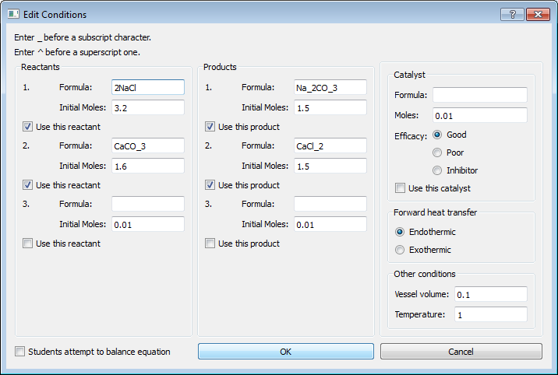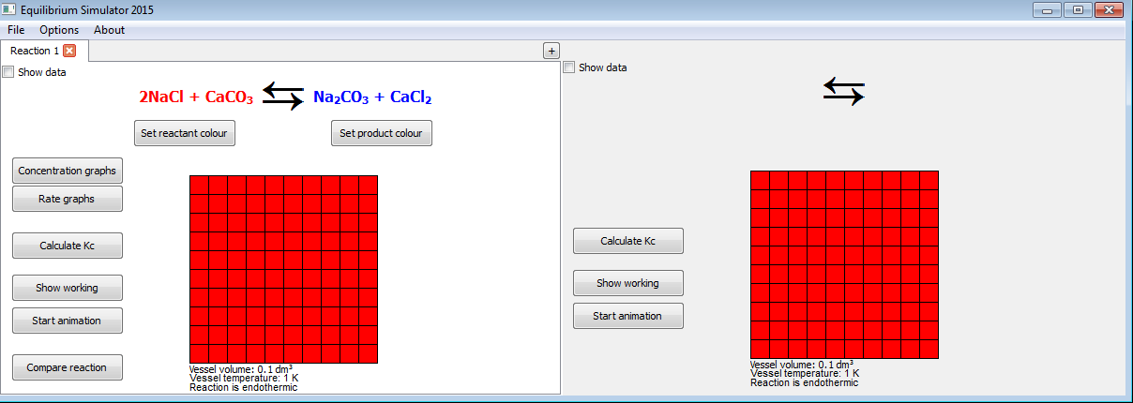

Figure 4.1.1: Window (left) closes, reaction updates and user can continue

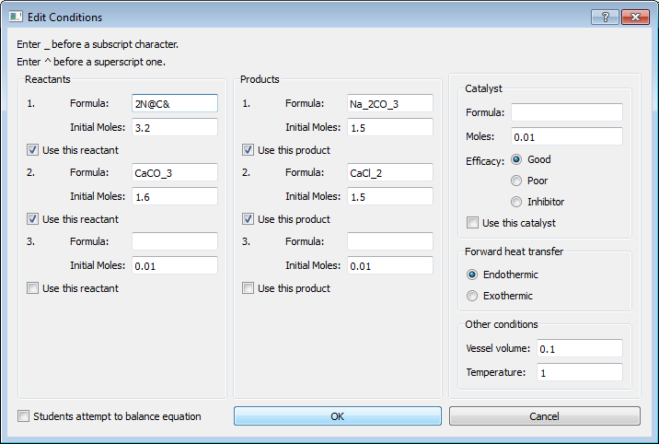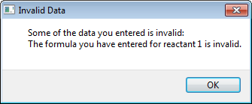

Figure 4.1.2: Popup box appears (right), explaining that formula is invalid

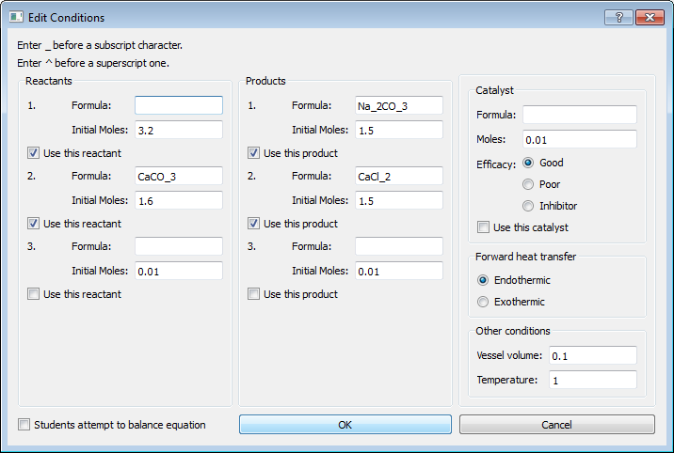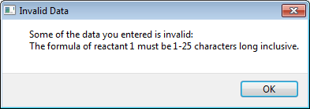

Figure 4.1.3: Popup box appears (right), explaining the accepted formula length

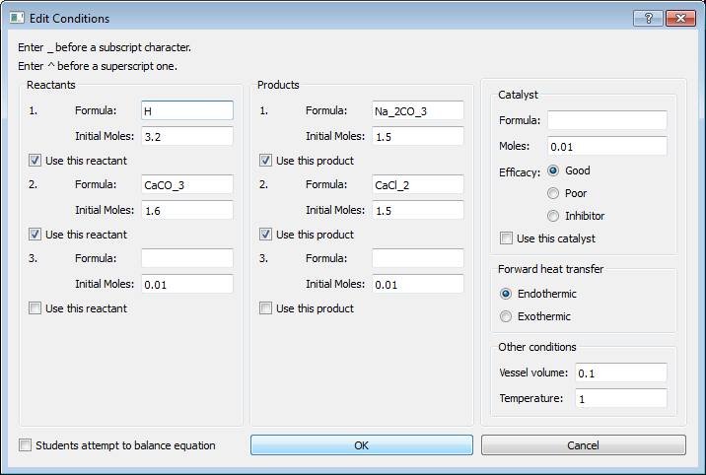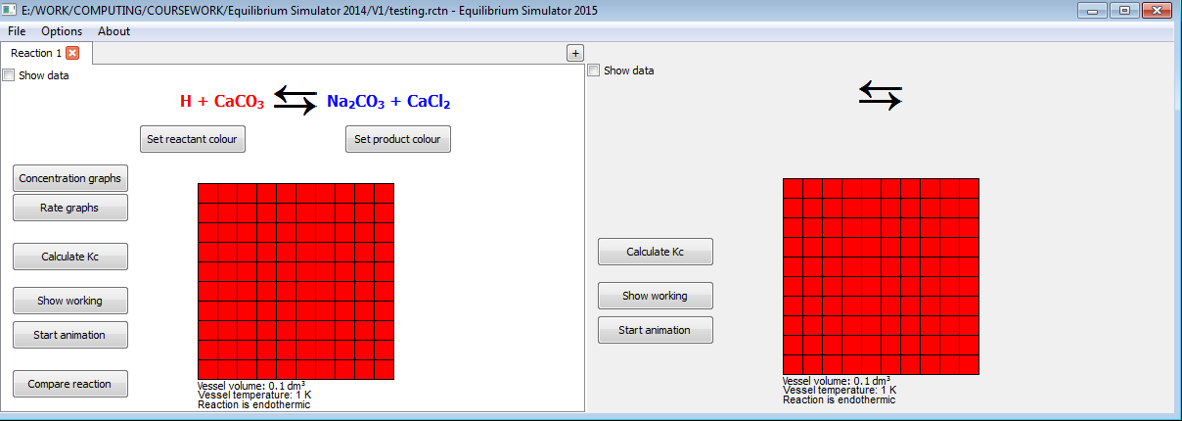

Figure 4.1.4: Window (left) closes, reaction updates and user can continue

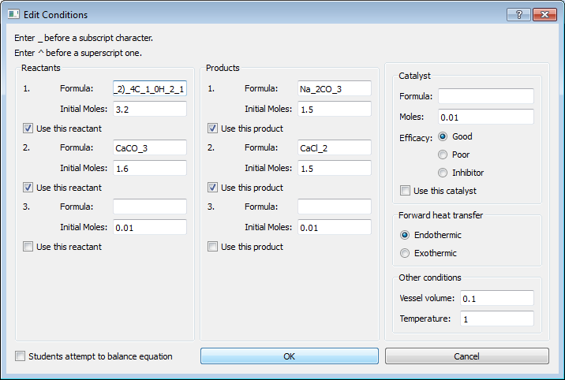 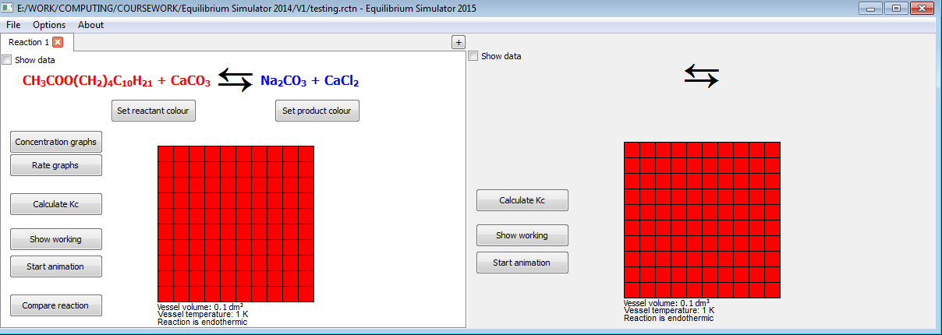

Figure 4.1.5: Window (left) closes, reaction updates and user can continue. Full string used: CH_3COO(CH_2)_4C_1_0H_2_1

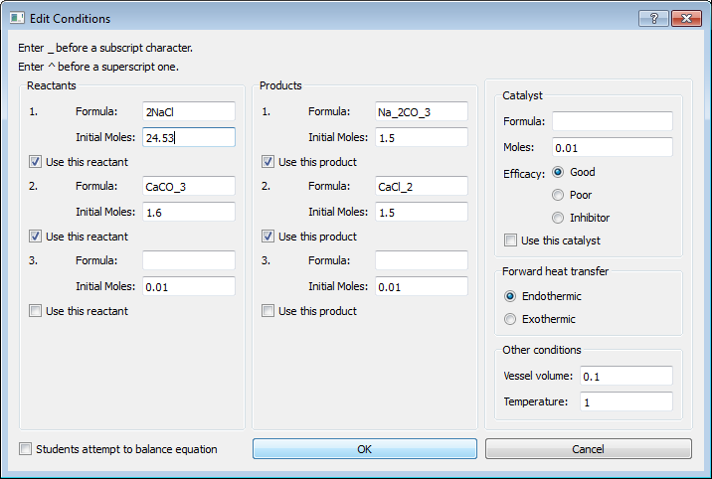 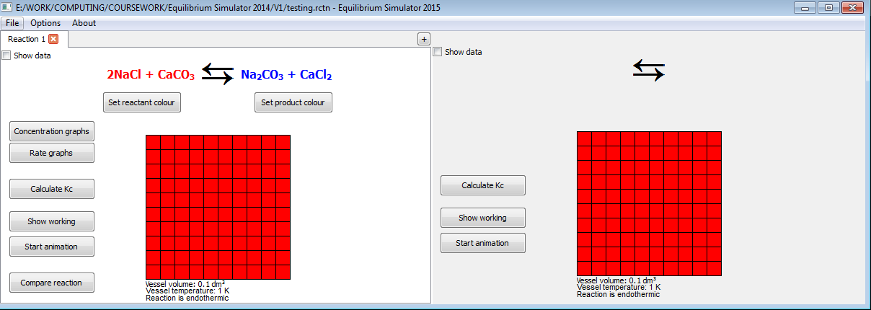

Figure 4.1.6: Window (left) closes, reaction updates and user can continue

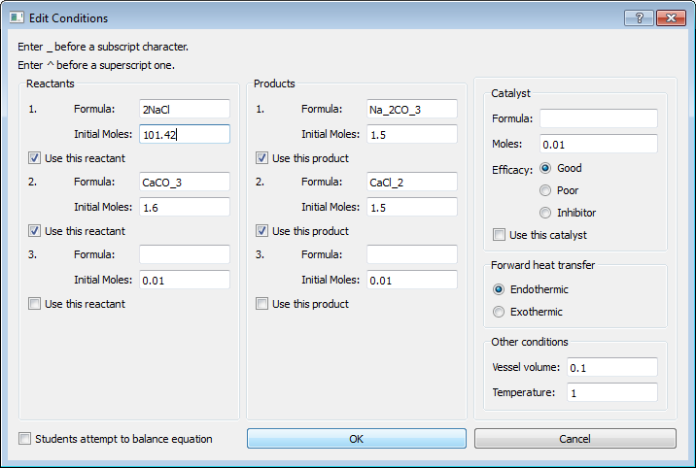 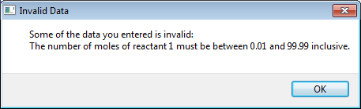

Figure 4.1.7: Popup box appears (right), explaining the accepted range

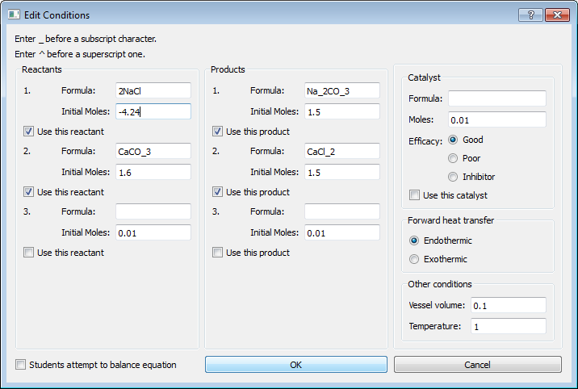 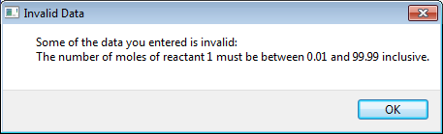

Figure 4.1.8: Popup box appears (right), explaining the accepted range

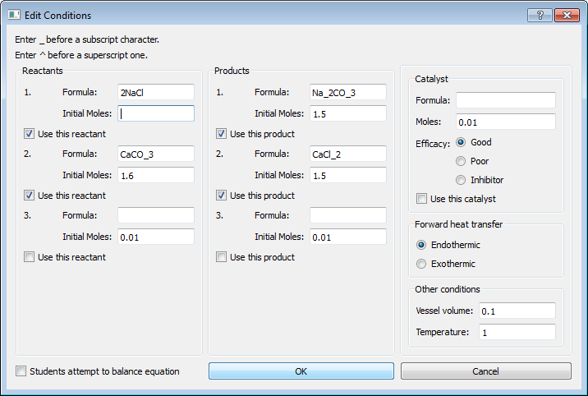 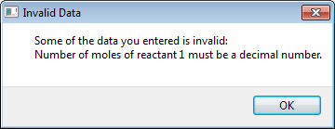

Figure 4.1.9: Popup box appears (right), explaining that a decimal number must be entered

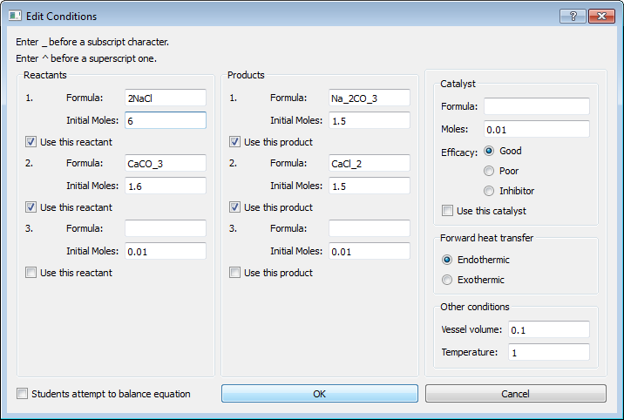 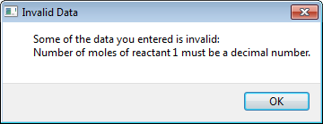

Figure 4.1.10: Popup box appears (right), explaining that a decimal number must be entered

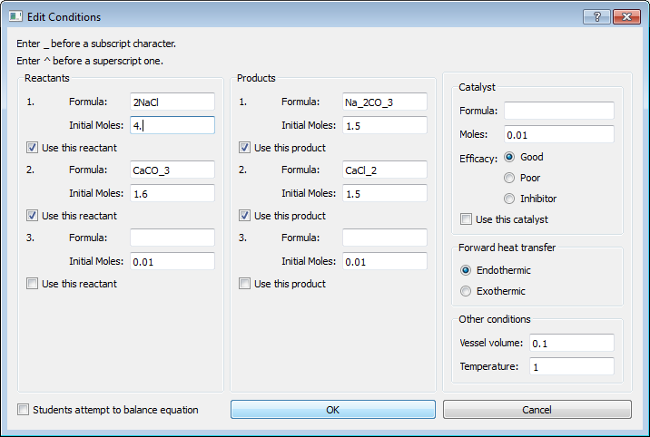 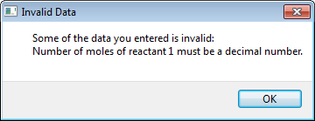

Figure 4.1.11: Popup box appears (right), explaining that a decimal number must be entered

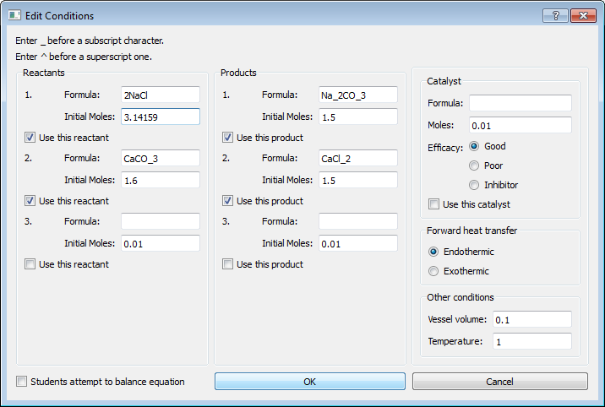 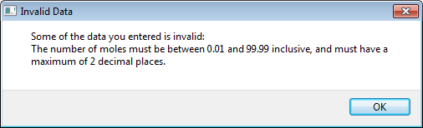

Figure 4.1.12: Popup box appears (right), explaining the accepted value range and precision

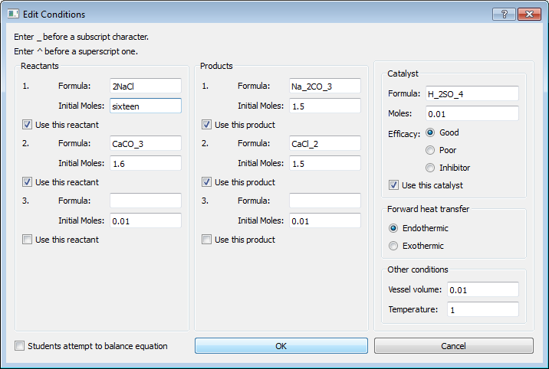 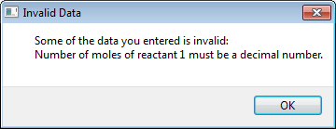

Figure 4.1.13: Popup box appears (right), explaining that it must be a decimal number

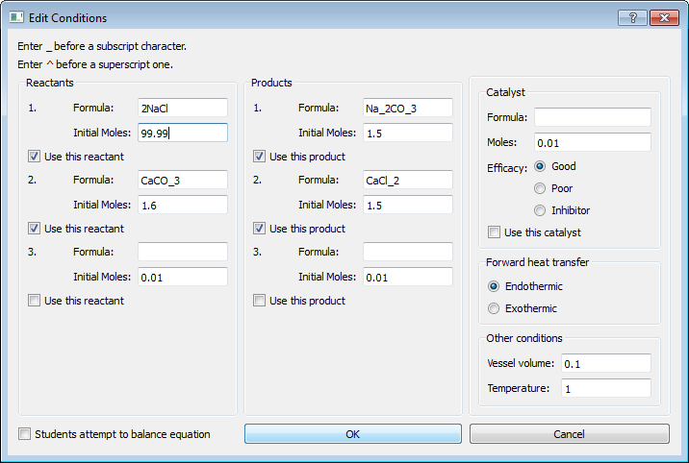 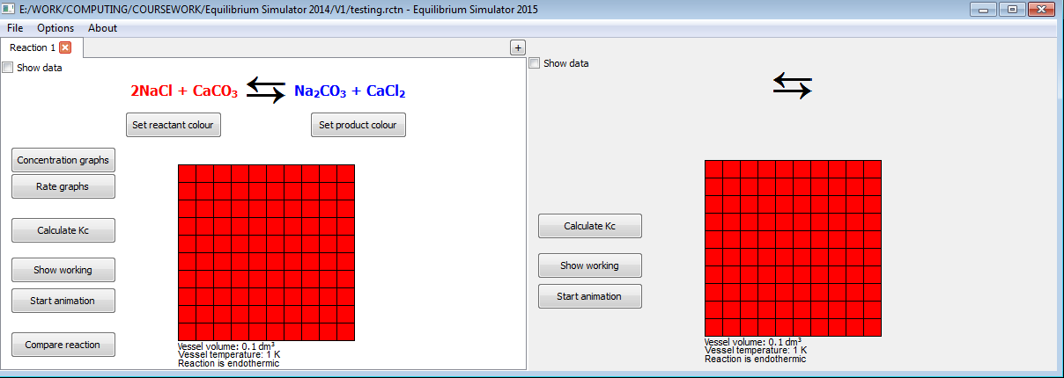

Figure 4.1.14: Window (left) closes, reaction updates and user can continue

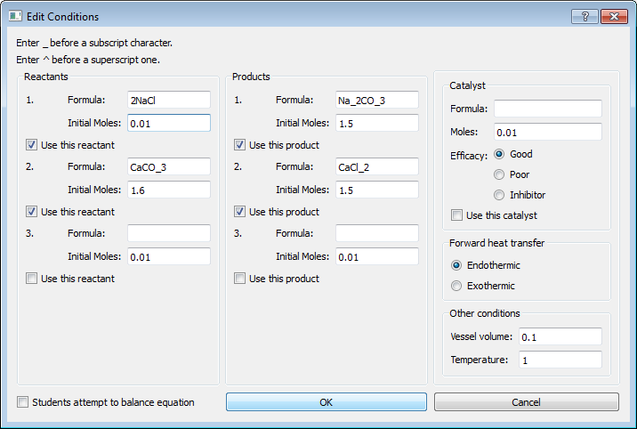 

Figure 4.1.15: Window (left) closes, reaction updates and user can continue

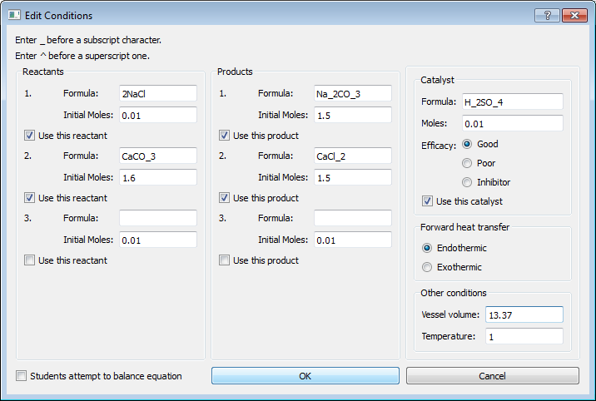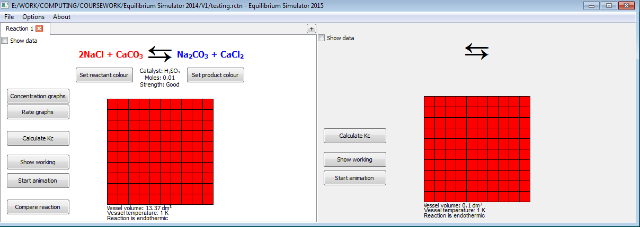

Figure 4.1.16: Window (left) closes, reaction updates and user can continue

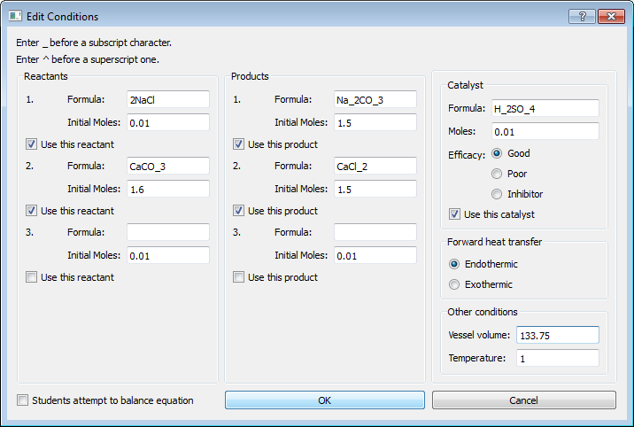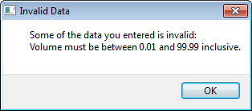

Figure 4.1.17: Popup box appears (right), explaining accepted range

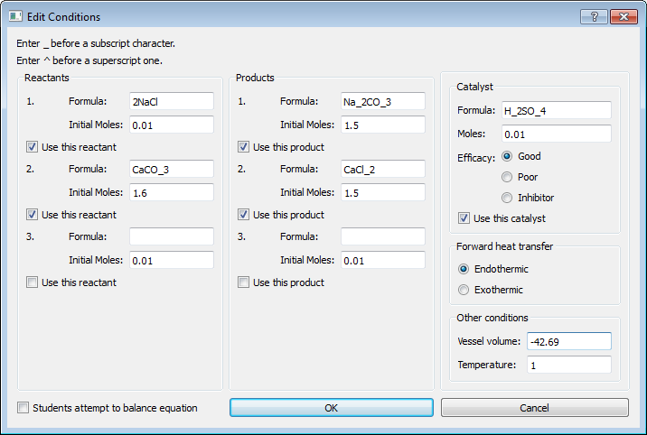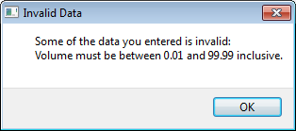

Figure 4.1.18: Popup box appears (right), explaining accepted range

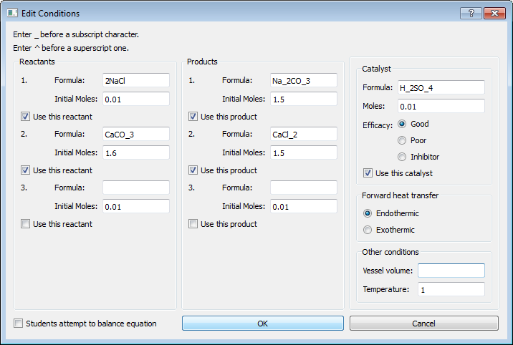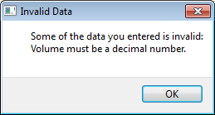

Figure 4.1.19: Popup box appears (right), explaining that a decimal number must be entered

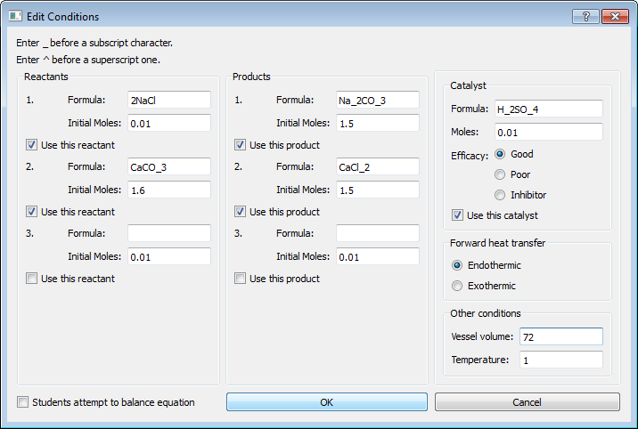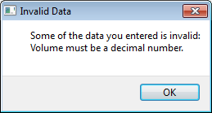

Figure 4.1.20: Popup box appears (right), explaining that a decimal number must be entered

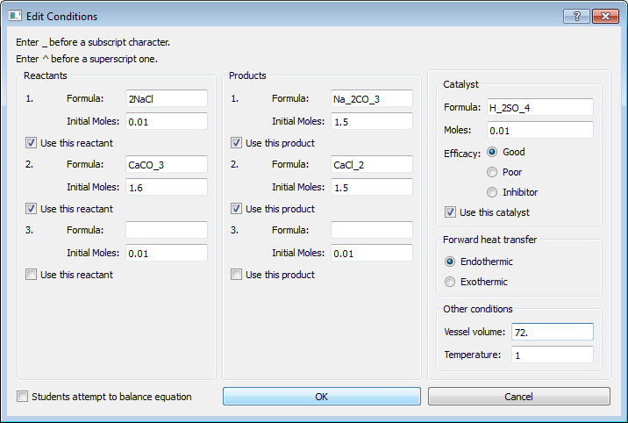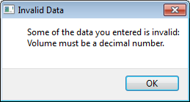

Figure 4.1.21: Popup box appears (right), explaining that a decimal number must be entered

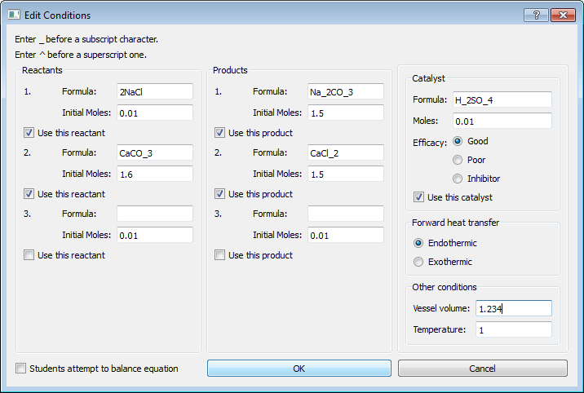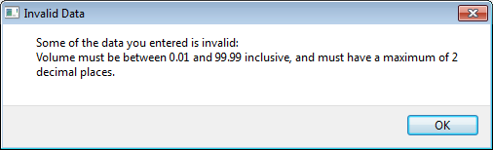

Figure 4.1.22: Popup box appears (right), explaining accepted value range and precision

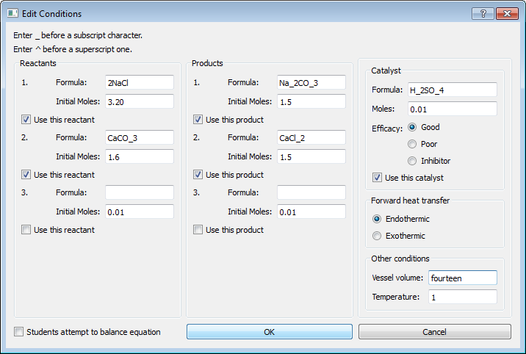 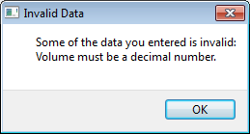

Figure 4.1.23: Popup box appears (right), explaining that a decimal number must be entered

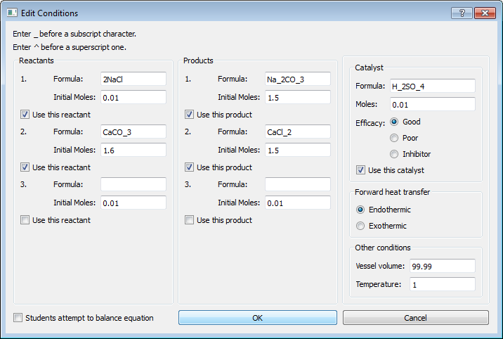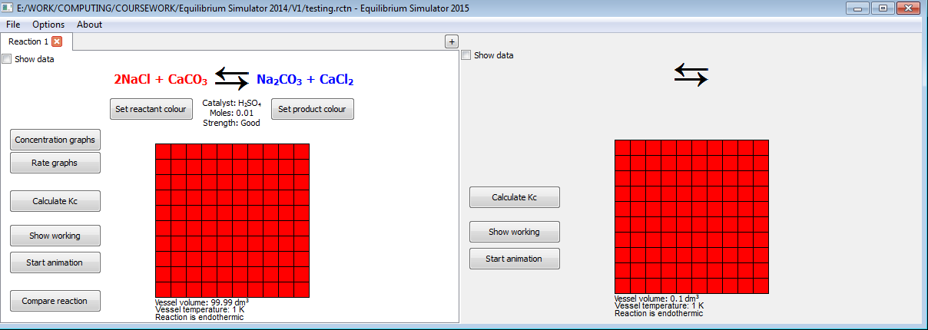

Figure 4.1.24: Window (left) closes, reaction updates and user can continue

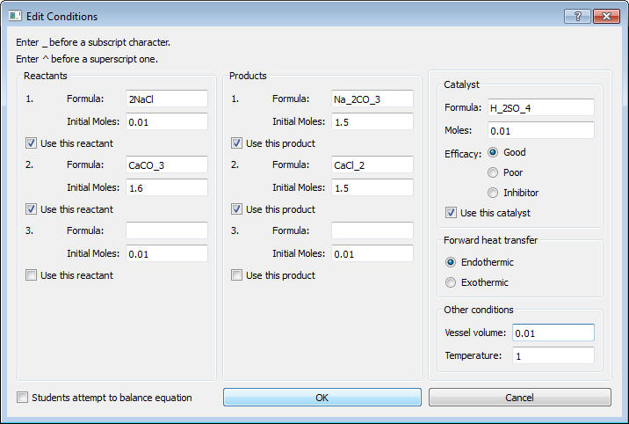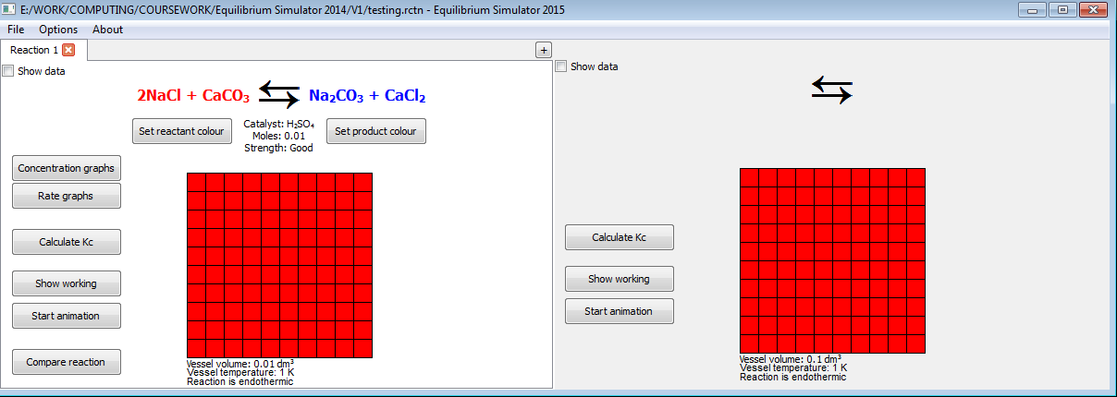

Figure 4.1.25: Window (left) closes, reaction updates and user can continue

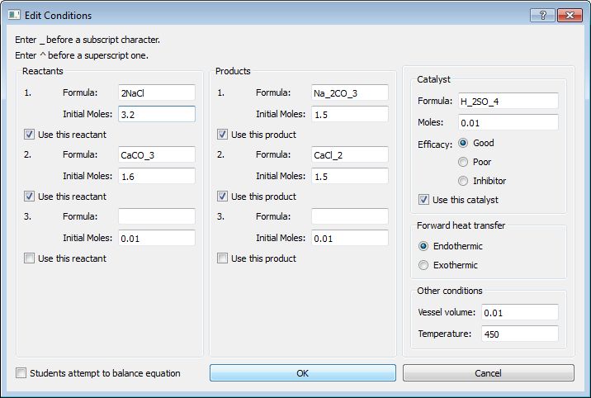 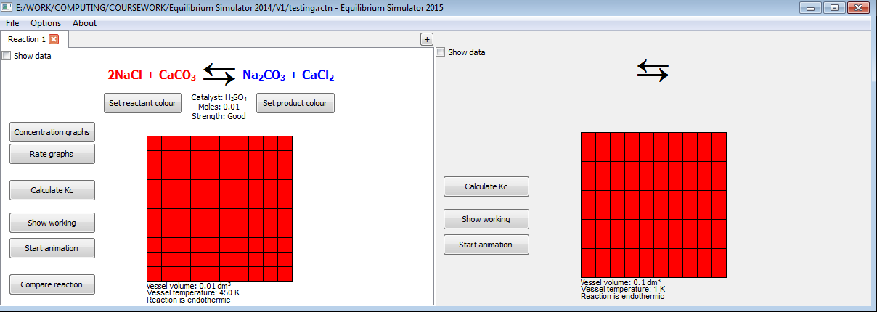

Figure 4.1.26: Window (left) closes, reaction updates and user can continue

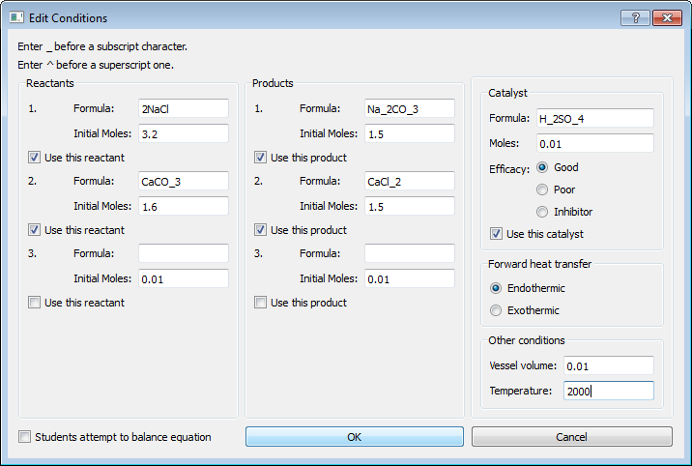 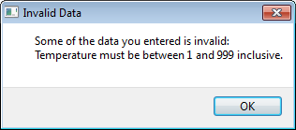

Figure 4.1.27: Popup box appears (right), explaining accepted range

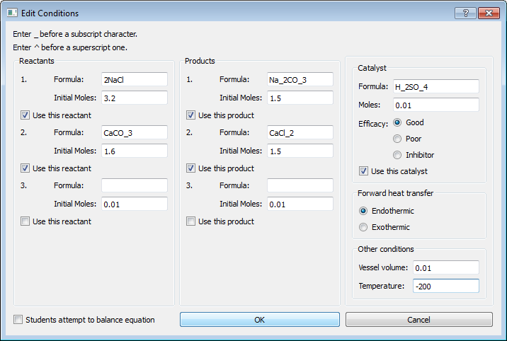 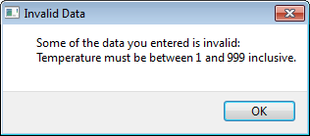

Figure 4.1.28: Popup box appears (right), explaining accepted range

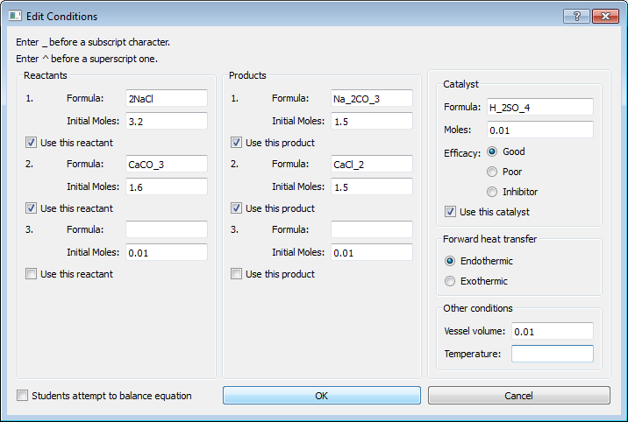 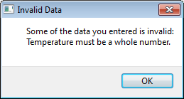

Figure 4.1.29: Popup box appears (right), explaining that an integer must be entered

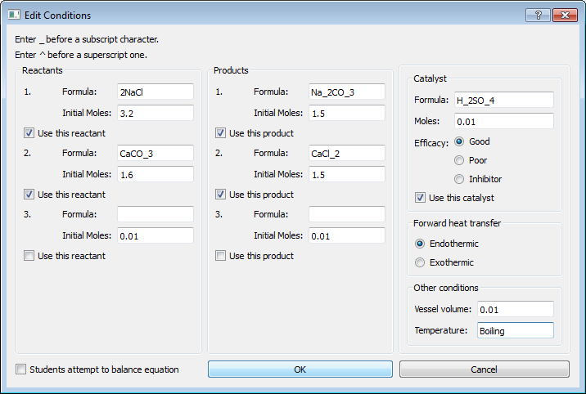 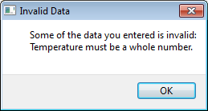

Figure 4.1.30: Popup box appears (right), explaining that an integer must be entered

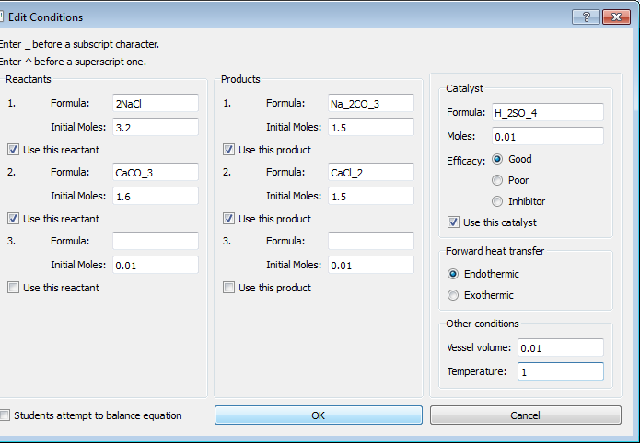 

Figure 4.1.31: Window (left) closes, reaction updates and user can continue

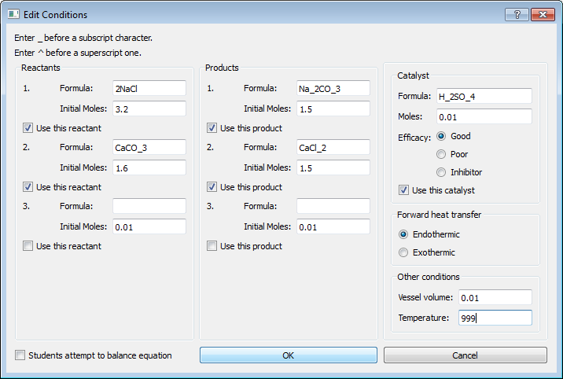 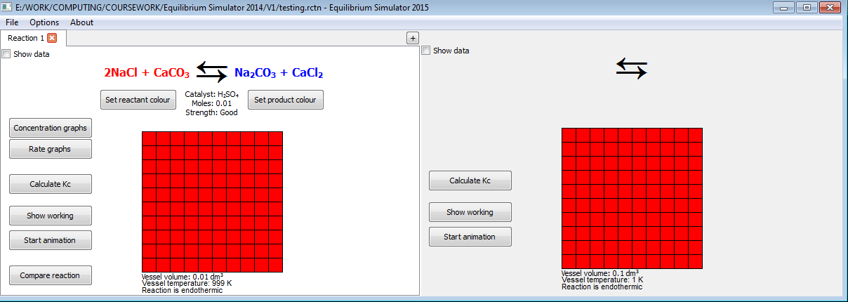

Figure 4.1.32: Window (left) closes, reaction updates and user can continue