HGVS
The Human Genome Variation Society (HGVS) nomenclature standard: variants in DNA, RNA, and protein sequences. [Variant, change, allelic variant. Can be used for cancer tissue: Mutation load and tumour mutation burden].
The mutation should include (In our case: reference : description):
- Reference sequence
- Variant description (Variant of the sequence, where in the CDS occurs the variation, and what is the variation)
- Predicted consequence in parentheses (no in our case, may be in the Protein Change column).
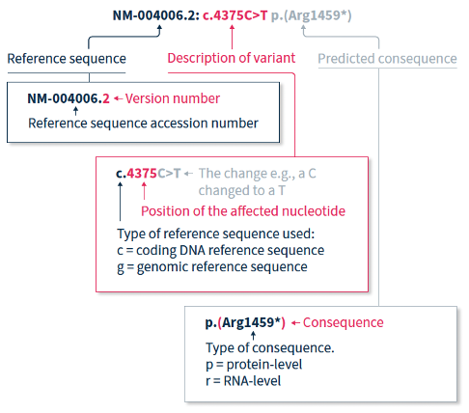
The reference sequence (unique sequence identifier)
A sequence file that is used as a reference to describe variants that are present in a sequence analysed.
Recommended Reference Sequences types are:#
- RefSeq sequences with the prefixes NC_, NT_, NW_, NG_, NM_, NR_, or NP_.
  - chromosome - NC_000023.11
  - genomic contigs or scaffolds - NT_010718.17, NW_003315950.2
  - gene/genomic region - NG_012232.1
  - coding transcript - NM_004006.2
  - non-coding transcript - NR_004430.2
  - protein - NP_003997.1
- Ensembl transcript (ENST) and protein (ENSP) which are not identified by Ensembl as being incomplete, e.g., CDS 5' incomplete (cds_start_NF), CDS 3' incomplete (cds_end_NF).
  - gene/genomic region - ENSG00000198947.15
  - coding transcript - ENST00000357033.8
  - non-coding transcript - ENST00000383925.1
  - protein - ENSP00000354923.3
- LRG sequences with the prefixes LRG_#, LRG_#t#, LRG_#p# (see examples below).
  - gene/genomic region - LRG_199
  - coding transcript (or non-coding transcript) - LRG_199t1
  - protein - LRG_199p1

Transcript sequence (ENST...)
An Ensembl transcript is a single splice variant that can be coding or noncoding. A coding transcript is comprised of UnTranslated Region (UTR) at the 5' and 3' ends, and the CoDing sequence (CDS).
Exons and Introns / cDNA and protein

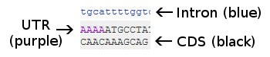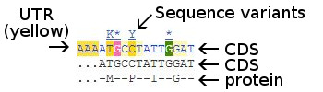
For what I understood, the gene sequence has exons (coding sequence(create protein)) + introns (exist, but non-coding (also called flanking part?)). When splicing the RNA the exons form the RNA coding sequence (the ones we have the HGVSs for, basically we do not have the flanks).

The variant description
Depending on the variants to be reported, different reference sequence files are used on the DNA, RNA, or protein level. It is mandatory to indicate the type of reference sequence file using a prefix preceding the variant description. Approved reference sequence types are c., g., m., n., o., p., and r..
DNA
g. = linear genomic reference sequence
o. = circular genomic reference sequence
m. = mitochondrial reference (special case of a circular genomic reference sequence)
c. = coding DNA reference sequence (based on a protein coding transcript)
n. = non-coding DNA reference sequence (based on a transcript not coding for a protein)
RNA
r. = RNA reference sequence
protein
p. = protein reference sequence

Important
After the sequence type prefix, the number and letters (e.g. 5C>A) indicate in what position of the CDS the change occurred and what type of change (in our case “>” are base substitutions).
Variant descriptions based on this format are very popular because they directly link to the encoded protein. In protein coding DNA reference sequences, numbering starts with 1 at the first position of the protein coding region; the A of the translation initiating ATG triplet (So in the case above “5C>A” refers to the base in brackets -> ATGX[X]XX…). Numbering ends at the last position of the ending triplet; the last position of the translation stop codon (TAA, TAG, or TGA). When you divide the position number from a "c." description by three, you get the affected amino acid residue from the protein sequence (description starting with "p."); for NM_004006.3:c.4375C>T (with predicted consequence on protein level p.(Arg1459Ter)), i.e. 4375 divided by three gives amino acid 1459.
NOTE: positions before the protein coding region get a hyphen-minus sign (e.g., "c.-26"), those after the translation stop an asterisk (e.g., c.*85). Numbering in intronic sequences has a format like c.530+6 or c.531-23. For details, see "Reference Sequences". The most frequently used coding DNA reference sequences are the NMs (RefSeq gene transcript sequences, e.g., NM_004006.2) and LRGs (Locus Genomic Reference sequences, e.g., LRG_199t1).

Links:
- https://www.sophiagenetics.com/resource/hgvs-nomenclature/?utm_source=chatgpt.com
- https://hgvs-nomenclature.org/stable/background/refseq/
- https://www.ensembl.org/Homo_sapiens/Info/Index
- https://en.wikipedia.org/wiki/RNA_splicing#:~:text=The%20word%20intron%20is%20derived,nucleotide%20involved%20in%20lariat%20formation.
- Download sequence (old data GRCh37-2014, ENST00000257430.4. Now GRCh38, ENST00000257430.9) (Can be done programmatically) (All references recommend using the version of the study, as info. might have changed): https://feb2014.archive.ensembl.org/Homo_sapiens/Transcript/Summary?db=core;g=ENSG00000134982;r=5:112073585-112181936;t=ENST00000257430

