Cancer Facts
https://seer.cancer.gov/statfacts/html/colorect.html
Colon – median age at diagnosis is 66, 65% 5 year survival rate
Lungs
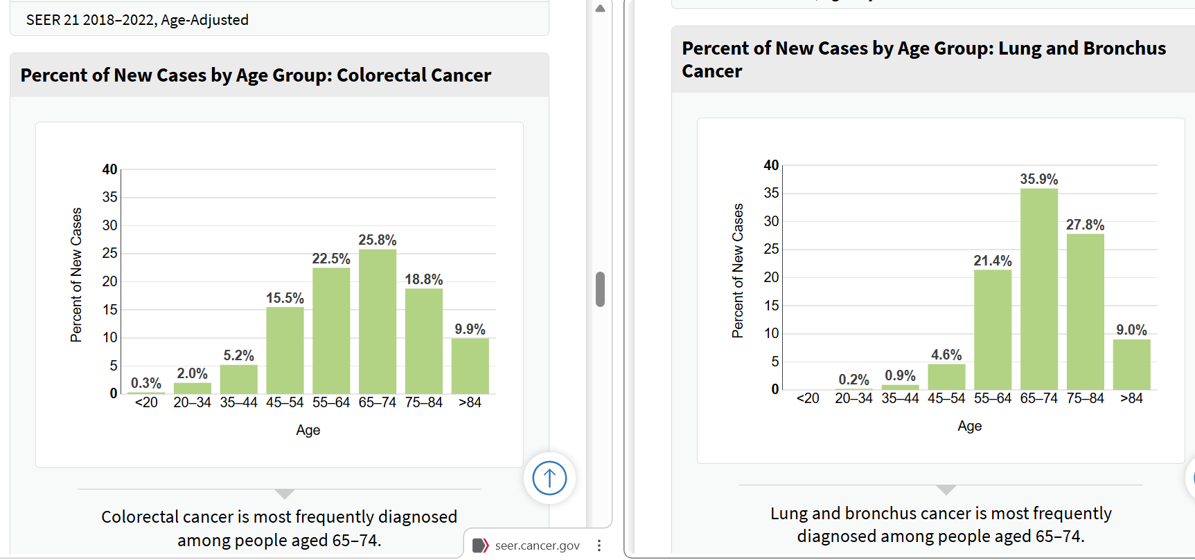
- Good comparison with similar spreads (except for the 45-54 brackets) and the same modal diagnosis age group
- Median diagnosis age is slightly high at 71
- 5 year survival rate at 28.1%
Brain
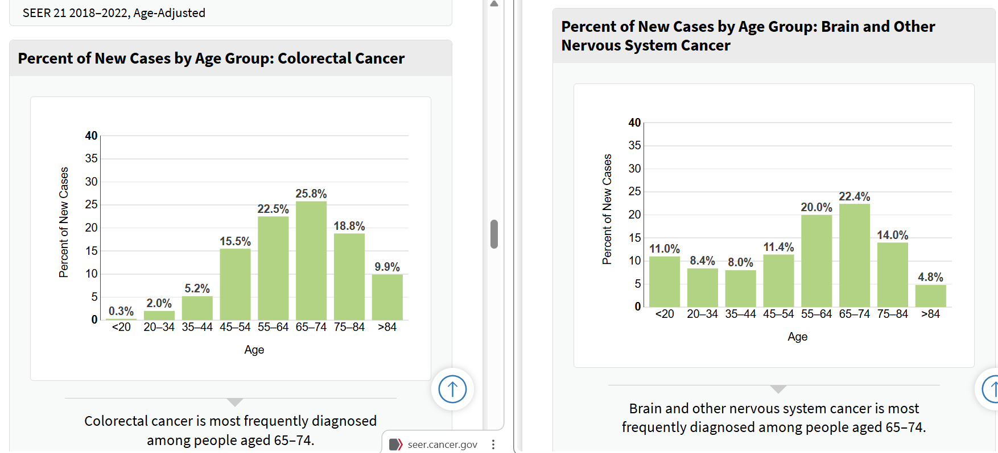
- The age distribution is not very similar overall, although it falls within a broadly similar age bracket.
- A greater proportion of diagnoses occur in younger people, while the percentages are fairly similar among those aged 45-84
- The median age at diagnosis is slightly lower, at 61
- The 5 year survival rate is 33%
Liver
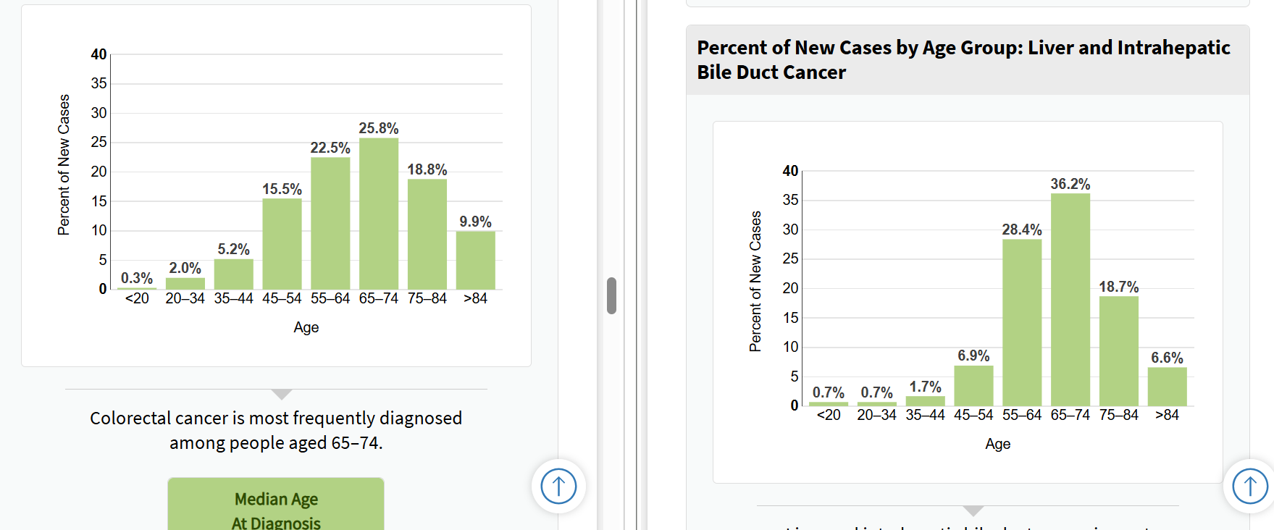
- Very similar median age at 67, though the distributions are not as similar as we would like them to be
- The 5 year survival rate is 22%
Breast
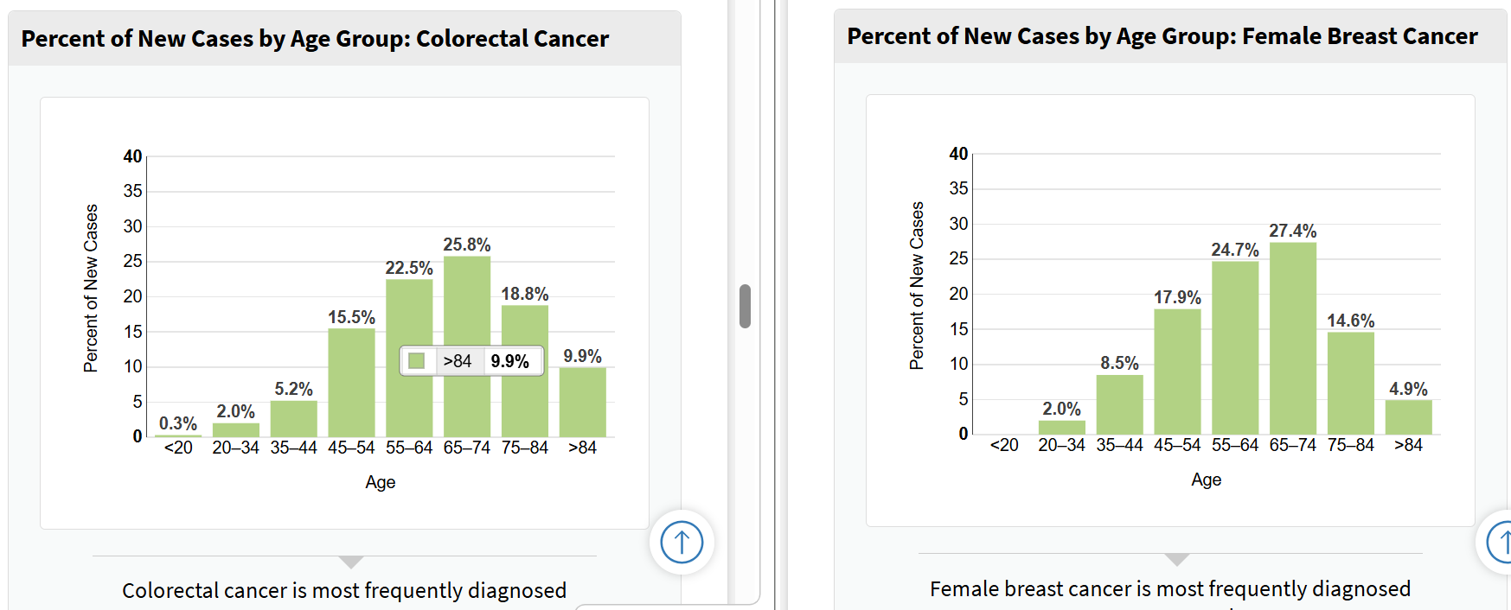
- The two distributions are quite similar, which is promising. This is perhaps the most closely similar distribution
- The median age is slightly lower than we would like at 63
- This is only female breast cancer and it is unlikely it will be as relevant as a comparison with our data
- The 5 year survival rate is 91.7%
Kidney
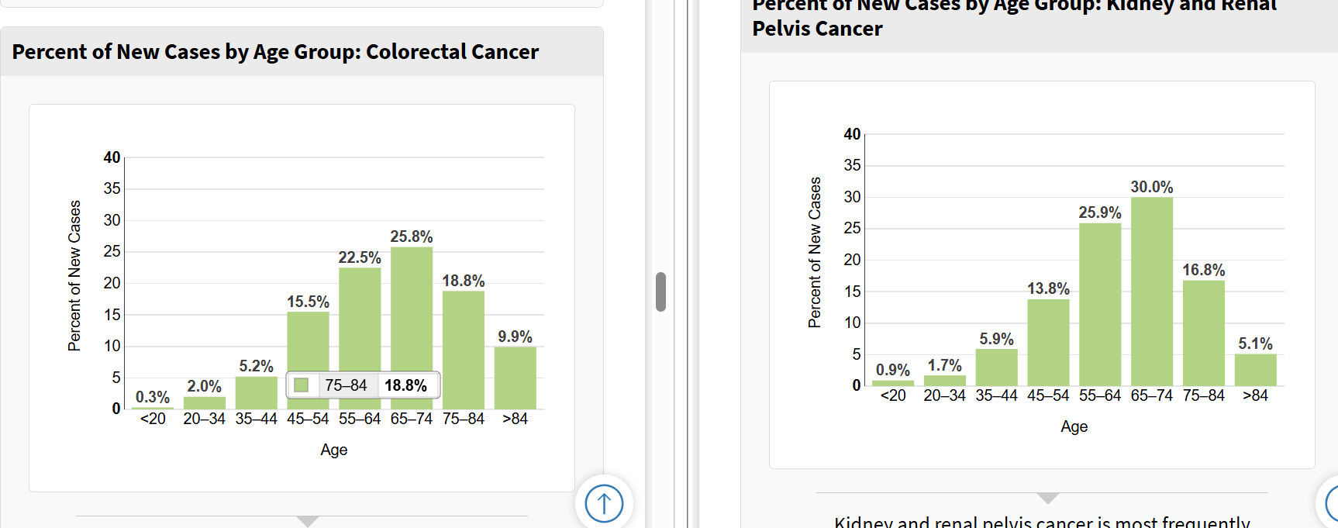
- Quite a similar distribution overall, but definitely more weighted to the 65-74 age range than the colorectal cancer distribution
- The median age is much closer, at 65 years old
- The 5 year survival rate is 78.6%
Pancreas
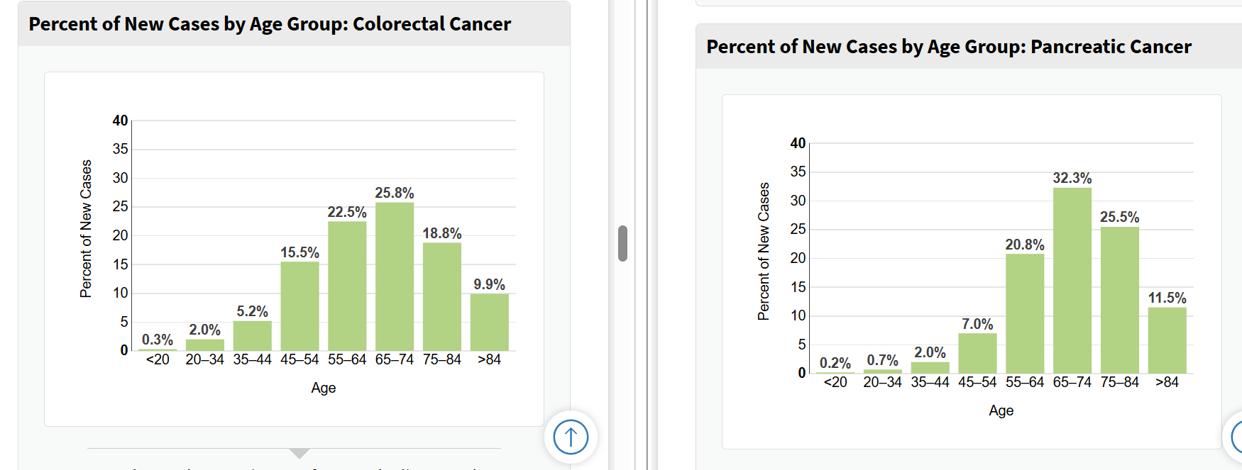
- This distribution is a similar shape, but not as close as some of the others
- The median age is quite a lot higher than we would like it to be at 71 years old
- The 5 year survival rate is 13.3%

