KEY FINDING: At the measured level of colibactin exposure in real TCGA colorectal tumours (alpha = 8.41%),. coli from colibactin-producing bacteria accounts for 8.41% of all somatic mutations and this best matches LogNormal at 10%
File | Contents and role
Context_SBS_2.txt | 96-channel COSMIC SBS probability matrix (GRCh38). Columns: SBS88, SBS1, SBS5, SBS18. Used in Part 1 sensitivity simulations.
signatures_GRCh37_SBS88_SBS1_SBS5_SBS18.csv | Same four signatures aligned to GRCh37. Used in Parts 2-5 for all loss optimisation, classification, ABC and APC curve analyses.
tcga_data.csv | TCGA colorectal cancer clinical data. Provides per-sample total mutation counts. MSS samples with >50 mutations: median N = 108. This N parameterises all simulation trials.
tcga_data2.csv | MSI status per sample. Used to filter the MAF to MSS samples only, excluding hypermutated MSI tumours whose high mutation burden would mask the SBS88 signal.
mc3.v0.2.8.PUBLIC.maf | TCGA MC3 pan-cancer open-access MAF file. Loaded in chunks, filtered to COAD and READ, further filtered to MSS samples. 45,393 SNVs across 102 MSS CRC samples. Processed by SigProfilerMatrixGenerator to build 96-channel spectra.
Data Sources

1.2

Sensitivity Simulations
At what colibactin injection level (alpha) can we reliably detect the SBS88 signature, and how does the answer depend on which probability distribution we use to model population-level heterogeneity in exposure?

Method
Five injection levels were tested: 1%, 5%, 10%, 15% and 20%. At each level, 200 simulation trials were run. In each trial, alpha was drawn from one of three distributions and N mutations were drawn from the resulting mixture spectrum P_infected(alpha), where N was sampled from the real TCGA mutation count distribution (median N = 108).

Distribution | Parameterisation
Gaussian N(mean_a, 0.1*mean_a) | Symmetric. Standard deviation fixed at 10% of the mean, matching Senkin et al. methodology. Values outside [0,1] clipped. Widest variance at low injection levels.
Beta Beta(alpha_s, beta_s) | Naturally bounded [0,1], no clipping needed. Parameterised by method of moments to match the same mean and variance as the Gaussian.
LogNormal LogNormal(log(mean_a), sigma=0.3) | Right-skewed. Median equals mean_a but a long right tail models a subset of patients with high sustained exposure. Most biologically realistic.

Detection was measured using cosine similarity between each simulated spectrum and the true SBS88 profile. Higher cosine similarity indicates the spectrum more closely resembles pure SBS88. Reference thresholds of 0.70 and 0.90 are marked.

Results
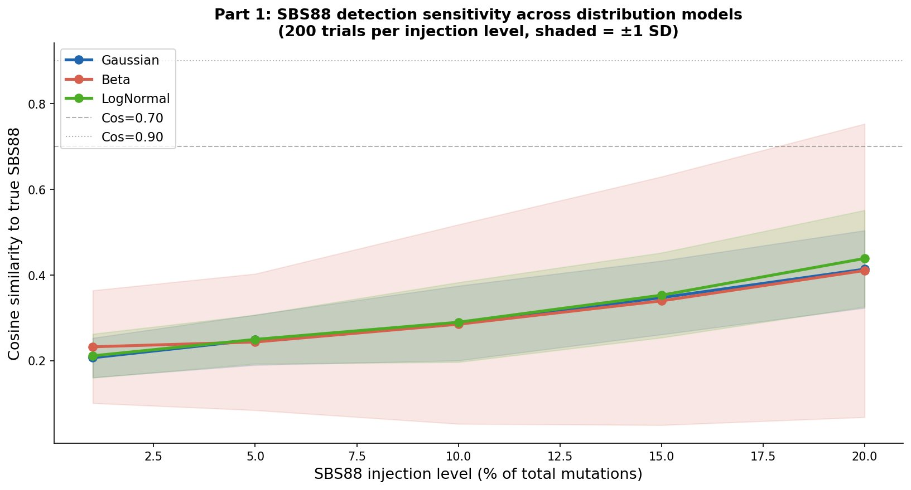

Real Alpha from TCGA Data

What fraction of mutations in real TCGA MSS CRC tumours are attributable to colibactin? This is the ground truth alpha_true that all subsequent analyses are calibrated to.

NNLS Attribution from Real Tumour Spectra
The TCGA MC3 public MAF file was loaded in memory-efficient chunks and filtered to colorectal (COAD and READ) MSS samples using MSI status from clinical data. This produced 45,393 SNVs across 102 MSS CRC samples. SigProfilerMatrixGenerator (GRCh37) was used to build the 96-channel trinucleotide spectrum for each sample by looking up the flanking bases from the reference genome for each variant position.
Non-negative Least Squares (NNLS) attribution was then run on each sample's 96-channel spectrum, solving for the weights h of the four signature components:
W @ h = spectrum, h >= 0 W is the 96×4 signature matrix: columns = [SBS1, SBS5, SBS18, SBS88] h[SBS88] / sum(h) = normalised SBS88 attribution = alpha for this sample
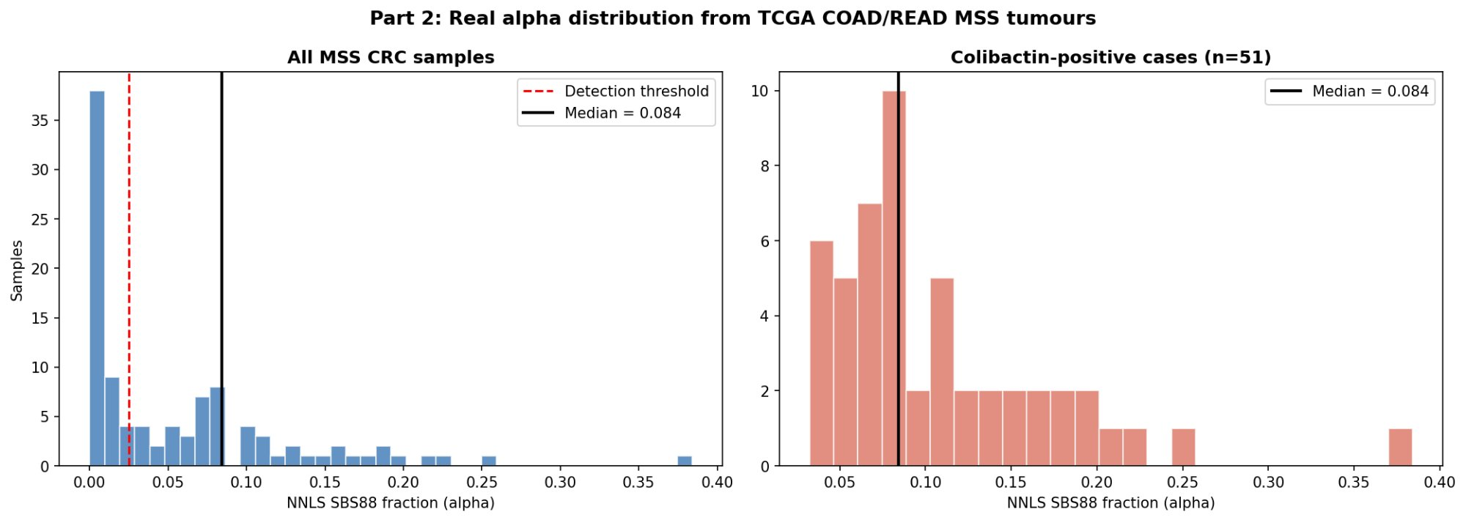

The distribution is strongly right-skewed. A large fraction of samples have near-zero SBS88 attribution, consistent with the majority of CRC patients not harbouring pks+ E. coli. However, 51 of 102 samples (50.0%) exceed the 2.5% detection threshold and are classified as colibactin-positive.
Key result: Median NNLS-attributed SBS88 fraction in colibactin-positive MSS CRC cases: alpha_true = 8.41%. This means that in colibactin-positive tumours, approximately 1 in 12 somatic mutations was caused by colibactin damage from E. coli.

Loss Optimisation Three Independent Methods
To validate the real data estimate independently, a grid search was run across 26 candidate mean_a values from 0% to 50% for each of the three population distributions. At each candidate, 100 synthetic spectra were simulated and their expected spectrum computed. Three independent loss functions were evaluated:

Loss function | What it measures
KL divergence loss | KL(observed || E[spectrum]) information-theoretic distance. Minimised when the expected spectrum matches the observed in the fullest distributional sense.
Cosine distance loss | 1 - cosine(observed, E[spectrum]) angular difference in 96D space. Measures spectral shape similarity, insensitive to scale.
NNLS attribution loss | |NNLS_SBS88(E[spectrum]) - alpha_true| how accurately does NNLS attribution recover the true alpha from the expected spectrum?

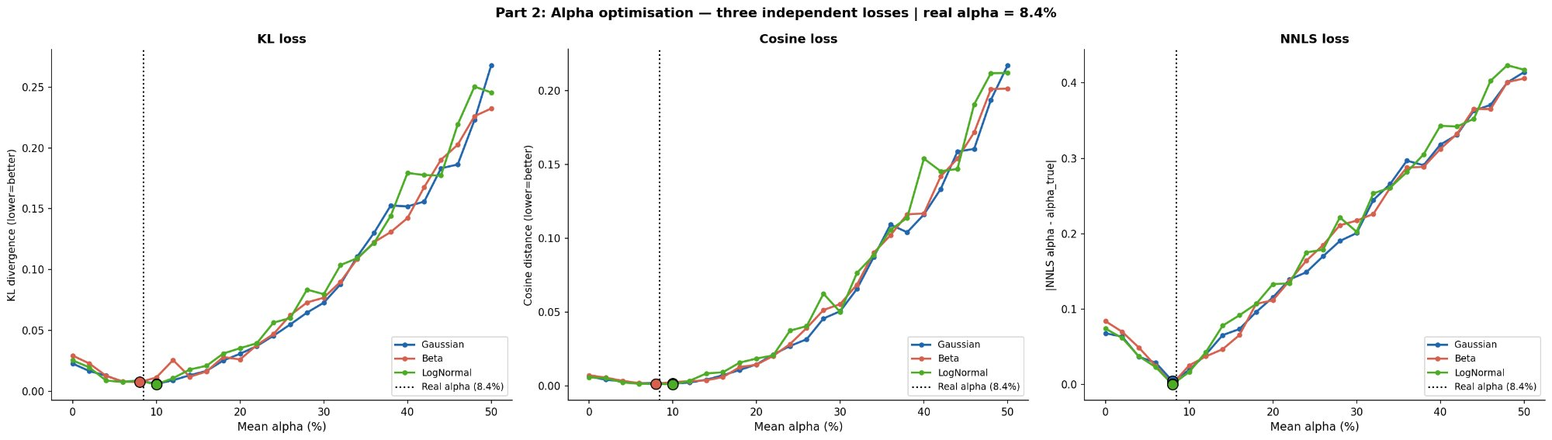

All three loss functions reach their minimum close to the real alpha value. The loss curves show a clear single minimum near 8-10% for all distributions and all three metrics. The filled circles (optima) are tightly clustered around the real data estimate.

Distribution | Optimal alpha under each loss
Gaussian | KL opt=10.0% Cos opt=10.0% NNLS opt=8.0% Agree: YES
Beta | KL opt=8.0% Cos opt=8.0% NNLS opt=8.0% Agree: YES
LogNormal | KL opt=10.0% Cos opt=10.0% NNLS opt=8.0% Agree: YES THIS WAS BEST

Best-fitting distribution: LogNormal (lowest KL divergence). Optimal alpha = 10%. The real TCGA value of 8.41% falls within one grid step (2%) of the optimum for every distribution and every loss function. This cross-validation confirms that the SBS88 signal in real TCGA tumours is consistent with a LogNormal population exposure model at approximately 8-10% colibactin fraction.

