NEW ENGLAND FAMILY HISTORY CONFERENCE 2013 EVALUATION

Demographics:
- Where Do You Live?
MA | 69
CT | 3
RI | 7
NH | 3
ME | 3
NY | 2

?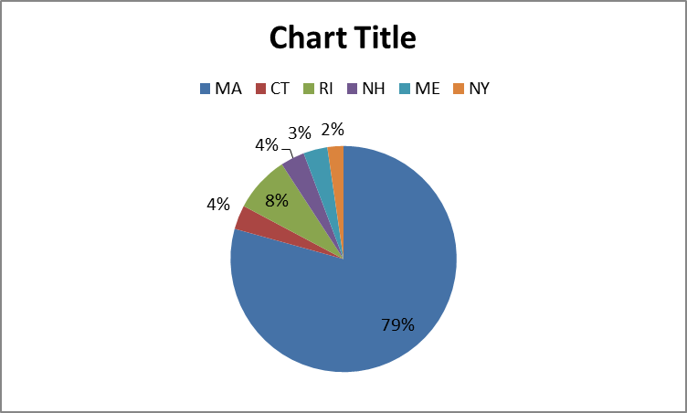

- How did hear about the Conference? Shows # Participants and how they heard. (Not percentage)
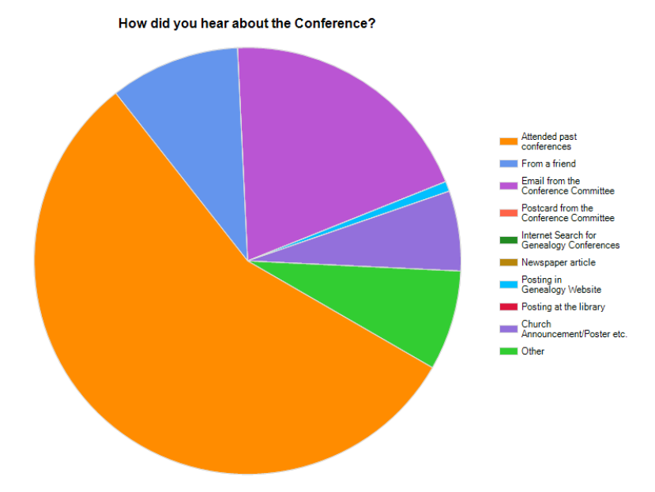

Attended Past Conference: 74
Email from Conference Committee: 26
Heard From Friend: 13
Other : 10
Church Announcements: 8
Posting on Genealogy website: 1
FYI ONLY
Total Participants Registered on Website: 432
Total Contacts: 1589

- Your Level of Expertise?
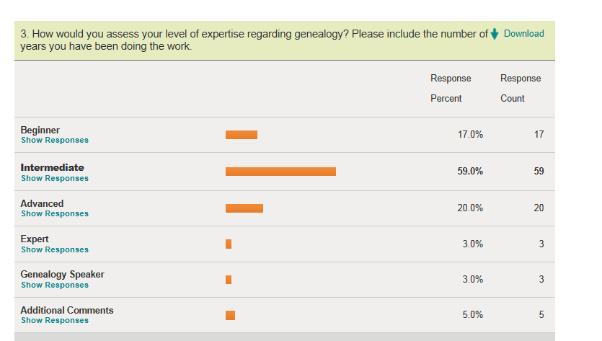

(Will try to break this down a little more if you need it)

Please Provide Feedback on Classes and Presenters: 1- Excellent, 2-Very good, 3- Fair, 4- Poor
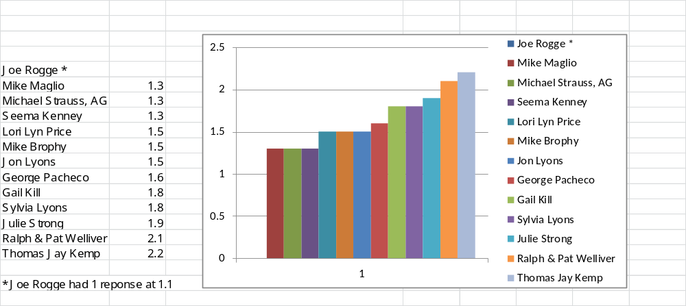

Points Most Often Stated in All Comments:
- Didn’t like having a remote internet speaker
- Some didn’t correctly read or weren’t clear on specifics of classes
- Many Kudos for Michael Strauss, AG
- Comments on absent handouts in the syllabus
- Many liked the choice of topics
- Many liked the lunches
- Registration went smoothly
- When things change or presenters can’t attend please let them know at the opening so adjustments can be made
- Would like more on FamilySearch Tree
- Very Organized
- Parking Better
Conclusion:
Many excellent comments. Overall this was a very successful conference!!
Congratulations to you all!

THE OFFERINGS:

Joe Rogge: Evaluation Average Score: 1.1 (Only 1 response)
_________________________________________________________________________________________
CLASSES

Session 1 - Basic Computer Skills by
- He was very organized and presented clearly. It was more basic than I had expected, would like to see him give an advanced one.

Session 2 - Basic Computer Skills by Joe Rogge: No responses

Lori Lyn Price: Evaluation Average Score: 1.5
_______________________________________________________________________________________

CLASSES

Session 1 - Bring your Ancestors to Life: Connect via Social History
- Interesting
- I thought that Lori was an excellent speaker, but I felt that there was not enough information towards her session that I was in. I enjoyed her talk anyway.
- Very good - good speaking skills and use of technology- concept was good but I've already done this
- Would like more tips on where to find
- Learned some things that I did not know already
- Very Good. She was well organized. The only downside of her presentation was that she spoke a little fast.
- She gave us a lot of good information on how to get to know a specific ancestor personally. It is really valuable to get to know some of the life of people in your family and not just create a name chain.
- Very good speaker - learned a lot
- Excellent - wish there had been more time for Q & A
Session 3 - Genealogy in your Pajamas: Put your Library Card to Use

• Helpful tools! A good program for learning new resources.
• More great info for working at our leisure at home.
• My fault that I didn't realize the focus was on Boston Public Library, out of reach for this CT Yankee,
Still she gave ideas for use with IConn
• Although Lori was not aware that Rhode Island residents could use the Heritage Quest website, I
found out recently that we can by going to AskRI.org
• Not a lot of new information but always good to review what we already knew or forgot to use
• Excellent Lori had wonderful examples can't wait to get started on some of her sites
• Very helpful information using Boston Public Library
• Very knowledgeable and was well presented
• Looking for new things. Good talk.

PRESENTERS
- Specific information; good resources
- I felt that there wasn't much to ask any questions related to what she taught
- Good Speaking skills and use of technology
- Excellent presenter. However I found out recently that Rhode Island

Julie Strong: Evaluation Average Score: 1.9
________________________________________________________________________________________

CLASSES

Session 1 - FamilySearch Series: Making the Most Out of the Family History Catalog

- Very informative, had never used the catalogue, but will now.
- Need to keep pace on the program. No allowance for loss of internet.
- Needed more preparation.
- The mike didn't work so couldn't hear to well.
- Ms. Strong did a great job in explaining.
- A very useful class which really extended the understanding of all the possibilities in using this portion of FamilySearch.
- She gave specific detailed insights and did not go too fast.
- Wish there was a hand out.
- Needs better preparation and to listen to questions.
- Search functions were well explained.
- Good content, new aspects for distant work through the internet .
- Excellent. She gave very informative tips and her presentation was well paced.
- Good; you need an option between very good & fair; took too many questions and I don't think she got through her planned material.
- The presenters should have a few min. with the mics before the presentation. I wish there had been a Handout or syllabus page for this one
Session 3 - British Connections- Beginner Level British Research

• Interesting
• Very good handling of a very large topic
• Good; seemed not sure of herself; a novice presenter?
• Lots of info, a flow chart would have helped, very very good
• She needs to be more organized - tends to go off on a tangent
• Very Good - basic info - good for beginner - did pick up on some tips
• Knowledgeable speaker but examples were not prepared in advanced, also billed as British but just
• England, helpful caveats on searches
• Realized 5 minutes same presentation as last year - and was boxed into the seat I was in

Session 4 - British Research the Cyberway
• Good info and insights, might have called English not British still very helpful
• Good basic introduction to the topic.
• Julie Strong was a great speaker, but she seemed just a little bit unorganized, but other than that I found her presentation mostly interesting and helpful. She was very nice to a few participants, one who asked irrelevant questions, and another who went on for too long about her individual genealogy question which was pretty much irrelevant to most people. Maybe she was a little too nice, but I understand it's not easy to deal with a situation like that, so it's more a comment on something that happened during the presentation than any fault of the speaker. I just went over the notes I took during her talk, and they're chalk full of helpful information, especially for someone like me who hasn't done much British research.
• Excellent found out some new information to assist in my English research
• Good - some bit repetitive of previous session on British research
• Very good. Picked up some great connections.
• Too much repetition from previous session
• Several good tips on accessing records. Well paced.
• Again difficult to read screen in the chapel. Presenter spent time at the end with questions that were very off topic
• Graphics not readable
• Not too informative

Julie Strong (cont.)
______________________________________________________________________________________

PRESENTERS

• Always upbeat and knowledgeable. Answers all questions in detail.
• Very good -- knew her stuff
• Allowed too many questions to misdirect pace.
• Fair w/ FHC would like outline/avoid un-needed note taking
• Great presenter, very knowledgeable on subject
• Needs to get organized and stick to the topic
• She knows her topic, and presents it well.
• I enjoyed your talk "British Research the Cyber Way" and thought you were friendly and helpful.
• One small criticism is that you came across as a little bit unorganized, but this didn't bother me very
much considering you still shared quite a bit of helpful information. Your slides were great, and made note-taking easy.
• Had facts about her geographic area at the tip of her tongue especially enjoyed info about yahoo Google
• Very good - good knowledge of topic
• Easy to listen to. Did not go too fast. Gave great insights.
• Needs more preparation and needs to listen to questions without interrupting serious inquiries.
• Not prepared but quite knowledgeable.
• Very clear and well-paced presenter. Courteous to all questions.
• Excellent. Well-paced and informative
• Needed to save questions for the end in order to get through material
• Disappointed as exactly the same as last year
• Fair - Julie had a small amount of info, and didn't present well.

Mike Maglio: Evaluation Average Score: 1.3
_________________________________________________________________________________________

CLASSES

Session 1 - Finding Living Cousins: Being a Genealogy Gumshoe
- Loved it. Would enjoy more on methodology.
- Well organized and presented.
- Knowledgeable, entertaining, well organized
- Nice guy but not helpful as it was really restricted to Massachusetts for vital records
- Needs to provide more info on how to
- Interesting subject, not enough info in the Syllabus and no name on the Syllabus, Good topic but
not enough info to refer to in the future. Also, no name of the speaker on the Syllabus...just "About
Mike: No way to contact him at a later date. Subject was interesting but no real info to take home other
than your own notes which you usually can't read.
- Excellent clever and detailed presentation
- Good - content good - a bit basic - could have expanded on to fill time.
- Am going to use one of the suggestions he gave
- Very good presentation. Well-paced but the handout was not detailed enough.
- Presented in a fun, easy to learn format. Enjoyed it!
- Very good and entertaining
- Excellent speaker, excellent material
- Excellent speaker, content excellent, pace was a little fast because he was afraid that he would run
- out of time
- Well prepared
- Very general
Session 3 - Mapping Your Tribe: Using DNA to Find Your Inner Barbarian
• Great help in understanding DNA research expectations.
• Mike is a great speaker.
• Good pace and presentation. Good storytelling. Not completely convinced about the effectiveness
• of the method.
• Well paced presentation. A little difficult to follow the approach he took but very knowledgeable.
• Not knowing, if I should take the DNA, or not, and is there any reason for me to. Mike Maglio got me
• thinking that I should. Thank you.
• Knew material and could explain it. Good speaking skills and technology skills, he owned the room!
• Provided answers to everyone’s questions and offered his contact info for other questions later.
• Need more presentations on DNA
• He was extremely informative/allowing as much information as possible in the one hour
• Good presentation of a complex topic. Mike had clear explanations and good examples.
• Extremely informative
• Excellent. I have recently had my DNA tested so it will help me intrepret the results.
• Enthusiastic and energizing. Made us want to learn more.
• Mike's talk was fascinating and inspiring!

Mike Maglio: (cont.)
_________________________________________________________________________________________

PRESENTERS

- Great enthusiasm.
- Good presentation style. Clear. Knows his material.
- Enjoyed very much, great presentation and there was plenty of time for questions.
- Displayed mastery of knowledge.
- Has good command of his subject
- Wonderful speaker, answered questions
- Knowledgeable, entertaining, helpful suggestions, excellent computer presentation
- Intro was cute, but a little long I almost left before he got down to business with anything solid you
could use.
- Extremely informative gentleman and with beneficial outcome.
- Needs to present a longer program with more specific info.
- Did a good job. Have him come back.
- Dynamic speaker and extremely knowledgeable about science and DNA. I also appreciate his taking.
the time to answer questions after the class.
- Great slides good information good question comment discussion at end.
- Good - entertaining and knowledgable.

Gail Kill: Evaluation Average Score: 1.8
___________________________________________________________________________________________

CLASSES

Session 1 - Organizing Your Research
- Just the right amount of specifics and plenty of ideas!
- Great sense of humor, practical ideas
- Well organized and presented
- I am not computer literate enough for this information
- Focus on content, great for anybody doing genealogy
- Gail Kill was excellent; her presentation was helpful and easy to follow, and I went home with some
- good tips. She's also very friendly and likable, and I loved her story at the end of class!
- Very well prepared, helpful tips, would like handout to match the presentation better and sample
sheets/forms
- I started when only paper was available. I want to keep up with the new . I learned a lot.
Session 2 - FamilySearch Series: Pedigree and Family Tree

• Poor speaking skills poor technology skills.
• People walked out and I should have joined them.
• Didn't cover selection material but told lots of stories wasting first 15 minutes not focused and
audience ?'s completely disrupted her train of thought if she had one to begin with.
• An outline handout would have been helpful. The syllabus did not relate to the talk. Talk would have
been better after the afternoon FS programs.
• Lots of good info but the discussion jumped all over.
• Very knowledgable, good overview of the program.
• Too much information for a beginning beginner.
• A little too basic for me but I am sure it was helpful to othes .
• I like to keep updated with Family Search. Good information.
• Scattered presentation; hard to follow.

Session 4 - Organizing Your Research

• Excellent
• Deserving a really poor rating. 3 people walked out of this session and after computer problems
(non-charged Battery) strayed way of topic and was very DISORGANIZED. Did not even begin to cover
course discription. there was no how to but only stories of buffalo bill , cooking, and her crying
grandbaby in the back of the room didn't help her case any. This speaker was very dissapointing
because I came to the conference for these two areas and didn't get out of it anything close to what i
thought I was supposed to.*********Need to get persons contact inf**********
• Very good information and an exceptional speaker
• Realized I had heard this before so I went to the Miliary Records workshop- an easy choice having
heard Mr. Strauss in the morning. I knew he would be good.
• Technical problems made it a little difficult to follow
• She was very good but the content was too basic for me. My error.

Gail Kill (cont.)
___________________________________________________________________________________________

PRESENTERS

- Nice presentation style - informative, good humored delivery
- No meat and potatoes of how to – too much personal story telling eating away at time. people left
- during presentations
- Probably assumed we knew more about the subject.
- Good presenter, talk presumed prior knowledge of FamiySearch Family Tree
- Excellent talk and presentation
- Pleasant, precise, clear speaker
- Very good
- Seemed a bit disorganized
- You are my favorite speaker at these conferences! :-) No changes recommended.
- Very knowledgeable. Did not go too fast. Gave good information.
- Wonderful storyteller, concrete suggestions. Thanks!
- She seemed to present the organizing better than the family pedigree.
- Scattered presentation
- Excellent - Gail is great! She adds humor and keeps your interest throughout her presentation

Michael Strauss, AG: Evaluation Average Score: 1.3
___________________________________________________________________________________________

CLASSES

Session 2 - Bankruptcy to Equity: Using Federal Court Records
- Excellent - learned lots.
- Wonderful outlines, engaging speaker, really brought what could have been a dull subject to life. I
would love to hear him again.
- Extremely pleased. Great speaker - totally organized.
- Michael presented a somewhat dry topic in a concise, entertaining way.
- Syllabus was informative, more info and descriptions to refer to in the future.
- Michael Strauss was interesting and entertaining at first, but most of the examples he used
were not very interesting to me (though I appreciate being informed of what types of things one can
find in Federal Court records). Also, he laughed extensively at, not with, a participant who answered his question about what Virginia and Massachusetts have in common (I didn't hear what she said
(possibly they're both Atlantic states???), but the correct answer -- which a number of us knew -- was
they're both commonwealths. I just thought it was inappropriate and condescending to go on and on
laughing about it (I felt bad for the woman). But other than that he was a pretty good speaker, and I
think he just needs to make some of the examples a bit more interesting. Some of the information
was indeed very good and I think the topic deserves attention.
- Excellent. Well organized content with pertinent examples and helpful handout.
- Could have had more detail, otherwise very good
- Very knowledgeable, good information
- Michael had excellent knowledge and used good examples
Session 4 - Military Records - Civil War
• The best! I learned so much, and Michael was gracious with his time
• Very interesting. Passionate about subject. A bit too much material for time however.
• I really love the Civil War, and I learn more this time around and Michael Strauss did excellent job.
• Both of his sessions were very helpful (World War I and II)
• Excellent presentation, extremely knowledgeable, very helpful suggestions, excellent presenter
• Very helpful- had absolutely the best outlines, so you could actually remember what he said
• Michael has such a passion, it is infectious
• Excellent !! Great presentation/speaker.
• Excellent, Very informative, Added personal experiences
• Loved his class could have sat longer and listened to him
• Excellent. Well organized content; comprehensive list of records to research and a good list of
• reference book. Very good handout.
• Mr. Strauss gave a great presentation.
• Enthusiastic, entertaining speaker
• Excellent!!! Suggest Michael do presentation in civil war uniform for greater effect.

Michael Strauss, AG (cont.)
___________________________________________________________________________________________

PRESENTERS
- Fantastic speaker
- Nice presentation. Good details.
- My favorite, so generous with his time!
- Excellent
- Love his energy on the Civil War, but not much time to ask questions and to get to the next session.
- I'm glad I went to both Military History sessions. Very good speaker "passionate"about his subject, I
feel confident about following up
- John was in this --and every one liked it sooo much it ran 15 minutes over and they wanted more
- Very helpful information, excellent presentation, very enthusiastic about C.W. subject matter
- What can I say. Is there anything better than excellent? How about superb! Great outlines so you can
remember, engaging style of presentation, and exceedingly well versed in the subjects presented.
- Great Speaker! Knowledgeable and extremely informative. Could listen to him for two hours easy!
- Good speaker, passionate about his subject
- Bring him back every year!!!
- Very engaging, has extensive knowledge of military history and personal experiences
- I appreciated hearing about Federal Court records, and I liked your style but please resist the
temptation to laugh at particpants as you did when a woman answered the Virginia/Massachusetts
commonwealth question.
- Excellent presenter. He has full knowledge of his subject matter. He keeps the audience engaged.
- One of the best!
- Excellent speaker, energetic and VERY interesting
- Very entertaining - great speaker
- Enthusiastic
- Excellent presentation. Wear your uniform during presentation for even greater effect.
- Excellent knowledge and was extra involved with his Civil War reenactment (too bad he could not
have brought the guns)

Mike Brophy: Evaluation Average Score: 1.5
_____________________________________________________________________________

CLASSES

Session 2: Capturing Images and Information from the Internet
- Learned a great deal. Would like more comparison info.
- Very interesting though I liked learning about the Snag It software - I was thinking that the
presentation would be about how to use my computer tools -- but the program was very enlightening
so I appreciated what was presented.
- Excellent: Fantastic new presentation
- Very informative, great presentation
- Good introduction to a new product but would have liked more real examples rather than videos we
could look up ourselves
- To many questions about legality of copyright material, Pace was somewhat slow due to so many
legal questions, He did a great job, intro software suggestions, great did not know it was about 1 product.
- OK presentation excellent speaker, content was a little above my computer knowledge, but I got enough information to pursue his recommendations, therefore I feel that the pace was a little fast
- Innovative ideas
- Presentation could have been better - did not relate to genealogy much.

Session 3 - Descendancy Research

• Wonderful, lively presentation
• Very Good - Interesting stories; good leads on how to find my living cousins
• Interesting view into the work of a professional "people finder"
• Mike is always interesting
• Interesting topic, good speaker, room size -- good
• Mike Brophy was a great speaker, very likable and interesting. He shared quite a bit of
information, so I enjoyed his class. One suggestion would be to spend a little bit more time showing
how descendency research works, in a big picture sense -- perhaps by showing an example -- and
then as he's going through his tips, refer back to the example. I think it would help people understand
the benefits of his the information he was sharing a bit more by making things more relevant instead
of isolated information. In other words, just a little bit more concrete examples. This is minor, though,
considering the wealth of information he shared and his engaging speaking style.
• Interesting class; not sure how it will translate to what I need to do, but I did enjoy the class
• Helpful, good resources provided
• Excellent presentation, even though content was similar to finding living cousins, it had a different
approach and different ways to do the same activity, pace was perfect

Mike Brophy (cont.)
_____________________________________________________________________________

PRESENTERS

- Good speaker. Well organized
- Strong presentation skills; good at taking and hearing audience participation
- Great presenter
- Very knowledgeable on subject, great presenter
- Outline was helpful and presentation held your interest.
- Professional and interesting
- Personable, calm , and very informed, somewhat of a slow pace
- I liked your talk about descendancy research; you were interesting and funny, and provided a
good amount of information.
- Good speaker, good involvement with audience
- Very professional
- Nice guy - presentation weak
- Very interesting to listen to, I would definitely attend other presentations by him
- Fair - I didn't think Mike presented in a way that genealogists can relate to - his examples had
nothing to do with genealogy.

Thomas Jay Kemp Evaluation Average Score: 2.2
________________________________________________________________________________

Top Ten Genealogical Websites: Sites You Will Use & Rely On

CLASSES
- Good, but not as effective as having the speaker in the room.
- Good but disconcerting to not have speaker present. Lost some audience interaction from this
approach.
- Lots of great info by an invisible speaker.
- Excellent information, method of presentation distracting
- The class could have been replaced by an expanded handout - no visible leader was disconcerting -
group was too large
- It was confusing at first by not having the speaker in person. However, I did find out valuable
information about various websites.
- I found this difficult to follow as he stood behind the group and used a microphone. I need to see
the presenter (???? ☺ Not sure about this comment)
- Fair - Good info; not use to this style of presentation; when attending a conference would prefer a 'live'
person
- Knowledgeable, helpful info, however, his absence was a distraction
- Too basic and not good hearing a speaker that is not present
- Very Poor !!!!! Total waste of time.
- Excellent that the presentation was skyped did not hinder the great information given I'd like to
thank Mr. Kemp for going ahead with his talk even when he had an family issue
- Too distracting with him not there & coughing so much
- Terrible- was done via internet- couldn't hear even in 2nd row- when ready to leave, turned around and 90% of attendees were gone.
- I've always enjoyed Mr. Kemp's presentations but found this one more difficult to understand. The "s"
sound was hard to hear. I hope he speaks in person next time! 3 for content, 2 for presentation.
- Good. Even though I do a lot of research online, he did present some sites that were new to me as
well as different ways to use those sites I currently use. The one bad comment is that he was not
physically there. I found having the presentation done via Skype to be very annoying.
- Remote speaker worked fairly well and good examples, but could use more detail on sites with a
longer session. Tom is always good with great suggestions.
- It was sometimes difficult to hear It was a little strange because the speaker was not actually present. I thought he had some great points to share and some that didn't seem as good. Overall he did a good job, where ever he was.
- Very disappointing - audio echo and no chance to read his lips while he spoke.
- Very informative and well organized
- Very good. I liked the handout with a short summary and comments about the website. Unfortunately, I would rather have seen the presenter in person.
- Excellent, info I really wanted and needed to know.
- Tough to see screen in the chapel. Not ideal doing presentation via electronics but understand there
was a family emergency

Thomas Jay Kemp

PRESENTERS
- Wish you were here in person
- Hard when it came to Q&A since he wasn't there and there was no moderator to facilitate the
- questions
- Excellent, knew what he was talking about
- Sorry but he basically just read the slides and the slides included more info than handout
- The information was useful but I need to see the speaker
- Knowledgeable, helpful tips, absence was a bit of a distraction
- Having been a presenter for so long, I was really confused that he had not pre-checked the
- equipment - one of the first rules of presenting
- Presentation does drag on
- Suggested some sites I never would have thought of using Pinterest and Facebook especially
seemed very comfortable using Skype
- Fair - not being there
- Would have been much better had he been there in person
- Better if I could have seen you but the information was great as usual.

Seema Kenney Evaluation Average Score: 1.3
_____________________________________________________________________________________________

CLASSES

Session 2 - Using Word 2010 to Write Your Family Story
- Seema provided excellent tips for genealogists. Excellent
- Helped me a lot since I never used words before.
- Excellent; picked up many things I didn't even know about; great ideas
- Seema was awesome!
Session 4 - Using Excel 2010 for Genealogical Research and Analysis

• I learned a lot.
• Again, Seema was excellent.
• Excellent: much great content; great presentation
• Good speaker, learned a lot of helpful info, She finished too soon, had more time...attendees did
ask questions but more explanations could have been given.
• Never bothered going to final class, not happy with the day in general *******Diana C. will try to identify this person so we can reach out if you want to.
• Was probably good info, but I was somewhat lost, as I don't use Excel much; still, I did pick up quite
a few things, and felt it good overall
• A little over my head, but I was able to glean a lot. I have used Excel for years, but hadn't learned to
use all of the icons heading the page.
• I needed to update my excel skills. I have not used it for genealogy before. Good info.
• Learned some good skills with Excel

PRESENTERS
- Excellent
- Excellent
- I am very glad I took both her Word and Excel classes. I began to use what I learned at work and will
not just use this for family history research.
- Very good subject, good explanations etc.
- Very good speaker
- Obviously knowledgeable about her topics, good interaction with people's questions; projected well in
a large room with non-working microphone
- I'm grateful for the tools your shared. Thanks!
- Topic well presented - fascinating to hear of the options available

George Pacheco Evaluation Average Score: 1.6

CLASSES

Session 3 - Basic Portuguese Research
- After speaking with George, I didn't take his class as it didn't pertain. However, he was most helpful
- in giving me his email address to further my investigation.
- Knowledgeable, speaker interesting
- Speaker very knowledgeable
Session 4 - Azorean Research- Finding Your Way to the Islands
• 2nd session not as organized

PRESENTERS
- I didn't take his class; however, I spoke with him. He gave me his email address for further use.
- Very considerate person.
- Very interesting, needs to narrow focus of lecture

Ralph & Pat Welliver Evaluation Average Score: 2.1
________________________________________________________________________________

CLASSES

Session 3 - FamilySearch Series: Beginner Level – Navigating FamilySearch
- Perhaps a little too basic for me. Didn't keep me engaged as well as the other sessions
- Excellent. Well organized and presented. Very helpful in using FT.
- No handout/syllabus - it would be helpful to take home and get started using FamilySearch
- Helpful information, nice presentation
- Very good
- Very boring, speaker put me to sleep
- Excellent
- Gave good insights. Easy to follow. Did not go too fast.
- Presentation was good. It was most interesting to learn about the "new" FamilySearch and I am eager
- to sign on.
- Wish there was a hand out
- Well organized, specific info given

Session 4 - Helping to Grow Online Resources: Contributing through Record Indexing

• Very helpful and answered several of my problems when indexing
• Indexing is very complicated, the presentation was very good, but a little too fast

PRESENTERS
- Good intro to FamilySearch but handout to help follow at home would be very helpful
- Nice presentation, very knowledgeable, helpful suggestions
- Very good
- Put me to sleep, very slow pace, no interactions with class, walk out earlier then class ended
- Very thorough and helpful information
- Very good speaker
- He seemed very nervous, and I think this made him a little bit unorganized; however, the subject is
very complicated, and he did get across how much he liked doing the indexing himself

Sylvia Lyons Evaluation Average Score: 1.8
_________________________________________________________________________________________

Session 3 - FamilySearch Series: Untangling Knots & Problems

CLASSES
- I had tried using Family Tree and ran into a problem with a person stuck in the middle of my Hubbard line (of no relation) Learned how to get him out and how to fix other things
- I have family search Tree, only to find out there is a new one. I'm glad that I went
- Always good to get new ideas on how to proceed
- Excellent – a lot of good info on how to make additions and deletions to incorrect info and what to
look for.
- Informative
- Thought it was family tree maker and not just family search, so was disappointed; left before session
was over
- It wasn't at all what I was expecting. She did a good job with her topic, but I thought it was not what I
thought it would be. The seating was very uncomfortable and I was frustrated that the topic and the
title didn't match up.
- Very good. Fun, interesting and informative.
- A good discussion on some common issues
- A lot of questions from the audience during the presentation were distracting.
- Excellent. Well presented. Again, many tips were presented. Pitfalls were explored and how they could be corrected
- I picked wrong, I thought this was about my own knots and problems not fixing problems already in the computer

PRESENTERS
- Well presented
- Enjoyed her speaking style and her details. Liked the song.
- Enjoyed her, learned a lot from her, and there was questions as she gave her experience. I felt that
she was great, found that I learn more this time around.
- Good talk, presumed prior knowledge of FamiySearch Family Tree
- Excellent- extremely knowledgeable - great presentation
- Great musical intro—
- My favorite presenter.
- Very good presenter. Accepted all questions.
- Excellent. Really interested in dispensing her knowledge and enthusiasm for genealogy

Jon Lyons Evaluation Average Score: 1.5
_____________________________________________________________________________

Session 4 - FamilySearch Series: Using the FamilySearch Research Wiki

CLASSES
- Good intro to wiki's. But wiki's need lots more work to be useful!
- Knew nothing about the wiki and learned a lot. Excellent instructor
- Introduction to a new area, very interesting speaker
- Again my fault for not realizing that this was about writing articles for wiki, I learned a lot but not
applicable to my research
- Well presented. Good syllabus outline. Helpful in understanding something I didn't know existed.
- Great presentation, lots of info
- Very Good - Well researched; wasn't sure of the subject matter, but did learn how to use the FS Wiki - I was hoping for more explanation on the categories vs. adding to the program
- Good introduction to an area I have never used
- Spoke clearly, did not go too fast, gave great insights.
- Very informative, well prepared
- Made a difficult topic enjoyable.
- He did a very good job with his presentation. It was great information, although minimally helpful to
me. I mostly just use Family Search when submitting names for ordinances. Also the seats were so
uncomfortable, especially after two classes in the same room.
- Could have had more depth, a good start on the topic, though.
- Excellent. This is an aspect of Family Search I did not know existed.

PRESENTERS
- Good presence
- Very dynamic and concise
- Excellent, interesting, kept us awake even the last class
- Great speaker and very knowledgeable on subject
- Good speaker. I was hoping for more explanation on categories that I can use.
- Knew his subject well. Presented in clear, well sequenced descriptions. Did not go too fast.
- Excellent. He was a little fast paced however he wanted to get through a lot of information. I found him
to be very knowledgeable

What Was The Best Part Of Your Experience This Year?
.
- Liked the choice of topics.
- Learning about Family Tree
- Classes of interest to me that gave me information of immediate use
- Opportunity to attend presentations with so many people who are willing and open to sharing their
expertise -- both speakers and audience.
- Michael Strauss answering questions at the end of his presentation. Only presenter who did this
over all a good conference -- it was nice that there were snacks/cookies/pastries that you could buy
- The overall helpfulness from each one of the courses I attended.
- Civil War presentation by Strauss
- Getting updated on all the new online and most of it free.
- Pedigree with Gail Kill
- My first but DNA tribal mapping was outstanding and well presented
- Talking to other participants about their experiences
- Feeling confident about following up with what I learned
- Everyone was friendly and helpful.
- Being among and conversing with many other genealogists
- Connecting with others
- British classes
- The lecturers really liked their subject and presented with feeling
- The best part of the conference was the many options available to choose from
- All of it. Always come away learning so much.
- Reconnecting with my second cousins who I only see at these yearly conferences
- Michael Strauss - Civil War speaker
- Information on the Federal Court Records and the DNA class
- Michael Strauss
- The ever increasing amount of attendees. The cohesion of the presentations. I really liked the focus
- on better use of the different areas of FamilySearch.
- Socializing, lunch, organization of the event was great, food was perfect. Parking well organized also.
- Learning more about how to use the new FamilySearch and Family Tree, as well as Indexing.
- I was impressed by all of the helpful people running the conference, from the men who were directing
here to park, to the people who helped me at the registration tables, to the girls selling Easter
cookies, to the people in the hallways who asked if I needed help finding anything (I didn't because
the map in the blue flyer was easy to follow).
a chance to meet and talk to others who share this interest is a great part of the conference.
- Kudos to the group who makes the lunches. They are always wonderful!
- Talk about DNA

- I learn by repetition and with visuals as well as speaking. New features are always being clarified and
re-explained for me.
- Able to hear the speaker more clearly and finding the classes better because areas were marked
- Also like that the registration was better due to being marked in line using your last name instead of one
line for persons being preregistered and other line for others just showing up. it was well organized.
- Information gained from sessions
- Michael Strauss
- Portuguese classes, it was nice to see it included
- Both presenters Strauss and Maglio were very professional. Very interesting subject matter.
- The sessions were very useful.
- Learning about the new Family Search.
- Very well organized
- New ideas and good speakers.
- Lunch. It was a great opportunity to check in with others about their thoughts and experiences.
- I was excited to be around people who can share what they know. Attendees as well as presenters.
- The syllabus is always worth the price.
- Seema Kenney's computer classes
- My first conference was great. You could feel the inspiration in the air.
- It was all good!
- Michael Strauss' Civil War
- It is always great - appreciate the lunch offered w/ snacks a great value and convenient.
- Hearing how other people approach their research. Picking up some new ideas
- Getting away from home and immersing myself in my passion - genealogy
- networking with friends and new acquaintances
- New and different information.
- Speakers were very good, Parking was improved. Once I had to walk up the hill from a side-street
where I parked. I am 70 and have trouble walking up hills and long distances, but do not have a
handicapped card.
- Finding cousins. Following the conference I went home and used suggestions and actually found a
cousin!
- Interesting leads for new research
- I am glad to see that both sessions that I took on the same subject (reverse genealogy), with 2
different presenters, gave me 2 aspects of the same subject, and a LOT of information, not one
repeating the other
- Civil War Segment
- Social interaction with people I already knew, and people I met for the first time.
- Help with British research
- Portuguese lecture
Is There An Aspect Of The Conference That You Would Like To See Improved?
- From my perspective, some subjects of interest were in the same session while other sessions had
subjects of lesser interest. However, I know it is bound to happen.
- I would love to see a session on finding Native American ancestors.
- A comfortable place for lunch. Tables were few and it was a little cold to eat outside.
- Maybe some discussion times with themes or topics - For example: A group might center their
common interest in a discussion of Italian research or How to Research Adoptions etc.
- Less time for lunch.
- Please ask that each lecturer submit a syllabus. I downloaded even those for sessions I did not attend.
I've read them all and will save for future reference.
- That the presenters don't expect the participants to know about family search.com before they come
- Corse descriptions followed by all - two selections were very disappointing
- No how to info provided - just entertainment of stories by presenter.
- Maybe a panel discussion about experiences in some area -- especially valuable for neophytes
- Not such a long introduction at beginning
- Better handouts
- More focus on the new Family Search Family Tree for non-LDS genealogists. Better understanding of
its implementation, how it works and how to manage duplicates, errors in the existing database, and
how to manage uploading (when available) a large GEDCOM file
- I'd like to see a fifth session. I know that's a lot to ask. But without the road show you spread the same
number of classes over five sessions. It might be worth considering
- If the speaker has to use a mike to be heard, should be better or put in a smaller room.
- I would like to see more 'real' stories about tracing a difficult family tree and less computerized info
- This is my first year and I was extremely impressed with the conference. I only wished that there was
more time to take more workshops. You do an exceptional job bringing this conference together. I
work in a school district and I know how hard it is to make everything run as smoothly as it is done in
your conference. My hat is off to you and I thank you for allowing me the opportunity to learn from the
best.
- A talk on researching ancestors from Scotland and Nova Scotia. A talk on Jewish ancestors from
Eastern Europe
- Meet ALL the speaker after the sessions for any additional questions. Both Mike's were available
afterwards.
- I would like to have another class on writing personal histories, and ancestor's histories
- I like the idea of having a syllabus that you can refer to after the conference (the way they were in the
There is so much information given during the day, it is hard to remember it all.
- There was not much attendance from our ward this year. The content is so good that I personally feel
confident endorsing the conference to friends. One of my goals for next year is to distribute the
conference fliers in a timely manner to visable locations in my neighborhood.
- Should announce when a class has been cancelled and what is in its place. not everyone has
computer emails when registering like I do .
- Provide more intermediate and advanced level sessions.
- If I had known the speaker would not be in person, I would opt out of the class and go somewhere else
- Don't use internet conferencing

- More detailed handouts for the sessions I could not attend.
- I would like to see more "how to" help on Family Tree Maker (and other programs as you could fit them
in--maybe take a poll of what people are using...) I've actually been in touch with them directly, and
STILL have problems I could use help with
- Can't think of much that could be improved.
- Earlier notification of cancellation of Marian P-L so I could have downloaded a different handout for
- notes. --how to access handouts after conference
- The bell system was not working well. The folding metal chairs are too uncomfortable for one hour
- I think you should raffle and/or randomly pick 5 people to help AT THE CONF. with the professionals.
Have computers at the ready and onlookers can see in real time how it’s done. Have people bring their
road blocks or just make it fun like the TV show, "Who Do You Think You Are?" 5 people walk away with
printed documents. Attendees also benefit having watched first hand. I understand this may be a
bust... but it is worth a try!
- Seema's room wasn't miked and it was hard to hear from the back at times
- If there is a presenter that is off site please have someone dedicated to repeating questions to the
presenter so things don't get off track.
- Addition of mainland Portugal Research.
- Titles of lectures to match topic. Ie Brophy - did not know it was about 1 product
- I MIGHT consider buying your prepared lunch if you offered a vegetarian choice!
- It would be nice to know if we have repeated a course that we took the year before
- I think everyone does a great job - especially when you consider they're donating their time!!
- Just that it was difficult to read the screen in the chapel.
- Graphics

Which Topics Are Of Greatest Interest To You?

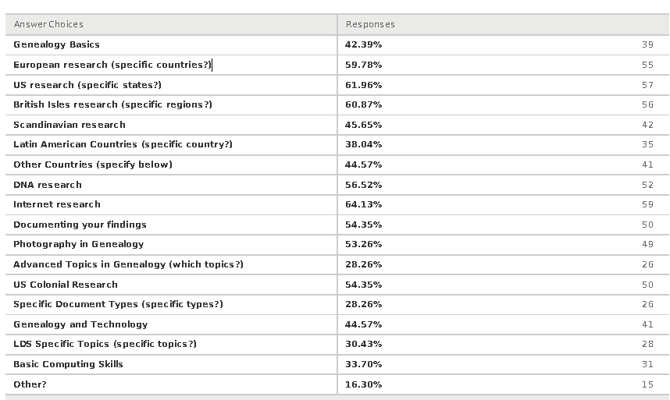

Breakdown: #’s of people interested in topic
Top Countries:
31 Ireland
29 England
14 Germany
14 Scotland
9 Sweden
9 Nova Scotia

Top United States:
12 New England + 26 Request for individual NE States
12 New York
4 Illinois
3 California

Specific Requests for Classes
- mtDNA especially so women can understand
- Newspapers and obituaries
- Best genealogical sites on the Internet
- Internet (Top)
- Meat and potatoes of how to Important to do, but can easily be overlooked in the excitement of the hunt.
- Would love to take a class in the day-to-day methods and procedures of research and recordkeeping,
- Aimed at intermediate level genealogists who have trouble being organized. I think it would
be helpful to have 3 to 5 people get together and teach this because there are different genealogy
programs, and I know people have their own ways of making notes, etc. So this wouldn't be about
genealogy standards; it would be about step-by-step 'what do you actually do to record what you've
found'. Thank you!
- It's taking me time to figure out how to add a source to the family tree in Family Search.
- How to work with notes vs confirmed info inserted to trees
- Dating and identification of old photos
- I'd like to learn about PhotoShop
- How to date photos, hairstyles over the years, dress, etc.
- Preserving old photo's
- Weighing and evaluating contradictory sources
- Using Genealogy for Medical History
- Yes - citations any advance topics
- Old Colony, Plymouth MA
- I'm looking into DAR applications
- US Colonial Research
- Probate and land records
- Ships' manifests, deeds etc.
- 5 birth, marriage and naturalization documents
- Bring back Marian Pierre-Louis!
- Military research is not well known and so useful
- Wills: Step-by-step probate research
- Finding citizenship documents
- Probate and Land Records
- Find A Grave - consider finding a speaker for this site
- Immigration/emigration records and patterns; US naturalization process
- Technical help with specific programs, such as Family Tree Maker; also, for those of us lucky

Please Provide Us With Any Additional Information Or Comments About Experience
- THANK YOU !!!!!!
- Thank you!!
- Having never been to a conference before, I found I thoroughly enjoyed this one. Most classes were
small enough to not feel like you were in a large college lecture hall. Lunches provided were excellent
and good value.
- Thank you for all the work which is required in planning and hosting this event. And the work extends
into the evaluation process! The hospitality and extra help provided by the hosts was very appreciated
and made for a warm welcome. By the way, I purchased some of the goodie treat bags for my family for
the Easter holiday from the bake sale table -- the treats were a big hit! Thank you again.
- Thank you again for all your hard work. Loved the bake sale and lunch sale.
- Thank you for so well organizing this conference. I look forward to it next year.
- Enjoyed the conference very much, can't wait for next year. well done; always learn something new; price is right; staff very helpful suggest presenter objectives stated at beginning of sessions, sets expectations and keeps everyone on task per timeline given for session. if you choose the wrong session you know to leave then and not 15 minutes into it disrupting the session you leave and the one you enter late. this add to the common core principals of education,
- The young people helping with arrangements were fabulous, the site is wonderful, and the lunch was
great. Parking was tight for people like us who were just on time. This was my first time; I was shocked
by how many people were attending & the high level workshops. It might be interesting for attendees
to bring a short description of a problem or question. These could be collected and used for a drawing
for responses in some format. Most of all, DO IT AGAIN!!!
- Well organized, well done volunteer conference. Thank you and keep going.
- I had a great day. I was able to meet up with my sister and her husband from Western MA and with
others I know from other wards and branches. It was a good learning experience with nice people. It
was an easy drive. Thank you.
- Everyone is always so pleasant and helpful.
- Always appreciate the planning that goes into a conference such as this. So good to see such a large
- turn-out every year, which signifies it is worthwhile.
- 16 Your workshop listing for this year, gave a great variety. I was impressed with it all. Many thanks!
Audrey Smith
- I enjoy the young people there that provide the lunches and assist when needed. They are so polite,
- helpful and friendly. They are such an asset to the conference.
- Bring back the ancestor roadshow!!! Thanks so much for having this every year!!!
- Very well organized. A pleasure to attend. Many thanks for providing this free event.
- Still need reference to basic computer research skills and organizing
- You are still the #1 conference of the ones I attend
- Been attending your session for 7 years...Never been disappointed. So much to learn!

Please Provide Us With Any Additional Information Or Comments About Experience (cont.)

- This was an excellent conference. I am grateful that you still make the paper copies available at a
reasonable cost. Also the lunch was much appreciated at such a good price. This was the best one
- I don't a have physical problem, but I did notice that the front of the building was blocked this year, and
I saw some people with walkers having to walk in from the far part of the parking lot; if you are trying to
keep the space open, perhaps you could loosen up and let handicapped persons park there while
keeping the rest out...
- I would very much like to thank the person(s) who had "reserved" seating signs for me in two classes. I
had no idea that would be done and it was welcomed, especially for T. Kemp's lecture in the Chapel.
Did I miss an email about this? I was so surprised and didn't now this would happen. Thank you again!
Also, thanks to all who put the conference together each year. It is so well organized, the lunch is
always delicious, and it's such an invigorating time! I look forward to next year's already.
- Friendly, helpful staff. Good first experience.
- Very comfortable physical setting, relaxed atmosphere. Thanks!
- Have people send in ONE old photo with application and set up a continuous slideshow in the hallway.
- (this would be just for fun)
- Lunch distribution well handled. Adequate restroom facilities for women
- Thank you for all of your hard work and the many hours you put in to making this year a success
- It was great as usual. My downfall I left my cell phone in the classroom. Mr. Mello found it and sent it to
- me and I recevid it on Tuesday - thank you
- I enjoy the conference very much! Am very grateful for this conference, and all the hard work that goes
into it.
- I LOVE the conference and recommend it frequently to friends and relatives. Thanks for all you do

People Who Have Expertise, Or Know Someone Who Does, In Any Area Of Genealogy/Technology. Also, Please Indicate The Area(S) Of Expertise.

Computing Technology, Windows PC Dale Gunn 978-562-8531 dcgunn@gmail.com

Personal Historian, family story writing workshop leader, freelance writer, book publisher. I would be
happy to submit a workshop proposal for next year's conference. Marjorie Turner Hollman,
508-883- 3443 marjorie@marjorieturner.com

Seema Kenney - 508-400-3931 - Seema@MassResearchers.com 4/3/2013 6:21 PM

