THE SYLLABUS

The following will provide you with the information that you need to compile the individual syllabus inserts into a single syllabus for printing, and how to upload the PDF files to the website to support the free download from the website. The Appendix to this document will show you how to use the website in the process.

Contents

Tools you will need 1
What you should have been given by the Program Committee 1
Advice on Getting Organized 1
Access to the website 2
How to put the Paper Syllabus together 2
Preparing the Syllabus for Download from the Website 2
Appendix: Using the Web Application for Creating the Syllabus 4
The Administrator Home Page 4
Events 4
Speakers 5
Presentations 5
Uploading Attachments to the Web Server 5

Tools you will need

- MS Word
- MS Excel
- PDF Converter (if files are not already converted) – Google Docs does this for free
- www.nefamilyhistory.com

What you should have been given by the Program Committee

- A MS Word version and a PDF version of each speaker’s syllabus insert(s) for each presentation.
- A jpg photo of each of the speakers

Advice on Getting Organized

1. Create the following folder structure on your hard drive

Syllabus
Word Files
PDF Files
Photo Files

2. As you place the files in each folder, make sure you know who the speaker is for each file. For example, add the speakers last name on the front of the file name, e.g. Price – Finding Heros of the Civil War

3. Create a check list from the website that tells you the name of the speaker, the name of the presentation and then you can make other columns to keep track of what has been done. Login to the website and go to the Presentations List. Download the list to Excel (see Appendix: Using the Web Application for Creating the Syllabus: Presentations). You can use this list as your checklist to make sure you have all the presentations in the syllabus. This file will show you which speaker is giving which presentation.

Access to the website

Use the following administrator login credentials for access to the information in the web application.

Username: Syllabus
Password: Syllabus

How to put the Paper Syllabus together

- Create a page for each speaker that has their photo and their bio on it. You can get all of this information from the website (see Appendix: Using the Web Application for Creating the Syllabus: Speakers). Use Header 1 for the name of the speaker.
- Create a section (using section break Next Page) for each speaker
- Arrange the speaker pages in alphabetical order, with a header, for each section, that has the speaker’s name right justified
- Add a new section break for each syllabus insert, this allows you to have a header that includes the name of the presentation at the top of the page.
- Copy the syllabus inserts(s) for each speaker after the speaker page. Use Header 2 for the presentation name. You should receive a MS Word version of the syllabus insert. If time gets short, and you only have a PDF, you can just paste a copy of the PDF into the Word file.
- Add a footer for the whole document that will read, “2013 Family History Conference Syllabus” (right justified) with the page number left justified, Page # of Pages, you may need to reiterate these in each presentation section.
- Add a table of contents using the 2 level option with Header 1 and Header 2
- Create a section on page 2, after the Table of Contents to house the Program. This section will need to be landscape. This page will have been created for the flyers so you can either ask for this page to be sent to you usually in Excel and then cut and paste it into Word. May require some tweaking to make it look nice.

Preparing the Syllabus for Download from the Website

You should receive a PDF file for each presentation. If you only have an MS Word version and time gets short you can convert the Word file using any PDF converter. Google Docs has a free option for this. The only restriction is on the size of the file. If the file is too large you can break it down in create the PDFs in parts.

Open the Presentation from the list of Presentations. You will see this (partial page).

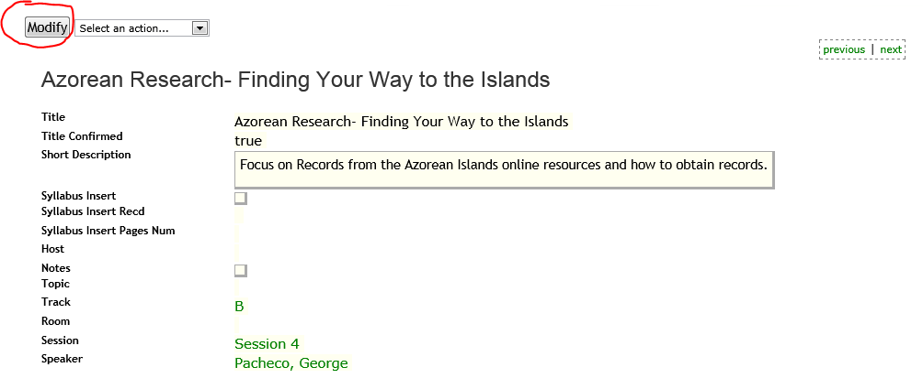

Click on the “Modify” button to put the page in modify mode. The syllabus insert field will appear as a text field. You will type

{doc:serverfilename.pdf}

Where serverfilename.pdf is the name you gave when you uploaded the file. The file must be a .PDF file. Make sure you write down the name, when you upload it, so you remember it when you get here. Save the page and then go to the Presentation in view only mode to test that the PDF file opens correctly.

If there is more than one syllabus insert for a given presentation, format each piece as shown here and put a comma between them.

{doc:serverfilename_part1.pdf},{doc:serverfilename_part2.pdf}
Appendix: Using the Web Application for Creating the Syllabus

The Administrator Home Page

When you first login you will see this page. You are interested in the Event, Speaker and Presentation information.

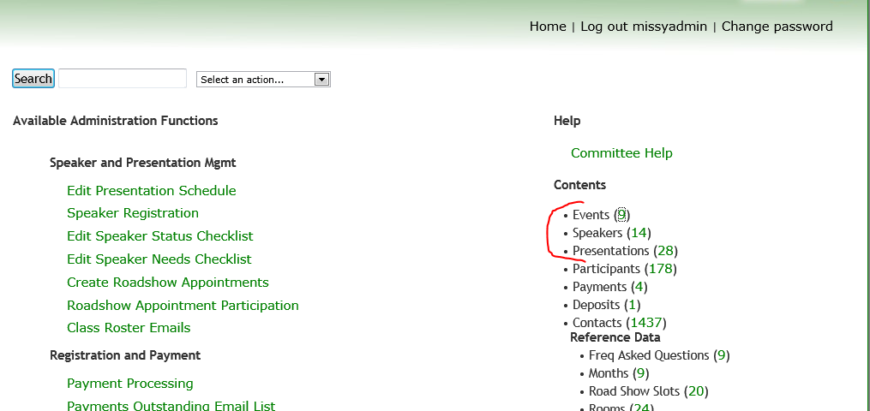

Events

Click on the green number next to Events and you will see a listing of the conferences from each year. Click on the current year in green and you will see this (only partial page shown). This page gives you all the overall information about the conference that you might need.

Click on the Home button at the top of the page to return to the main page.

Speakers

Next click on the green number next to “Speakers”, you will come to a list of speakers. This is where you will find the speakers biography and photo. If you have not been given the photo as a separate file, you can just cut and paste it from the speaker page.

Presentations

Go back to the home page and click on the green number next to “Presentations”. This is where you will find the presentations. To download this list, or any other list, to a csv file, click on the drop down list next to the button called “Block View”, and select “Download CSV”. Depending on which browser you are using, this will either open the file in Excel or provide you the ability to save it somewhere on your hard drive. The name of the presentation is on the far right and the name of the speaker is on the far left. This should be all that you need so you can wipe out the rest if you need to. You also may want to reorder the spreadsheet so the speaker name is in the first column and the presentations in the second column, then sort by Speaker name and then by Presentation name.

Uploading Attachments to the Web Server

Go to the home page and click on “select an action…”, and click on “Manage Attachments” at the bottom.

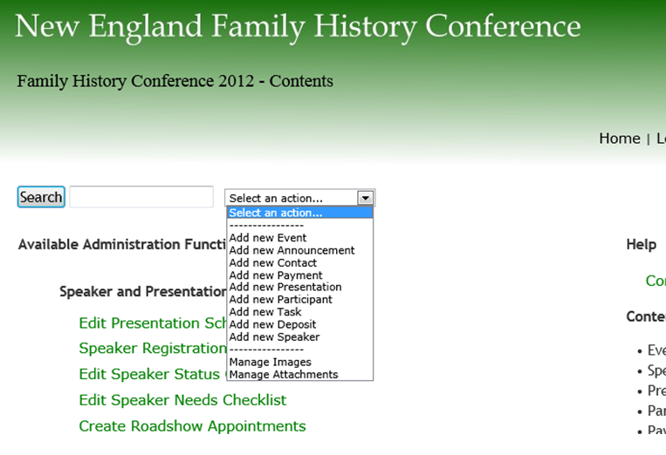
You will see this page. Browse to find the syllabus insert (PDF version) on your harddrive. Then provide a name it will be known by on the web server; it must have a .PDF extension. This name cannot have any spaces and must be a PDF file. Write down this name so you have it when you link it to the Presentation. Then click on the “Upload” button to copy the file from your hard drive to the web server.

