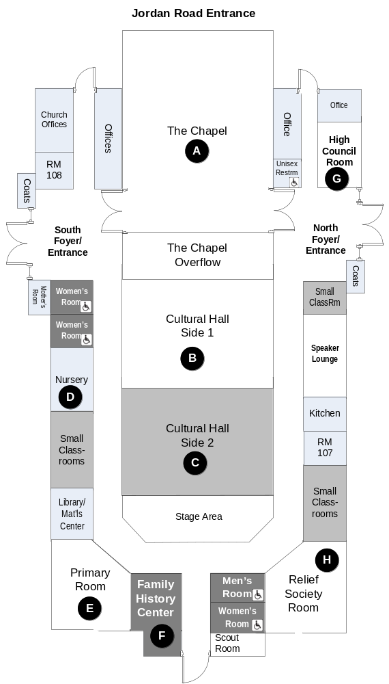 | NEW ENGLAND FAMILY HISTORY CONFERENCE  Saturday, March 30, 2013  Room
 | 8:15 – 9:00 Registration  9:00 – 9:20 Conference Opening  Organ Prelude  Welcome  Invocation  Remarks  Introductions/Announcements | Emily Mello  Manuel Mello  Dennis Hawley  David Martin  Manuel Mello | A
 | CLASSES | SPEAKERS | J
 | Session 1 – 9:30 – 10:30 |  | I
 | Bring your Ancestors to Life: Connect via Social History | Lori Lyn Price | B
 | Word War I & II Research | Mike Strauss | G
 | Organizing Your Research | Gail Kill | H
 | LDS Ward Focus: Hastening the Work/Enthusiasm in Church Wards | Thomas Jay Kemp | A
 | Finding Living Cousins: Being a Genalogy Gumshoe | Mike Maglio | B
 | Basic Computer Skills | Joe Rogge | D
 | Family Search Series: Making the most of Family History Catalog | Julie Strong | C
 | Session 2 – 10:40 – 11:40
 | Bankruptcy to Equity: Using Federal Court Records | Michael Strauss | E
 | Family Search Series: Untangling Knots & Problems | Sylvia Lyons | G
 | Capturing Images and information from the Internet | Mike Brophy | H
 | Top Ten Genealogical Websites: Sites You will Use and Rely On | Thomas Jay Kemp | A
 | Using Word 2010 to Write Your Family Story | Seema Kenney | B
 | Basic Computer Skills (repeat) | Joe Rogge | D
 | Family Search Series: Pedigree and Family Tree | Gail Kill | C
 | 11:50 – 12:30 Lunch
 | Session 3 - 12:40 – 1:40
 | Family Search: Beginner Level – Navigating Family Search | Ralph & Pat Welliver | E
 | Genealogy in Your Pajamas: Put your Library Card to Use | Lori Lyn Price | G
 | Descendancy Research | Mike Brophy | H
 | British Connections - Beginner level British Research | Julie Strong | A
 | Mapping Your Tribe: Use DNA to Find Your Inner Barbarian | Mike Maglio | B
 | Basic Portuguese Research | George Pacheco |  | D
 | Family Search Series: Untangling Knots & Problems | Sylvia Lyons | C
 | Session 4 – 1:50 – 2:50
 | Help to Grow Online Resources: Contributing thru Record Indexing | Ralph & Pat Welliver | E
 | Military Records – Civil War | Michael Strauss | G
 | Organizing Your Research (repeat) | Gail Kill | H
 | British Research the Cyberway | Julie Strong | A
 | Using Excel 2010 for Genealogical Research and Analysis | Seema Kenney | B
 | Azorean Research Finding Your Way to the Islands | George Pacheco | D
 | Family Search Series: Using the Family Search Research Wiki | Jon Lyons | C
 | 3:00 – 4:00 Networking & Refreshments |  | B/C

ANNOUNCEMENTS:  - Classes: Pre-registered patrons will enter classrooms first. Walk-ins [blue name tags] are welcome to the remaining available seats. Your host will direct this process.  - Bells: Bells will be used to dismiss the classes. There will be a 5 minute warning bell. These bells are loud, be prepared. ☺  - Lunch: At the close of the 2nd session of classes (11:40 am) those with a lunch ticket can pick up lunch in foyers (left or right side). You then are free to dine anywhere in the building, however, the chapel will be closed during this time. We have a very few extra lunches for sale - ask at registration.  - Contacting You: We are using Mail Chimp to manage our mailing list. If you registered on our website your email address will automatically be added to our Mail Chimp mailing list. Unfortunately, this is the last year we will use postcards to contact those without email addresses. Please connect with a fellow conference attendee to get messages, if you do not have email.  - Family History Center: The Franklin Family History Center (Location F on the map) will be staffed and open from 9 - 4 today during the conference. Please feel free to drop in for help with FamilySearch, Family Tree, help getting started, or with any other questions.  - Historian to Historian Bulletin Board: Please use this bulletin board space to communicate with others at the conference and perhaps find an ancestor in common!  - Recycling of Materials: If you do not need the white envelope and gold paper clips, that you got from registration, you are welcome to drop them off at the registration tables for reuse next year.  - Suggestion box: If you think of something that you might not remember for the Evaluation, please drop it in our suggestion box.  - Evaluations: We depend on your feedback! It directs us in our plans for next year. You will receive an email shortly after the conference with a link to our on-line survey. Thank you! |  | 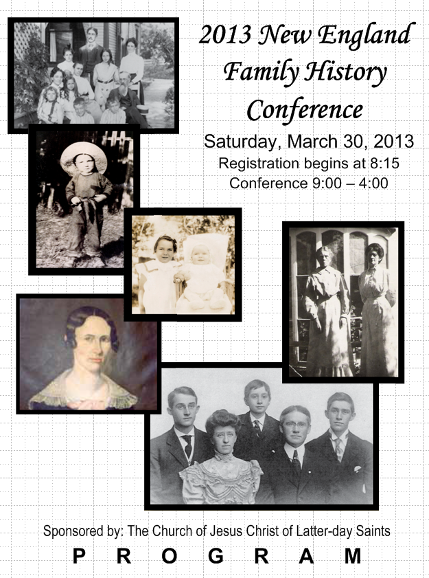  "A pack rat is hard to live with, but makes a fine ancestor!" Anonymous

