# Mar-Z AI Design

# (A Star & Barricade AI)

COMP4981 Linux Game

AI Team

Fred Yang A00777792

Mar-Z AI Design 1

(A Star & Barricade AI) 1

Overview 3

Generic Mode 3

A* Pathfinding 3

Basic Concept 3

How A* Actually Works 5

Why A* Be Used? 6

A* Time Complexity 7

State Flow Diagrams 8

A* Pathfinding STD 8

Zombie AI STD 9

Barricade AI STD 10

Pseudocode 11

A* Pathfinding 11

Zombie AI 11

Idle 11

Move 11

Attack 12

Hit 12

Die 12

Barricade AI 12

Search surroundings 12

Determine barricades 12

Destroy barricades 13

Walk around 13

Listings 14

# Overview

In video games, Artificial Intelligence (AI) is used to simulate human-like intelligence and intelligent behaviors primarily in non-player characters like NPCs and minions.

## Generic Mode

In the project, the behavior of a minion can be classified as 3 generic modes: Idle, Move, and Attack.

**Idle** – Not able to find an available cell or be in the stop-move-condition.

**Move** – Able to find an available cell to move on. Movement towards towers, a minion can evaluate its surroundings in real time and perform its actions such as searching for directions, pathfinding at a crossway, and pathfinding at the end of a path.

**Attack** –The mode of a zombie will be switched to Attack if a tower, turret, barricade or player is in its attack range.

## A* Pathfinding

A-star (A*) is probably the most commonly used algorithm in games pathfinding and graph traversal. With the A-star search algorithm it’s possible to find the shortest path from one node to another on a tile map, especially in scenarios when there’re chasms, rocks or other obstacles on the way.

A* uses a best-first search and finds a least-cost path from a given initial node to one goal node by maintaining a pair of lists: open list (fringe) and closed list. open list (fringe) is a list of all locations immediately adjacent to areas that have already been explored and evaluated, while closed list is a list of all locations which have been explored and evaluated by the algorithm. For every iteration, A* always picks the neighbor with a least actual cost to proceed to.

#### Basic Concept

The classic cost representation in A* algorithm is  
  
**f(n) = g(n) + h(n)**   
  
**g(n)** represents the total cost from the starting node to the current node.   
  
**h(n)** is the estimated cost from the current node to the destination. A heuristic function is used to create this estimate on how far away it will take to reach the goal state.   
  
**f(n)** is the sum of **g(n)** and **h(n)**. This is the cost of the current estimated shortest path.

Here are a few more concepts need to be considered:

* **Node:** It can be a tile (cell) in a tile-based environment or a point along a path. An A* path contains at least 2 nodes: a starting node and an ending node. A* will calculate all the nodes to get from the start to the end.
* **Parent Node:** When a node is examined, its neighbors (directly connected nodes) are assigned that node as their parent.
* **Open list (fringe):** a list of all locations immediately adjacent to areas that have already been explored and evaluated (the closed list).
* **Closed list:** a list of all locations which have been explored and evaluated by the algorithm.
* **Cost:** Cost is the distance travelled. In pathfinding, nodes with a lower cost are preferably used over nodes with a higher cost.
* **Heuristic:** The heuristic function tells A* an estimate of the minimum cost from a particular node to the destination. It’s important to choose a good heuristic function in searching for a path.
* **Euclidean Distance:** The shortest distance from a particular node to the goal. If your objects can move at any angle instead of grid directions, then you should probably use a straight line distance.
* **Manhattan Distance**: The standard heuristic for a square grid is the Manhattan distance. This is an approximation of the distance between two points based on adding the horizontal distance and vertical distances rather than computing the exact difference. That would look like this:

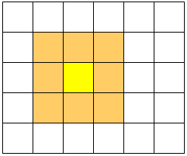

Figure 1. The current location is the yellow square, it is now part of the closed list. The orange squares surrounding around the yellow are the fringe, these are the possible options which the algorithm can experiment with.

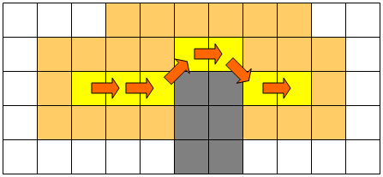

Figure 2. As the path progresses, the closed and fringe lists grow. Note that this path cuts corners. If the gray area represents an obstacle, like a wall, this path might be invalid since it passes unhindered through the wall.

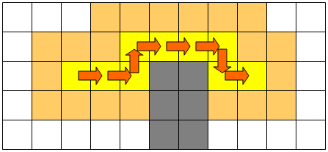

Figure 3. When cornering rules are imposed, the path will be better suited to avoiding obstacles.

#### How A* Actually Works

Now that you understand the basic concepts, before we start coding, let’s just take a look at how A* actually works.

1). Provide a starting node (or square) and an ending node (or square).

2). Add the starting node to the open list.

3). Start the search loop.

a). Look for the lowest f(n) cost on the open list– we refer to this as the current node. When we first run the loop this will obviously be our starting node.

b). If the current node is the same as the destination then we are done and we can move on to step 4 to build the path.

c). For each of the 8 neighbor nodes adjacent to the current node:

* + If the node is not traversable or if it’s on the closed list, skip it. Otherwise do the following.
  + If it isn’t on the open list, add it to the open list. Calculate the cost of that node and set the current node as the parent.
  + If it’s already on the open list, see if this path to that node has a lower G cost. If so, switch the parent of the node to the current node, and recalculate the G and F scores of the square.

d) Quit the loop when:

* The target node is added onto the closed list, which means the path has been found. Or
* Fail to find the target node, and the open list is empty. In this case, there is no path.

4). Construct the path. Working backwards from the target node, go from each node to its parent until it reaches the starting node.

#### Why A* Be Used?

As mention above, A-star (A*) is probably the most commonly used algorithm in games pathfinding and graph traversal. A* can help find the shortest path from one node to another on the map, especially in scenarios when there’re chasms, rocks or other obstacles on the way.

As shown in figure 4, the zombie can easily find the most efficient way to get to the player using A* algorithm. Other algorithms, such as Monte Carlo algo, or Manhattan algorithm, are not possible to find the shortest path on the map shown in figure 4.

Although A* time complexity is O(logN), which is longer than Monte Carlo / Manhattan algorithm, testing of endless zombie waves on several work stations did NOT see any delays.

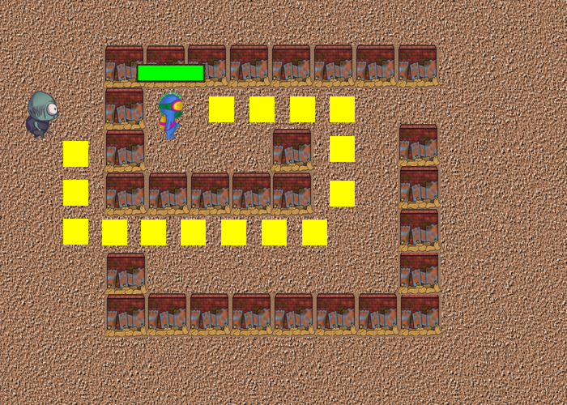

Figure 4 The zombie finds the shortest path to the player using A* algorithm

#### A* Time Complexity

A* time complexity is, O(logN),

here N = max{numOfRowFromBase, numOfColumnFromBase}

3 <= N <= 25 for Mar-Z game.

Monte Carlo / Manhattan time complexity is, O(1)

# State Flow Diagrams

## A* Pathfinding STD

C:\Users\fredy\Downloads\astar.png

## Zombie AI STD



## Barricade AI STD



# Pseudocode

## A* Pathfinding

Initialize the open list

Initialize the closed list

Put the starting node on the open list

While the open list is not empty

Find the node with the least cost on the open list, call it Q

Pop Q off the open list

Generate Q's 8 successors and set their parents to Q

For each successor

If successor is the goal, stop the search

Calculate total cost between successor and Q

Calculate estimated cost from goal to successor

Set current cost = total cost + estimated cost

If a node with the same position as successor is in the OPEN list

which has a lower current cost than successor, skip this successor

if a node with the same position as successor is in the CLOSED list

which has a lower current cost than successor, skip this successor

otherwise, add the node to the open list

push Q on the closed list

end

## Zombie AI

#### Idle

Pick a random (SEEDED) spot on the border of the map

Initialize the zombie’s coordinates

Initialize any needed attributes (eg. Health, speed, armour, etc)

If a player is within “X” range, find path to player

Otherwise find path to tower

Place zombie on the spot

MOVE*[STATE]*

#### Move

Use current position as starting node

If player is “nearby” and tower is not “nearby”, switch target to player

If target is a player and tower is nearby, switch target to tower

Traverse the path from the starting node to ending node (A*)

While the zombie is not at the target

Set mode as MOVE

If the zombie is attacked, go to HIT*[STATE]*

If another potential target is nearby, switch target

Update minion’s coordinates, move on to next node

Target is in range, go to ATTACK*[STATE]*

#### Attack

If a tower/player is in range

Set mode as ATTACK

Update minion’s attributes

Update tower’s attributes

Update server that an attack has occurred

#### Hit

Update minion’s attributes

If HP reaches zero

Go to DIE*[STATE]*

Update server on what has happened

#### Die

Cancel any ongoing operation

Remove from map

Free resource and memory associated with minion object

Update server that a zombie has died

## Barricade AI

#### Search surroundings

Retrieve zombie’s coordinates

Retrieve zombie’s directions (one of 8 directions)

Retrieve objects nearby and put onto a *barricades* list

If a player is within the range

Find path to the player and attack him

Otherwise if a tower is within the range and no barricades

Go ahead and attack it

Otherwise if a barricade is within the range

Go to DETERMINE BARRICADES [state] { *barricades* }

Otherwise

Go back to MOVE [state]

#### Determine barricades

If a new barricade added

Check if there exists a faster path to tower if walk around it

(the cost of walk-around path must be less than the specified value, eg. < 130%)

If so, go WALK AROUND [state]

Otherwise go DESTROY BARRICADES [state]

Otherwise the barricade has already been evaluated

Go back to MOVE [state]

#### Destroy barricades

While the barricade isn’t destroyed

Attack the barricade

Update barricade’s attributes (decrement HP)

If the barricade has been destroyed

Go back to MOVE [STATE]

#### Walk around

If the cost of destroying a barricade is larger than the threshold

Generate a path to walk around the barricade

Go back to MOVE [state]

Otherwise

Destroy the barricade

# Listings

All files of Zombie /Barricade AI reside in **creeps** folder.

*GameMap.h* – WYSIWYG game map for A* algo. The game map is loaded from map.csv file later.

*Node.h* – This header file is used for the A* algorithm in navigating the map.

*Zombie.h* – This header file includes the macro definitions and function prototypes for Zombie class.

*Zombie.cpp* – this class wraps A* / Monte Carlo algorithms and other basic methods for Zombie.