DSP Final Exam. Class:_______電通三甲_, Student ID:___01050435______, Name:_____闕源均____

- Compute the DFS coefficients of the following periodic sequences using Matlab.
.
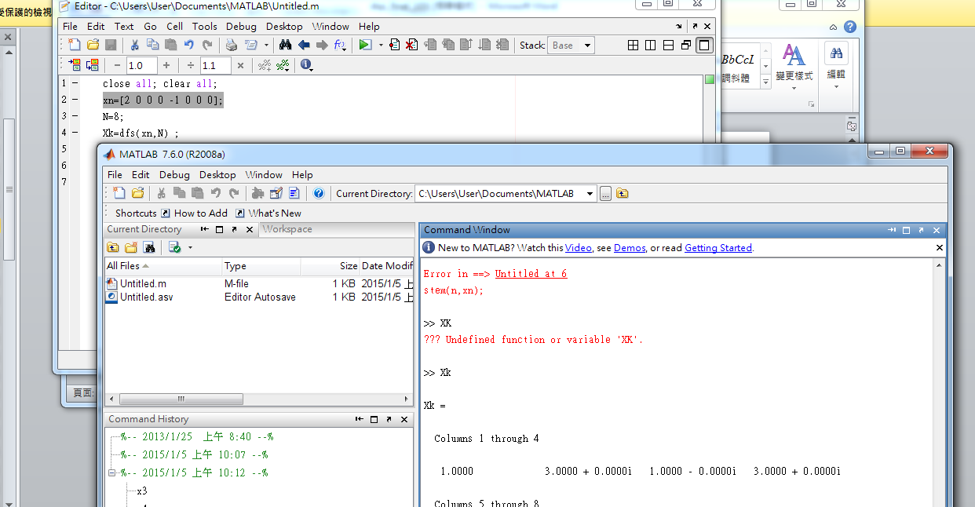

2. Let x(n) be a 4-point sequence:
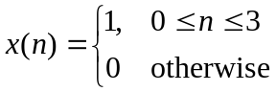
- Compute the discrete-time Fourier transform (DTFT)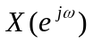and plot its magnitude and phase.
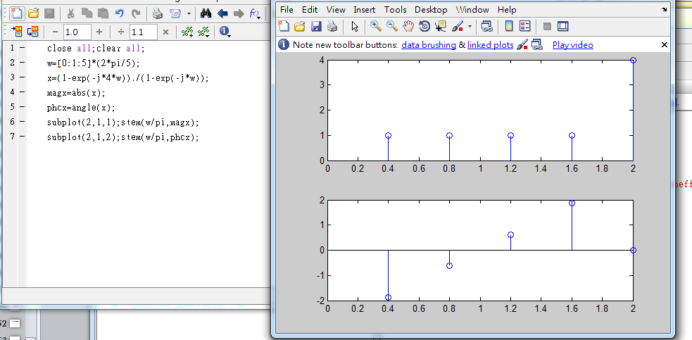

- Compute and plot the 8-point DFT of x(n).
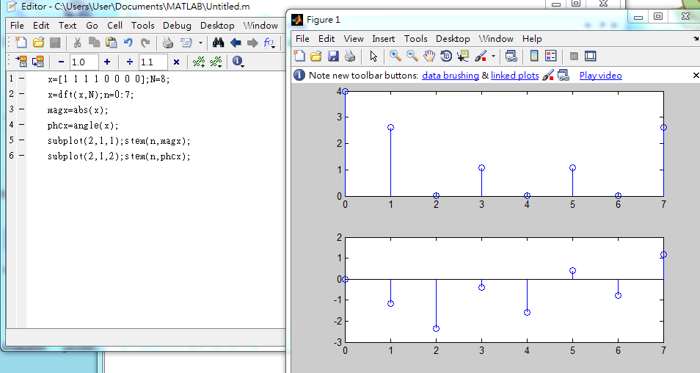

- Compute and plot the 16-point DFT of x(n)
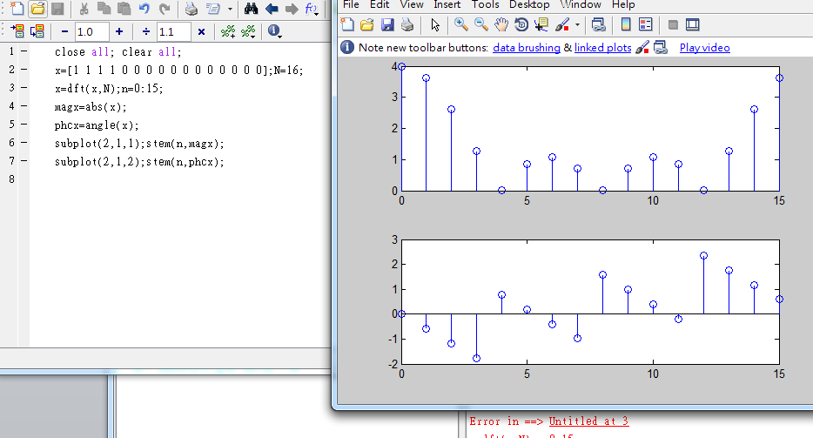

.

- Let 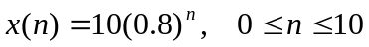 be an 11-point sequence

- Determine and plot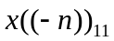, that is, a circular folding of 11 samples.

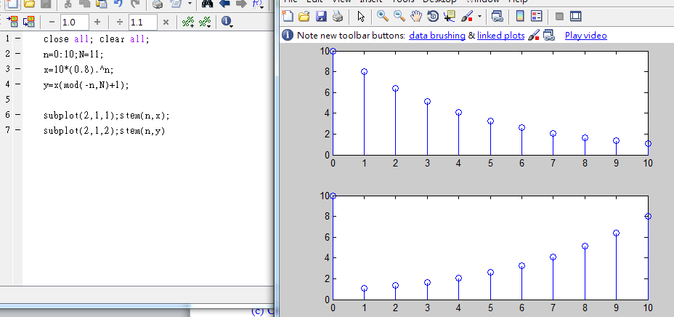

- Determine and plot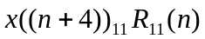, that is, a circular shift by 4 samples toward the left

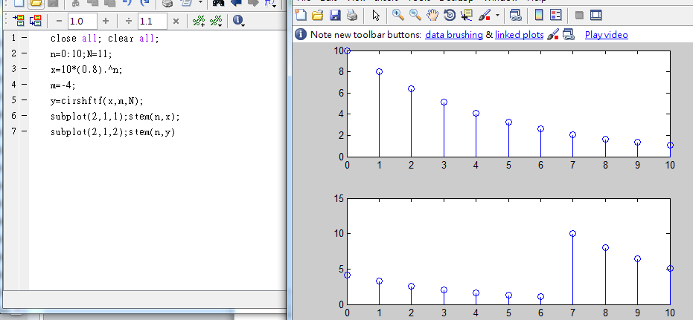

4. Given the sequences 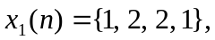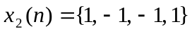
(a) Compute the 4-point circular convolution of 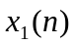and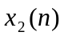by hand
(b) Determine their linear convolution 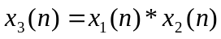 using conv( ).
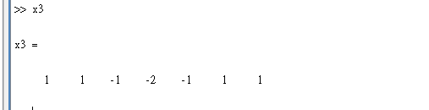

- Compute the circular convolution of andfor N=4, 5, and 6 using MATLAB.

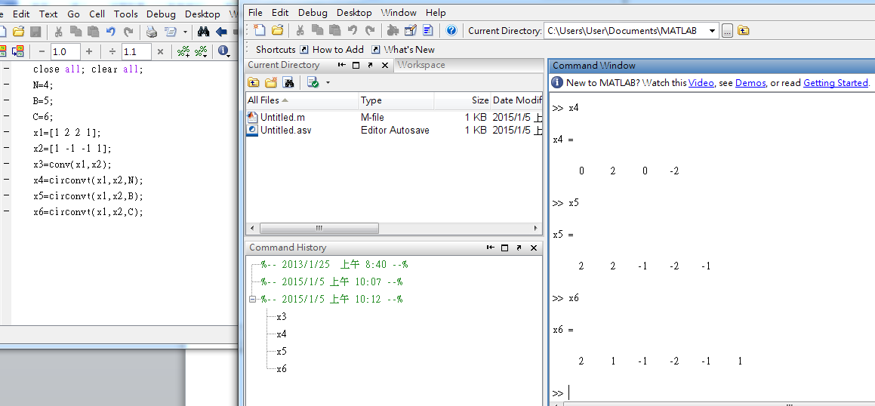
(d) Determine the minimum value of N so that linear and circular convolutions are same on the N-point interval.

- Consider the LTI system given by
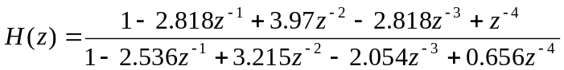
- Draw the normal direct-form-II structure block diagram.
- Draw a cascade structure containing 2nd-order normal direct-form-II sections. Use function dir2cas( ) to obtain the coefficients.
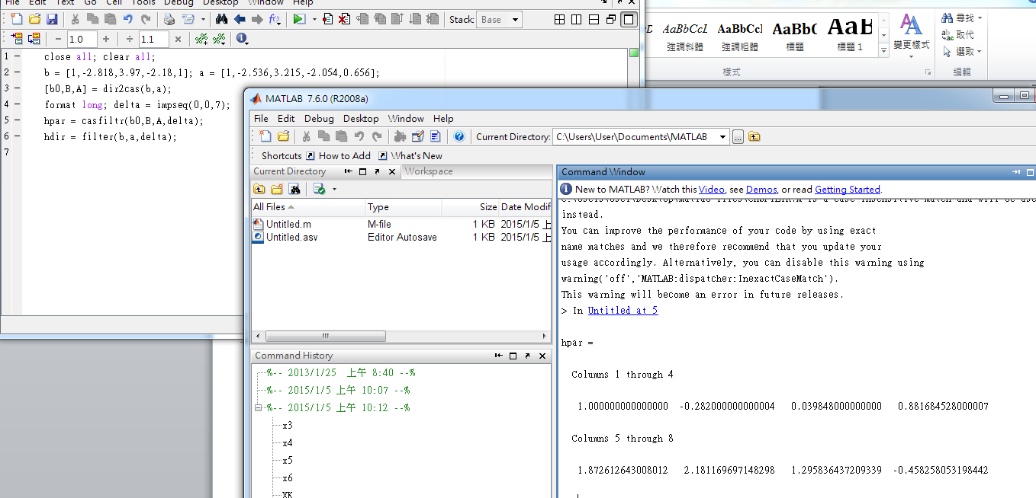

- Draw a parallel structure containing 2nd-order normal direct-form-II sections. Use function dir2par( ) to obtain the coefficients.
