DSP Final Exam. Class:__電通三乙__, Student ID:__02050311__, Name:__鄭若涓__

- Compute the DFS coefficients of the following periodic sequences using the DFS definition.
.

- A periodic “square wave” sequence is given by
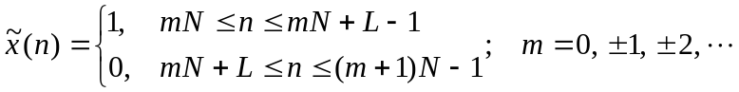
where N is the fundamental period and L/N is the duty cycle.
(a) Determine an expression for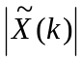 in terms of L and N.
(b) Plot the magnitudefor L=5, N=20; and L=7, N=60.

close all;
clear all;

L = 5;
N = 20;
xn = [ones(1,L),zeros(1,N-L)];
Xk = dfs(xn,N);
magXk = abs([Xk(N/2+1:N) Xk(1:N/2+1)]);
k = [-N/2:N/2];

stem(k,magXk);
axis([-N/2,N/2,-0.5,5.5]);
xlabel('k');
ylabel('Xtilde(k)');
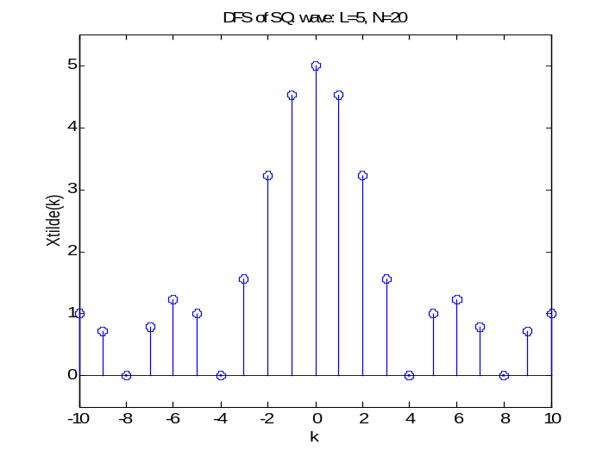
title('DFS of SQ. wave: L=5, N=20');

close all;
clear all;

L = 7;
N = 60;
xn = [ones(1,L),zeros(1,N-L)];
Xk = dfs(xn,N);
magXk = abs([Xk(N/2+1:N) Xk(1:N/2+1)]);
k = [-N/2:N/2];

stem(k,magXk);
axis([-N/2,N/2,-0.5,7.5]);
xlabel('k');
ylabel('Xtilde(k)');
title('DFS of SQ. wave: L=7, N=60');

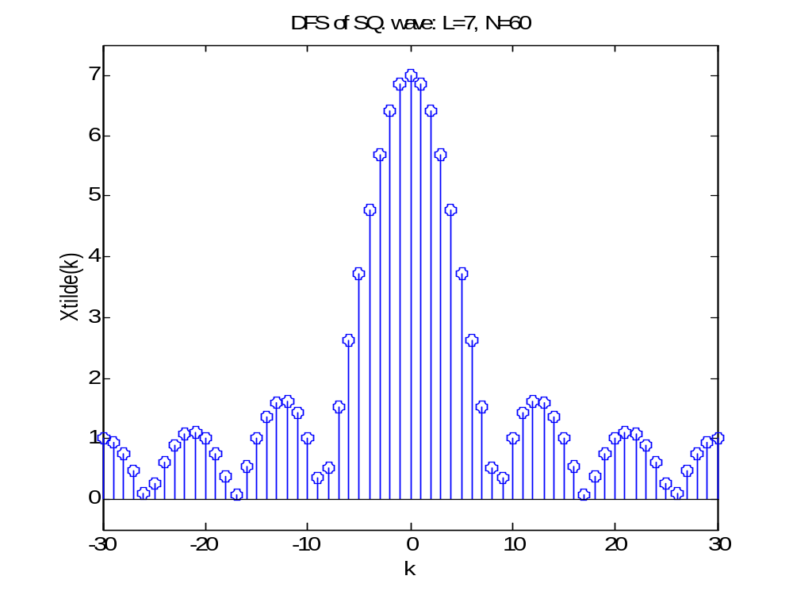

- Let x(n) be a 4-point sequence:
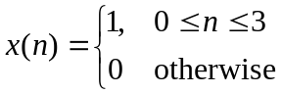
  - Compute the discrete-time Fourier transform (DTFT)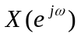and plot its magnitude and phase.

close all;
clear all;

w = [0:500]*(pi/250);
x = 1+exp(-j*w)+exp(-j*2*w)+exp(-j*3*w);
mag = abs(x);
pha = angle(x);

subplot(2,1,1);
plot(w/pi,mag);
grid on;

subplot(2,1,2);
plot(w/pi,pha);
grid on;

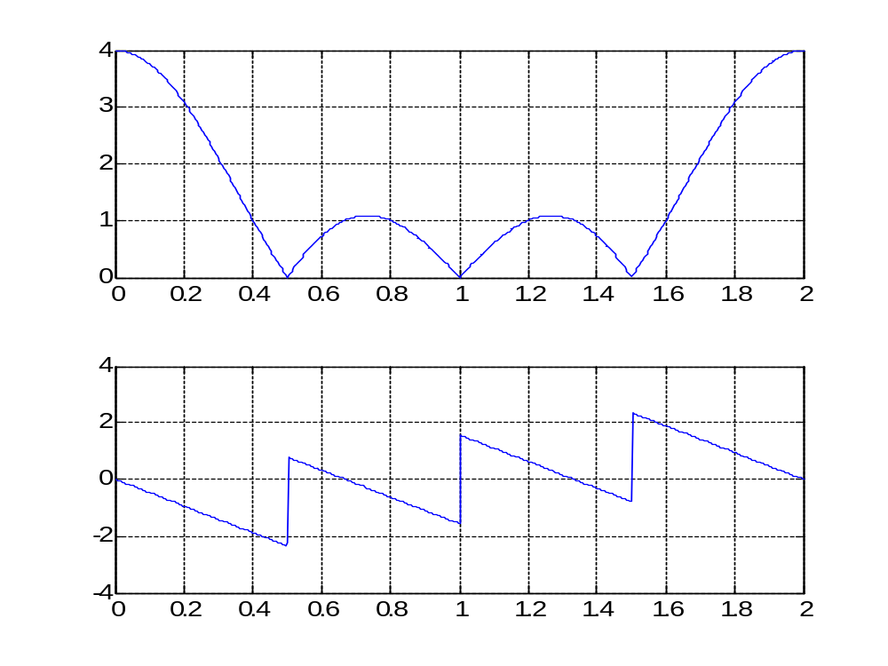

  - Compute and plot the 8-point DFT of x(n).

close all;
clear all;

x = [1 1 1 1 zeros(1,4)];
N = 8;
X = dft(x,N);
n = 0:7;
mag = abs(X);
pha = angle(X);

subplot(2,1,1);
stem(n,mag);

subplot(2,1,2);
stem(n,pha);

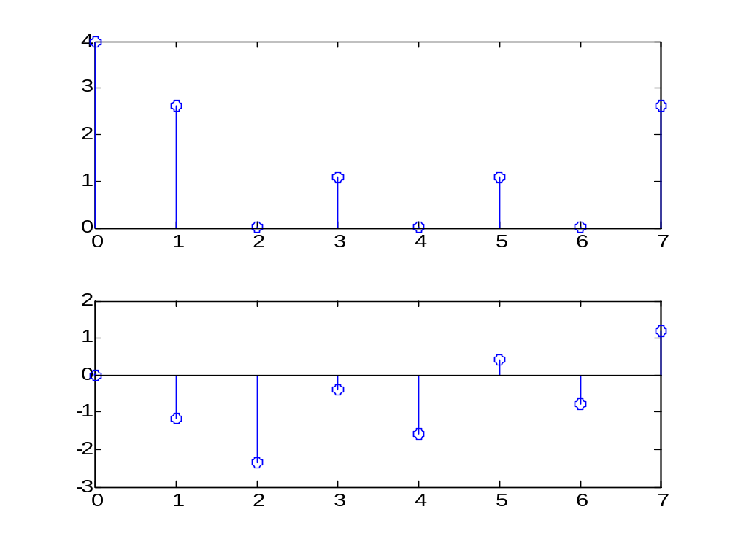

(c) Compute and plot the 16-point DFT of x(n).

close all;
clear all;

x = [1 1 1 1 zeros(1,12)];
N = 16;
X = dft(x,N);
n = 0:15;
mag = abs(X);
pha = angle(X);

subplot(2,1,1);
stem(n,mag);

subplot(2,1,2);
stem(n,pha);

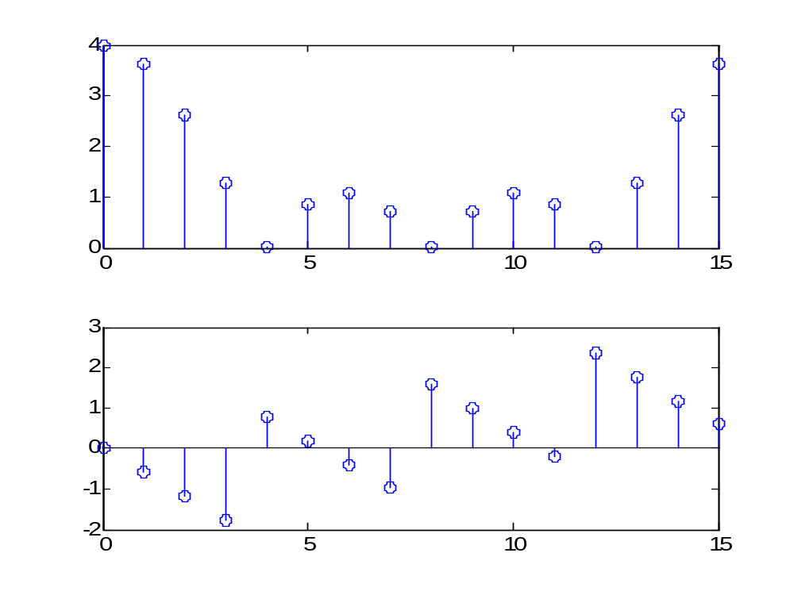

- Let 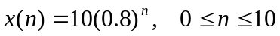 be an 11-point sequence
- Determine and plot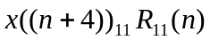, that is, a circular shift by 4 samples toward the left.

close all;
clear all;

n = 0:10;
N = 11;
x = 10*(0.8).^n;
y = cirshftt(x,-4,N);

subplot(2,1,1);
stem(n,x);

subplot(2,1,2);
stem(n,y);

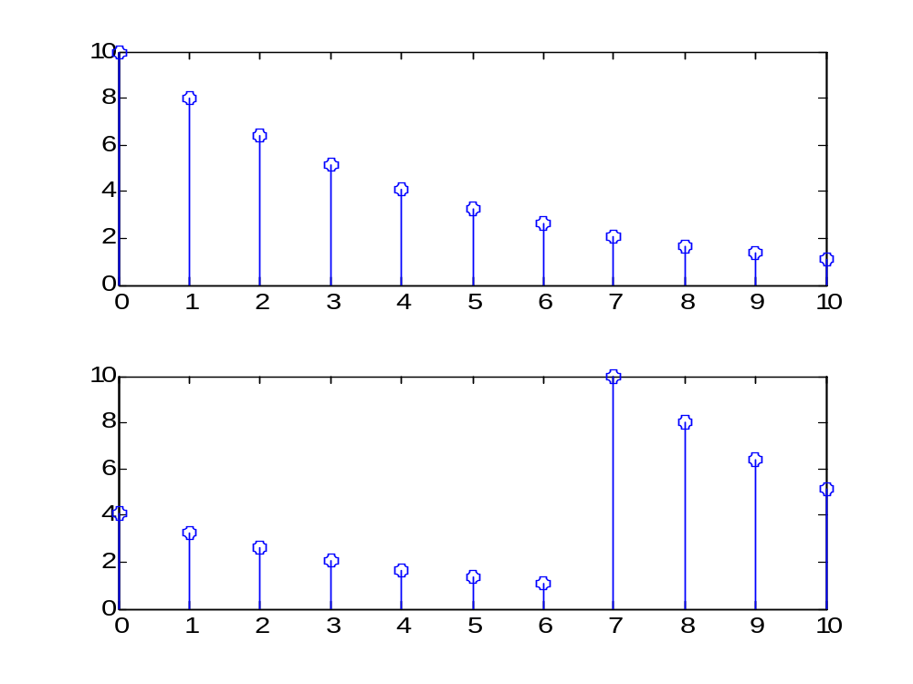

- Determine and plot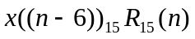, that is, a circular shift by 6 samples toward the right, where x(n) is assumed to be a 15-point sequence.

close all;
clear all;

n = 0:10;
N = 15;
x = 10*(0.8).^n;
y = cirshftt(x,6,N);
n=0:14;
x=[x,zeros(1,4)];

subplot(2,1,1);
stem(n,x);

subplot(2,1,2);
stem(n,y);

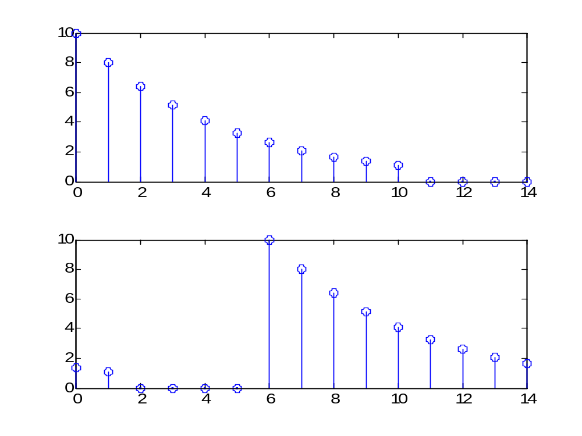

5. Given the sequences 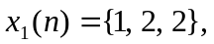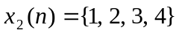
(a) Compute the 4-point circular convolution of 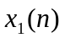and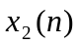by hand
(b) Compute the circular convolution of andfor N=4, 5, and 6 using MATLAB.

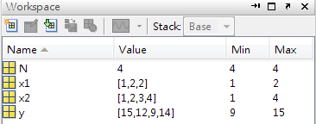
close all;
clear all;

x1 = [1 2 2];
x2 = [1 2 3 4];
N = 4;
y = circonvt(x1,x2,N);
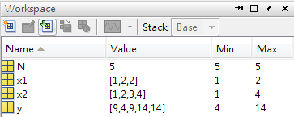
close all;
clear all;

x1 = [1 2 2];
x2 = [1 2 3 4];
N = 5;
y = circonvt(x1,x2,N);

close all;
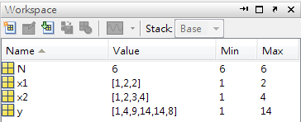
clear all;

x1 = [1 2 2];
x2 = [1 2 3 4];
N = 6;
y = circonvt(x1,x2,N);

(c) Determine the minimum value of N so that linear and circular convolutions are same on the N-point interval.

- Draw Direct Form I block diagram structures for the following LTI system with input node x(n) and output node y(n):

- An FIR filter is described by the difference equation
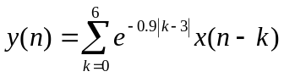

- Find the FIR filter coefficients

close all;
clear all;

k = 0:6;
b = exp(-0.9*abs(k-3));
a = 1;
[b0,B,A] = dir2cas(b,a);

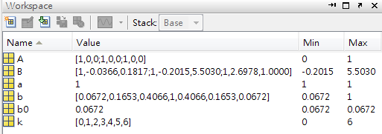
- Draw the Direct Form I block diagram structure.
- Draw the Cascade Form block diagram structure.

