DSP Final Exam. Class:__電通三乙_, Student ID:__03050841, Name:_傅冠珅_

- Compute the DFS coefficients of the following periodic sequences using Matlab.
.

- Plot the DFT (a) magnitude and (b) angle of the following sequence (N=100, ω: 0~π).

x(n)={1, 2, 3, 4, 3, 2, 1}
close all; clear all;
w=[0:500]*pi/500;
X=2*cos(3*w)+4*cos(2*w)+6*cos(w)+4;
mag=abs(X); pha=angle(X);
subplot(211); plot(w/pi,mag);
subplot(212); plot(w/pi,pha);

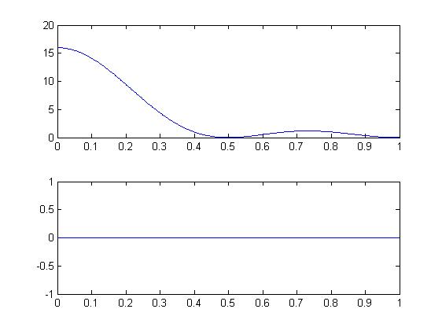

- Let x(n) be a 4-point sequence:
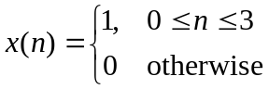
  - Compute the discrete-time Fourier transform (DTFT)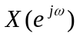and plot its magnitude and phase.
close all; clear all;
clc;
x=[1 1 1 1 ];
N=4;
n=0:3;
X=dft(x,N);
mag=abs(X);
pha=angle(X)*180/pi;
subplot(2,1,1);
stem(n,mag);
subplot(2,1,2);
stem(n,pha);
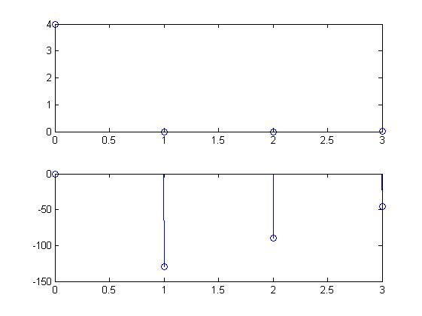

  - Compute and plot the 8-point DFT of x(n).

close all; clear all;
w=[0:1:500]*(2*pi/500);
x=(1-exp(-j*4*w))./(1-exp(-j*w));
mag=abs(x);
pha=angle(x);
subplot(411);plot(w/pi,mag);
subplot(412);plot(w/pi,pha);
X=[1 1 1 1 0 0 0 0];N=8;
X=dft(X,N);n=0:7;
magX=abs(X);
phaX=angle(X);
subplot(413);stem(n,magX);
subplot(414);stem(n,phaX);

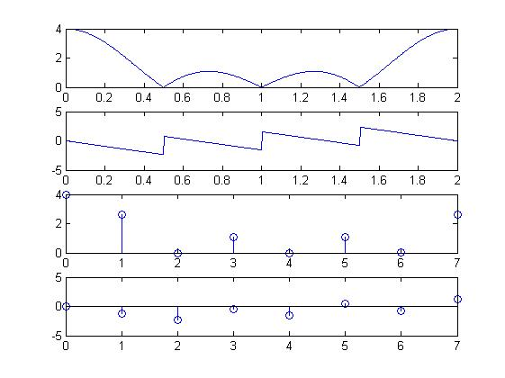

(c) Compute and plot the 16-point DFT of x(n).

w=[0:1:500]*(2*pi/500);
x=(1-exp(-j*4*w))./(1-exp(-j*w));
mag=abs(x);
pha=angle(x);
subplot(411);plot(w/pi,mag);
subplot(412);plot(w/pi,pha);
X=[1 1 1 1 0 0 0 0 0 0 0 0 0 0 0 0];N=16;
X=dft(X,N);n=0:15;
magX=abs(X);
phaX=angle(X);
subplot(413);stem(n,magX);
subplot(414);stem(n,phaX);

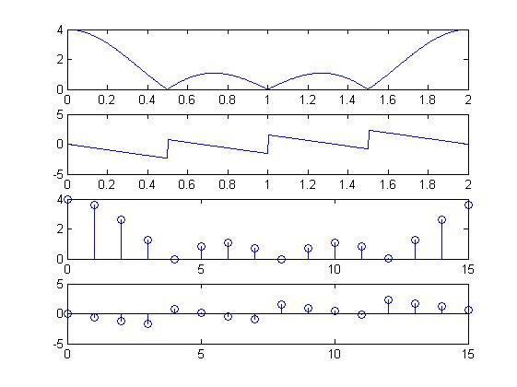

- Let 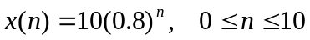 be an 11-point sequence
- Determine and plot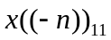, that is, a circular folding of 11 samples.

- Determine and plot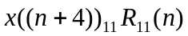, that is, a circular shift by 4 samples toward the left

clc;
n=0:10;
N=11;
x=10*(0.8).^n;
y=cirshftt(x,-4,N);
subplot(2,1,1);
stem(n,x);
subplot(2,1,2);
stem(n,y);

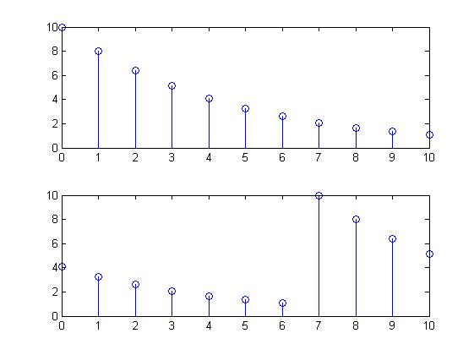

5. Given the sequences 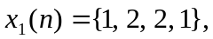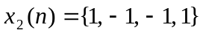
(a) Compute the 4-point circular convolution of 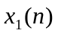and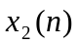by hand
(b) Determine their linear convolution 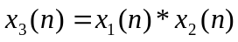 using conv( ).
(c) Compute the circular convolution of andfor N=4, 5, and 6 using MATLAB.
(d) Determine the minimum value of N so that linear and circular convolutions are same on the N-point interval.

- Draw Direct Form I block diagram structures for the following LTI system with input node x(n) and output node y(n):

- An FIR filter is described by the difference equation
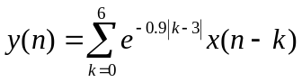

- Find the FIR filter coefficients

close all; clear all;

K=0:6;
b=exp(-0.9*abs(K-3));

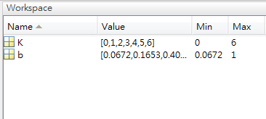

- Draw the Direct Form I block diagram structure.
- Draw the Cascade Form block diagram structure.

