電通二乙微處理器實驗 實驗結報

實驗名稱
組別 |  | 組員

- 實驗目的
透過藍芽使用手機控制led
- 實驗步驟
- 接好7697後開BeaconAdvertisement EddystonURLadvertisement 的範例程式 修改數值
- 程式碼

#include <LBLE.h>
#include <LBLEPeriphral.h>

void setup() {
//Initialize serial and wait for port to open:
Serial.begin(9600);

// Initialize BLE subsystem
Serial.println("BLE begin");
LBLE.begin();
while (!LBLE.ready()) {
delay(100);
}
Serial.println("BLE ready");

// configure our advertisement data as iBeacon.
LBLEAdvertisementData beaconData;

// This is a common AirLocate example UUID.
LBLEUuid uuid("E2C56DB5-DFFB-48D2-B060-D0F5A71096E0");
beaconData.configAsIBeacon(uuid, 01, 64, -40);

Serial.print("Start advertising iBeacon with uuid=");
Serial.println(uuid);

// start advertising it
LBLEPeripheral.advertise(beaconData);
}

void loop() {
// The underlying framework will advertise periodically.
// we simply wait here.
//
// You can use iBeacon apps such as
// "Locate Beacon" by Radius Networks on iOS devices
// to locate this beacon.
delay(3000);
}

#include <LBLE.h>
#include <LBLEPeriphral.h>

void setup() {
//Initialize serial and wait for port to open:
Serial.begin(115200);

// Initialize BLE subsystem
Serial.println("BLE begin");
LBLE.begin();
while (!LBLE.ready()) {
delay(100);
}
Serial.println("BLE ready");

// configure our advertisement data as iBeacon.
LBLEAdvertisementData beaconData;

// make an Eddystone-URL beacon that board casts
// https://labs.mediatek.com
// Note 1: You can obmit the suffix and tail part, e.g.
// https://goo.gl/Aq18zF
// can be constructed with
// configAsEddystoneURL(EDDY_HTTPS, "goo.gl/Aq18zF");
// Note 2: Note that total url length must not exceed 17 bytes.
//
// Please refer to https://github.com/google/eddystone/tree/master/eddystone-url#url-scheme-prefix
// to know how the prefix/suffix/tails are expanded.
beaconData.configAsEddystoneURL(EDDY_HTTPS, "05050164", EDDY_DOT_COM);

Serial.print("Start advertising Eddystone-URL");

// start advertising it
LBLEPeripheral.advertiseAsBeacon(beaconData);
}

void loop() {
// The underlying framework will advertise periodically.
// we simply wait here.
//
// You should be able to search this beacon with tools such as "Beacon Tools" on iOS or
// "Physical Web" app on Android.
delay(3000);
}
- 實驗結果及分析
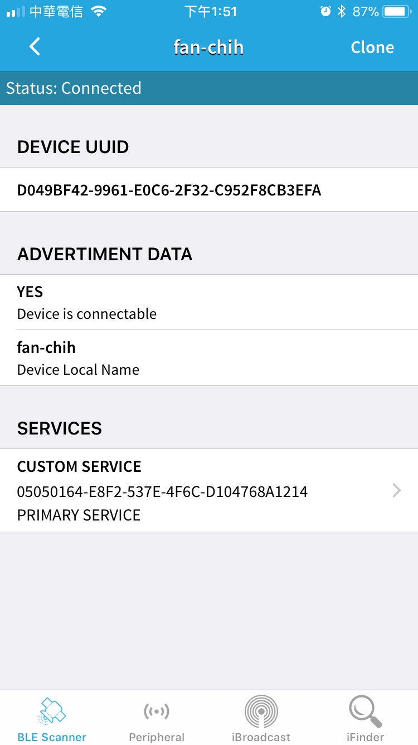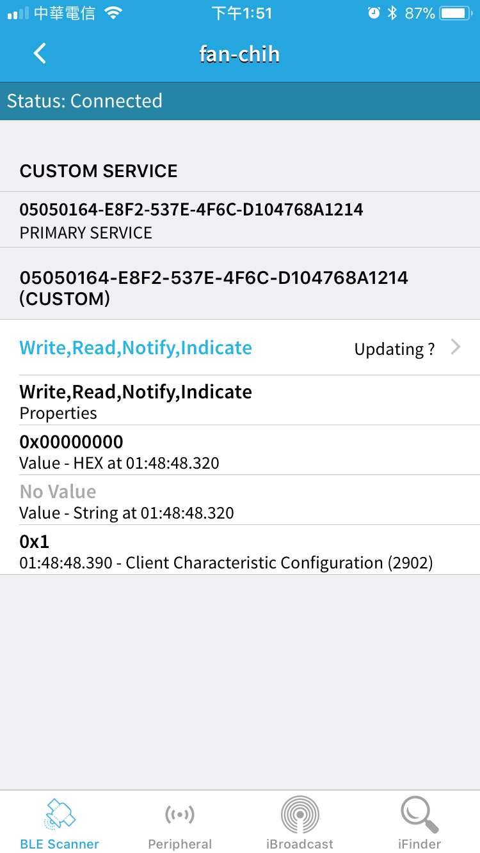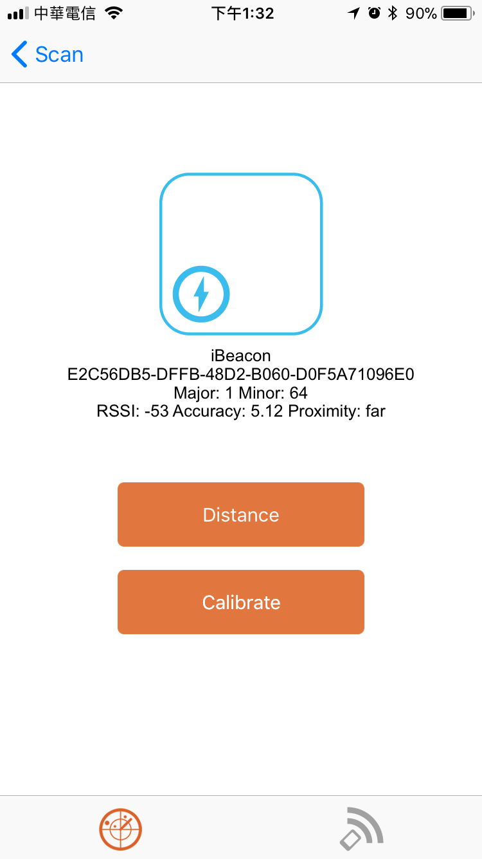

- 心得討論
這次實驗簡單很多,很快就做完了,也了解藍芽通訊在7697怎麼寫
- 修正電路圖
- 修正程式碼

