電通二乙微處理器實驗 實驗結報

實驗名稱 | Lab11
組別 | 12 | 組員 | 郭凡智

- 實驗目的
使用wifi控制7697的led及上傳數值到雲端
- 實驗步驟
- 設定MCS的產品原型跟資料通道
修改程式碼
上傳

- 程式碼
C.P.1
#include <LWiFi.h>
#include "MCS.h"

char _lwifi_ssid[] = "iPhone";
char _lwifi_pass[] = "00000000";
MCSDevice mcs("DUJ9WIMU", "VCIhfHLhEmp6yQb0");

MCSControllerOnOff led("LED_control");
MCSDisplayOnOff remote("led");
void setup()
{
Serial.begin(9600);

Serial.println("Connect to Wifi");
while (WiFi.begin(_lwifi_ssid, _lwifi_pass) != WL_CONNECTED) {
Serial.println("Wifi Reconnecting..");
delay(1000);
}

Serial.println("Connect to MCS...");
while (!mcs.connected()) {
Serial.println("MCS Reconnecting..");
mcs.connect();
}
Serial.println("MCS Connected!");
mcs.addChannel(led);
mcs.addChannel(remote);
pinMode(7, OUTPUT);

}

void loop()
{
while(!led.valid())
{
Serial.println("read LED value from MCS...");
led.value(); //¨ú±oMCS¼ÆÈ
}
Serial.print("done, LED value = ");
Serial.println(led.value());

while (!mcs.connected()) {
mcs.connect();
if (mcs.connected()) {
Serial.println("MCS Reconnect");
}
}
mcs.process(1000);

if (led.value() == 1) {
digitalWrite(7, HIGH);

} else {
digitalWrite(7, LOW);

}
delay(200);
digitalWrite(7, led.value() ? HIGH : LOW);
if(!remote.set(led.value()))
{
Serial.print("Failed to update remote");
Serial.println(remote.value());
}
}

C.P.2
#include <LWiFi.h>
#include "MCS.h"

char _lwifi_ssid[] = "iPhone";
char _lwifi_pass[] = "00000000";
MCSDevice mcs("DUJ9WIMU", "VCIhfHLhEmp6yQb0");

MCSDisplayInteger Temp("Temp");

void setup()
{
Serial.begin(9600);

Serial.println("Connect to Wifi");
while (WiFi.begin(_lwifi_ssid, _lwifi_pass) != WL_CONNECTED) {
Serial.println("Wifi Reconnecting..");
delay(1000);
}

Serial.println("Connect to MCS...");
while (!mcs.connected()) {
Serial.println("MCS Reconnecting..");
mcs.connect();
}
Serial.println("MCS Connected!");

mcs.addChannel(Temp);

}

void loop()
{
while (!mcs.connected()) {
mcs.connect();
if (mcs.connected()) {
Serial.println("MCS Reconnect");
}
}
mcs.process(1000);

int sensor = analogRead(A0);

Temp.set(sensor);
Serial.println("Add sensor value.");
delay(200);
}
- 實驗結果及分析
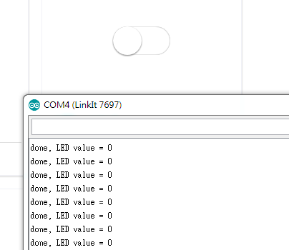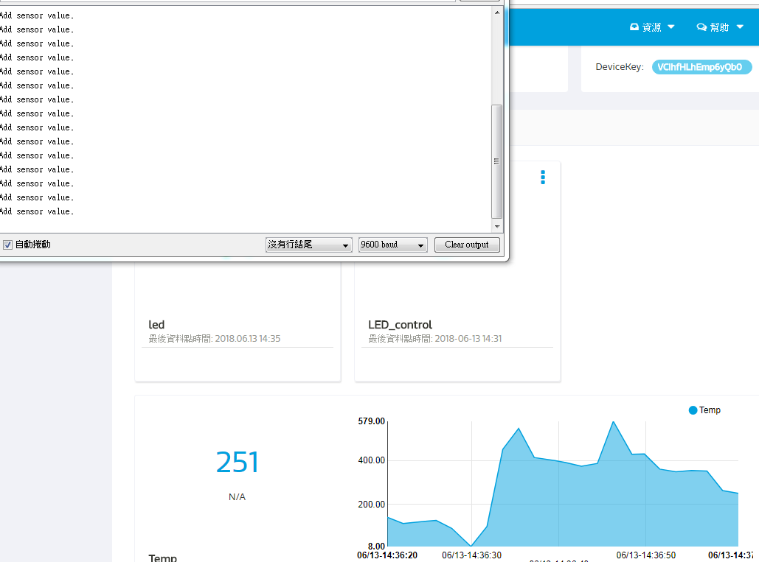

- 心得討論
使用WIFI操控7697的感覺很有趣
- 修正電路圖
- 修正程式碼

