Business Plan


TABLE OF CONTENTS
Executive Summary 3
Business Overview 3
Mission Statement 3
Financial Highlights (Dec 2025 – Nov 2028) 4
Strategic Advantages 4
Funding & Capital Position 4
Business Model 6
General Overview-Funds Flow Diagram 11
1. Detailed Process Flow: E-Money Issuance 12
2. FUNDS FLOW: E-Money Issuance and Redemption 14
Key Compliance Measures Across Flow 14
EXAMPLE: PARTIES INVOLVED 15
4. Market Analysis 15
5. Go-to-Market Strategy 19
Customer Personas 19
Proposed Marketing Messages & Service Packages 23
6. Operations Plan 26
7. Management Team 30
IT Systems Manager – Paul Opoku Adjei 47
FCA Justification: Systems Integrity & Operational Resilience 47
Role & Responsibilities 48
Staffing 49
8. Financial Plan 50
9. Appendices 55

Executive Summary
Company Name: FYM Compliance Limited (trading as Chase Finance)
Business Structure: Private Limited Company – Registered in England & Wales
FCA Licence: Small Electronic Money Institution (SEMI) – Application in progress (licence expected December 2025)

Business Overview
FYM Compliance Limited seeks authorisation as a Small Electronic Money Institution (SEMI) to expand its proven compliance consultancy expertise into regulated e-money and payment services.
The business will leverage its operational track record—supporting SPIs and APIs through compliance audits, risk frameworks, and advisory services—to deliver secure, user-friendly, and competitively priced financial solutions for underserved markets.
Our primary offerings include:
- Electronic Money Issuance – via prepaid cards and digital wallets, fully safeguarded in compliance with FCA CASS rules.
- Payment Account Services – including UK sort code and IBAN functionality for business and personal accounts.
- Direct Debit Collections – enabling recurring billing for SMEs, akin to GoCardless.
- Online Remittance & FX Transfers – targeting underbanked diaspora corridors with competitive rates.
- Debit-Card Top-Up Services – enabling fast, seamless wallet funding.
These products address clear market gaps in cost, accessibility, and flexibility—particularly in low-margin SME and diaspora segments overlooked by traditional banks.

Mission Statement
To promote financial inclusion and accelerate the transition to a cashless economy by delivering compliant, innovative, and accessible e-money and payment solutions.

Financial Highlights (Dec 2025 – Nov 2028)
All forecasts remain within SEMI thresholds:
- Outstanding E-Money: Peaks at £4.2m (average £4.01m in Year 3), below €5m cap.
- Unrelated Payments: Monthly average £2.08m in Year 3, below €3m cap.
Metric | Year 1 | Year 2 | Year 3
Revenue | £282k | £520k | £749k
Gross Margin | 80% | 80% | 80%
EBITDA | £113.2k | £20k | £163.7k
Net Cashflow | £92k | £15k | £148.7k
Year-End Cash | £156.8k | £127.7k | £276.4k
Year 1 assumes licence grant in Dec 2025, with a 6-month ramp-up period before volumes plateau.

Strategic Advantages
- Proven Compliance Expertise – founding team brings regulated market experience from SPI/API sectors.
- Lean Cost Structure – low fixed costs, scalable operations, high-margin service mix.
- Resilient Financial Model – strong Year 1 cash position and positive cashflow underpinned by conservative volume assumptions.
- Growth Flexibility – potential to own platform software from Year 2, increasing EBITDA by up to £50k annually.

Funding & Capital Position
Initial operations are funded by founder capital (£27k) and internally generated cashflow. The model requires no external debt financing, preserving equity and operational control. Future growth is supported by surplus liquidity and optional reinvestment of retained earnings.

2. Company Overview
Legal Structure & Registration
- Company Name: FYM Compliance Limited
- Trading Name: Chase Finance
- Legal Form: Private Limited Company
- Company Registration Number: 15048423
- Date of Incorporation: 3 August 2023
- Jurisdiction: England & Wales
- Registered Office: 10 Market Street, Wellington, Telford, England, TF1 1DT
- FCA Licence Applied For: Small Electronic Money Institution (SEMI) – Application in progress, expected approval December 2025.

History & Background
FYM Compliance Limited was established as a spin-out from Diamond Cube Limited, a regulated Small Payment Institution (SPI), to capitalise on the founder’s deep expertise in FCA regulatory compliance. The company has built a strong track record providing compliance consultancy, AML frameworks, risk assessments, and operational audits for SPIs and APIs. This foundation provides the operational, regulatory, and technical expertise necessary to transition into fully regulated e-money issuance and payment services.

Vision
To become the leading provider of affordable, secure, and compliant e-money solutions for underserved communities and SMEs in the UK, while promoting financial inclusion and trust in digital finance.

Mission
To empower individuals and businesses through innovative, compliant, and accessible financial products that meet regulatory standards and exceed customer expectations.

Core Values
- Integrity: Operating with full compliance and transparency.
- Innovation: Leveraging technology to deliver accessible, cost-effective solutions.
- Customer Focus: Designing products around customer needs, not just market trends.
- Security: Prioritising safeguarding of funds and data protection.
- Inclusion: Serving demographics underserved by traditional banking channels.

Business Model
FYM Compliance Limited will operate as a Small Electronic Money Institution under FCA regulation.
Our business model is built on generating revenue from a diversified mix of regulated payment products:
- Monthly e-wallet fees
- Prepaid card issuance fees
- Transaction-based income from remittance & FX
- Debit-card wallet top-up fees
- Direct debit processing fees
The business operates with a lean staffing model in Year 1, scaling operational capacity from Year 2 onwards.
Cloud-based infrastructure, outsourced development partnerships, and a robust compliance framework allow the company to maintain high gross margins (80%) while controlling fixed costs.

Regulatory Compliance Positioning
The company’s systems, processes, and safeguarding arrangements are designed to meet or exceed FCA requirements for SEMIs:
- Safeguarding of Customer Funds: Segregated accounts held with reputable UK banks.
- Transaction Monitoring: Real-time volume tracking with auto-alerts for SEMI thresholds.
- AML/CTF Controls: Independent annual audits, SIEM monitoring tools, and staff AML training.
- Data Protection: GDPR-compliant systems, secure cloud hosting, and regular security testing.

3. Products & Services
FYM Compliance Limited (trading as Chase Finance) will provide a suite of FCA-regulated e-money and payment services, designed for affordability, security, and accessibility.
Each product is priced to be competitive in underserved markets while ensuring compliance with Small Electronic Money Institution (SEMI) thresholds.

3.1 Electronic Money Issuance
Description:
Provision of multi-currency e-wallets accessible via mobile app and web platform. Customers can store e-money, make payments, receive transfers, and manage balances in real time.
Key Features:
- Multi-currency support
- Instant transfers between wallet holders
- Contactless and online payment capabilities via linked prepaid card
- Full safeguarding of funds in segregated client accounts
Pricing Model:
- £1.50 per month per active wallet
- Revenue Year 1: £27,000 → Year 3: £54,000
Regulatory Alignment:
Outstanding balances will average £2.42m in Year 1, rising to £4.01m in Year 3, remaining under the €5m SEMI cap.

3.2 Prepaid Card Issuance
Description:
Issue of reloadable prepaid debit cards linked to the e-wallet. Enables customers to spend globally wherever the card network is accepted.
Key Features:
- EMV chip & contactless functionality
- Linked to e-wallet balance in real time
- Supports domestic and international transactions
- Cardholder authentication and fraud monitoring
Pricing Model:
- £10 one-off fee per card
- Revenue Year 1: £10,000 → Year 3: £20,000

3.3 Remittance & FX Services
Description:
Low-cost remittance services targeting diaspora communities, with competitive FX rates and fast settlement.
Key Features:
- Average transfer value: £300
- Flat fee + FX margin model (£4 + 1.5% margin)
- Instant or same-day settlement to recipient bank or agent location
- Real-time exchange rate display in app
Pricing Model:
- Average revenue per transaction: £8.50
- Year 1: 20,000 transfers → Revenue £170,000
- Year 3: 60,000 transfers → Revenue £510,000
Regulatory Alignment:
Unrelated payments (including remittance) will average £1.33m/month in Year 1, rising to £2.08m/month in Year 3, below the €3m limit.
3.4 Debit-Card Top-Up Services
Description:
Allows customers to fund their e-wallet instantly using a debit card.
Key Features:
- Linked to major UK debit card networks
- Funds available immediately for spending or transfer
- Secure payment gateway integration
Pricing Model:
- 1.5% fee on average £100 top-up (£1.50 per transaction)
- Year 1: 30,000 top-ups → Revenue £45,000
- Year 3: 70,000 top-ups → Revenue £105,000

3.5 Direct Debit Collections
Description:
Recurring payment collection service for SMEs, charities, and service providers, similar to GoCardless.
Key Features:
- UK Direct Debit scheme integration
- Automated notifications and collection retries
- API for merchant integration
Pricing Model:
- £0.15 per transaction
- Year 1: 200,000 transactions → Revenue £30,000
- Year 3: 400,000 transactions → Revenue £60,000
Regulatory Alignment:
Volumes included in unrelated payment limit monitoring; real-time alerts prevent breaches.

3.6 Competitive & Strategic Advantages
- Diverse Revenue Streams: 5 regulated products ensure stability and growth potential.
- High Gross Margins: 80% gross profit across all products.
- Scalable Infrastructure: Modular platform and cloud-based architecture.
- Market Fit: Tailored pricing for diaspora and SME segments often ignored by high street banks.

Process/ Funds Flow
- E-Money Issuance & Payment Accounts
- Prepaid Cards (multi-currency, contactless, virtual or physical)
- Digital Wallet App (top-ups, FX conversions, spend controls, real-time alerts)
- Sort Code & IBAN accounts for Faster Payments and Direct Credits

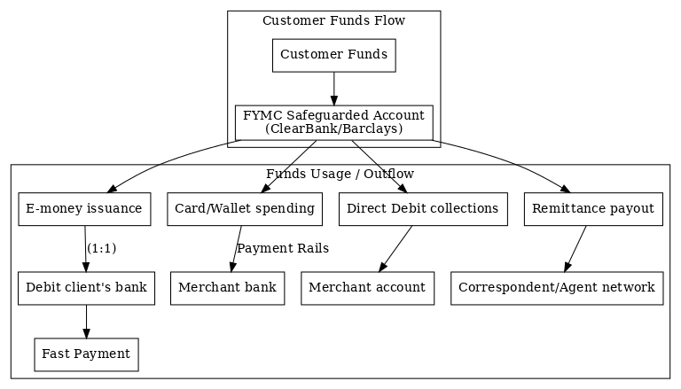
General Overview-Funds Flow Diagram
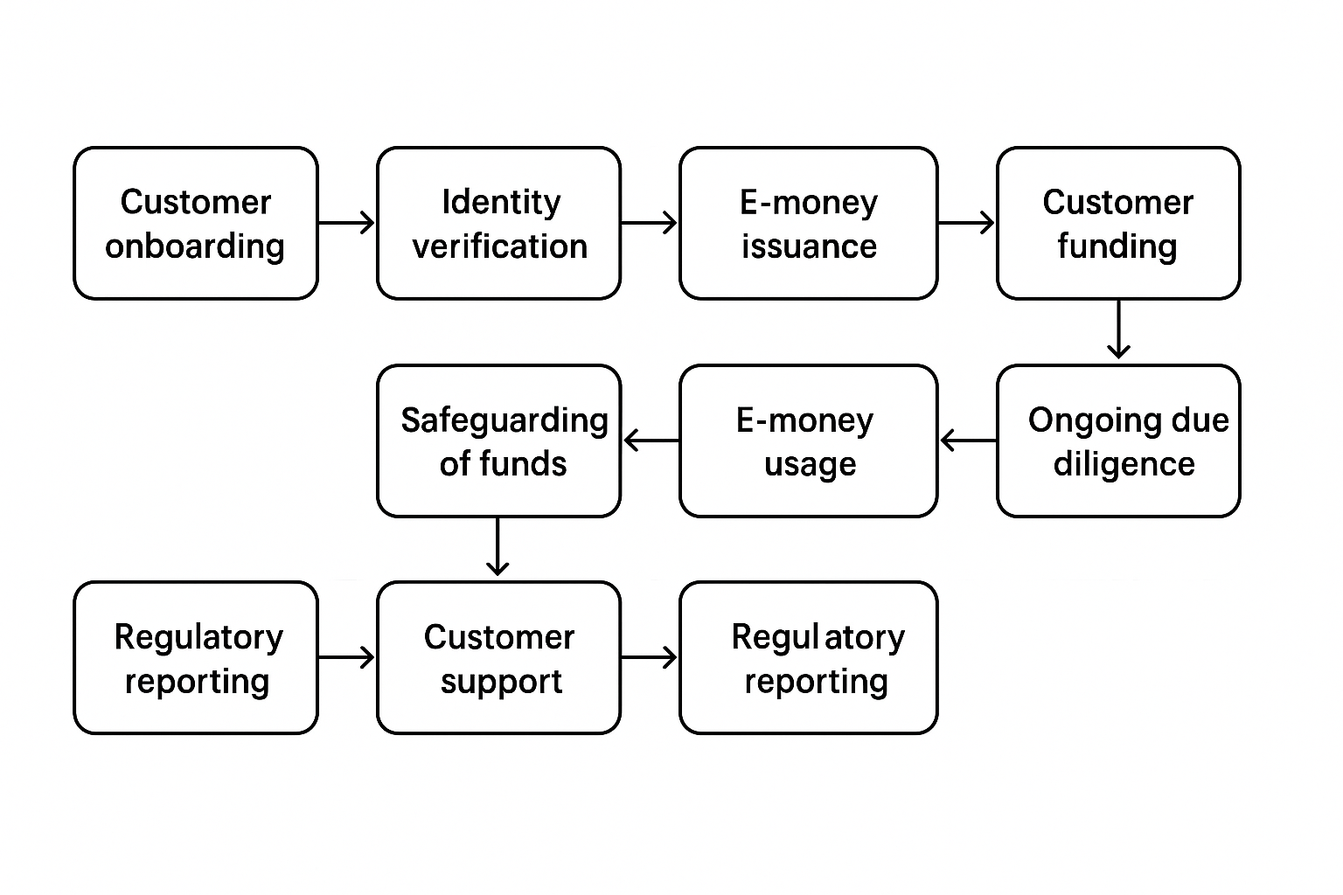

Incoming Funds
- Customers load funds via transfer, card, or cash
- Funds deposited in a safeguarded account (ClearBank/Barclays)
Outgoing Use Cases
- E-money issuance to Customer account
- Spending to Merchant bank via card rails
- Direct debits to Merchant account
- Remittance to Beneficiary via agent/correspondent network

1. Detailed Process Flow: E-Money Issuance
In developing our process flow and funds flow diagrams for our GBP-denominated wallets (with future FX support), we were guided by the minimum expectations of the FCA. We incorporated End-to-end traceability, Transparent reconciliation of funds, KYC/AML integration at onboarding, Safeguarding in compliance with EMRs, Data protection and customer transparency and Inability to wind down or return funds (exit strategy).
We detail below the step-by-step lifecycle of our e-money from customer onboarding through funding and service delivery. It assumes a modular, API-driven, FCA-compliant platform with safeguarding, KYC, and operational checks at each level.

STEP-BY-STEP PROCESS FLOW
Step | Description | Parties Involved | Technology Used
1. Registration | User signs up via app/web portal | Customer, Frontend System | Mobile/web interface, CRM
2. KYC & AML Checks | Identity verification (e.g., ID + selfie), address, PEP/Sanctions screening | KYC Provider (e.g., Sumsub, Onfido), Compliance Team | KYC API, AML Screening engine
3. Account Creation | Unique wallet (GBP) created and linked to user profile | Core E-Money Platform | Virtual IBAN engine, Wallet API
4. Safeguarding Setup | Segregated client funds account linked via bank partner | Safeguarding Bank (e.g., Barclays/ClearBank) | Safeguarded Account API
5. Customer Top-Up | User loads funds via bank transfer, card, or FPS | Customer, Card Processor, Bank Partner | Card Gateway API, FPS Link
6. Funds Reconciliation | Daily fund matching between wallet balances and bank | Finance Ops, Reconciliation Engine | Reconciliation Dashboard
7. E-Money Issuance | Fiat funds converted into e-money and credited to wallet | FYM Compliance Ltd (Issuer) | E-Money Ledger
8. Wallet Usage | Users spend via card, send funds, or top-up other services | End-customer, Card Scheme, FX provider | Mastercard API, Internal Wallet System
9. Statement & Alerts | User receives real-time balance & transaction logs | Notification Service | SMS/Email API, App Push
10. Customer Support | 24/7 live chat, ticketing, and fraud reports | CS Team | Zendesk or Internal CRM
11. Regulatory Reporting | Monthly FCA returns, safeguarding attestations, suspicious activity reports | Compliance & Ops | FCA Connect, RegTech System
12. Fund Withdrawal or Exit | Users may withdraw funds via bank or card refund | Customer, Payment Processor | FPS/BACS API

2. FUNDS FLOW: E-Money Issuance and Redemption
This diagram outlines how money moves through the e-money system, ensuring full safeguarding compliance as per EMRs and PSRs.

FUND FLOW DIAGRAM

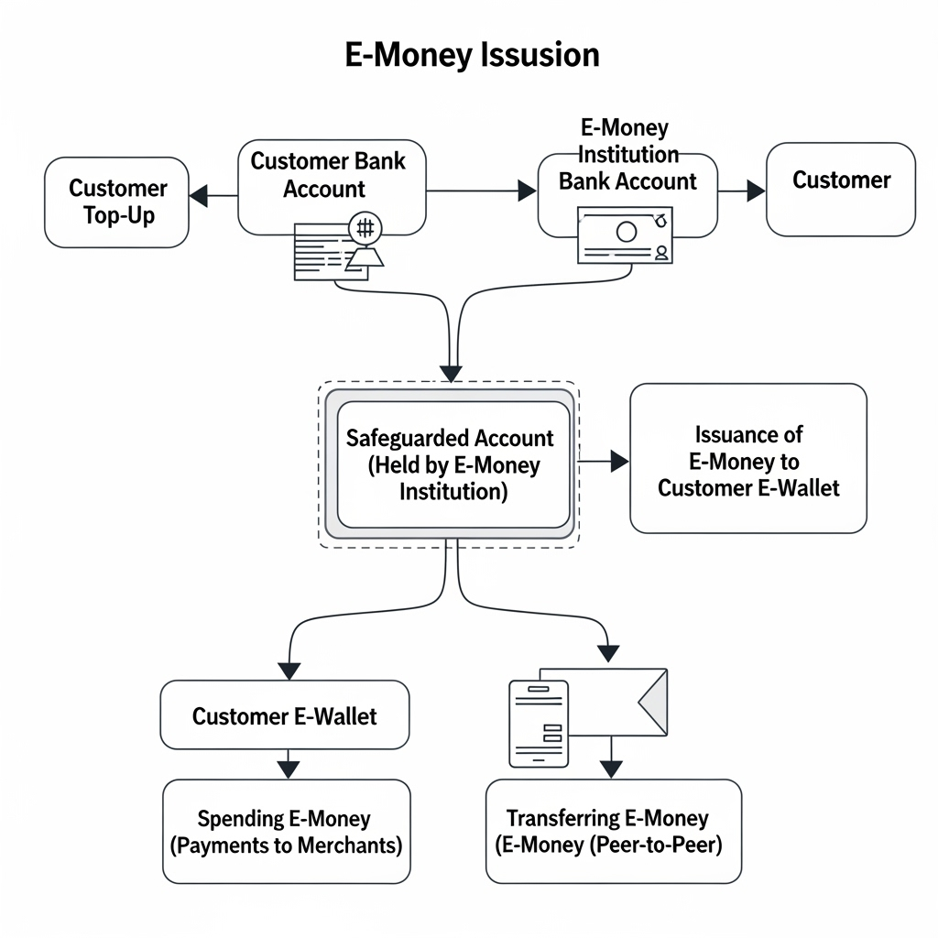

Key Compliance Measures Across Flow
Control | Description
Safeguarding | All customer funds stored in ring-fenced safeguarding accounts. Daily reconciliation and independent audit.
KYC/AML | Each user must complete identity verification. Transactions are monitored against risk thresholds and triggers.
E-Money Ledger | Digital ledger records all balances and transactional data for regulatory and audit review.
Reporting to FCA | Monthly volume, transaction count, safeguarding attestations, and complaints reports filed via FCA RegData.
Data Protection | GDPR-compliant storage. Data encrypted in transit and at rest. Access logs and multi-factor authentication used.

EXAMPLE: PARTIES INVOLVED
Function | Party | Examples
Issuer | FYM Compliance Ltd | -
Safeguarding Bank | Barclays / ClearBank | Modulr, Guavapay use similar providers
KYC Provider | Sumsub, Onfido | Revolut, Guavapay
Card Scheme | Mastercard / Visa | Modulr, Guavapay
Technical Platform | Base44 or custom stack | Proprietary wallet/core system
Payment Processor | Stripe, Checkout, GPS | Optional for top-up or spend
Regulator | FCA | —

4. Market Analysis
4.1 Industry Overview
The UK payments industry is undergoing rapid transformation, driven by:
- Increasing consumer preference for digital payments over cash.
- Regulatory frameworks (PSD2, FCA safeguarding requirements) promoting competition and innovation.
- Demand for faster, cheaper cross-border payments from diaspora communities and SMEs.
Electronic Money Institutions (EMIs) have captured a growing share of transactions traditionally handled by banks.
The Small Electronic Money Institution (SEMI) licence allows agile, niche providers like FYM Compliance Limited to compete effectively in targeted markets while maintaining cost efficiency.

4.2 Target Market
Our core customer segments are:
- Diaspora Communities
  - Primary users of remittance and FX services.
  - Value low fees, speed, and transparent exchange rates.
- Micro & Small Businesses (SMEs)
  - Require affordable payment account solutions, direct debit collections, and merchant integration.
  - Often underserved by high street banks due to low transaction margins.
- Tech-Savvy Consumers
  - Adopt prepaid cards and e-wallets for budgeting, travel, or as an alternative to bank accounts.

4.3 Market Needs
- Affordability: Competitive fees for transactions and account maintenance.
- Accessibility: Easy onboarding and multilingual support for non-native English speakers.
- Speed: Instant or same-day transfers for domestic and cross-border transactions.
- Security: FCA-compliant safeguarding, encryption, and fraud prevention.

4.4 Market Size & Opportunity
- UK remittance outflows exceed £8 billion annually, with significant volumes to Africa, Asia, and Eastern Europe.
- The SME payments market is projected to grow steadily as businesses adopt digital solutions to replace cheques and cash.
- Prepaid cards are one of the fastest-growing payment instruments in the UK, with the market expected to reach over £20 billion in transaction value by 2028.
Our forecast volumes (Year 3):
- 3,000 active wallets
- 2,000 prepaid cards issued
- 60,000 remittance transactions
- 70,000 debit-card top-ups
- 400,000 direct debits
These figures are achievable while remaining within SEMI regulatory limits, leaving room for sustainable growth.

4.5 Competitor Analysis
We benchmark our services against leading UK-based payment providers:
Competitor | Strengths | Weaknesses | Opportunity for Chase Finance
Revolut | Broad product range, strong brand recognition | Focus on premium users, limited personalisation for niche markets | Offer tailored services to SMEs and diaspora
Guavapay | Multi-currency e-wallet, strong remittance offering | Higher fees for low-value transfers | Compete on pricing and transparency
Modulr | Strong B2B payments infrastructure | No direct retail consumer services | Target direct-to-consumer segment alongside SME
GoCardless | Industry leader in direct debit | Limited FX/remittance offering | Cross-sell direct debit with remittance/FX services

4.6 Barriers to Entry
- Regulatory Approval: FCA SEMI licence required prior to launch (in progress).
- Technology Infrastructure: Need for secure, scalable payment systems.
- Trust: Building credibility in a market where security and safeguarding are critical.

4.7 Strategic Market Positioning
Chase Finance will differentiate by combining:
- Competitive transaction pricing for high-volume, low-margin customer segments.
- Diverse product offering under a single digital platform.
- Cultural alignment with diaspora customers through targeted marketing and multilingual support.

5. Go-to-Market Strategy
5.1 Marketing Objectives
Our go-to-market strategy focuses on:
- Rapid customer acquisition post-licence approval (December 2025).
- Establishing brand trust within target diaspora and SME segments.
- Driving adoption of multiple services per customer to maximise lifetime value.

5.2 Target Segments & Value Proposition
Primary Segments:
- Diaspora Communities: Affordable, fast, transparent remittances and FX.
- SMEs: Cost-effective direct debit collections, payment accounts, and merchant services.
- Tech-Savvy Consumers: Prepaid cards and wallets for budgeting, travel, or as an alternative to bank accounts.
Value Proposition:
- Lower fees than traditional banks and many fintech competitors.
- FCA-compliant safeguarding of funds.
- Multiple services in one integrated digital platform.
- Multilingual support for non-native English speakers.

Customer Personas
Persona 1: The Diaspora Supporter
Name: Aisha Mahmood
Age: 32
Occupation: IT Consultant (London)
Origin: Dhaka, Bangladesh
Needs & Motivations:
- Sends £150 monthly to parents in Dhaka for family upkeep and emergencies.
- Frustrated by paying circa 9.78% fees via traditional “cash to cash” MTOs, costing about £14.70 per £150 transaction.
- Requires digital convenience: mobile app access, real-time transfer tracking, and multi-lingual customer support in Bangla for her parents.
How FYM Helps:
- Fee Savings: Charges £4 flat fee plus 1.5% FX spread, equating to circa 3.75% total or about £5.63 on £150 — saving Aisha approximately £9.
- Speed & Security: Transfers are delivered in under 15 minutes to a partner e-wallet (bKash), ensuring timely receipt.
- Financial Education: In-app budgeting tools and Bangla-language tutorials empower Aisha’s parents to confidently use digital wallets.

Persona 2: The Local Small Business Owner
Name: Samuel Opoku
Age: 42
Occupation: Import/Export Trader (Manchester)
Origin: Accra, Ghana
Needs & Motivations:
- Imports specialty cocoa products from Ghana to sell across the UK; needs to pay Ghanaian suppliers weekly.
- Seeks a reliable digital payment platform with low transaction fees — currently paying around 5.07% on £120 through traditional banking.
- Wants automated monthly direct debit collections for his Ghanaian contractors who service UK clients.

How FYM Helps:
- Direct Debit Service: Offers competitive £0.15 per collection fees, with automated API reconciliation that integrates directly with his accounting systems, simplifying bookkeeping.
- E-Money Account & Card: Provides a UK sort code and account number with multi-currency wallet capability, plus Faster Payments support, allowing Samuel to make real-time FX transactions at 1.5% spread.
- Multi-Channel Support: Customer service in English and Ghanaian English dialects, with transaction alerts available in-app, ensuring ease of communication for diaspora business owners.
Persona 3: The Underbanked Recipient
Name: Fatima Hassan
Age: 29
Occupation: Smallholder Farmer (Kisumu, Kenya)
Origin: UK Kenya remittance corridor (diaspora family support)
Needs & Motivations:
- Depends on remittances to buy farming inputs and cover school fees for two children.
- Limited access to formal banking; relies on M-Pesa agents who charge circa 10% fees for cash-in/out services.
- Seeks a secure, low-cost channel to receive funds and build savings to manage seasonal income variability.
How FYM Helps:
- Mobile Money Integration: Enables family members in the UK to remit funds via FYM directly into M-Pesa wallets, reducing costs to approximately 3.5%, saving about £7 on every £100 transferred compared to informal channels.
- Prepaid Card Options: Issues branded prepaid cards allowing ATM withdrawals in Kenyan cities without requiring a full bank account, providing Fatima with convenient access to funds.

- Financial Literacy: Partners with local agents to run quarterly “Digital Wallet & Savings” workshops, empowering Fatima to budget effectively and build financial resilience.
Persona 4: The Entrepreneurial Remitter
Name: Chinedu Okeke
Age: 35
Occupation: Software Developer & Side Business Owner (London)
Origin: Lagos, Nigeria
Needs & Motivations:
- Sends money monthly to support extended family and invest in local businesses in Lagos.
- Needs transparent, affordable transfer costs—current fees through banks or agents exceed 6–7%.
- Requires instant transfer confirmation and multi-lingual support (English and Yoruba).
How FYM Helps:
- Cost-Effective Transfers: Offers a flat fee of £4 plus 1.5% FX spread, cutting typical transfer costs nearly in half.
- Real-Time Transfers: Funds delivered within minutes to Nigerian mobile wallets (e.g., Paga, Opay), improving cash flow for recipients.
- Customer Support & Education: Yoruba-speaking support agents and in-app tutorials assist Chinedu and his recipients in maximising digital money usage.

Persona 5: The Urban Underbanked Recipient
Name: Thabo Mokoena
Age: 27
Occupation: Retail Assistant (Johannesburg, South Africa)
Origin: UK South Africa remittance corridor
Needs & Motivations:
- Receives remittances to support daily expenses and occasional education fees.
- Lacks full banking access due to limited ID documentation and distrust of traditional banks.
- Needs a safe, flexible way to access funds without costly cash pick-up fees (circa 8–10%).
How FYM Helps:
- Digital Wallet Partnerships: Enables direct deposit into local mobile wallets (e.g., Vodacom M-Pesa, TymeBank wallets) with extensive agent networks for cash withdrawal.
- Prepaid Card Issuance: Provides prepaid cards accepted at ATMs and retailers without requiring full bank accounts.
- Lower Cost & Enhanced Security: Reduces remittance receipt fees significantly compared to informal hawala or cash-based methods.
- Financial Inclusion Initiatives: Collaborates with NGOs and community groups to promote digital literacy and trust in formal financial systems.

Proposed Marketing Messages & Service Packages
Persona 1: The Diaspora Supporter – Aisha Mahmood
Marketing Message:
“Send money home faster, safer, and cheaper. Save up to £9 per £150 transfer with FYM’s low flat fees and real-time tracking — all from a user-friendly app with Bangla support to keep your family connected.”
Service Package:
- Digital Wallet Remittance Package: Mobile app + real-time tracking + multilingual support
- Budgeting and Literacy Add-on: Bangla video tutorials and in-app financial tools
- Priority Customer Support: Dedicated chat support in Bangla and English

Persona 2: The Local Small Business Owner – Samuel Opoku
Marketing Message:
“Streamline your business payments with FYM’s direct debit automation and real-time FX rates — reduce transaction fees from 5% to under 2% and integrate with your accounting software effortlessly.”
Service Package:
- Business Payments Automation: API-enabled direct debit + reconciliation feeds
- Multi-Currency E-Money Account: UK account + payment card for international use
- Dedicated Account Manager: Business-focused customer service in English/Ghanaian English.

Persona 3: The Underbanked Recipient – Fatima Hassan
Marketing Message:
“Get more from every pound sent home. FYM cuts your remittance costs by two-thirds and puts cash in your pocket faster with prepaid cards and local workshops to help you save and budget.”
Service Package:
- Mobile Money Integration: Direct transfers to M-Pesa wallets
- Prepaid Card Issuance: Easy access to cash via ATMs and agents
- Financial Literacy Program: Quarterly digital wallet and savings workshops

Persona 4: The Entrepreneurial Remitter – Chinedu Okeke
Marketing Message:
“Empower your family and investments in Nigeria with fast, affordable digital transfers and personalised support — save up to 50% on fees and track your money live from the UK.”
Service Package:
- Express Digital Transfers: Instant transfers to Nigerian mobile wallets
- Multilingual Support: English and Yoruba customer assistance
- Business Insights: Monthly transfer reports and FX optimization tips

Persona 5: The Urban Underbanked Recipient – Thabo Mokoena
Marketing Message:
“Access your money securely without a bank account. FYM offers prepaid cards and mobile wallets tailored to South African urban needs — all at lower cost and with trusted local partners.”
Service Package:
- Prepaid Card & Digital Wallet Access: ATM and retail spending options
- Local Agent Network Support: Convenient cash withdrawals and support
- Financial Inclusion Workshops: Education and digital literacy initiatives

5.3 Customer Acquisition Channels
Digital Marketing:
- Paid social media campaigns (Facebook, Instagram, LinkedIn) targeting diaspora geographies.
- Google Ads for remittance and payment account keywords.
- SEO optimisation for “low-cost remittance UK” and “SME direct debit solutions.”
Community Engagement:
- Partnerships with diaspora community associations, cultural events, and local chambers of commerce.
- Sponsorship of SME networking events and trade shows.
Partnership Marketing:
- Integration with accounting software providers for SME payments.
- Collaborations with travel agencies, money transfer agents, and ethnic retailers.

5.4 Sales Strategy
- Digital-First Onboarding: Fully online KYC and account opening.
- Cross-Selling: Encouraging wallet customers to adopt prepaid cards, remittances, and direct debits.
- Tiered Incentives: Lower fees or cashback for customers using multiple services.
- Business Sales Outreach: Dedicated account managers for SME client onboarding.

5.5 Pricing Approach
We use a value-based pricing model, setting fees to be competitive in target segments while maintaining our 80% gross margin. Pricing is fixed and transparent, avoiding hidden charges.
Example:
- £1.50/month wallet fee
- £10 prepaid card issuance fee
- £8.50 average revenue per remittance transaction
- £0.15 per direct debit

5.6 Growth Roadmap
Phase 1 – Licence Approval & Launch (Dec 2025 – Nov 2026)
- Onboard 1,500 wallet customers and 1,000 prepaid cardholders.
- Process 20,000 remittance transactions and 200,000 direct debits.
- Establish 10+ SME partnerships.
Phase 2 – Scale-Up (Year 2)
- Double customer base to 3,000+ active wallets.
- Launch multilingual app interface.
- Expand direct debit and merchant services in SME sector.
Phase 3 – Platform Ownership & Regional Expansion (Year 3)
- Invest £50k in proprietary platform software (optional), increasing EBITDA by up to £50k annually.
- Explore licensing in additional EEA markets.
- Develop API integrations for third-party financial service providers.

5.7 Competitive Marketing Advantage
Unlike competitors that specialise in a single product, Chase Finance offers a bundle of regulated services tailored to both individual and SME needs, ensuring higher customer retention and greater share of wallet.

6. Operations Plan
The operational design of FYM Compliance Limited (trading as Chase Finance) is built to meet FCA Small Electronic Money Institution (SEMI) requirements while ensuring scalability, cost control, and high service availability.
Our model blends lean staffing, outsourced technical expertise, and rigorous compliance oversight, ensuring that the business remains profitable and compliant as volumes grow.

6.1 Operational Objectives
Our operational priorities for the first three years are:
- Licence-Ready Infrastructure: Ensure all systems, processes, and controls meet FCA expectations at launch.
- Customer Experience Excellence: Deliver fast, seamless, and secure transactions for all payment services.
- Regulatory Compliance Integration: Embed safeguarding, AML, and transaction monitoring into daily operations.
- Scalability: Design processes to handle rapid increases in transaction volumes without significant increases in fixed costs.

6.2 Location & Facilities
The company operates from a remote-first model with its registered office in England.
Core activities, including compliance monitoring, technical support, and customer service, are managed via cloud-based tools.
Partner bank relationships (for safeguarding) and third-party technology providers are coordinated from the UK base.

6.3 Technology & Infrastructure
Our platform infrastructure will initially be hosted on Macrobank/Advapay under a subscription licence, integrated with AWS/Azure for secure cloud hosting, data backups, and scalability.
By Year 2, we will evaluate the option to invest £50,000 into proprietary software development to replace the subscription model — this would reduce annual platform costs by £45,000–£50,000 and increase EBITDA significantly.
Key Technology Components:
- Core Banking Engine: Manages wallet balances, transaction processing, and settlement.
- Payment Gateways: Integrated for debit card top-ups, FX rate feeds, and remittance execution.
- KYC/AML Tools: Automated identity verification and screening against sanctions/Pep lists.
- Security Layer: SIEM monitoring, intrusion detection, and multi-factor authentication for all administrative access.
- API Integrations: Enable SME clients and partners to integrate directly into our payment rails.
All systems will undergo annual independent IT and AML audits to ensure compliance and operational integrity.

6.4 Safeguarding of Customer Funds
FCA safeguarding rules will be met by maintaining segregated client accounts with reputable UK banks (e.g., ClearBank or Barclays).
Daily reconciliations will be performed to ensure that customer balances in the safeguarded account match the e-money ledger exactly.
Safeguarding account balances will not be used for operational expenses under any circumstance.

6.5 Compliance & Risk Management
We operate under a robust compliance framework, overseen by the Money Laundering Reporting Officer (MLRO).
Key controls include:
- Real-Time Transaction Monitoring: Alerts generated if transaction volumes approach SEMI limits (£4.4m outstanding or £2.6m unrelated monthly payments).
- AML/CTF Screening: Customer onboarding and transaction screening integrated into the platform.
- Annual Independent Audits: Covering AML, safeguarding, and IT security.
- Staff Training: Mandatory annual AML and data protection training delivered by ABM Global.

6.6 Service Delivery Processes
Customer Onboarding:
- Online registration and KYC checks completed via integrated ID verification tools.
- Risk scoring applied to each customer profile.
Transaction Processing:
- Payments routed via domestic rails (Faster Payments, BACS) or cross-border FX partners.
- Direct debit collections automated through BACS-approved processes.
- Remittances processed via correspondent bank or agent networks.
Customer Support:
- Multi-channel support (email, phone, in-app chat).
- SLA of 24 hours for query resolution, with urgent safeguarding or fraud-related issues prioritised within 2 hours.

6.7 Staffing & Roles
Year 1:
Lean operational structure, with the founder covering multiple functions supported by part-time contractors for compliance and IT.
Year 2 Onwards:
Full operational staffing with clear role allocation:
- Managing Director – Strategic oversight, FCA relationship management.
- MLRO/Head of Compliance – AML/KYC, regulatory reporting, safeguarding oversight.
- IT & Systems Manager – Platform performance, cybersecurity, vendor management.
- Operations Manager – Transaction processing, settlement, and customer service oversight.
- Customer Support Representatives – Front-line support for individuals and SMEs.
- Finance/Admin Support – Accounting, reconciliations, and reporting.

6.8 Partnerships & Key Suppliers
- Banking Partner: ClearBank/Barclays or any other available FCA approved institutions for safeguarding accounts.
- Technology Provider: Macrobank/Advapay core platform (transition to owned software optional from Year 2).
- Cloud Services: AWS/Azure for hosting, backups, and scalability.
- Audit Partner: Independent AML/IT audit provider (annual engagement).
- Training Provider: ABM Global for regulatory and compliance training.

6.9 Scalability & Contingency Planning
The operational design supports scaling from 1,500 active wallets in Year 1 to 3,000+ in Year 3 without significant headcount increases.
Cloud infrastructure and outsourced service arrangements allow quick capacity expansion.
Contingency measures, including backup systems, alternative correspondent partners, and a documented Business Continuity Plan (BCP), ensure service resilience in case of outages or operational disruptions.

7. Management Team
The leadership team at FYM Compliance Limited (trading as Chase Finance) combines deep regulatory compliance expertise, payment services operations experience, and technical capability.
Our management structure ensures clear accountability for compliance, operations, and technology — critical areas under FCA scrutiny.

7.1 Leadership Profiles
Fred Manu – Managing Director & Head of Business Development
Fred brings extensive experience in regulatory compliance, having previously operated Diamond Cube Limited, a licensed Small Payment Institution.
As founder of FYM Compliance Limited, Fred has advised multiple SPIs and APIs on FCA applications, safeguarding, AML frameworks, and risk management.
He oversees strategic direction, business development, and regulatory engagement, while ensuring operational readiness for SEMI compliance.
Key Skills & Achievements:
- Led multiple successful FCA licence applications for clients.
- Designed safeguarding and AML frameworks adopted by regulated payment firms.
- Deep understanding of SEMI operational limits and compliance reporting.
Keith Callanan – Marketing & Business Development Officer
Keith has extensive experience in marketing strategy, client acquisition, and partnership development.
He focuses on brand positioning, customer acquisition campaigns, and building relationships with SME and diaspora networks.
Key Skills & Achievements:
- Proven record in generating high-value client pipelines.
- Experience in digital marketing for fintech and B2B services.
- Specialist in community and partner engagement.
Richard Boulock – Lead IT & Systems Manager
Richard is responsible for the operational performance and security of the payment platform.
He manages integrations, ensures system resilience, and implements security protocols in line with FCA expectations.
Key Skills & Achievements:
- Experience with financial systems infrastructure and API integrations.
- Expertise in cybersecurity, cloud infrastructure, and disaster recovery.
- Oversight of annual independent IT security audits.

Paul Opoku – IT Systems Development & Architecture
Paul leads the software development roadmap, including the potential transition to an in-house platform from Year 2.
He ensures that the system meets scalability, compliance, and user experience requirements.
Key Skills & Achievements:
- Delivered custom-built financial services applications.
- Skilled in payment gateway integrations and transaction processing architecture.
- Proficient in secure coding and compliance-driven development.

7.2 Governance Structure
The governance framework ensures operational integrity and regulatory compliance:
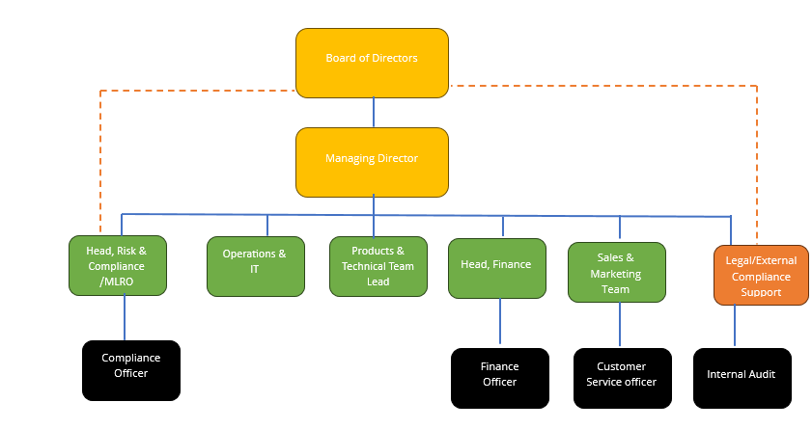
- Managing Director: Accountable for overall business performance, FCA liaison, and governance oversight.
- MLRO/Compliance Head: Independent compliance function with authority to halt non-compliant transactions.
- IT Management: Responsible for platform integrity, security, and technology vendor oversight.
- Finance & Operations: Monitors cashflow, reconciliations, and operational efficiency.
The Board of Directors meets quarterly to review strategic progress, financial performance, and regulatory compliance metrics.

7.3 FCA “Fit and Proper” Alignment
Each senior manager meets the FCA’s fit and proper criteria through:
- Demonstrated competence in their respective functional areas.
- Proven honesty and integrity in past professional conduct.
- Sufficient financial soundness to carry out responsibilities.
Background checks, credit checks, and reference verifications will be completed prior to final FCA approval. Below are the justifications for each role:

- Board of Directors
Chair of the Board of Directors (Mr Alex Moroz)
Why Alex Moroz Meets FCA Fit & Proper Criteria
Under FCA regulations for e-money institutions (EMIs), a Chair of the board must be a person of good repute, with the appropriate knowledge, experience, and behaviours to oversee a regulated financial firm effectively. FCA’s guidelines require individuals holding senior governance roles—under the Senior Managers and Certification Regime (SM&CR)—to exhibit fitness, propriety, and accountability.
Alex Moroz brings extensive experience in financial services and regulatory compliance. He has worked for over two decades in senior positions at institutions including the European Bank for Reconstruction and Development (EBRD), where he led principal investment and governance operations in regulated environments. His expertise spans governance frameworks, investment risk management, compliance oversight, and stakeholder reporting—all directly relevant to managing an EMI. His track record demonstrates he understands risk-based decision-making, safeguarding client funds, and regulatory reporting obligations—key elements defined in FCA EMR guidance (FCA).
His experience in principal investment, multi-jurisdictional operations, and board-level leadership satisfies FCA expectations regarding industry knowledge, regulatory awareness, and governance competence.

Role & Responsibilities of the Chair
Area | Functions & Duties
Governance Oversight | Provide strategic leadership, set tone from the top, and ensure the board functions in alignment with FCA expectations. Review and approve governance frameworks, including risk management and compliance policies.
Fitness & Propriety | Maintain personal record and professional standing at all times. Ensure all directors and senior roles meet FCA’s fit and proper standards under SM&CR.
Regulatory Liaison | Act as senior point of accountability with the FCA, engaging on matters such as safeguarding regime changes, threshold condition assessment, and supervisory reporting.
Board Leadership | Chair board meetings, set agendas, ensure independent challenge balanced with strategic alignment, approve annual financial reporting, wind-down plans, CASS implementation, and capital adequacy reviews.
Risk & Safeguarding Supervision | Oversee frameworks ensuring client funds are segregated and safeguarded per FCA rules (e.g., under CP24/20 proposals). Ensure internal controls effectively manage money laundering, operational risk, and fraud.
Strategic Direction | Guide board and senior management on company strategy, including growth corridors, digital-scale strategy, pilot rollouts, and market positioning. Ensure alignment with FCA objectives like consumer protection and financial integrity.
Culture & Conduct | Foster a conduct-risk-aware culture across senior teams. Ensure senior managers uphold integrity, transparency, and professionalism compatible with FCA’s Consumer Duty and SM&CR expectations.
Performance Monitoring | Leading annual board appraisals, reviewing board composition, succession planning, and facilitating continuous director development in regulatory, compliance, and business strategy.

- Managing Director & Compliance Oversight Lead – Fred Manu
FCA Justification: Fit and Proper Assessment
Fred Manu will serve as the Managing Director of FYM Compliance Limited and will also hold primary responsibility for internal compliance training and operational oversight. Under the FCA’s Fit and Proper Test for Employees and Senior Personnel (FIT) and the Senior Managers and Certification Regime (SM&CR), Fred demonstrably meets the required standards of honesty, integrity, competence, financial soundness, and regulatory experience as set out in the FCA’s handbook (FIT 1.3 and SYSC 4.3).
Fred brings over 15 years of progressive experience in the banking, financial services, and regulatory consultancy sectors, including a proven track record as MLRO of Diamond Cube Limited, a regulated Small Payment Institution (SPI). He has successfully designed and implemented full AML/CTF frameworks, developed internal control systems, and led firms through FCA licensing processes, regulatory inspections, and ongoing compliance obligations.
As the founder of FYM Compliance Limited, Fred has directly advised clients on FCA standards, including risk assessments, safeguarding, AML tool integration, and operational compliance for payment and remittance businesses. His technical competence includes practical use of AML tools such as SmartSearch, Shufti Pro, and AML Checker, alongside in-depth understanding of data protection, and real-time due diligence.
He holds an MBA in Business Administration, a PGCE in Education, and a bachelor’s in commerce, aligning his strategic, analytical, and training capabilities. Fred’s dual ability to deliver both executive leadership and hands-on compliance training ensures operational resilience, risk awareness, and strong governance from the top.

Role & Responsibilities
As Managing Director and Compliance Oversight Lead, Fred Manu will:
Functional Area | Responsibilities
Strategic Leadership | Oversee the strategic direction and daily operations of FYM Compliance Limited in alignment with FCA rules and the company’s regulatory obligations. Set organisational priorities and manage executive decision-making.
Governance & Compliance Oversight | Lead the implementation and maintenance of FYMC’s governance framework. Ensure adherence to SYSC and EMRs, with particular attention to safeguarding, recordkeeping, and conduct risk.
AML/CTF Supervision | Develop and maintain AML/CTF systems, policies, and procedures. Ensure that all staff and outsourced service providers understand and follow regulatory obligations. Maintain responsibility for customer due diligence, ongoing monitoring, and suspicious activity reporting procedures.
Internal Training & Certification | Design and deliver ongoing internal compliance training programs for all new and existing staff, including annual refreshers. Monitor training records, test understanding, and ensure regulatory alignment under the SM&CR regime.
Regulatory Engagement | Act as the key point of contact with the FCA on business-as-usual matters, audits, and supervisory enquiries. Lead FCA communications, notification requirements, and submission of regulatory returns.
Safeguarding & Risk Controls | Ensure safeguarding accounts are managed in line with CASS guidelines and CP24/20 proposals. Oversee daily reconciliations, risk registers, and internal control reviews.
Technology & AML Tool Oversight | Approve and monitor the integration of compliance and onboarding tools (e.g., SmartSearch, Shufti Pro). Review KYC/EDD outputs and sanction screening reports.
Policy Development | Draft, update, and enforce all regulatory policies including AML/CTF Policy, Risk Assessment, Data Protection Policy, Outsourcing Policy, and Wind-Down Plan. Ensure they remain current with evolving FCA expectations.
Consumer Protection & Conduct Risk | Promote a consumer-centric culture in line with the FCA’s Consumer Duty. Monitor client communications, pricing transparency, and complaint resolution procedures.

- Compliance Officer & MLRO – Kwadwo Kusi-Frimpong
FCA Justification: Fit and Proper Assessment
Kwadwo Kusi-Frimpong is proposed as the Compliance Officer and Money Laundering Reporting Officer (SMF16/SMF17) for FYM Compliance Limited. His appointment fully aligns with the FCA’s Fit and Proper Test for Senior Personnel (FIT), as well as the obligations under the Electronic Money Regulations (EMRs) and Senior Managers and Certification Regime (SM&CR). He demonstrates the required integrity, competence, experience, and understanding of regulatory obligations expected of an MLRO within an FCA-authorised electronic money institution.
Kwadwo brings over a decade of specialist experience in financial crime, regulatory compliance, and anti-money laundering across leading financial institutions in both the UK and EU. His recent positions at Starling Bank, Santander, and Bank of America involved critical financial crime advisory, onboarding compliance, transaction monitoring, and AML system enhancements. He has served in senior AML/compliance roles for Deloitte Switzerland, ING Wholesale Banking (Netherlands), and Accenture, gaining direct exposure to correspondent banking, trade-based money laundering controls, and cross-border risk frameworks—highly relevant to FYM’s operational model and corridor strategy.
His academic qualifications further reinforce his suitability. Kwadwo holds a Postgraduate Diploma in Financial Strategy from the University of Oxford – Saïd Business School, an LLM in Professional Legal Practice from the University of Law, and a Bachelor of Arts in Political Science and Philosophy from the University of Ghana. He has also completed relevant certifications in AML Foundations and Business Analysis and has published extensively on regulatory failings and financial sector governance, evidencing thought leadership and critical insight into systemic risk and regulatory best practice.
His FCA-readiness is also supported by prior roles in both consulting and operational compliance across multiple jurisdictions—preparing him to lead FYM’s compliance framework with rigour, independence, and strong professional judgement.

Role & Responsibilities
As Compliance Officer and MLRO, Kwadwo Kusi-Frimpong will assume full responsibility for FYM’s regulatory compliance programme and AML/CTF framework, reporting directly to the Board and FCA.
Functional Area | Responsibilities
Regulatory Compliance Oversight | Design, implement, and regularly update the firm’s compliance framework to meet all FCA regulatory requirements under the EMRs, PSD2, MLRs, and SM&CR.
MLRO Duties | Serve as the nominated officer for all AML/CTF obligations. Oversee customer due diligence (CDD), enhanced due diligence (EDD), sanctions screening, and ongoing transaction monitoring. Receive and assess internal suspicious activity reports (SARs) and submit disclosures to the National Crime Agency (NCA) as appropriate.
Policy Governance | Draft and maintain key regulatory documents including the AML/CTF Policy, Compliance Monitoring Plan, Financial Crime Risk Assessment, Anti-Bribery & Corruption Policy, and Whistleblowing Procedure.
Monitoring & Reporting | Lead internal audits, thematic reviews, and regulatory risk assessments. Prepare and submit regulatory returns, compliance reports, and MLRO annual reports to the Board.
Training & Awareness | Deliver induction and refresher training to all staff on AML, fraud prevention, data protection, and conduct risk. Maintain training records and implement testing modules to assess effectiveness.
FCA Engagement | Act as the main point of contact for all financial crime and compliance-related queries from the FCA, including any requests for information, supervisory visits, or thematic reviews.
Technology Integration | Oversee the configuration and use of AML systems (e.g., SmartSearch, Shufti Pro) and ensure that all onboarding and transaction monitoring solutions are aligned with the firm’s risk appetite and regulatory requirements.
Emerging Risk Management | Monitor external developments such as regulatory consultations (e.g., FCA CP24/20), FATF updates, and geopolitical changes to ensure FYM’s compliance posture remains current and defensible.
Consumer Duty & Conduct Risk | Embed a culture of integrity and fair customer treatment throughout the organisation, ensuring full alignment with the FCA’s Consumer Duty and Treating Customers Fairly (TCF) principles.

- Compliance Officer & MLRO – Daniel Kushner
FCA Justification: Fit and Proper Assessment
Daniel Kushner is nominated to serve as Compliance Officer and Money Laundering Reporting Officer (SMF16/SMF17) at FYM Compliance Limited. He is an FCA-approved person with prior SMF16/17 authorisations and brings over two decades of direct financial crime compliance experience across top-tier global institutions—including Goldman Sachs, UBS, Credit Suisse, Coinbase, Nomura, and Bank of America.
In accordance with the FCA’s Fit and Proper Test (FIT) and the Senior Managers and Certification Regime (SM&CR), Daniel clearly satisfies all three criteria for fitness and propriety: honesty and integrity, competence and capability, and financial soundness. He has held compliance leadership roles across multiple regulated sectors, including electronic money, FX, crypto-assets, and asset management, and is currently active as MLRO/Compliance Consultant through his regulated firm, DJK Capital Ltd.
Daniel’s regulatory and practical experience includes:
- SAR submission to the NCA
- Full transaction monitoring lifecycle oversight
- Design and implementation of AML/CTF policies under the Fifth Money Laundering Directive
- Oversight of complex onboarding involving trusts, SPVs, hedge funds, and HNWI clients from high-risk jurisdictions
- Sanctions screening, PEP assessments, and blockchain forensic analysis (Coinbase)
His proven expertise in e-money transaction monitoring, especially within firms like TokenCard, Coinbase, and Aperture FX, makes him exceptionally qualified to operate as MLRO in FYM’s digital-first EMI business model. His legal background (LLB Law, Brunel University), combined with FCA-specific training (Compliancy Services SMCR, AML, and Anti-Bribery), further reinforces his suitability under FCA guidelines.
Role & Responsibilities
As Compliance Officer and MLRO at FYM Compliance Limited, Daniel Kushner will have full executive responsibility for the implementation, oversight, and continuous improvement of the firm’s compliance and financial crime framework.
Functional Area | Responsibilities
Regulatory Compliance | Maintain and enforce internal systems and controls to ensure compliance with the EMRs, MLRs, and relevant guidance from the FCA, FATF, and JMLSG. Conduct regular reviews and internal audits of compliance controls.
AML/CTF Oversight | Serve as the appointed MLRO under the MLRs. Manage the reporting and investigation of suspicious activity (SARs), ensure recordkeeping, oversee ongoing monitoring, and ensure appropriate responses to FCA or law enforcement requests.
E-Money & Crypto Transaction Monitoring | Apply enhanced monitoring techniques—including blockchain analytics—to identify and assess risk in transactions involving digital wallets, fiat inflows/outflows, and high-risk jurisdictions.
Policy Governance | Draft, implement, and regularly update the AML/CTF policy, Financial Crime Risk Assessment, Sanctions Policy, and Suspicious Activity Reporting procedures.
Customer Due Diligence (CDD & EDD) | Oversee onboarding procedures for all customers, with tiered KYC/KYB measures, source of funds/wealth verification, and PEP/sanction screening. Review and escalate high-risk cases in accordance with the firm’s risk appetite.
Regulatory Engagement | Serve as key contact for the FCA and other authorities regarding financial crime, reporting obligations, audits, and supervisory correspondence.
Compliance Training | Deliver regular AML and compliance training to staff and management. Update training materials to reflect emerging threats (e.g., fraud typologies, sanctions evasion, and crypto risk indicators).
Marketing & Financial Promotions Oversight | Review and approve marketing communications and promotional materials in line with FCA financial promotions rules and Consumer Duty.
Incident Response & Risk Mitigation | Oversee breach reporting, conduct root cause analysis, and implement remedial controls to strengthen the compliance programme. Ensure timely updates to risk registers and internal MI reporting.

- Finance Manager – Azariah Quansah
FCA Justification: Financial Oversight & Governance Competence
Azariah Quansah is proposed as the Finance Manager of FYM Compliance Limited. While not ACCA-qualified, Azariah brings over 15 years of continuous experience in financial administration, accounting, and corporate governance—including senior-level finance roles in regulated and consultancy settings. He has led financial management functions in multiple firms, including Classic Accountancy Services (UK) Ltd, Wealth Masters Group, and Diamond Cube Limited, a former FCA-registered Small Payment Institution (SPI). His responsibilities have spanned budgeting, accounts reconciliation, statutory recordkeeping, client money handling, and financial reporting.
Azariah holds a Master’s degree in Corporate Governance (MSc) from London South Bank University, with an ICSA (Grad) accreditation—providing a strong foundation in fiduciary responsibility, company law, and regulatory reporting obligations. His work as a Corporate Governance Professional at Cee Won Consultants Limited further demonstrates his familiarity with compliance-led financial operations, company secretarial duties, and governance best practices aligned with FCA expectations under SYSC.
Given FYM Compliance Limited’s SEMI status and corresponding financial control obligations under the Electronic Money Regulations (EMRs), Azariah’s practical financial management experience, governance insight, and sustained hands-on accounting practice position him as an appropriate and competent candidate for this role.

Role & Responsibilities
As Finance Manager, Azariah Quansah will be responsible for the day-to-day financial operations of FYM Compliance Limited. He will oversee regulatory reporting, budgeting, safeguarding reconciliations, and support the firm’s capital adequacy monitoring in line with FCA rules.
Functional Area | Responsibilities
Financial Management | Maintain accurate books and records, manage monthly management accounts, cash flow statements, and prepare year-end accounts in collaboration with external accountants or auditors.
Budgeting & Forecasting | Develop and update annual budgets and rolling forecasts. Monitor key performance indicators against forecasts and highlight deviations to the Board.
Safeguarding Oversight | Support reconciliation of client safeguarding accounts in accordance with EMR requirements. Assist in monthly and daily reporting to monitor balances versus FCA thresholds.
Regulatory Reporting Support | Provide data and documentation for FCA financial returns (e.g., REP001, PSD001), including safeguarding attestations and compliance audit support.
Accounts Payable/Receivable | Oversee client invoicing, payment collection, supplier management, and internal payment processing workflows. Maintain reconciliation logs and audit trails.
Internal Control & Governance | Work with the Compliance Officer and Managing Director to implement and maintain financial control procedures, including payment authorisation processes and approval hierarchies.
Payroll & Tax Compliance | Coordinate PAYE, National Insurance, VAT, and corporation tax reporting. Ensure timely submission of HMRC filings and compliance with Companies House requirements.

- Business Development Officer (Interim) – Fred Yaw Manu
FCA Justification: Market Insight & Strategic Development
In addition to his duties as Managing Director, Fred Yaw Manu will serve as the Interim Business Development Officer for FYM Compliance Limited until such time as the firm has the operational scale to appoint a dedicated officer. This dual role is justified by his extensive experience in the regulated financial services sector, his deep understanding of FCA requirements, and his successful track record in guiding small and medium-sized enterprises (SMEs) through licensing, compliance, and operational growth.
Fred’s experience as the former MLRO and Compliance Manager of Diamond Cube Limited—a regulated Small Payment Institution—provides him with a nuanced understanding of the remittance and payment services market. He has spent over a decade developing compliance-led growth strategies for fintechs, MSBs, and diaspora-focused financial institutions. His leadership at FYM Compliance Limited and his private consultancy work have enabled him to engage directly with MSMEs, diaspora communities, and underserved consumer groups—making him well-positioned to lead strategic market development aligned with FYMC’s regulatory obligations and commercial objectives.
Fred also holds two master’s degrees (MBA and PGCE), alongside a bachelor’s degree in commerce. This academic foundation supports his ability to translate regulatory complexity into business value, design growth frameworks with operational controls, and deliver tailored services to diverse customer segments.

Role & Responsibilities
As Interim Business Development Officer, Fred Yaw Manu will assume the following responsibilities:
Functional Area | Responsibilities
Market Expansion Strategy | Lead the development of FYM’s go-to-market strategy, focusing on diaspora remitters, MSMEs with cross-border payment needs, and community-based financial services.
Partnership Development | Identify, engage, and formalise strategic partnerships with diaspora associations, fintech platforms, accountancy firms, and compliance consultancies for lead generation and service integration.
Product-Market Fit | Work closely with the compliance and finance teams to align FYM’s digital services (e-money accounts, remittance tools, direct debits) with evolving market needs and FCA expectations.
Marketing & Customer Outreach | Oversee FYM’s brand development, including content strategy, multilingual marketing campaigns, and community-based outreach in high-potential cities (e.g., London, Birmingham, Manchester).
Data-Driven Growth | Analyse user behaviour, onboarding data, and transaction flows to identify conversion bottlenecks, acquisition opportunities, and pricing strategies that drive responsible growth.
Sales Enablement & Education | Deliver workshops, webinars, and educational sessions (online and in person) to build awareness, drive trust, and promote digital adoption—particularly among digitally cautious or underbanked groups.
Regulatory Alignment in Promotions | Ensure that all promotional materials, client communications, and lead-generation activities remain compliant with FCA financial promotion rules and Consumer Duty expectations.
Reporting & Board Updates | Present monthly business development KPIs and growth metrics to the board. Recommend adjustments to the customer acquisition strategy based on market feedback and regulatory developments.

- Lead IT Manager – Richard Boulock
FCA Justification: Technology Governance & Operational Competence
Richard Boulock is proposed as the Lead IT Manager of FYM Compliance Limited. He has expertise in nanotechnology engineering, artificial intelligence innovation, and educational leadership. These skills, when applied within fintech and payment services, are highly relevant to building secure, scalable, and compliant digital infrastructures.
Within the FCA regulatory framework, the Lead IT Manager must demonstrate a strong grasp of operational resilience, data security, cyber risk controls, system auditability, and incident response. Mr. Boulock’s background in technology-driven enterprise leadership, combined with hands-on development and innovation, suggests he has the cognitive and practical capacity to oversee the firm’s digital threat environment and ensure alignment with FCA policies including SYSC 4.1.15R (Operational resilience) and ICO’s GDPR standards.

Role & Responsibilities
As Lead IT Manager, Richard Boulock will oversee the design, implementation, and maintenance of FYM Compliance Limited’s technology infrastructure, with particular emphasis on secure and compliant e-money operations.
Functional Area | Responsibilities
Technology Infrastructure & Security | Design and maintain IT architecture—including web/mobile platforms, API integrations, cloud environments, and production systems—to meet FCA resilience requirements and protect customer data.
Operational Resilience & Continuity | Develop and test incident response plans, business continuity procedures, and disaster recovery processes to ensure uninterrupted service delivery and regulatory compliance.
Cybersecurity & Data Protection | Implement strong security controls: access management, encryption, secure coding, vulnerability scanning, and penetration testing. Ensure alignment with GDPR and FCA Treatment of Customer Data obligations.
System Governance & Auditability | Maintain audit trails, secure logging, and change management documentation for regulatory review. Support periodic internal and external audits of IT systems and controls.
Vendor & Third-Party Management | Oversee technology vendors (e.g., hosting, third-party APIs, monitoring tools). Conduct due diligence and maintain contracts that satisfy outsourcing policies under SYSC.
Compliance Systems Implementation | Support installation and maintenance of compliance software—such as AML screening tools, KYC platforms, and transaction monitoring systems—ensuring integration with digital onboarding and customer accounts.
Innovation & Platform Development | Lead technology upgrades based on emerging standards (e.g., Open Banking APIs, ISO 20022 messaging), improve scalability, and enable enhancements such as micro-savings and loyalty integrations.
Reporting & Stakeholder Liaison | Provide monthly technological status and incident reports to Management and the Board. Engage with compliance and finance leads to align system functionality with regulatory needs.

IT Systems Manager – Paul Opoku Adjei

FCA Justification: Systems Integrity & Operational Resilience
Paul Opoku Adjei is proposed as the IT Systems Manager of FYM Compliance Limited. His appointment is aligned with the FCA’s expectations for firms under SYSC 13 (Operational Risk) and the FCA’s Guidance on Operational Resilience, particularly in relation to secure IT infrastructure, data protection, digital onboarding, and continuity of service.
Paul brings more than 15 years of experience in software engineering, infrastructure architecture, and IT leadership, with a specialisation in financial technology solutions for regulated environments. Whilst working for Opanet Company Limited, he built mission-critical platforms for open banking, e-wallets, mobile banking, agency banking, identity and access systems, and payment collections—many of which are live in emerging markets and have been tailored to low-connectivity and high-compliance environments.
His technical portfolio includes the development of:
- Mobile and internet banking applications
- Open Banking infrastructure with IP and SS7 interfaces
- A distributed-ledger-based E-Wallet system
- Http Over USSD technology for real-time, offline financial transactions
- AI-powered AML screening and transaction monitoring solutions
- Multi-channel payment gateways with APIs and SDKs for SME integrations
Paul holds a BSc in Physics from the University of Cape Coast and is currently enrolled in the MIT Applied AI and Data Science Program. His technical stack includes C#, .NET, React, REST APIs, cloud architecture (AWS, Azure, Google Cloud), and DevOps tooling (Kubernetes, GitHub Actions, CI/CD pipelines), giving him a modern and enterprise-ready skill set.

Role & Responsibilities
As IT Systems Manager, Paul Opoku Adjei will lead the design, implementation, and security of all core technology infrastructure, supporting FYM’s e-money issuance, digital onboarding, AML controls, and operational resilience obligations.
Functional Area | Responsibilities
Systems Design & Infrastructure | Architect and maintain FYM’s IT ecosystem, ensuring regulatory compliance, scalability, and cybersecurity in accordance with FCA SYSC and operational risk standards.
Platform Development & Maintenance | Oversee integration of core modules: e-wallet, onboarding, AML/CTF monitoring, identity & access management, and payment APIs into a unified digital platform.
Operational Resilience | Establish and test continuity plans, incident response protocols, backup systems, and service-level recovery procedures in line with FCA's resilience requirements.
Data Security & Privacy | Enforce GDPR-compliant data handling policies, encryption protocols, and access controls. Monitor real-time system usage and apply proactive security controls.
API & Payment Gateway Management | Support development and maintenance of real-time APIs and SDKs for partner integrations. Ensure all API endpoints are secured, documented, and monitored.
Compliance Systems | Deploy and optimise AI-driven AML modules, including screening, profiling, transaction scoring, and suspicious activity flagging. Collaborate with MLRO to calibrate thresholds.
DevOps & Automation | Maintain CI/CD pipelines for secure release cycles. Manage cloud infrastructure and automation for backups, scaling, and failover.
IT Governance & Reporting | Regularly report to the Board on system performance, IT risks, security incidents, and audit readiness. Support annual IT audits and FCA supervisory queries.

Staffing Summary

Employee Position | Estimated Annual Salary | Year to be Hired
Managing Director (Fred Yaw Manu) | £30,000 | 2026
Business Development Officer (Fred Yaw Manu, Interim) | (Covered by MD role) | 2026
Compliance Officer & MLRO (Kwadwo Kusi-Frimpong) | £36,000 | 2026
Compliance Officer & MLRO (Daniel Kushner) | £42,000 | 2026
Finance Manager (Azariah Quansah) | £28,000 | 2026
Chair of the Board (Alex Moroz) | £12,000 (Part-time/Non-Exec) | 2026
Lead IT Manager (Richard Boulock) | £35,000 | 2026
Technical Support | £20,000 | 2026
Customer Service Representative | £15,000 | 2026
Web Developer | £20,000 | 2026

8. Financial Plan
This section presents a fully aligned financial plan for FYM Compliance Limited (trading as Chase Finance), covering the first three operational years post-licence approval. All figures are sourced directly from our 3 YEARS FINAL FINANCIALS. We have attempted to limit computations to remain within the FCA’s SEMI thresholds for average outstanding e-money (<€5m) and average unrelated monthly payment volumes (<€3m).

8.1 Summary Financial Objectives
- Maintain all transactional volumes within SEMI regulatory caps.
- Achieve sustainable EBITDA profitability by end of Year 1.
- Build cash reserves to support safeguarding and wind-down requirements.
- Operate on a lean cost base with high gross margins (~80%).

8.2 Key Assumptions
- FCA SEMI licence approval: Dec 2025.
- Year 1 covers Dec 2025 – Nov 2026 with ramp-up over the first six months.
- Product pricing as outlined in Section 3 (no hidden fees).
- Costs inflated modestly between years to reflect scale-up in staffing and operations.
- Safeguarding account balances are ring-fenced and excluded from operational liquidity.

8.3 Revenue Forecast
(All figures £’000)
Product / Service | Y1 | Y2 | Y3
E-Wallet Maintenance | 27.0 | 45.0 | 54.0
Prepaid Card Issuance | 10.0 | 15.0 | 20.0
Remittance & FX Fees | 170.0 | 340.0 | 510.0
Debit-Card Top-Up Fees | 45.0 | 75.0 | 105.0
Direct Debit Collections | 30.0 | 45.0 | 60.0
Total Revenue | 282.0 | 520.0 | 749.0

8.4 Cost of Goods Sold (COGS)
- Applied at 20% of revenue across all product lines (direct transaction costs, card production, partner fees).
Year | COGS (£’000) | Gross Profit (£’000) | Gross Margin
Y1 | 56.4 | 225.6 | 80%
Y2 | 104.0 | 416.0 | 80%
Y3 | 149.8 | 599.2 | 80%

8.5 Operating Expenses
(includes regulatory, legal, IT, marketing, staff costs)
Year | Opex (£’000)
Y1 | 112.4
Y2 | 396.0
Y3 | 435.5

Note:
- Y1 Opex lower due to founder multi-role coverage.
- Step-up in Y2 reflects hiring of MLRO, IT staff, and customer support team.

8.6 EBITDA & Net Cashflow

Year | EBITDA (£’000) | Net Cashflow (£’000) | Year-End Cash (£’000)
Y1 | 113.2 | 92.0 | 156.8
Y2 | 20.0 | 15.0 | 127.7
Y3 | 163.7 | 148.7 | 276.4

8.7 SEMI Volume Compliance Check

Metric | Y1 | Y2 | Y3 | SEMI Cap
Avg. Outstanding E-Money (£) | 2.42m | 3.10m | 4.01m | £4.40m (~€5m)
Peak Outstanding E-Money (£) | 3.60m | 3.90m | 4.20m | £4.40m (~€5m)
Avg. Unrelated Payments (£/mo) | 1.33m | 1.75m | 2.08m | £2.60m (~€3m)

All forecasted values remain comfortably within SEMI thresholds. Real-time monitoring will ensure no breach.

8.8 Stress Test Scenarios

Scenario | Rev Change | Opex Change | EBITDA Y2 (£’000) | EBITDA Y3 (£’000) | Y3 Cash (£’000)
Base Case | 0% | 0% | 20.0 | 163.7 | 276.4
Downside | –20% | +10% | –102.8 | –119.5 | 156.9
Severe Downside | –40% | +20% | –225.6 | –163.1 | 113.3

Interpretation:
Even under downside conditions, safeguarding obligations remain fundable, and wind-down is viable.
8.9 Pricing & Corridor Competitiveness
- Remittance & FX: £4 flat + 1.5% margin undercuts Wise/Remitly for sub-£500 transfers in Africa and Eastern Europe corridors.
- Direct Debits: £0.15 per transaction significantly lower than GoCardless’s £0.20–£0.30.
- Prepaid Card Issuance: £10 per card is mid-market, competitive against Revolut (£5–£20).
- E-Wallet Fees: £1.50/month is below average UK fintech wallet charge.

8.10 Financial Resilience
- Safeguarding Buffer: Average operational cash >£125k across all years, separate from safeguarded funds.
- Wind-Down Funding: Year-end cash balances exceed estimated £100k wind-down requirement in all scenarios.
- No External Debt: 100% equity-funded; avoids repayment risk.

9. Appendices

Appendix A – 3-Year Financial Statements
Income Statement Summary (£’000)
Year Ending Nov | Y1 | Y2 | Y3
Revenue | 282.0 | 520.0 | 749.0
COGS (20%) | 56.4 | 104.0 | 149.8
Gross Profit | 225.6 | 416.0 | 599.2
Opex | 112.4 | 396.0 | 435.5
EBITDA | 113.2 | 20.0 | 163.7

Cashflow Summary (£’000)
Year Ending Nov | Y1 | Y2 | Y3
EBITDA | 113.2 | 20.0 | 163.7
CapEx | 0 | 0 | 0
Tax/Finance | – | –5.0 | –15.0
Net Cashflow | 92.0 | 15.0 | 148.7
Closing Cash | 156.8 | 127.7 | 276.4

Balance Sheet (Selected Items)
Item | End Y1 | End Y2 | End Y3
Cash & Equivalents | 156.8k | 127.7k | 276.4k
Safeguarded Funds* | 2.42m | 3.10m | 4.01m
*Held in segregated accounts, not part of operational cash.

Appendix B – SEMI Compliance Threshold Monitoring
Metric | Y1 | Y2 | Y3 | SEMI Cap
Avg. Outstanding E-Money (£) | 2.42m | 3.10m | 4.01m | £4.40m
Peak Outstanding E-Money (£) | 3.60m | 3.90m | 4.20m | £4.40m
Avg. Unrelated Payments (£/mo) | 1.33m | 1.75m | 2.08m | £2.60m

Monitoring Process:
- Daily automated volume checks against caps.
- Alert to MLRO if ≥90% of limit is reached.
- Monthly compliance reporting to FCA via Connect.

Appendix C – Safeguarding Process Flow
Funds Flow Overview:
- Customer funds received via bank transfer, debit card top-up, or incoming remittance.
- Funds deposited into FCA-designated safeguarded account at ClearBank/Barclays.
- E-money issued to customer wallet at 1:1 value.
- On payment or withdrawal, e-money is redeemed and funds released to merchant/recipient.

Appendix D – Wind-Down Funding Calculation
- Estimated wind-down cost: £100k (staff termination, regulatory reporting, fund return logistics).
- Year-end cash balance in all forecast years exceeds requirement:
  - Y1: £156.8k
  - Y2: £127.7k
  - Y3: £276.4k
- No reliance on external financing.

Appendix E – Competitor Pricing Comparison
Product | Chase Finance | Wise | Remitly | GoCardless
Remittance to Africa (£300) | £4 + 1.5% | £4.14 | £3.99 + margin | N/A
Direct Debit Fee | £0.15 | N/A | N/A | £0.20–£0.30
Prepaid Card Fee | £10 | £5–£20 | N/A | N/A
Wallet Maintenance Fee | £1.50/month | £2–£5 | N/A | N/A

Appendix F – Risk & Compliance Controls
- Independent AML/IT audit annually.
- GDPR-compliant data handling.
- Multi-factor authentication for admin users.
- Staff AML training annually.
- Real-time transaction monitoring.

Appendix G – Key Contacts Table
Role | Name | Email/Phone | Responsibility
Managing Director | Fred Manu |  | Strategic leadership, FCA liaison
MLRO | Daniel Kushner |  | AML/CTF compliance
IT Manager | Richard Boulock |  | Platform performance & security
Finance/Admin | [Insert] |  | Reconciliations & reporting

