1. Lagash vs Umma, ca. 2525 BCE (Ancient Sumer)
Historical background

Who: Eannatum of Lagash vs Enakalle of Umma
Where: Mesopotamia
Result: Ennatum's victory
Forces: unknown
Why it matters: The first recorded battle in which the two opponents are known
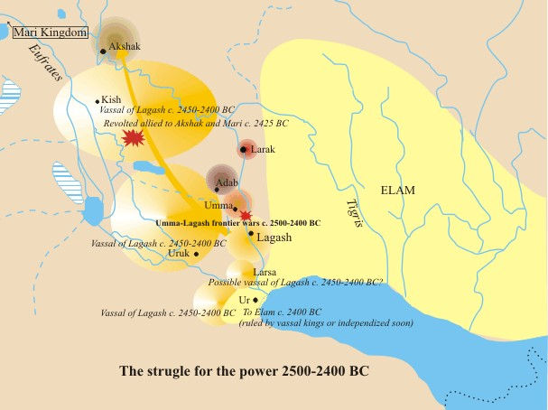
Illustration 2 : Umma-Lagash Wars
Our journey starts in Mesopotamia (the land between the two rivers according to the old Greek language), the site of some of the earliest recorded battles in history and where the most sophisticated armies of the Bronze Age were born. The first recorded battle was between the forces of Lagash and Umma ca 2500 BC. The evidence comes from the Stele of the Vultures (found in the ruins of Girsu) that was erected as a monument of the victory of Eannatum of Lagash over Enakalle of Umma. At this time in Sumer it was more regal to be pulled or ride on a Onager (Wild Ass) then it was a horse so Sumerian chariots were pulled by 4 Onagers. Also the city states of Sumer were fielding body guards to the king of around 6-700 men (the first professional troops).

Playing the battle

Simulating the battle of Lagash is absolutely as taking a trip to nowhere. We don't know anything about the battlefield (surely plain terrain) and above also about the exact number of the units involved. By browsing the web I could find a scenario made by Kim Meints based on the game Armageddon (SPI 1972). There are only three thousand men on each side and there are also some chariots, the weapon which shaped the battles of the Bronze Age albeit those Sumer chariots are not surely so mobile and effective. Moreover we cannot speak of an organized army. Yes, there were some loyal men who protected their king, but nothing else. In his scenario Kim doesn't use the 10 hexes of movement of the chariots and he suggests 6 movement points since the chariots were still big wood boxed drawn by asses. We can imagine the vultures flying over the 3600 corpses cited by Eannatum. The inscription proclaims : "Eannatum struck at Umma. The bodies were soon 3,600 in number [...]. I, Eannatum, like a fierce storm wind, I unleashed the tempest!" .
It seems to me the movie Gladiator but that's another battle! However let's play again that mythical clash.

