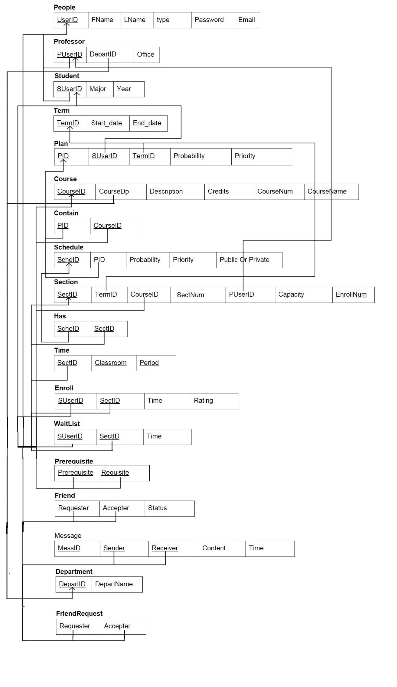

UserID uniquely identify one person in the system.

PID, SchelD, MessID, DepartID and CourseID are auto incremented for every insertion. These keys would not make any sense to the software users.