We ran

run possibleReliabe for 3 but 1 Data, 1 Packet

This generates a possible way to send 1 data or packet.

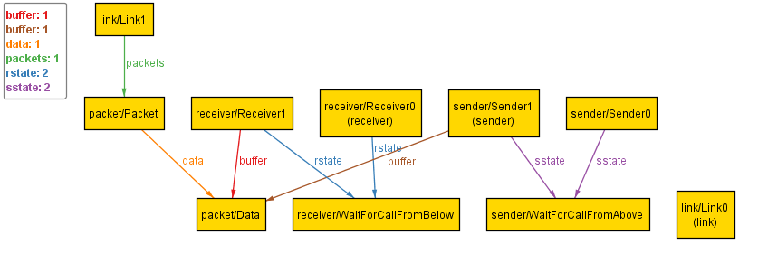

At Time0, the sender(sender/Sender1) contains the only data, the link(link/Link0) has no packets in it, and the receiver(receiver/Receiver0) has not gotten anything in the buffer.

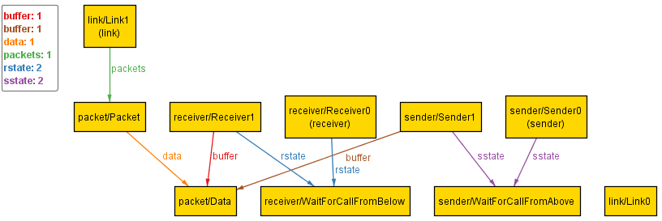

At Time1, the sender(sender/Sender0) contains no data, the link(link/Link1) gets the packet just sent, and the receiver(receiver/Receiver0) has not gotten anything in the buffer.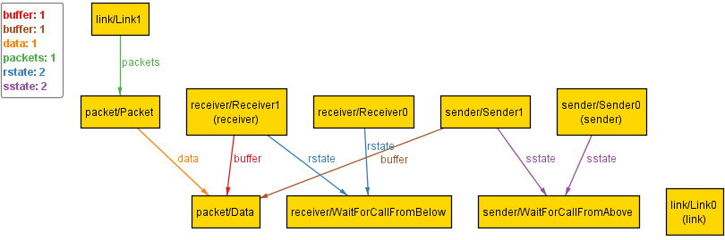

At Time2, the sender(sender/Sender0) contains no data, the link(link/Link0) gives the packet to receiver and has no packets left, and the receiver(receiver/Receiver1) has received one packet and extract data from it. Thus, the whole process succeeds.