CSC110 Fall 2019 Final Code

UML Diagram

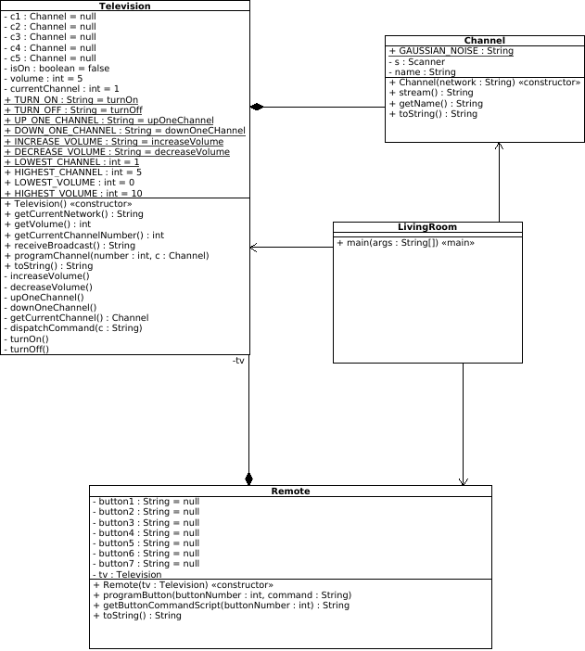
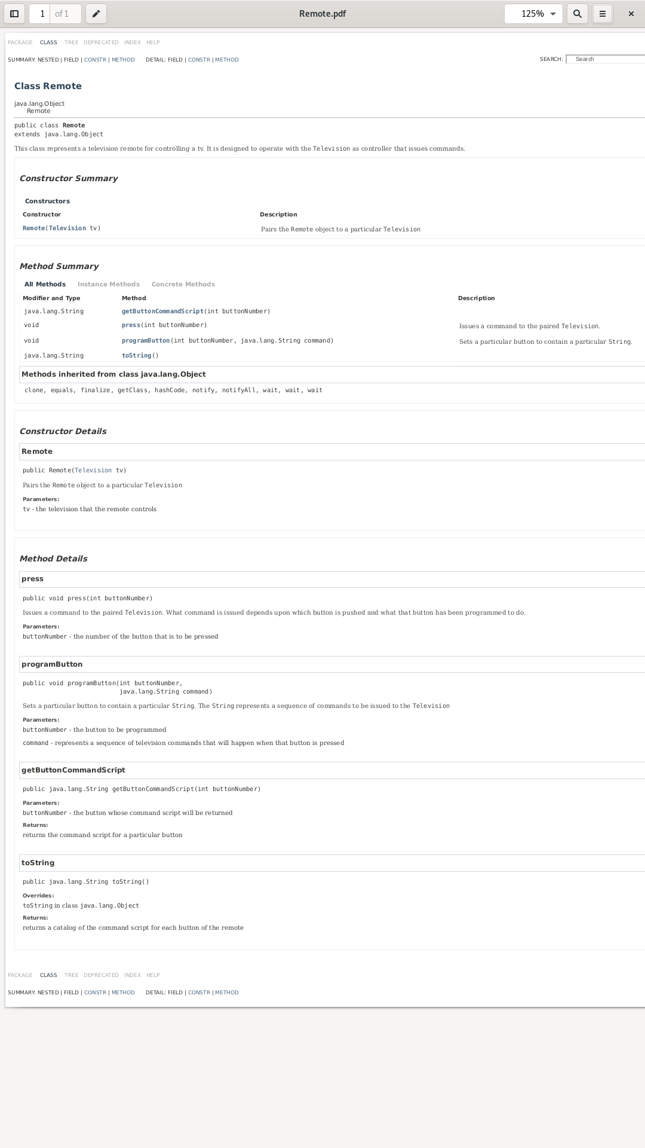
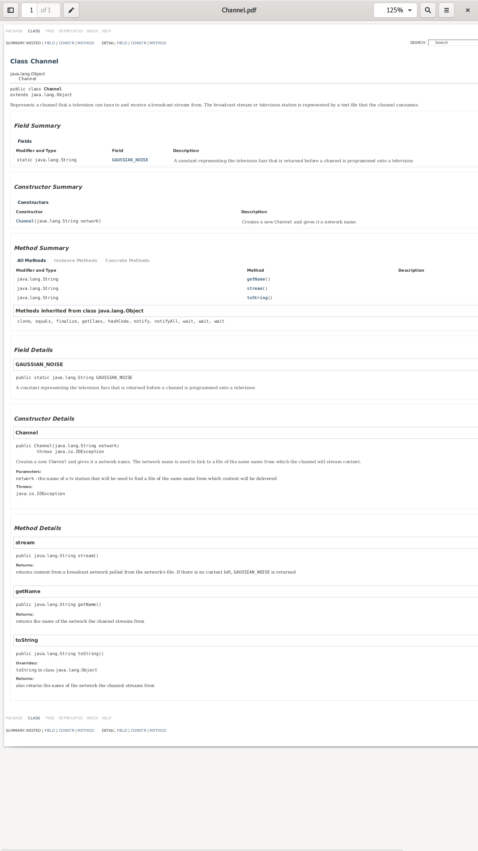
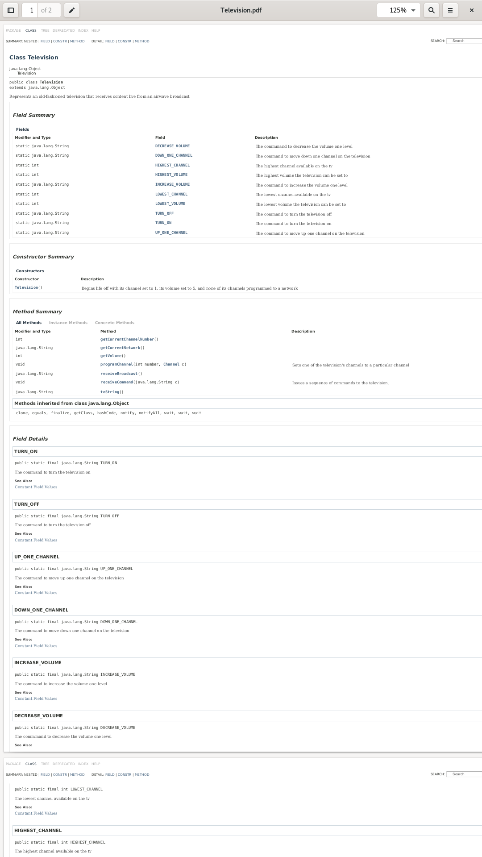
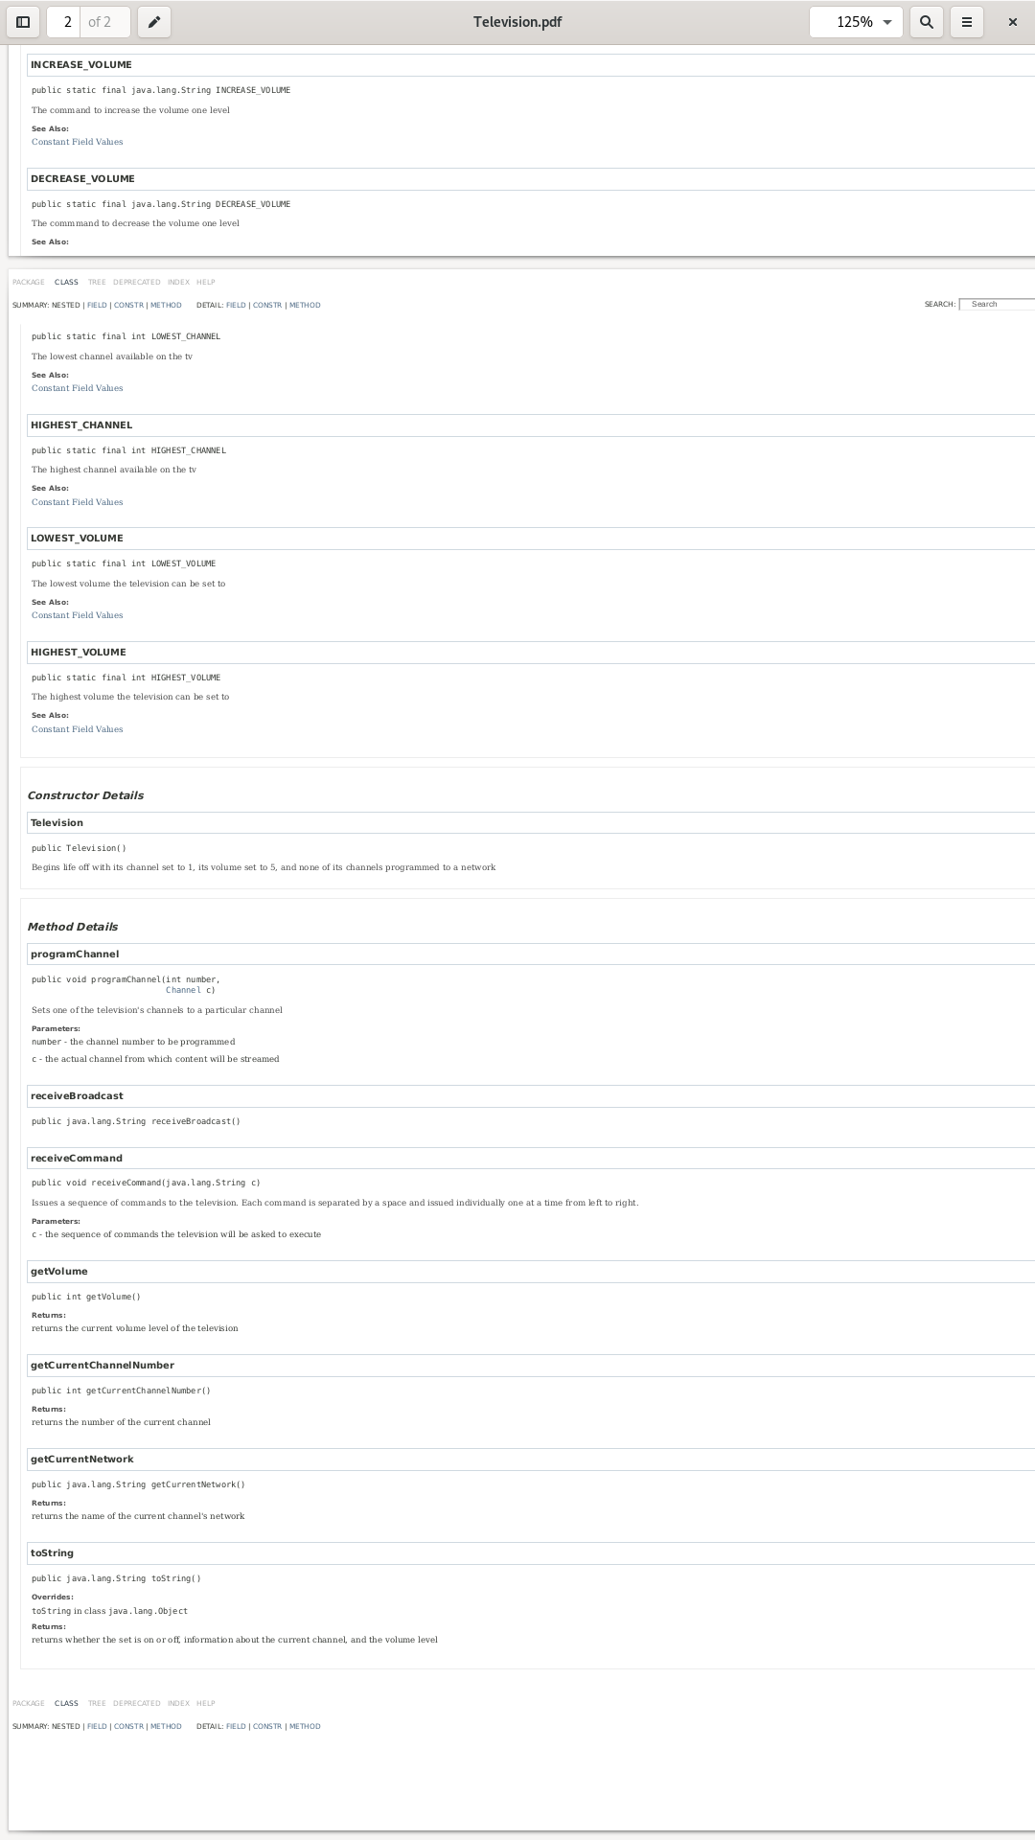
import java.util.Scanner;
import java.io.File;
import java.io.IOException;

public class Channel {
public Channel(String network) throws IOException{
this.name = network;
s = new Scanner(new File(network + ".txt"));
}

public String stream(){
String screen = GAUSSIAN_NOISE;

if(s.hasNext()){
screen = s.nextLine();
}

return screen;
}

public String getName(){
return name;
}

public String toString(){
return getName();
}

public static String GAUSSIAN_NOISE = "<GAUSSIAN STATIC>.34.2.92-23-92-935.25029sjlkgset39690)(%*)(^*@#(@)(^)(@#%)TLj..c...gdkgkjp[][ppppfj4309506390346t#%*(@)@(%(@)// fjkalsf;lsksjflkslskkdfjsk...<NO BROADCAST>";
private Scanner s;
private String name;
}

import java.io.IOException;

public class LivingRoom{
public static void main(String [] args) throws IOException{
Television tv = new Television();
Remote remote = new Remote(tv);

Channel nbc = new Channel("nbc");
Channel mtv = new Channel("mtv");
Channel abc = new Channel("abc");

tv.programChannel(1, nbc);
tv.programChannel(3, mtv);

remote.programButton(1, Television.TURN_ON);
remote.programButton(2, Television.TURN_OFF);
remote.programButton(3, Television.UP_ONE_CHANNEL);
remote.programButton(4, Television.DOWN_ONE_CHANNEL);
remote.programButton(5, Television.INCREASE_VOLUME);
remote.programButton(6, Television.DECREASE_VOLUME);

String maxVolumeCommandScript = "";

for(int i = 0; i < Television.HIGHEST_VOLUME; i++){
maxVolumeCommandScript += (Television.INCREASE_VOLUME + " ");
}

remote.programButton(7, maxVolumeCommandScript);
System.out.println(remote.getButtonCommandScript(7));

String muteCommandScript = "";

for(int i = 0; i < Television.HIGHEST_VOLUME; i++){
muteCommandScript += (Television.DECREASE_VOLUME + " ");
}

remote.programButton(8, muteCommandScript);
System.out.println(remote.getButtonCommandScript(8));

System.out.println(tv);

remote.press(1);
remote.press(3);
remote.press(3);
remote.press(7);

System.out.println(tv);

System.out.println(tv.receiveBroadcast());
System.out.println(tv.receiveBroadcast());

remote.press(3);
remote.press(3);
remote.press(3);

System.out.println(tv);

System.out.println(tv.receiveBroadcast());
System.out.println(tv.receiveBroadcast());

remote.press(3);
System.out.println(tv);
System.out.println(tv.receiveBroadcast());
}
}

public class Remote{
public Remote(Television tv){
this.tv = tv;
}

public void press(int buttonNumber){
switch(buttonNumber){
case 1:
tv.receiveCommand(button1);
break;
case 2:
tv.receiveCommand(button2);
break;
case 3:
tv.receiveCommand(button3);
break;
case 4:
tv.receiveCommand(button4);
break;
case 5:
tv.receiveCommand(button5);
break;
case 6:
tv.receiveCommand(button6);
break;
case 7:
tv.receiveCommand(button7);
break;
case 8:
tv.receiveCommand(button8);
break;
}
}

public void programButton(int buttonNumber, String command){
switch(buttonNumber){
case 1:
button1 = command;
break;
case 2:
button2 = command;
break;
case 3:
button3 = command;
break;
case 4:
button4 = command;
break;
case 5:
button5 = command;
break;
case 6:
button6 = command;
break;
case 7:
button7 = command;
break;
case 8:
button8 = command;
break;
}
}

public String getButtonCommandScript(int buttonNumber){
String commandScript = "";

switch(buttonNumber){
case 1:
commandScript = button1;
break;
case 2:
commandScript = button2;
break;
case 3:
commandScript = button3;
break;
case 4:
commandScript = button4;
break;
case 5:
commandScript = button5;
break;
case 6:
commandScript = button6;
break;
case 7:
commandScript = button7;
break;
case 8:
commandScript = button8;
break;
}

return commandScript;
}

public String toString(){
String strRemote = "";

strRemote += ("button1: " + button1);
strRemote += ("button2: " + button2);
strRemote += ("button3: " + button3);
strRemote += ("button4: " + button4);
strRemote += ("button5: " + button5);
strRemote += ("button6: " + button6);
strRemote += ("button7: " + button7);
strRemote += ("button8: " + button8);

return strRemote;
}

private String button1;
private String button2;
private String button3;
private String button4;
private String button5;
private String button6;
private String button7;
private String button8;

private Television tv;
}

public class Television{

public Television(){
isOn = false;
currentChannel = 1;
volume = 5;
}

public void programChannel(int number, Channel c){
switch(number){
case 1:
c1 = c;
break;
case 2:
c2 = c;
break;
case 3:
c3 = c;
break;
case 4:
c4 = c;
break;
case 5:
c5 = c;
break;
default:
c5 = c;
}
}

private void increaseVolume(){
if(volume < HIGHEST_VOLUME){
volume++;
}
}

private void decreaseVolume(){
if(volume > LOWEST_VOLUME){
volume--;
}
}

private void upOneChannel(){
if(currentChannel < HIGHEST_CHANNEL){
currentChannel++;
} else {
currentChannel = LOWEST_CHANNEL;
}
}

private void downOneChannel(){
if(currentChannel > LOWEST_CHANNEL){
currentChannel--;
} else {
currentChannel = HIGHEST_CHANNEL;
}
}

public String receiveBroadcast(){
String stream = "<Tv is off>";

if(isOn){
if(getCurrentChannel() != null){
stream = getCurrentChannel().stream();
} else{
stream = Channel.GAUSSIAN_NOISE;
}
}

return stream;
}

private Channel getCurrentChannel(){

Channel channelToReturn = null;

switch(currentChannel){
case 1:
channelToReturn = c1;
break;
case 2:
channelToReturn = c2;
break;
case 3:
channelToReturn = c3;
break;
case 4:
channelToReturn = c4;
break;
case 5:
channelToReturn = c5;
break;
}

return channelToReturn;
}

private void dispatchCommand(String c){
switch(c){
case TURN_ON:
turnOn();
break;
case TURN_OFF:
turnOff();
break;
case UP_ONE_CHANNEL:
upOneChannel();
break;
case DOWN_ONE_CHANNEL:
downOneChannel();
break;
case INCREASE_VOLUME:
increaseVolume();
break;
case DECREASE_VOLUME:
decreaseVolume();
break;
}
}

private void turnOn(){
isOn = true;
}

private void turnOff(){
isOn = false;
}

public void receiveCommand(String c){
if(isOn){

String [] splitted = c.split(" ");

for(int i = 0; i < splitted.length; i++){
dispatchCommand(splitted[i]);
}

} else{

if(c.equals("turnOn")){
dispatchCommand(c);
}

}
}

public int getVolume(){
return volume;
}

public int getCurrentChannelNumber(){
return currentChannel;
}

public String getCurrentNetwork(){
return getCurrentChannel().getName();
}

public String toString(){
String str = "";

str += ("\nSet: " + (isOn ? "On" : "Off") + "\n");
str += ("Channel " + getCurrentChannelNumber() + ": " + getCurrentChannel() + "\n");
str += ("Volume: " + getVolume() + "\n\n");

return str;
}

public static final String TURN_ON = "turnOn";
public static final String TURN_OFF = "turnOff";
public static final String UP_ONE_CHANNEL = "upOneChannel";
public static final String DOWN_ONE_CHANNEL = "downOneChannel";
public static final String INCREASE_VOLUME = "increaseVolume";
public static final String DECREASE_VOLUME = "decreaseVolume";

public static final int LOWEST_CHANNEL = 1;
public static final int HIGHEST_CHANNEL = 5;
public static final int LOWEST_VOLUME = 0;
public static final int HIGHEST_VOLUME = 10;

private Channel c1;
private Channel c2;
private Channel c3;
private Channel c4;
private Channel c5;

private boolean isOn;
private int volume;
private int currentChannel;

}
Text Files
Each block is its own file,
the name of the file at the top of each block is not part of the file

vh1.txt:

vh1 signal 1
vh1 signal 2
vh1 signal 3
vh1 signal 4
vh1 signal 5
vh1 signal 6
vh1 signal 7
vh1 signal 8
vh1 signal 9
vh1 signal 10

cmt.txt:

cmt signal 1
cmt signal 2
cmt signal 3
cmt signal 4
cmt signal 5
cmt signal 6
cmt signal 7
cmt signal 8
cmt signal 9
cmt signal 10

cnn.txt:

cnn signal 1
cnn signal 2
cnn signal 3
cnn signal 4
cnn signal 5
cnn signal 6
cnn signal 7
cnn signal 8
cnn signal 9
cnn signal 10

cn.txt:

cn signal 1
cn signal 2
cn signal 3
cn signal 4
cn signal 5
cn signal 6
cn signal 7
cn signal 8
cn signal 9
cn signal 10

hbo.txt:

hbo signal 1
hbo signal 2
hbo signal 3
hbo signal 4
hbo signal 5
hbo signal 6
hbo signal 7
hbo signal 8
hbo signal 9
hbo signal 10

tbs.txt:

tbs signal 1
tbs signal 2
tbs signal 3
tbs signal 4
tbs signal 5
tbs signal 6
tbs signal 7
tbs signal 8
tbs signal 9
tbs signal 10

mtv.txt:

mtv signal 1
mtv signal 2
mtv signal 3
mtv signal 4
mtv signal 5
mtv signal 6
mtv signal 7
mtv signal 8
mtv signal 9
mtv signal 10

nbc.txt:

nbc signal 1
nbc signal 2
nbc signal 3
nbc signal 4
nbc signal 5
nbc signal 6
nbc signal 7
nbc signal 8
nbc signal 9
nbc signal 10

qvc.txt:

qvc signal 1
qvc signal 2
qvc signal 3
qvc signal 4
qvc signal 5
qvc signal 6
qvc signal 7
qvc signal 8
qvc signal 9
qvc signal 10

abc.txt:

abc signal 1
abc signal 2
abc signal 3
abc signal 4
abc signal 5
abc signal 6
abc signal 7
abc signal 8
abc signal 9
abc signal 10

cbs.txt:

cbs signal 1
cbs signal 2
cbs signal 3
cbs signal 4
cbs signal 5
cbs signal 6
cbs signal 7
cbs signal 8
cbs signal 9
cbs signal 10

cc.txt:

cc signal 1
cc signal 2
cc signal 3
cc signal 4
cc signal 5
cc signal 6
cc signal 7
cc signal 8
cc signal 9
cc signal 10

