ME400 - Computer Applications in Mechanical Engineering

Project #2 Option 2

Instructions:
Complete each of the following steps. When you have completed all steps assigned, upload the files associated with the project on Canvas. Make sure the filenames you upload as part of your project submission have the exact names specified in each step of the project. If the filenames do not match exactly, then your project submission will not be graded.

Ultrasonic Sensors:
Ultrasound is high-pitched sound waves with frequencies higher than the audible limit of human hearing.
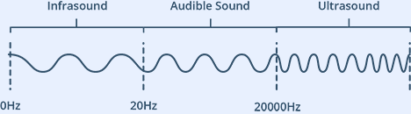
Human ears can hear sound waves that vibrate in the range from about 20 times a second (a deep rumbling noise) to about 20,000 times a second (a high-pitched whistling). However, ultrasound has a frequency of over 20,000 Hz and is therefore inaudible to humans.
At its core, the HC-SR04 Ultrasonic distance sensor consists of two ultrasonic transducers. One acts as a transmitter which converts electrical signal into 40 KHz ultrasonic sound pulses. The other acts as a receiver that listens for the transmitted pulses. If it receives the pulses, then it produces an output pulse whose width can be used to determine the distance the pulse travelled.
The HC-SR04 sensor is small and easy to use in robotics project.
- It offers excellent non-contact range detection between 2 cm to 400 cm
- It has an accuracy of 3mm (My testing does not support this claim).
- It has a resolution of approximately 3mm.
- It operates on 5 volts and can be powered by directly connecting to the 5V source on our microcontroller.
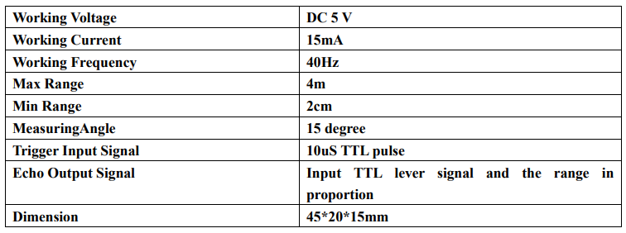
The process of measuring distance works as follows:
- A pulse of at least 10 µS in duration is sent to the Trigger pin.
- The sensor responds by transmitting a sonic burst of eight pulses at 40 KHz.
- This 8-pulse pattern makes the “ultrasonic signature” from the device unique, allowing the receiver to differentiate the transmitted pattern from the ambient ultrasonic noise.
- The eight ultrasonic pulses travel through the air away from the transmitter.
- When this signal is sent the echo pin is automatically set to HIGH to process the signal that is echoed back to the sensor.
If pulses are reflected back, then the echo pin goes LOW as soon as the signal is received. This produces a pulse whose width varies between 150 µS to 25 mS, depending upon the time it took for the signal to be received. The width of the received pulse is then used to calculate the distance to the reflected object.
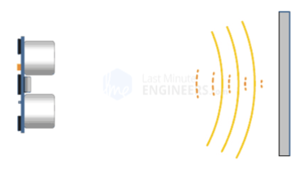

Option Requirements:
In this option, the robot will use the ultrasonic sensor as a feedback device while it moves. Unlike the final navigation option, the target will remain in place and may be measured repeatedly. The robot will therefore be able to correct its direction as it approaches the target.
The basic process is to locate the target, determine whether it is to the left or right of the robot, rotate toward the target, move forward a limited distance, stop, and measure the target again. This process is repeated until the robot reaches the required stopping distance.
For Option 2 implement code that seeks the target. The details associated with this implementation are listed below:
- Implement code that ensures that Option 2 cannot be selected until the straight-line motor control functionality developed in Option 1 has been completed.
- The existing code calls a function Option2() when Option 2 is executed. Implement your code within this function. Note: You are highly encouraged to break the code up for this option into several functions and call this code from your implementation in the function Option2(). Placing all of your functionality in Option2() without the use of supporting functions is considered bad coding practice and you will receive a deduction if you implement your code in this matter.
- When Option 2 is selected, immediately update the TFT to indicate that the robot is preparing to seek a target. The TFT display should display exactly as shown below.

PREPARING
TO
ACQUIRE
TARGET

- Use the pan servo and ultrasonic sensor to search for the target. The target will be positioned within the operating region specified by the instructor.
- Determine the direction of the target relative to the centerline of the robot and determine the measured distance to the target. A target located directly in front of the robot should have a target angle of 90 degrees. Update the TFT to display the target angle and distance as follows:

TARGET DIST
98 CM
TARGET ANGLE
47 DEGREES

- If the target is not centered within plus or minus 10 degrees, rotate the robot toward the target using differential drive. One motor should rotate forward while the other rotates in reverse when an in-place turn is required.
- Use the encoder signals to monitor wheel motion while the robot turns. Use the motor-control techniques developed in Option 1 to command the two motors. Perform all in-place rotational movements at a motor duty cycle of 30%. Monitor both encoder signals while the robot turns and use the encoder counts to determine the motion of each wheel.
- Once the target is approximately centered, command the robot to move forward a limited distance. It is up to you to determine an appropriate forward travel increment based on the measured distance to the target. The travel increment should decrease as the robot approaches the target to prevent the robot from overshooting the required stopping distance. Monitor both encoders while the robot moves and correct for unequal wheel motion as required.
- Stop the robot after each movement increment and repeat the ultrasonic measurement. Do not simply command the robot to drive continuously toward the target without periodically remeasuring the target position. Update the TFT with the updated target angle and distance as shown below:

TARGET DIST
98 CM
TARGET ANGLE
47 DEGREES

- Continue the measure-turn-move-measure process until the ultrasonic sensor indicates that the robot is within 2 cm of the target. Stop both motors at this point and allow your instructor to measure the robot's final position. The ultrasonic sensor measurement, rather than the wheel encoder measurements, should be used to determine when the final target distance has been reached.
- At any time while the robot is moving, pressing the RETURN button on the IR remote should immediately stop both motors and return to the main menu.
- Once the instructor has verified the robot's final position and recorded any pertinent information displayed on the TFT screen, pressing the RETURN button (i.e., double-arrow key) on the IR remote should redisplay the main menu.

