ME400 - Computer Applications in Mechanical Engineering

Project #2 Option 3

Instructions:
Complete each of the following steps. When you have completed all steps assigned, upload the files associated with the project on Canvas. Make sure the filenames you upload as part of your project submission have the exact names specified in each step of the project. If the filenames do not match exactly, then your project submission will not be graded.

Option Background:
A servo motor is a self-contained electrical device, that rotates parts of a machine with high efficiency and with great precision. They are used in 3D printers, CNC machines, etc.
- The Servo Motor utilizes a regular motor coupled with a sensor for positional feedback.
- The output shaft of this motor can be moved to a particular angle/position with a precision that cannot be obtained using a regular motor.
- A servo does not typically rotate more than one turn. In fact, most will only rotate between an angle of 0 and 180 degrees.
To move a servo to a specific angle a single pulse is sent over the control wire (i.e., the orange wire).
- The angle is determined by the duration of a pulse that is applied to the control wire. This is called Pulse Width Modulation.
- The servo expects to see a pulse every 20 milliseconds. The length of the pulse determines how far the motor turns.
- A 1.5 millisecond pulse, for example, makes the motor turn to the 90-degree position (often called as the neutral position).
- If the pulse is shorter than 1.5 milliseconds, then the motor will turn the shaft closer to 0 degrees.
- If the pulse is longer than 1.5 milliseconds, the shaft turns closer to 180 degrees.

Ultrasonic Sensors:
Ultrasound is high-pitched sound waves with frequencies higher than the audible limit of human hearing.
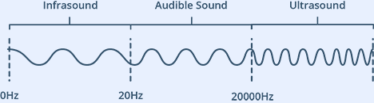
Human ears can hear sound waves that vibrate in the range from about 20 times a second (a deep rumbling noise) to about 20,000 times a second (a high-pitched whistling). However, ultrasound has a frequency of over 20,000 Hz and is therefore inaudible to humans.
At its core, the HC-SR04 Ultrasonic distance sensor consists of two ultrasonic transducers. One acts as a transmitter which converts electrical signal into 40 KHz ultrasonic sound pulses. The other acts as a receiver that listens for the transmitted pulses. If it receives the pulses, then it produces an output pulse whose width can be used to determine the distance the pulse travelled.
The HC-SR04 sensor is small and easy to use in robotics projects.
- It offers excellent non-contact range detection between 2 cm to 400 cm
- It has an accuracy of 3mm (My testing does not support this claim).
- It has a resolution of approximately 3mm.
- It operates on 5 volts and can be powered by directly connecting to the 5V source on our microcontroller.
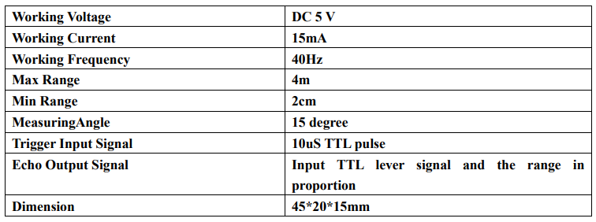
The process of measuring distance works as follows:
- A pulse of at least 10 µS in duration is sent to the Trigger pin.
- The sensor responds by transmitting a sonic burst of eight pulses at 40 KHz.
- This 8-pulse pattern makes the “ultrasonic signature” from the device unique, allowing the receiver to differentiate the transmitted pattern from the ambient ultrasonic noise.
- The eight ultrasonic pulses travel through the air away from the transmitter.
- When this signal is sent the echo pin is automatically set to HIGH to process the signal that is echoed back to the sensor.
If pulses are reflected back, then the echo pin goes LOW as soon as the signal is received. This produces a pulse whose width varies between 150 µS to 25 mS, depending upon the time it took for the signal to be received. The width of the received pulse is then used to calculate the distance to the reflected object.
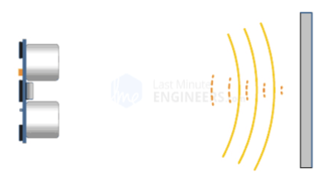

Option Requirements:
For Option 3 implement code that performs a radar sweep to locate a target positioned within 120 centimeters of the robot. The program must determine the direction and distance to the target so this information can be used by Option 4. The details associated with this implementation are listed below:
- Modify your implementation in the setup() function Implement code in the setup() routine to set the pan servo to 90 degrees and the tilt servo such that the ultrasonic sensor is parallel with the surface of the floor. If this does not position the pan/tilt assembly such that the ultrasonic sensor is centered from right to left, then adjust the servo arms such this is the resulting positioning. Note: The ultrasonic sensor should be mounted on the pan/tilt mechanism perpendicular to the platform of the pan/tilt mechanism.
- The existing code calls a function Option3() when Option 3 is executed. Implement your code within this function. Note: You are highly encouraged to break the code up for this option into several functions and call this code from your implementation in the function Option3(). Placing all of your functionality in Option3() without the use of supporting functions is considered bad coding practice and you will receive a deduction if you implement your code in this matter.
- For the competition portion of the project, you will need to position the robot at the marked starting location before accessing this option. The robot must remain stationary throughout execution of the code in this option.
- Setup code so that when Option 3 is selected the screen displays the following text for displaying the servo angle and the distance returned from the ultrasonic sensor along with a radar screen to the TFT display as follows (Must be displayed in landscape):
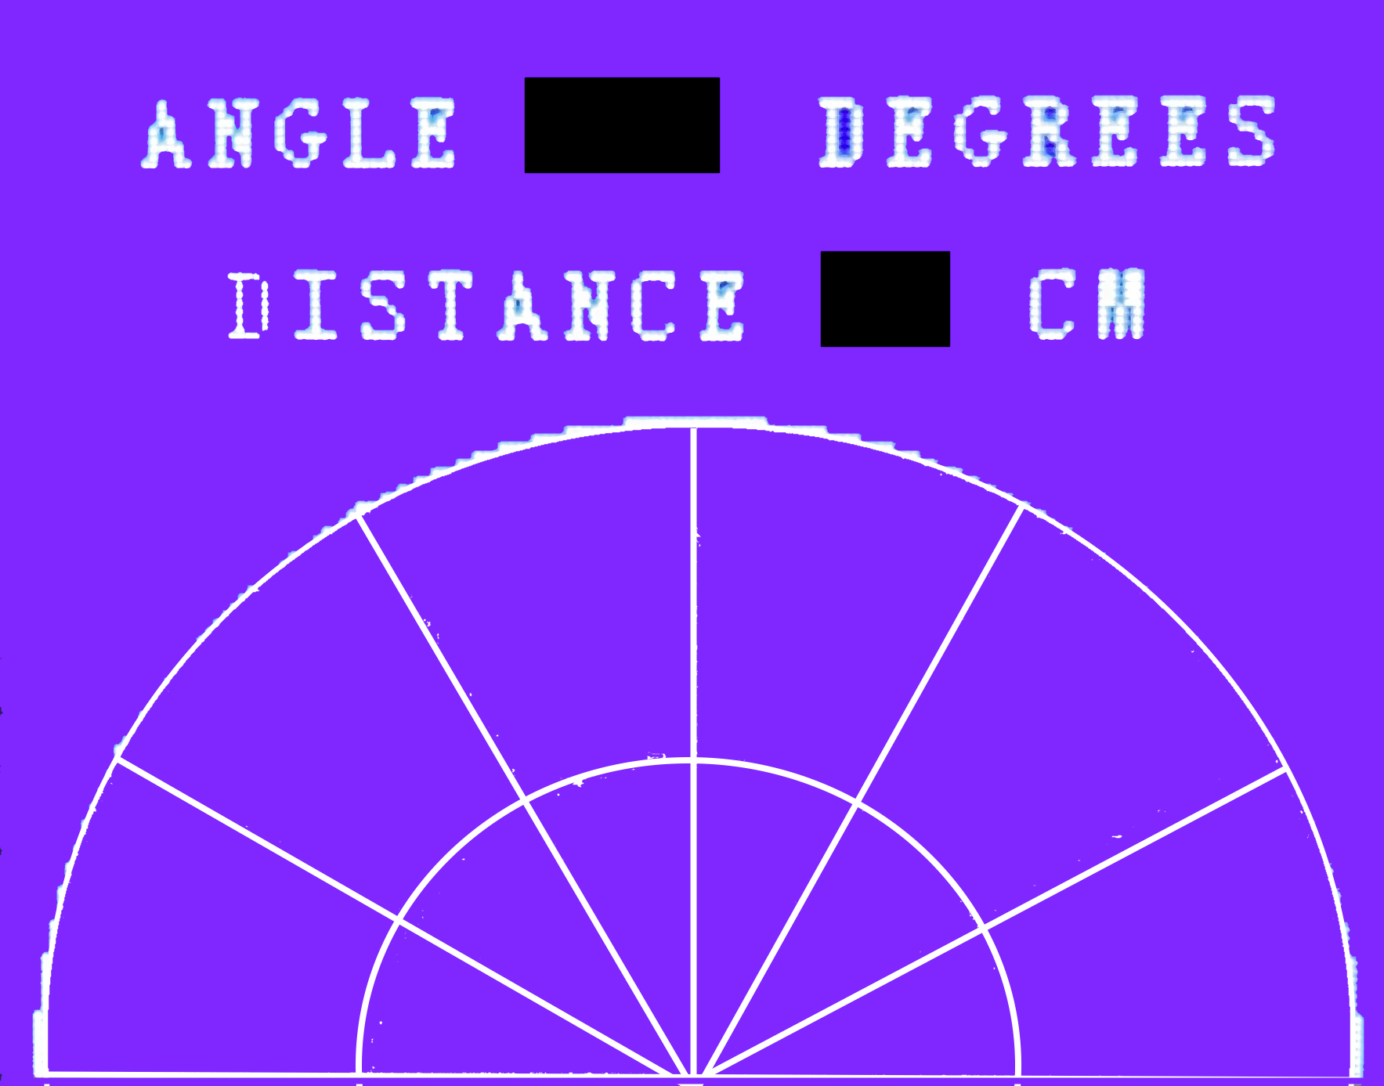
- Swing the pan servo from the 15 to 165 degrees in two degree increments and then from 165 to 15 degrees in one-degree increments. To move the servo to a specific angle use the servowrite() function. It accepts two integer arguments. The first argument represents the pin on which the signal to the servo is generated, and the second argument represents the angle to move the servo to in degrees. The implementation of the servowrite() function is already included in your code, but is provided below to illustrate the functionality used to move a servo to a specific angle (DO NOT USE the ESP32Servo library or any other servo manipulation library in your implementation. Doing so will result in a large deduction and may cause problems when implemented with the other options required in your implementation):
void servowrite(int pin, int angle, int numpulses)
{
// Move servo attached to pin to the specified angle.
// The numpulses shoul be set to approximately 3 for
// an angular movement of 2 or less degrees. For a large
// angular change numpulses should be set to 10.
// Set the pulse height in microseconds associated
// with the servo angles of 0 and 180 degrees
int microzero=500;
int micro180=2400;
int lenMicroSecondsOfPeriod = 20 * 1000; // 20ms period
// Map the correct pulse width in microseconds to the desired angle
int lenMicroSecondsOfPulse = map(angle, 0, 180, microzero, micro180);
// Loop long enough for servo to see enough of waveform to fully
// move to the new position.
for (int i = 0; i< numpulses; i++){
// Servos work by sending a 20 ms pulse.
// a 1.0 ms pulse turns the servo to the 0 degree position
// a 1.5 ms pulse turns the servo to the 90 degree position
// a2.0 ms pulse will turns the servo to the 180 degree position
// Turn voltage high to start the 20ms period and required pulse
digitalWrite(pin, HIGH);
// Delay for the length of the pulse (i.e., between 1 and 2 ms)
delayMicroseconds(lenMicroSecondsOfPulse);
// Turn the voltage low to end the pulse
digitalWrite(pin, LOW);
// Delay this loop for the remainder of the period so we don't
// send the next signal with in the 20ms period.
delayMicroseconds(lenMicroSecondsOfPeriod - lenMicroSecondsOfPulse);
}
}
Please review the comments in this function and review the background section. This should allow you to discern how the pulse necessary to move a servo to a specific angle is generated.
- At every degree increment use the ultrasonic sensor to measure the distance to the nearest object in centimeters. If the distance is greater than 120 centimeters, then set the distance to 120 centimeters. The distance can be measured by calling the calculateDistance() function. This function is already included in the code provided, but is listed below to illustrate the underlying functionality:
//
// Function for calculating the distance measured by the Ultrasonic sensor
//
int calculateDistance(int tPin, int ePin){

digitalWrite(tPin, LOW);
delayMicroseconds(2);
// Sets the trigPin on HIGH state for 10 micro seconds
digitalWrite(tPin, HIGH);
delayMicroseconds(10);
digitalWrite(tPin, LOW);
duration = pulseIn(ePin, HIGH, 15000); // Reads the echoPin, returns the sound wave travel time in microseconds
distance= duration*0.034/2;
return distance;
}
The two arguments represent the trigger and echo pins attached to the ultrasonic sensor. The pin tPin is physically connected to digital pin 38 and ePin is physically connected to digital pin 37 in your setup.
- The distance returned in Step 6 is between 0 and 120. Scale this distance to a value between 0 and r where r represents the inner edge of outer radar circle. At every degree increment draw a ray from the center of the radar circle to the border of the outer radar circle. The portion of the ray that is greater than the scaled distance returned from the ultrasonic sensor should be drawn in red. The portion less than the scaled distance should be drawn in blue. The resulting radar sweep should display as follows:
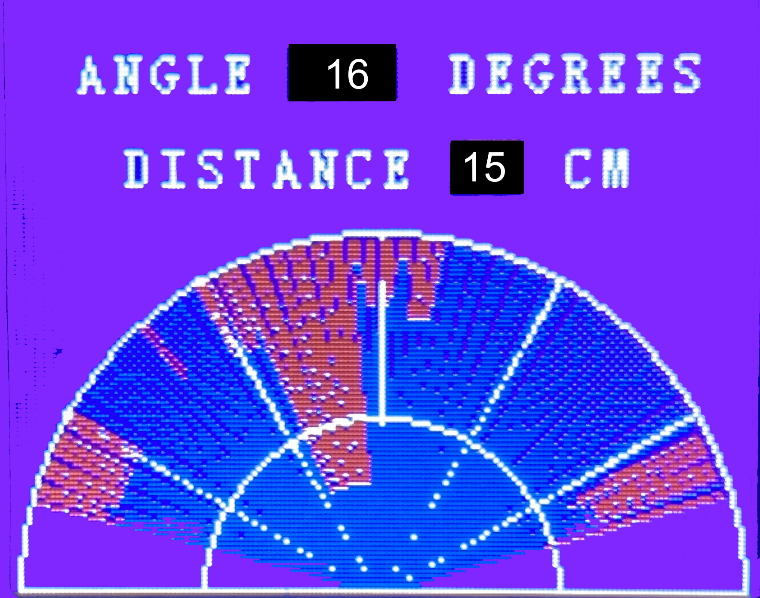
Note: For help with drawing the lines and circles refer to the documentation for the TFT_eSPI class. In particular, you must use the drawLine and drawCircle methods to implement the radar screen. These are the only drawing commands you are allowed to use when implementing this functionality.
- For the radar output make sure the inner circle and outer radar circle remain intact. The radar screen should also update the angle and distance for each degree interval and the radar display should clear when switching from 15 to 165-degree swing to the 165 to 15-degree swing.
- As the pan servo swings from 15 to 165 degrees, analyze the ultrasonic sensor measurements to identify the group of adjacent measurements associated with the target closest to the robot. Do not simply use the single minimum-distance measurement to determine the target location. Your group must develop an algorithm that uses the group of measurements associated with the target to estimate the center angle and distance to the target. Store the resulting angle and distance as the forward-sweep target angle,$θ_{f}$, and forward-sweep target distance${,d}_{f}$.
- Repeat the target-detection process as the pan servo swings from 165 to 15 degrees. Independently determine the center angle and distance to the target using the measurements obtained during this sweep. Store the resulting values as the reverse-sweep target angle, $θ_{r}$, and reverse-sweep target distance, ${,d}_{r}$.
- After both sweeps have been completed, calculate the final target angle by averaging the target angles determined from the forward and reverse sweeps:
$$θ_{target}=\frac{θ_{f}+θ_{r}}{2}$$
Calculate the final target distance by averaging the target distances determined from the forward and reverse sweeps:
$$d_{target}=\frac{d_{f}+d_{r}}{2}$$
The final target angle should use the same coordinate system as the pan servo and radar display. A target located directly in front of the robot should have a target angle of 90 degrees. The physical movement of the servo from left to right should correspond to movement of the radar display from left to right. Store the final target angle and target distance in global variables so they remain available after Option 3 returns to the main menu..
- Once the pan servo has completed a complete sweep in both directions and the final target angle and target distance have been calculated, display the estimated target angle and target distance on the TFT screen as shown below:

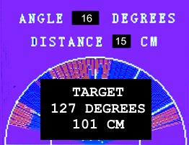
- If a valid target is not detected during both sweeps, display TARGET NOT FOUND, do not update the stored target direction or distance, and do not enable Option 4.
- Implement code so that pressing the return button (i.e double arrow key) on the remote returns to the main menu.

