Unit-1 Introduction:
WHAT IS DATA STRUCTURE?
In computer science, a data structure is a way of organizing and storing data in a computer program so that it can be accessed and used efficiently. Data structures provide a means of managing large amounts of data, enabling efficient searching, sorting, insertion and deletion of data.

Data structures can be categorized into two types: Primitive data structures and non- primitive data structures.

Primitive data structures are the most basic data structures available in a programming language, such as integers, floating-point numbers, characters and Booleans.
Non-primitive data structures are complex data structures that are built using primitive data types, such as arrays, linked lists, stacks, queues, trees, graphs and hash tables.
The choice of data structure for a particular task depends on the type and amount of data to be
processed, the operations that need to be performed on the data and the efficiency requirements of the program. Efficient use of data structures can greatly improve the performance of a program, making it faster and more memory-efficient. A data structure is a particular way of organizing data in a computer so that it can be used effectively. The idea is to reduce the space and time complexities of different tasks.
The choice of a good data structure makes it possible to perform a variety of critical operations effectively. An efficient data structure also uses minimum memory space and execution time to process the structure.

Data Structure is a systematic way to organize data in order to use it efficiently. Following terms are the foundation terms of a data structure.
- Interface − Each data structure has an interface. Interface represents the set of operations that a data structure supports. An interface only provides the list of supported operations, type of parameters they can accept and return type of these operations.

- Implementation − Implementation provides the internal representation of a data structure. Implementation also provides the definition of the algorithms used in the operations of the data structure.

Characteristics of a Data Structure
- Correctness − Data structure implementation should implement its interface correctly.
- Time Complexity − Running time or the execution time of operations of data structure must be as small as possible.
- Space Complexity − Memory usage of a data structure operation should be as little as possible.

Need for Data Structure
As applications are getting complex and data rich, there are three common problems that applications face now-a-days.
- Efficient data processing: Data structures provide a way to organize and store data in a way that allows for efficient retrieval, manipulation and storage of data. For example, using a hash table to store data can provide constant-time access to data.
- Memory management: Proper use of data structures can help to reduce memory usage and
optimize the use of resources. For example, using dynamic arrays can allow for more efficient use of memory than using static arrays.
- Code reusability: Data structures can be used as building blocks in various algorithms and programs, making it easier to reuse code.
- Abstraction: Data structures provide a level of abstraction that allows programmers to focus on the logical structure of the data and the operations that can be performed on it, rather than on the details of how the data is stored and manipulated.
- Algorithm design: Many algorithms rely on specific data structures to operate efficiently. Understanding data structures is crucial for designing and implementing efficient algorithms.
- Data Search − Consider an inventory of 1 million (106) items of a store. If the application is to search an item, it has to search an item in 1 million (106) items every time slowing down the search. As data grows, search will become slower.

- Processor Speed − Processor speed although being very high, falls limited if the data grows to billion records.
- Multiple Requests − As thousands of users can search data simultaneously on a web server, even the fast server fails while searching the data.

Importance of Data Structures in Programming
  - Efficient data access and manipulation: Data structures enable quick access and manipulation of data. For example, an array allows constant-time access to elements using their index, while a hash table allows fast access to elements based on their key. Without data structures, programs would have to search through data sequentially, leading to slow performance.
  - Memory management: Data structures allow efficient use of memory by allocating and deallocating memory dynamically. For example, a linked list can dynamically allocate memory for each element as needed, rather than allocating a fixed amount of memory upfront. This helps avoid memory wastage and enables efficient memory management.
  - Code reusability: Data structures can be reused across different programs and projects. For example, a generic stack data structure can be used in multiple programs that require LIFO (Last-In-First-Out) functionality, without having to rewrite the same code each time.
  - Optimization of algorithms: Data structures help optimize algorithms by enabling efficient data access and manipulation. For example, a binary search tree allows fast searching and insertion of elements, making it ideal for implementing searching and sorting algorithms.
  - Scalability: Data structures enable programs to handle large amounts of data effectively. For example, a hash table can store large amounts of data while providing fast access to elements based on their key.

Basic Terminology
  - Data − Data are values or set of values.
  - Data Item − Data item refers to single unit of values.
  - Group Items − Data items that are divided into sub items are called as Group Items.
  - Elementary Items − Data items that cannot be divided are called as Elementary Items.
  - Attribute and Entity − An entity is that which contains certain attributes or properties, which may be assigned values.
  - Entity Set − Entities of similar attributes form an entity set.
  - Field − Field is a single elementary unit of information representing an attribute of an entity.
  - Record − Record is a collection of field values of a given entity.
  - File − File is a collection of records of the entities in a given entity set.

Classification of Data Structures
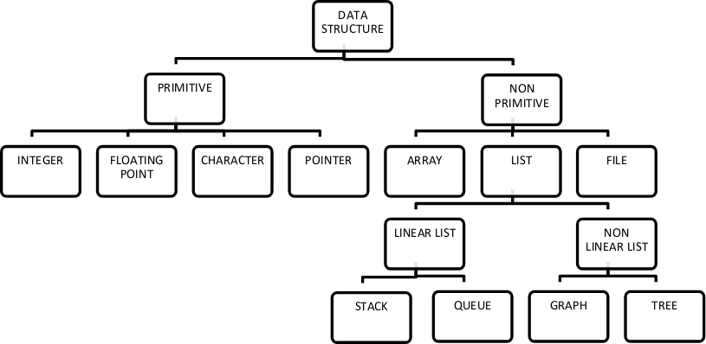

Data structures can broadly be classified into two main categories:
- Primitive Data Structures
Primitive data structures are the most basic types of data structures provided by programming languages. They include:
  - Integer: Whole numbers (e.g., 1, 2, 100).
  - Float: Numbers with decimal points (e.g., 3.14, 0.001).
  - Character: Single characters (e.g., ‘A’, ‘B’).
  - Boolean: Logical values (true or false).

Non-Primitive Data Structures
Non-primitive data structures are more complex and are built using primitive data types. They are further divided into:

Linear Data Structures
In linear data structures, elements are arranged sequentially, and each element has a unique predecessor and successor (except the first and last elements).
  - Array: A collection of elements of the same type, stored in contiguous memory locations.
  - Linked List: A collection of nodes where each node contains data and a pointer to the next node.
  - Stack: A collection of elements following the Last In First Out (LIFO) principle.
  - Queue: A collection of elements following the First In First Out (FIFO) principle.

Non-Linear Data Structures
In non-linear data structures, elements are not arranged sequentially but follow a hierarchical or interconnected structure.
  - Tree: A hierarchical structure where each node has a parent node and zero or more child nodes.
  - Graph: A set of nodes (vertices) connected by edges, representing relationships.

File Structures
Specialized data structures designed for storing data in secondary storage for efficient retrieval and updates. Examples include B-trees and hash files.

Applications of Data Structures:
Arrays: Arrays are used to store a collection of homogeneous elements contiguous memory locations. They are commonly used to implement other data structures, such as stacks and queues, and to represent matrices and tables.
Linked lists: Linked lists are used to store a collection of heterogeneous elements with dynamic memory allocation. They are commonly used to implement stacks, queues and hash tables.
Trees: Trees are used to represent hierarchical data structures, such as file systems, organization charts, and network topologies. Binary search trees are commonly used to implement dictionaries and symbol tables.
Graphs: Graphs are used to represent complex relationships between data elements, such as social networks, transportation networks and computer networks. They are commonly used to implement shortest path algorithms and graph traversal algorithms.
Hash tables: Hash tables are used to implement associative arrays, which store key-value pairs. They provide fast access to data elements based on their keys.

- Stacks: Stacks are used to store a collection of elements in a last-in-first-out (LIFO) order. They are commonly used to implement undo-redo functionality, recursive function calls and expression evaluation.
- Queues: Queues are used to store a collection of elements in a first-in-first-out (FIFO) order. They are commonly used to implement waiting lines, message queues and job scheduling.

Common operations on various Data Structures:
Data Structure is the way of storing data in computer’s memory so that it can be used easily and efficiently. There are different data-structures used for the storage of data. It can also be defined as a mathematical or logical model of a particular organization of data items. The representation of particular data structure in the main memory of a computer is called as storage structure.
For Examples: Array, Stack, Queue, Tree, Graph, etc.

Operations on different Data Structure:
There are different types of operations that can be performed for the manipulation of data in every data structure. Some operations are explained and illustrated below:

- Traversing: Traversing a Data Structure means to visit the element stored in it. It visits data in a systematic manner. This can be done with any type of DS.
- Searching: Searching means to find a particular element in the given data-structure. It is considered as successful when the required element is found. Searching is the operation which we can performed on data-structures like array, linked- list, tree, graph, etc.
- Insertion: It is the operation which we apply on all the data-structures. Insertion means to add an element in the given data structure. The operation of insertion is successful when the required element is added to the required data-structure. It is unsuccessful in some cases when the size of the data structure is full and when there is no space in the data-structure to add any additional element. The insertion has the same name as an insertion in the data-structure as an array, linked-list, graph, tree. In stack, this operation is called Push. In the queue, this operation is called Enqueue.

- Deletion: It is the operation which we apply on all the data-structures. Deletion means to delete an element in the given data structure. The operation of deletion is successful when the required element is deleted from the data structure. The deletion has the same name as a deletion in the data- structure as an array, linked-list, graph, tree, etc. In stack, this operation is called Pop. In Queue this operation is called Dequeue.
- Create: It reserves memory for program elements by declaring them. The creation of data structure can be done during
  - Compile-time
  - Run-time.
- Selection: It selects specific data from present data. You can select any specific data by giving condition in loop.
- Update: It updates the data in the data structure. You can also update any specific data by giving some condition in loop like select approach.
- Sort: Sorting data in a particular order (ascending or descending). We can take the help of many sorting algorithms to sort data in less time. Example: bubble sort which takes O (n^2) time to sort data. There are many algorithms present like merge sort, insertion sort, selection sort, quick sort, etc.
- Merge: Merging data of two different orders in a specific order may ascend or descend. We use merge sort to merge sort data.
- Split Data: Dividing data into different sub-parts to make the process complete in less time.

Algorithm Specifications:
What is an Algorithm? Algorithm Basics
The word Algorithm means” A set of finite rules or instructions to be followed in calculations or other problem-solving operations” or” A procedure for solving a mathematical problem in a finite number of steps that frequently involves recursive operations”. Therefore, Algorithm refers to a sequence of finite steps to solve a particular problem.

Use of the Algorithms:
Algorithms play a crucial role in various fields and have many applications. Some of the key areas where algorithms are used include:
Computer Science: Algorithms form the basis of computer programming and are used to solve problems ranging from simple sorting and searching to complex tasks such as artificial intelligence and machine learning.
Mathematics: Algorithms are used to solve mathematical problems, such as finding the optimal solution to a system of linear equations or finding the shortest path in a graph.
Operations Research: Algorithms are used to optimize and make decisions in fields such as transportation, logistics, and resource allocation.
Artificial Intelligence: Algorithms are the foundation of artificial intelligence and machine learning, and are used to develop intelligent systems that can perform tasks such as image recognition, natural language processing and decision-making.
Data Science: Algorithms are used to analyze, process, and extract insights from large amounts of data in fields such as marketing, finance and healthcare.
These are just a few examples of the many applications of algorithms. The use of algorithms is continually expanding as new technologies and fields emerge, making it a vital component of modern society.

Algorithms can be simple and complex depending on what you want to achieve.

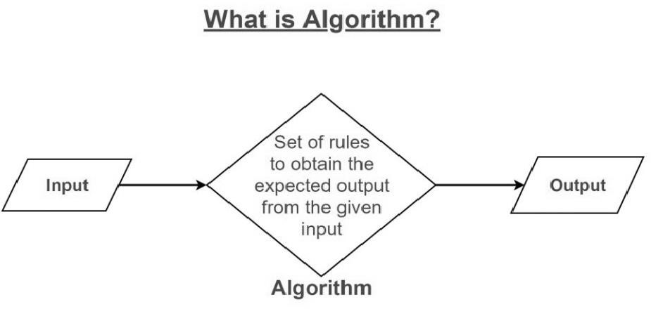
It can be understood by taking the example of cooking a new recipe. To cook a new recipe, one reads the instructions and steps and executes them one by one, in the given sequence. The result thus obtained is the new dish is coo ed perfectly. Every time you use your phone, computer, laptop or calculator you are using Algorithms. Similarly, algorithms help to do a task programming to get the expected output.
The Algorithm designed is language-independent, i.e. they are just plain instructions that can be implemented in any language, and yet the output will be the same, as expected.

What is the need for algorithms?
Algorithms are necessary for solving complex problems efficiently and effectively.
- They help to automate processes and make them more reliable, faster and easier to perform.
- Algorithms also enable computers to perform tasks that would be difficult or impossible for humans to do manually.
- They are used in various field such as mathematics, computer science, engineering, finance and 22many others to optimize cases, analyse data, make predictions and provide solutions to problems.

What are the characteristics of an Algorithm?
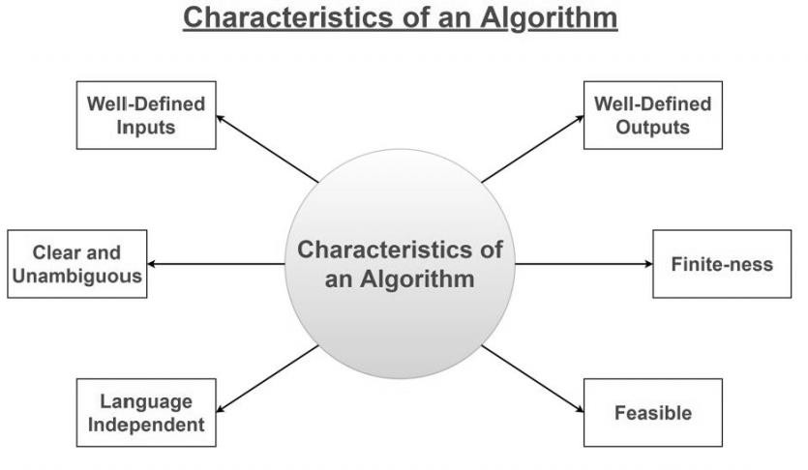

As one would not follow any written instructions to cook the recipe, but only the standard one. Similarly, not all written instructions for programming is an algorithm. In order for some instructions to be an algorithm, it must have the following characteristics:
  - Clear and Unambiguous: The algorithm should be clear and unambiguous. Each of its steps should be clear in all aspects and must lead to only one meaning.
  - Well-Defined Inputs: If an algorithm says to take inputs, it should be well- defined inputs. It may or may not take input.
  - Well-Defined Outputs: The algorithm must clearly define what output will be yielded and it should be well-defined as well. It should produce at least 1 output.
  - Feasible: The algorithm must be simple, generic, and practical, such that it can be executed with the available resources. It must not contain some future technology or anything.
  - Language Independent: The Algorithm designed must be language-independent,
i.e. it must be just plain instructions that can be implemented in any language, and yet the output will be the same, as expected.
  - Input: An algorithm has zero or more inputs. Each that contains a fundamental operator must accept zero or more inputs.
  - Output: An algorithm produces at least one output. Every instruction that contains a fundamental operator must accept zero or more inputs.
  - Definiteness: All instructions in an algorithm must be unambiguous, precise, and easy to interpret. By referring to any of the instructions in an algorithm one

can clearly understand what is to be done. Every fundamental operator in instruction must be defined without any ambiguity.
  - Finiteness: An algorithm must terminate after a finite number of steps in all test cases. Every instruction which contains a fundamental operator must be terminated within a finite amount of time. Infinite loops or recursive functions without base conditions do not possess finiteness.
  - Effectiveness: An algorithm must be developed by using very basic, simple, and feasible operations so that one can trace it out by using just paper and pencil.

Properties of Algorithm:
  - It should terminate after a finite time.
  - It should produce at least one output.
  - It should take zero or more input.
  - It should be deterministic means giving the same output for the same input case.
  - Every step in the algorithm must be effective i.e. every step should do some work.

Advantages of Algorithms:
- It is easy to understand.
- An algorithm is a step-wise representation of a solution to a given problem.
- In Algorithm the problem is broken down into smaller pieces or steps hence, it is easier for the programmer to convert it into an actual program.

Disadvantages of Algorithms:
- Writing an algorithm takes a long time so it is time-consuming.
- Understanding complex logic through algorithms can be very difficult.
- Branching and Looping statements are difficult to show in Algorithms.

How to Design an Algorithm?
In order to write an algorithm, the following things are needed as a pre-requisite:
- The problem that is to be solved by this algorithm i.e. clear problem definition.
- The constraints of the problem must be considered while solving the problem.
- The input to be taken to solve the problem.
- The output to be expected when the problem is solved.
- The solution to this problem, is within the given constraints.

How to express an Algorithm?
- Natural Language: Here we express the Algorithm in natural English language. It is too hard to understand the algorithm from it.
- Flow Chart: Here we express the Algorithm by making graphical/pictorial representation of it. It is easier to understand than Natural Language.
- Pseudo Code: Here we express the Algorithm in the form of annotations and informative text written in plain English which is very much similar to the real code but as it has no syntax like any of the programming language, it can’t be compiled or interpreted by the computer. It is the best way to express an algorithm because it can be understood by even a layman with some school level programming knowledge.

ARRAYS:
Definition- An array is a linear data structure that collects elements of the same data type and stores them in contiguous and adjacent memory locations

Types of arrays-
Array in Care of two types; Single dimensional arrays and Multidimensional arrays.
- Single Dimensional Arrays: Single dimensional array or 1-D array is the simplest form of arrays that can be found in C. This type of array consists of elements of similar types and these elements can be accessed through their
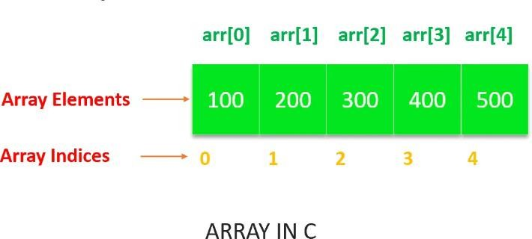
indices.

- Multi-dimensional Arrays: The most common type of multi-dimensional array that is used in the C language is a 2-D array. However, the number of dimensions can be more than 2 depending upon the compiler of the user’s system. These arrays consist of elements that are array themselves.

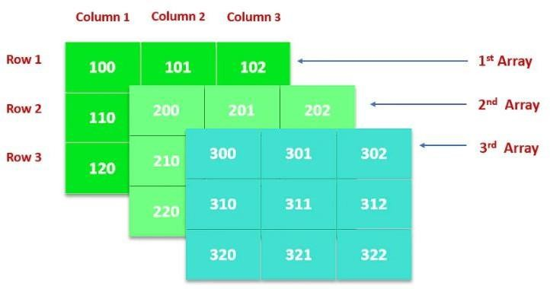

OPERATION ON ARRAYS
There are a number of operations that can be performed on an array which are:
- Traversal
- Sorting
- Insertion
- Deletion
- Searching
- Merging
Traversal: Traversal means accessing each array element for a specific purpose, either to perform an operation on them.
Sorting: It is a process of arranging the elements in the array.
Insertion: it is a process of adding a new element to the array in the specified location. Deletion: it is a process of removing an element from the array from the specified location.
Searching: it is a process of finding an element in an array
Merging: it is a process of combining the elements of two array.
ABSTRACT DATA TYPE(ADT): Abstract Data Type (ADT) is a data type, where only behaviour is defined but not implementation. Examples: Array, List, Queue, Stack, Tree are ADTs.

MEMORY REPRESENTATION

One dimensional array-
Let’s first declare and initialise an one-dimensional array num with 10 elements int num[] = {-3, 5, 12, 89, 91, 94, 23, 34, 45, 76};
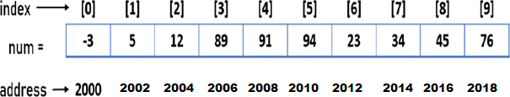

Memory Representation of an array with elements, address and indexes
Like other variables and constants an array also requires memory blocks to store the elements. An array is a collection of similar elements, so it requires contiguous memory blocks. Look at the image depicted above , at the bottom of the image the addresses of each elements are displayed. Now let’s understand the addressing and indexing of the num array.
Addressing- The type of num is int, so each elements of the num array will take 2 bytes of memory. For example, consider the starting address of first memory block is 2000. So the next elements of the array will get next contiguous 4 bytes memory block and the memory address will be 2002 (as 2000 + 2 bytes) and so on for other elements. In the above figure, the addresses are displayed here, are the starting address of each memory block assigned to individual element of the array.
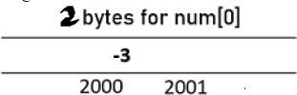

2 bytes memory block assigned to each element What is Indexing
Indexing is a process to get the location of an element in the array. So, when we write
num[0], it informs the compiler about the location of the first element.
In C, array indexing is started from 0 for the first element. So, 0 will be passed with subsscripting operator [ ], to access the first element of the array.

num[0] = 9; //it updates the value of first element
An index value must be greater than or equal to 0

num[-1] = 4; //an illegal; statement and raised to run-time error.
The highest index of an array is equal to size - 1, size is the number of elements in the array.

How to calculate the address of the 1D array
Address of A[i] = Base_Address + W(i – Lower_Bound)
Where Base Address is the address of the first element in an array.
W= is the weight (size) of a data type.
i = is the index of array element to be calculated.
Lower-bound= is the index of the first element.

Ex: Given an array int marks[] = {99,67,78,56,88,90,34,85}, calculate the address of marks[4] if the base address = 1000.
Solution :
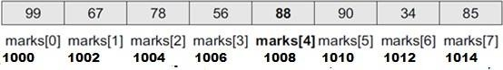
We know that storing an integer value requires 2 bytes, therefore, its size is 4 bytes.

Address of A[i] = Base Address + W(i - Lower_Bound)
Marks[4]=1000+2(4-0)

=1000+ 2(4)
= 1008 [Ans]

Data Structures - Searching Algorithms
In the previous section, we have discussed various Sorting Techniques and cases in which they can be used. However, the main idea behind performing sorting is to arrange the data in an orderly way, making it easier to search for any element within the sorted data.
Searching is a process of finding a particular record, which can be a single element or a small chunk, within a huge amount of data. The data can be in various forms: arrays, linked lists, trees, heaps, and graphs etc. With the increasing amount of data nowadays, there are multiple techniques to perform the searching operation.

Searching Algorithms in Data Structures
Various searching techniques can be applied on the data structures to retrieve certain data. A search operation is said to be successful only if it returns the desired element or data; otherwise, the searching method is unsuccessful.
There are two categories these searching techniques fall into. They are −
- Sequential Searching
- Interval Searching

Sequential Searching
As the name suggests, the sequential searching operation traverses through each element of the data sequentially to look for the desired data. The data need not be in a sorted manner for this type of search.
Example − Linear Search

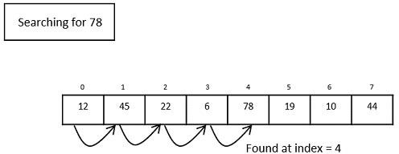

Fig. 1: Linear Search Operation Interval Searching
Unlike sequential searching, the interval searching operation requires the data to be in a
sorted manner. This method usually searches the data in intervals; it could be done by either dividing the data into multiple sub-parts or jumping through the indices to search for an element.
Example − Binary Search, Jump Search etc.

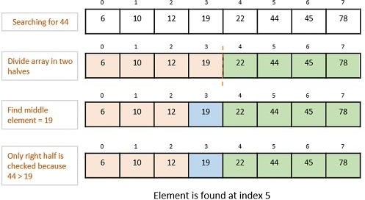

Fig. 2: Binary Search Operation

Linear Search Algorithm
Linear search is a type of sequential searching algorithm. In this method, every element within the input array is traversed and compared with the key element to be found. If a match is found in the array the search is said to be successful; if there is no match found the search is said to be unsuccessful and gives the worst-case time complexity.
For instance, in the given animated diagram, we are searching for an element 33. Therefore, the linear search method searches for it sequentially from the very first element until it finds a match. This returns a successful search.
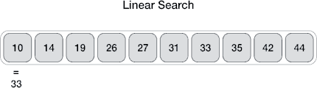

In the same diagram, if we have to search for an element 46, then it returns an unsuccessful search since 46 is not present in the input.

Linear Search Algorithm
The algorithm for linear search is relatively simple. The procedure starts at the very first index of the input array to be searched.
Step 1 − Start from the 0th index of the input array, compare the key value with the value present in the 0th index.
Step 2 − If the value matches with the key, return the position at which the value was found.
Step 3 − If the value does not match with the key, compare the next element in the array. Step 4 − Repeat Step 3 until there is a match found. Return the position at which the match was found.
Step 5 − If it is an unsuccessful search, print that the element is not present in the array and exit the program.

Pseudocode
procedure linear_search (list, value) for each item in the list
if match item == value return the item's location
end if end for
end procedure

Analysis
Linear search traverses through every element sequentially therefore, the best case is when the element is found in the very first iteration. The best-case time complexity would be O(1).

However, the worst case of the linear search method would be an unsuccessful search that does not find the key value in the array, it performs n iterations. Therefore, the worst-case time complexity of the linear search algorithm would be O(n).

Example
Let us look at the step-by-step searching of the key element (say 47) in an array using the linear search method.
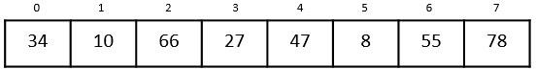

Step 1
The linear search starts from the 0th index. Compare the key element with the value in the 0th index, 34.

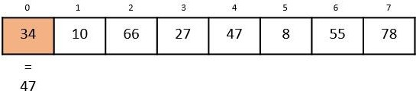

However, 47 ≠ 34. So it moves to the next element.

Step 2
Now, the key is compared with value in the 1st index of the array.

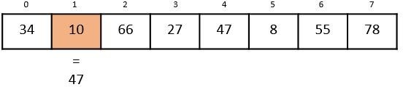

Still, 47 ≠ 10, making the algorithm move for another iteration.

Step 3
The next element 66 is compared with 47. They are both not a match so the algorithm compares the further elements.

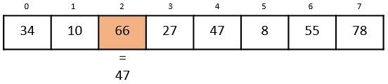

Step 4
Now the element in 3rd index, 27, is compared with the key value, 47. They are not equal so the algorithm is pushed forward to check the next element.

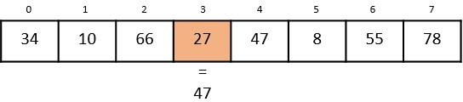

Step 5
Comparing the element in the 4th index of the array, 47, to the key 47. It is figured that both the elements match. Now, the position in which 47 is present, i.e., 4 is returned.

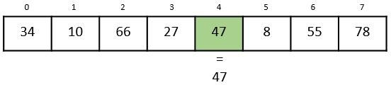

The output achieved is “Element found at 4th index”.
Implementation
In this tutorial, the Linear Search program can be seen implemented in four programming languages. The function compares the elements of input with the key value and returns the position of the key in the array or an unsuccessful search prompt if the key is not present in the array.
#include <iostream> using namespace std;
void linear_search(int a[], int n, int key){ int i, count = 0;

for(i = 0; i < n; i++) {
if(a[i] == key) { // compares each element of the array cout << "The element is found at position " << i+1 <<endl; count = count + 1;
}
}
if(count == 0) // for unsuccessful search
cout << "The element is not present in the array" <<endl;
}
int main(){ int i, n, key; n = 6;
int a[10] = {12, 44, 32, 18, 4, 10};
key = 18; linear_search(a, n, key); key = 23; linear_search(a, n, key); return 0;
}

Output
The element is found at position 4
The element is not present in the array

Binary Search Algorithm
Binary search is a fast search algorithm with run-time complexity of Ο(log n). This search algorithm works on the principle of divide and conquer, since it divides the array into half before searching. For this algorithm to work properly, the data collection should be in the sorted form.
Binary search looks for a particular key value by comparing the middle most item of the collection. If a match occurs, then the index of item is returned. But if the middle item has a value greater than the key value, the right sub-array of the middle item is searched. Otherwise, the left sub-array is searched. This process continues recursively until the size of a subarray reduces to zero.
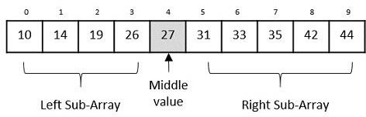

Binary Search Algorithm
Binary Search algorithm is an interval searching method that performs the searching in intervals only. The input taken by the binary search algorithm must always be in a sorted array since it divides the array into subarrays based on the greater or lower values. The algorithm follows the procedure below −
Step 1 − Select the middle item in the array and compare it with the key value to be searched. If it is matched, return the position of the median.
Step 2 − If it does not match the key value, check if the key value is either greater than or less than the median value.
Step 3 − If the key is greater, perform the search in the right sub-array; but if the key is lower than the median value, perform the search in the left sub-array.
Step 4 − Repeat Steps 1, 2 and 3 iteratively, until the size of sub-array becomes 1.
Step 5 − If the key value does not exist in the array, then the algorithm returns an unsuccessful search.

Pseudocode
The pseudocode of binary search algorithms should look like this − Procedure binary_search
A ← sorted array n ← size of array
x ← value to be searched

Set lowerBound = 1 Set upperBound = n

while x not found
if upperBound < lowerBound EXIT: x does not exists.
set midPoint = lowerBound + ( upperBound - lowerBound ) / 2 if A[midPoint] < x
set lowerBound = midPoint + 1

if A[midPoint] > x
set upperBound = midPoint - 1

if A[midPoint] = x
EXIT: x found at location midPoint end while
end procedure

Analysis
Since the binary search algorithm performs searching iteratively, calculating the time complexity is not as easy as the linear search algorithm.
The input array is searched iteratively by dividing into multiple sub-arrays after every unsuccessful iteration. Therefore, the recurrence relation formed would be of a dividing function.
To explain it in simpler terms,
- During the first iteration, the element is searched in the entire array. Therefore, length of the array = n.
- In the second iteration, only half of the original array is searched. Hence, length of the array = n/2.
- In the third iteration, half of the previous sub-array is searched. Here, length of the array will be = n/4.
- Similarly, in the i^{th} iteration, the length of the array will become n/2^{i}
- To achieve a successful search, after the last iteration the length of array must be 1. Hence,
n/2i = 1
That gives us – n = 2i
Applying log on both sides, log n = log 2i
log n = i. log 2 i = log n
The time complexity of the binary search algorithm is O(log n) Example
For a binary search to work, it is mandatory for the target array to be sorted. We shall learn
the process of binary search with a pictorial example. The following is our sorted array and let us assume that we need to search the location of value 31 using binary search.
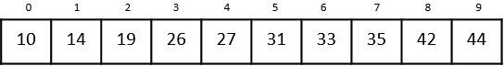
First, we shall determine half of the array by using this formula − mid = low + (high - low) / 2
Here it is, 0 + (9 - 0) / 2 = 4 (integer value of 4.5). So, 4 is the mid of the array.
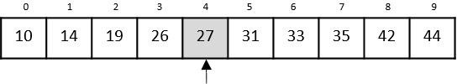
Now we compare the value stored at location 4, with the value being searched, i.e. 31. We find that the value at location 4 is 27, which is not a match. As the value is greater than 27

and we have a sorted array, so we also know that the target value must be in the upper portion of the array.
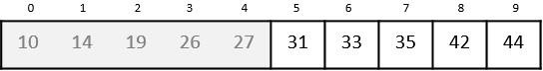
We change our low to mid + 1 and find the new mid value again. low = mid + 1
mid = low + (high - low) / 2
Our new mid is 7 now. We compare the value stored at location 7 with our target value 31.
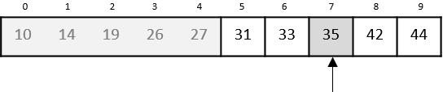
The value stored at location 7 is not a match, rather it is less than what we are looking for. So, the value must be in the lower part from this location.
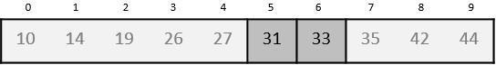
Hence, we calculate the mid again. This time it is 5.
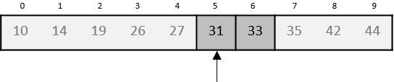
We compare the value stored at location 5 with our target value. We find that it is a match.
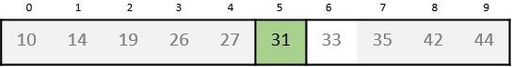
We conclude that the target value 31 is stored at location 5.
Binary search halves the searchable items and thus reduces the count of comparisons to be made to very less numbers.
- be implemented using a linked list. A queue implemented using a linked list can organize unlimited elements.

Queue applications in Data Structure
A queue data structure is generally used in scenarios where the FIFO approach (First In First Out) has to be implemented. The following are some of the most common queue applications in data structure:

Approach | Sequential (element by element) | Divide and conquer (halves the search space)
Data Requirement | Works on both sorted and unsorted data | Requires the data to be sorted in advance
Time Complexity | O(n) (linear time) | O(log n) (logarithmic time)
Efficiency | Slower, especially for large datasets | Much faster for large, sorted datasets
Implementation | Simple to implement | Slightly more complex to implement
Best Use Case | Small or unsorted datasets | Large, sorted datasets

Time Complexity is a concept in computer science that deals with the quantification of the amount of time taken by a set of code or algorithm to process or run as a function of the amount of input. In other words, the time complexity is how long a program takes to process a given input. The efficiency of an algorithm depends on two parameters:

Time Complexity

Space Complexity

Time Complexity: It is defined as the number of times a particular instruction set is executed rather than the total time taken. It is because the total time taken also depends on some external factors like the compiler used, the processor's speed, etc.

Space Complexity: It is the total memory space required by the program for its execution.

The

complexity of data structures (DS) refers to the efficiency of their operations, typically measured in terms of time complexity (execution time) and space complexity (memory usage) as the input size $(n)$ grows. This is often expressed using Big O notation, which describes the upper bound or worst-case performance.

Key Concepts

Time Complexity: Measures how the execution time of an operation changes with the input size. It is analyzed in best, average, and worst-case scenarios.

Space Complexity: Measures the total memory space required by the data structure and its operations during execution.

Big O Notation: The standard mathematical notation used to classify algorithms based on their growth rate, abstracting away machine-specific constants. Common complexities include:

O(1) (Constant): Time/space does not change with input size (e.g., accessing an array element by index

).

O(log n) (Logarithmic): Time/space increases slowly as input size grows (e.g., binary search).

O(n) (Linear): Time/space grows proportionally to the input size (e.g., searching an unsorted linked list).

O(n log n) (Linearithmic): Common in efficient sorting algorithms like Merge Sort.

O(n²) (Quadratic): Time/space grows with the square of the input size (e.g., simple sorting algorithms like Bubble Sort)

