# Branch and Bound Introduction

Branch and bound is an algorithm design paradigm which is generally used for solving combinatorial optimization problems. These problems typically exponential in terms of time complexity and may require exploring all possible permutations in worst case. Branch and Bound solve these problems relatively quickly.

Let us consider below 0/1 Knapsack problem to understand Branch and Bound.

Given two integer arrays ***val[0..n-1]*** and ***wt[0..n-1]*** that represent values and weights associated with n items respectively. Find out the maximum value subset of val[] such that sum of the weights of this subset is smaller than or equal to Knapsack capacity W.

Let us explore all approaches for this problem.

1. A [**Greedy** approach](http://www.geeksforgeeks.org/fractional-knapsack-problem/) is to pick the items in decreasing order of value per unit weight. The Greedy approach works only for [fractional knapsack](http://www.geeksforgeeks.org/fractional-knapsack-problem/) problem and may not produce correct result for [0/1 knapsack](http://www.geeksforgeeks.org/dynamic-programming-set-10-0-1-knapsack-problem/).
2. We can use [**D**ynamic **P**rogramming (**DP**) for 0/1 Knapsack problem](http://www.geeksforgeeks.org/dynamic-programming-set-10-0-1-knapsack-problem/). In DP, we use a 2D table of size n x W. The **DP Solution doesn’t work if item weights are not integers**.
3. Since DP solution doesn’t always work, a solution is to use **Brute Force**. With n items, there are 2n solutions to be generated, check each to see if they satisfy the constraint, save maximum solution that satisfies constraint. This solution can be expressed as **tree**.

[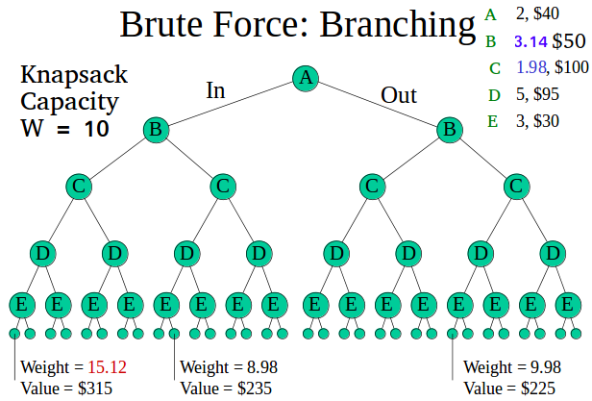](http://www.geeksforgeeks.org/wp-content/uploads/i2.png)

1. We can use **Backtracking** to optimize the Brute Force solution. In the tree representation, we can do DFS of tree. If we reach a point where a solution no longer is feasible, there is no need to continue exploring. In the given example, backtracking would be much more effective if we had even more items or a smaller knapsack capacity.

[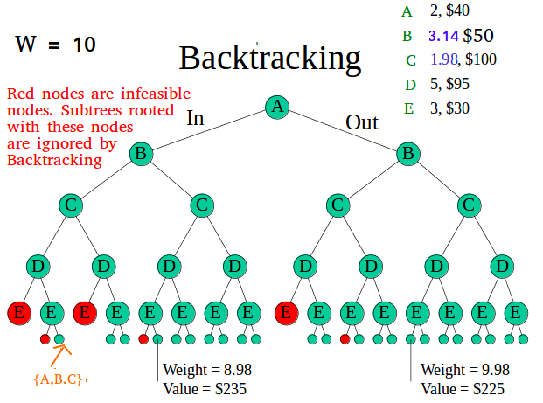](http://www.geeksforgeeks.org/wp-content/uploads/i4.png)

**Branch and Bound**

The backtracking based solution works better than brute force by ignoring infeasible solutions. We can do better (than backtracking) if we know a bound on best possible solution subtree rooted with every node. If the best in subtree is worse than current best, we can simply ignore this node and its subtrees. So we compute bound (best solution) for every node and compare the bound with current best solution before exploring the node.

Example bounds used in below diagram are, **A** down can give $315, **B** down can $275, **C** down can $225, **D** down can $125 and **E** down can $30. In the [next article](http://www.geeksforgeeks.org/branch-and-bound-set-2-implementation-of-01-knapsack/), we have discussed the process to get these bounds.

[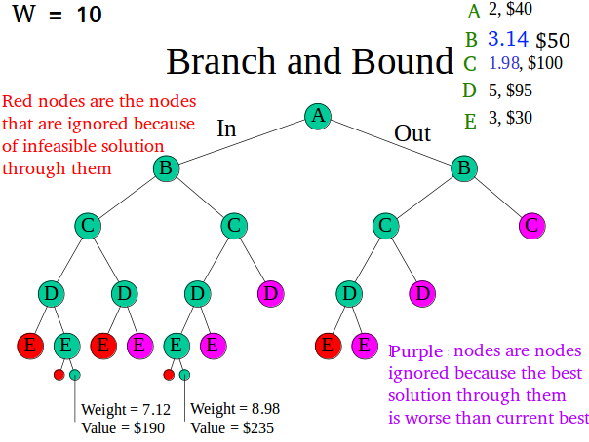](http://www.geeksforgeeks.org/wp-content/uploads/i51.png)

Branch and bound is very useful technique for searching a solution but in worst case, we need to fully calculate the entire tree. At best, we only need to fully calculate one path through the tree and prune the rest of it.