Cordic Core
Specification

Author: Richard Herveille

Rherveille@opencores.org

Rev. 0.3

This page left intentionally blank

Revision History
Rev. | Date | Author | Description
0.1 | 14/01/01 | Richard Herveille | First Draft
0.2 | 21/06/01 | Richard Herveille | Fixed some minor issues. Improved readability.
0.3 | 22/06/01 | Richard Herveille | Completely revised section 1.1

Contents
Introduction 1
Architecture 6
Polar to Rectangular Conversion 8
Sine and Cosine calculations 9
Rectangular to Polar Conversion 12

Introduction
CORDIC (Coordinate Rotation Digital Computer) is a method for computing elementary functions using minimal hardware such as shifts, adds/subs and compares.

CORDIC works by rotating the coordinate system through constant angles until the angle is reduces to zero. The angle offsets are selected such that the operations on X and Y are only shifts and adds.

1.1 The numbers
This section describes the mathematics behind the CORDIC algorithm. Those not interested in the numbers can skip this section.

The CORDIC algorithm performs a planar rotation. Graphically, planar rotation means transforming a vector (Xi, Yi) into a new vector (Xj, Yj).
Y
X
(Xj, Yj)
(Xi, Yi)
θ

Using a matrix form, a planar rotation for a vector of (Xi, Yi) is defined as
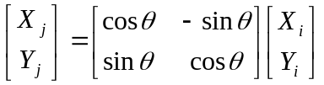 (1)

The θ angle rotation can be executed in several steps, using an iterative process. Each step completes a small part of the rotation. Many steps will compose one planar rotation. A single step is defined by the following equation:
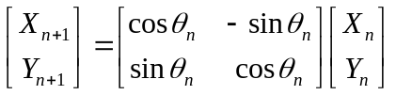 (2)

Equation 2 can be modified by eliminating the 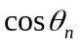factor.
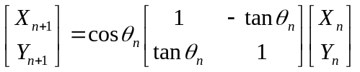 (3)

Equation 3 requires three multiplies, compared to the four needed in equation 2.
Additional multipliers can be eliminated by selecting the angle steps such that the tangent of a step is a power of 2. Multiplying or dividing by a power of 2 can be implemented using a simple shift operation.

The angle for each step is given by
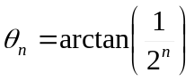 (4)
All iteration-angles summed must equal the rotation angle θ.
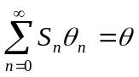 (5)
where
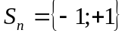 (6)

This results in the following equation for 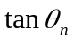
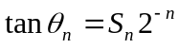 (7)

Combining equation 3 and 7 results in
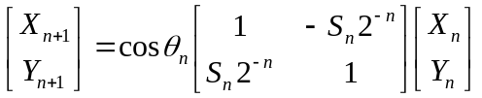 (8)

Besides for the coefficient, the algorithm has been reduced to a few simple shifts and additions. The coefficient can be eliminated by pre-computing the final result. The first step is to rewrite the coefficient.
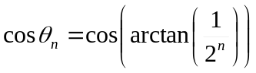 (9)

The second step is to compute equation 9 for all values of ‘n’ and multiplying the results, which we will refer to as K.
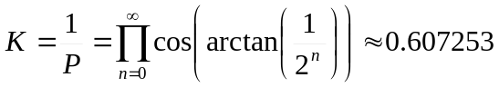 (10)
K is constant for all initial vectors and for all values of the rotation angle, it is normally referred to as the congregate constant. The derivative P (approx. 1.64676) is defined here because it is also commonly used.

We can now formulate the exact calculation the CORDIC performs.
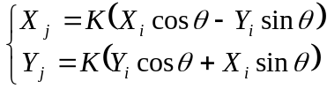 (11)

Because the coefficient K is pre-computed and taken into account at a later stage, equation 8 may be written as
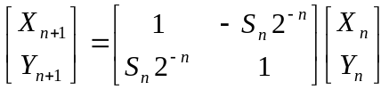 (12)
or as
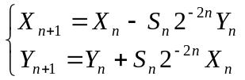 (13)

At this point a new variable called ‘Z’ is introduced. Z represents the part of the angle θ which has not been rotated yet.
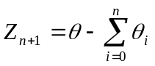 (14)

For every step of the rotation Sn is computed as a sign of Zn.
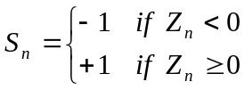 (15)

Combining equations 5 and 15 results in a system which reduces the not rotated part of angle θ to zero.
Or in a program-like style:
For i=0 to n-1
If (Z(n) >= 0) then
Z(n + 1) := Z(n) – atan(1/2^i);
Else
Z(n + 1) := Z(n) + atan(1/2^i);
End if;
End for;

The atan(1/2^i) is pre-calculated and stored in a table.
If we add the computation for X and Y we get the program-like style for the CORDIC core.
For i=0 to n-1
If (Z(n) >= 0) then
X(n + 1) := X(n) – (Yn/2^n);
Y(n + 1) := Y(n) + (Xn/2^n);
Z(n + 1) := Z(n) – atan(1/2^i);
Else
X(n + 1) := X(n) + (Yn/2^n);
Y(n + 1) := Y(n) – (Xn/2^n);
Z(n + 1) := Z(n) + atan(1/2^i);
End if;
End for;
This algorithm is commonly referred to as driving Z to zero. The CORDIC core computes:

There’s a special case for driving Z to zero:
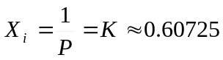
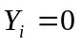
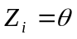
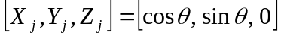

Another scheme which is possible is driving Y to zero. The CORDIC core then computes:
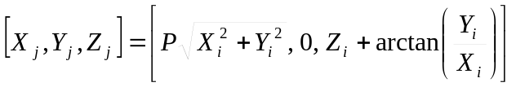

For this scheme there are two special cases:
1) 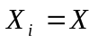
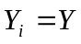
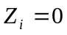
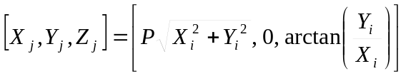

2) 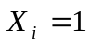
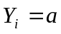
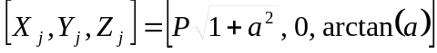

Architecture
All CORDIC Processor cores are built around three fundamental blocks. The pre-processor, the post-processor and the actual CORDIC core. The CORDIC core is built using a pipeline of CordicPipe blocks. Each CordicPipe block represents a single step in the iteration processes.
CORDIC Processor (CorProc)
CORDIC
CordicPipe
pre-processor
post-processor

2.1 Pre- and Post-Processors
Because of the arctan table used in the CORDIC algorithm, it only converges in the range of –1(rad) to +1(rad). To use the CORDIC algorithm over the entire 2π range the inputs need to be manipulated to fit in the –1 to +1 rad. range. This is handled by the pre-processor. The post-processor corrects this and places the CORDIC core’s results in the correct quadrant. It also contains logic to correct the P-factor.

2.2 CORDIC
The CORDIC core is the heart of the CORDIC Processor Core. It performs the actual CORDIC algorithm. All iterations are performed in parallel, using a pipelined structure. Because of the pipelined structure the core can perform a CORDIC transformation each clock cycle. Thus ensuring the highest throughput possible.

2.3 CORDIC Pipeline
Each pipe or iteration step is performed by the CordicPipe core. It contains the atan table for each iteration and the logic needed to manipulate the X, Y and Z values.

Polar to Rectangular Conversion
Only CORDIC and CordicPipe are coded so far.

Coming soon.

Sine and Cosine calculations
Sine and Cosine can be calculated using the first CORDIC scheme which calculates:

By using the following values as inputs
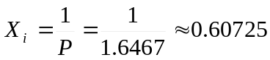
the core calculates:

The input Z takes values from –180degrees to +180 degrees where:
0x8000 = –180degrees
0xEFFF = +80degrees
But the core only converges in the range –90degrees to +90degrees.

The other inputs and the outputs are all in the range of –1 to +1. The congregate constant P represented in this format results in:
Example:
Calculate sine and cosine of 30degrees.
First the angle has to be calculated:
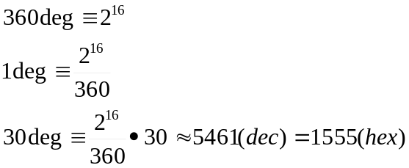

The core calculates the following sine and cosine values for Zi=5461:
Sin : 16380(dec) = 3FFC(hex)
Cos : 28381(dec) = 6EDD(hex)
The outputs represent values in the –1 to +1 range. The results can be derived as follows:
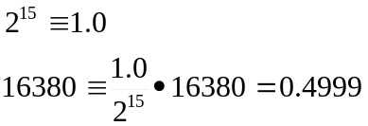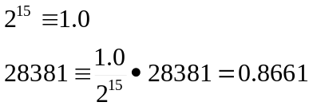
Whereas the result should have been 0.5 and 0.8660.

 | 0 deg | 30 deg | 45 deg | 60 deg | 90 deg
Sin | 0x01CC | 0x3FFC | 0x5A82 | 0x6EDC | 0x8000
Cos | 0x8000 | 0x6EDD | 0x5A83 | 0x4000 | 0x01CC
Sin | 0.01403 | 0.49998 | 0.70709 | 0.86609 | 1.00000
Cos | 1.00000 | 0.86612 | 0.70712 | 0.50000 | 0.01403
Table 1: Sin/Cos outputs for some common angles
Although the core is very accurate small errors can be introduced by the algorithm (see example and results table). This should be only a problem when using the core over the entire output range, because the difference between +1 (0x7FFF) and –1 (0x8000) is only 1bit.

4.1 Core structure
p2r_cordicpipe.vhd
p2r_cordic.vhd
sc_corproc.vhd

4.2 IO Ports
Port | Width | Direction | Description
CLK | 1 | Input | System Clock
ENA | 1 | Input | Clock enable signal
Ain | 16 | Input | Angel input
Sin | 16 | Output | Sine output
Cos | 16 | Output | Cosine output
Table 2: List of IO Ports for Sine/Cosine CORDIC Core

5.3 Synthesis Results
Vendor | Family | Device | Resource usage | Max. Clock speed
Xilinx | Spartan-II | XC2S100-6 | 387slices | 116MHz
Table 3: Synthesis results for Rectangular to Polar CORDIC Core

Rectangular to Polar Conversion
The rectangular to polar coordinate processor is built around the second CORDIC scheme which calculates:

It takes two 16bit signed words as inputs (Xin, Yin), which are the rectangular coordinates of a point in a 2-dimensional space. The core returns the equivalent Polar coordinates where Rout is the radius and Aout the angle or θ .

5.1 Core structure
r2p_cordicpipe.vhd
r2p_cordic.vhd
r2p_corproc.vhd
r2p_pre.vhd
r2p_post.vhd

5.2 IO Ports
Port | Width | Direction | Description
CLK | 1 | Input | System Clock
ENA | 1 | Input | Clock enable signal
Xin | 16 | Input | X-coordinate input. Signed value
Yin | 16 | Input | Y-coordinate input. Signed value
Rout | 20 | Output | Radius output. Unsigned value.
Aout | 20 | Output | Angle (θ) output. Singed/Unsigned value.
Table 4: List of IO Ports for Rectangular to Polar CORDIC Core

The outputs are in a fractional format. The upper 16bits represent the decimal value and the lower 4bits represent the fractional value.
The angle output can be used signed and unsigned, because it represents a circle; a -180 degree angle equals a +180 degrees angle, and a –45 degrees angle equals a +315 degrees angle.

5.3 Synthesis Results
The table below shows some synthesis results using a pipeline of 15 stages.
Vendor | Family | Device | Resource usage | Max. Clock speed
Altera | ACEX | EP1K50-1 | 2190lcells | 68MHz
Xilinx | Spartan-II | XC2S100-6 | 704slices | 93MHz
Table 5: Synthesis results for Rectangular to Polar CORDIC Core

