ESoCL
Ethernet Switch on Configurable Logic

Design Document

Copyright (C) LogiXA and OPENCORES.ORG

This source file may be used and distributed without restriction provided that this copyright statement is not
Removed from the file and that any derivative work contains the original copyright notice and the associated disclaimer.
This source file belongs to free software; you can redistribute it and/or modify it under the terms of the GNU Lesser General Public License as published by the Free Software Foundation; either version 2.1 of the License, or (at your option) any later version. This source is distributed in the hope that it will be useful, but WITHOUT ANY WARRANTY; without even the implied warranty of MERCHANTABILITY or FITNESS FOR A PARTICULAR PURPOSE. See the GNU Lesser General Public License for more details. You should have received a copy of the GNU Lesser General Public License along with this source; if not, download it from http://www.opencores.org/lgpl.shtml

History
Revision | Description | Reports | Author | Date
--C00 | First draft release |  | L.Maarsen

Table of contents

No table of contents entries found.

List of figures

No table of figures entries found.

List of tables

No table of figures entries found.

Introduction
This document describes the Ethernet Switch on Configurable Logic, further referred to as ESoCL.

The ESoCL is a flexible configurable Ethernet Switch that can be used for highly integrated solutions that require Ethernet Switch functionality. The ESoCL supports up to 16 MAC ports, the MAC ports support the (R)MII and (R)GMII and each MAC port has its own serial PHY management interface.

The ESoC is a VLAN capable Ethernet Switch. Untagged packets received by a port are tagged by the port default VLAN ID before they are processed further. After switching the packet to the destination port(s) the default tag is removed. Tagged packets can be re-tagged by the port default VLAN ID before or after they are processed further.

The ESoCL is self-learning Ethernet Switch, source address of incoming packets are stored into the internal MAC Address table, together with the VLAN ID. The MAC Address table is addressed by hash function of the IOD of the MAC Address, qwkjwekljfklwdjfk with an configurable aging mechanism. The MAC address table

The ESoCL can operate in unmanaged and managed mode. For unmanaged applications the ESoCL has an integrated boot ROM. For managed applications the ESoCL can be managed by a processor platform. Managed applications with challenging start-up requirements related to the switch functionality can use the boot ROM as well.

Introduction
An Ethernet switch connects a number of Ethernet stations, forming an Ethernet network. Different ports of the switch can be connected to different network segments or individual nodes. The switch learns the MAC addresses observed from frames received through each port and uses this information to forward incoming frames only to the intended destination instead of flooding the network.

The Ethernet Switch core integrates 10/100/1000 Ethernet MACs allowing direct connection to external PHY devices through standard interfaces like MII or GMII or their pin-reduced variants. One dedicated port offers a flexible FIFO interface for integration into any system environment.

The Core is delivered either in generic Verilog synthesizable HDL code for ASIC and FPGA implementations, or in an encrypted format for FPGA implementations.,

Switch Core Main Features
Ethernet switch engine with up to 16 ports with a shared total switching capacity of typically 2-6 Gbps (depending on target technology used).
Integrated Ethernet MACs with (R)MII or (R)GMII
Configuration procesos por
Full-duplex line rate support at all speeds and optionally half-duplex operation for 10/100 networks
MAC address table with up to 8192 entries.
Fully hardware controlled learning and aging with flexible control for address table management allowing static and dynamic address entries
Support for VLAN tagged frames according to IEEE 802.1Q specification with configurable VLAN verification and support for up to 32 VLAN domains
Priority classification and configurable remapping using VLAN priority or IP layer Diffserv/COS fields
QoS Support implementing 4 or 8 output queues per port
Strict priority or weighted fair queuing selection for queues
Configurable Parsers for AVB traffic classification and Credit Based Shaper (802.1Qav) bandwidth control
Optional configurable Random Early Detection (RED) RFC 2309 congestion management on output queues
Programmable frame maximum length up to 1700 byte
Configurable Multicast and Broadcast flooding control
Management Frame (BPDU) filtering and special forwarding capabilities to host processor port supporting network management protocol implementations
Statistics counters for IEEE 802.3 basic Management Information Database (MIB) package, Ethernet MIB (RFC 2665) and Remote Network Monitoring (RFC 2819)
Frame timestamping enabling IEEE 1588 (PTP) and 802.1as (AVB) applications
Automatic 1-step correction field update for IEEE 1588v2 Layer 2 frames for transparent clock support
Integrated software adjustable timer module providing seconds and nanoseconds values
Integrated Clause 22 MDIO master controllers for PHY management on the external ports
Optional Mirroring and Snooping functions for use by network and application management protocols

Deliverables
Verilog Synthesizable RTL or encrypted RTL for FPGA implementation
Behavioral Verilog testbenches and Verification test cases
Support for FPGA and ASIC design tools

Target Technology | Complexity for  4-Port Example  64Kbyte Buffer, 2048 address table | Complexity for  10-Port Example  64Kbyte Buffer, 2048 address table | Performance
ASIC | ~300K - 400K gates  ~900Kbit memory | ~700K - 900K gates  ~1.4Mbit memory | > 300 MHz
FPGA | ~30000 LEs  ~1Mbit memory | ~55000 LEs  ~1.4Mbit memory | >140MHz

Language Code | Delivery Language
VLOG | Synthesizable RTL Verilog Source Code.
BIN | Encrypted RTL for FPGA technology.

Design

Feature list

Block diagram
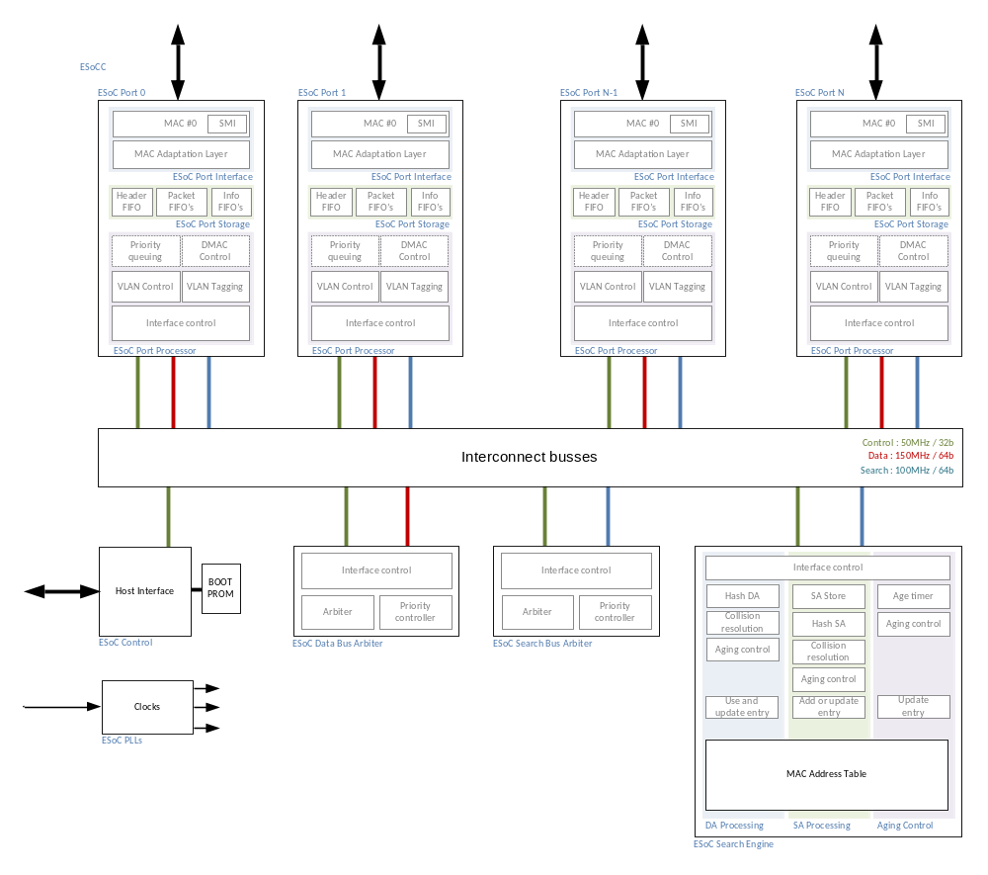

Figure 1: block diagram of ESoCL

Configuration

Build time configuration

Configuration file

Memory Initialisation File (MIF)

Software configuration

registerXYZ

Testbench

Block diagram

Macro’s

Stimuli
Control interface
Ethernet interfaces

Logging

