ESoCL
Ethernet Switch on Configurable Logic

Product Brief

Copyright (C) LogiXA and OPENCORES.ORG

This source file may be used and distributed without restriction provided that this copyright statement is not
Removed from the file and that any derivative work contains the original copyright notice and the associated disclaimer.
This source file belongs to free software; you can redistribute it and/or modify it under the terms of the GNU Lesser General Public License as published by the Free Software Foundation; either version 2.1 of the License, or (at your option) any later version. This source is distributed in the hope that it will be useful, but WITHOUT ANY WARRANTY; without even the implied warranty of MERCHANTABILITY or FITNESS FOR A PARTICULAR PURPOSE. See the GNU Lesser General Public License for more details. You should have received a copy of the GNU Lesser General Public License along with this source; if not, download it from http://www.opencores.org/lgpl.shtml
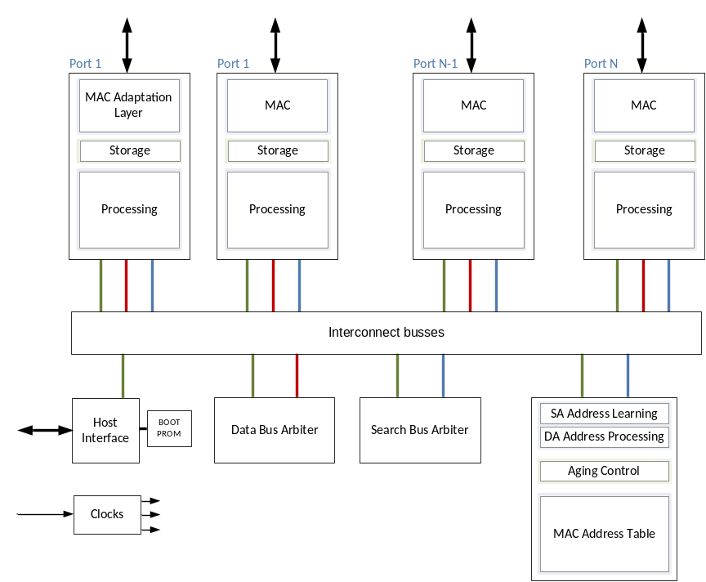Introduction
This document describes
the Ethernet Switch on Configurable Logic, further referred to as ESoCL.

The ESoCL is a configurable Ethernet Switch that can be used to design Ethernet Switch functionality into FPGA based solutions to achieve a more flexible and integrated solution. The ESoCL supports up to 16 MAC ports, the MAC ports support an (R)MII or an (R)GMII MAC interface towards an external Ethernet PHY. Each MAC port has its own serial PHY management interface.

The ESoC is a VLAN capable Ethernet Switch. Untagged packets received by a port are tagged by the port default VLAN ID before they are processed. After switching an untagged packet to the destination port(s) the default tag is removed. Tagged packets can be re-tagged by the port default VLAN ID before or after they are processed further.

The ESoCL is a self-learning Ethernet Switch, the source address of incoming packets are stored or renewed in the internal MAC Address table, together with the associated VLAN ID. The MAC address table is monitored by an aging mechanism that removes expired MAC addresses.

The ESoCL can operate in unmanaged and managed mode. For unmanaged applications the ESoCL has an integrated boot ROM that can be used to configure the Ethernet Switch after reset is de- asserted. For managed applications the ESoCL has a generic, asynchronous, memory mapped interface that can be used by a processor platform to configure the Ethernet Switch. Managed applications with challenging start-up requirements related to the Ethernet Switch functionality can use the boot ROM as well.

Main Features
- Ethernet Switch with up to 16 ports
- Shared total switching capacity of 6-9 Gbps
- Serial PHY management on each port
- Integrated Ethernet MACs with (R)MII or (R)GMII interface from Altera, Xilinx or Open CoresError: Reference source not found.
- MAC address table with up to 8192 entries
- Configurable address learning and aging mechanism
- VLAN tagged frames, according to IEEE 802.1Q, up to 4096 VLAN ID’s
- Generic host or Open Cores Wish Bone interface
- Unmanaged and managed operation
- Initialization by boot ROM
- Extensive set of counters
Sources
- Synthesizable VHDL for FPGA targetsError: Reference source not found
- Semi-automated functional test bench

Target resources

Resources: 8 port ESoCL Target: EP3CLS100F484I7 (Altera Cyclone 3LS)
Units | Logic cells | Memory bits | Fmax
Generic  (Arbiters, Control) | 1217 | 8192 bits  1 M9K Block | CLK_CTRL ≤ 50MHz  CLK_DATA ≤ 140MHz  CLK_SEARCH ≤ 100MHz
RGMII Port  (MAC, MAL, Storage, Processing) | 5904 | 337328 bits  51 M9K Blocks | CLK_CTRL ≤ 50MHz  CLK_DATA ≤ 140MHz  CLK_SEARCH ≤ 100MHz
Search engine | 945 | 582400 bits  72 M9K Blocks | CLK_CTRL ≤ 50MHz  CLK_DATA ≤ 140MHz  CLK_SEARCH ≤ 100MHz
Total | 49394 | 337328 bits  481 M9K Blocks | CLK_CTRL ≤ 50MHz  CLK_DATA ≤ 140MHz  CLK_SEARCH ≤ 100MHz

Documentation
- Product Brief
- Design Description
- Release Bulletin

Depends on target device and average packet size
Altera is supported, a Xilinx and a full Open Cores version are on the roadmap
Open Cores Wish Bone interface is on the roadmap

