INTRODUCTION:
‘Instruction List’ is a PLC programming language, defined in IEC 61131-3 standards. It is similar to assembly programming for a microcontroller. The processor is built with reference to the instruction set defined for the Instruction List language. The instruction set, however, is not limited to Instruction List, but extended for peripherals to work.
The instruction set is included, with short description, in another portable document file.

TOP-LEVEL BLOCK DIAGRAM:
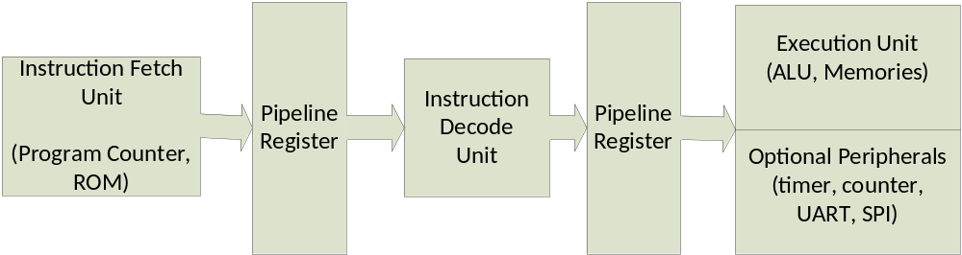

There are basically 3 functional units, separated and pipelined by 2 pipeline registers. All three are functioning simultaneously.

FEATURES:
The key features of processor are
Fixed-length instruction
Three-stage pipelining
8-bit ALU
Input & Output (digital) processing capability
‘N’ bit in instruction field, to negate the operand (specified in IEC 61131-3)
bit- and byte- memories

PERIPHERALS:
Besides the memories, other peripherals can be optionally included:
Timer & Counter
UART
Serial Peripheral Interface (SPI) Master

The peripherals are optional and can included or excluded using “defines.v” file. Though timer and counter are different peripherals, they are both included or excluded in design using same `define directive, since they share common resources. Number of timer and counter are also variable and they can be manipulated in the same file.

