8-bit Pipelined Processor- Instruction Set
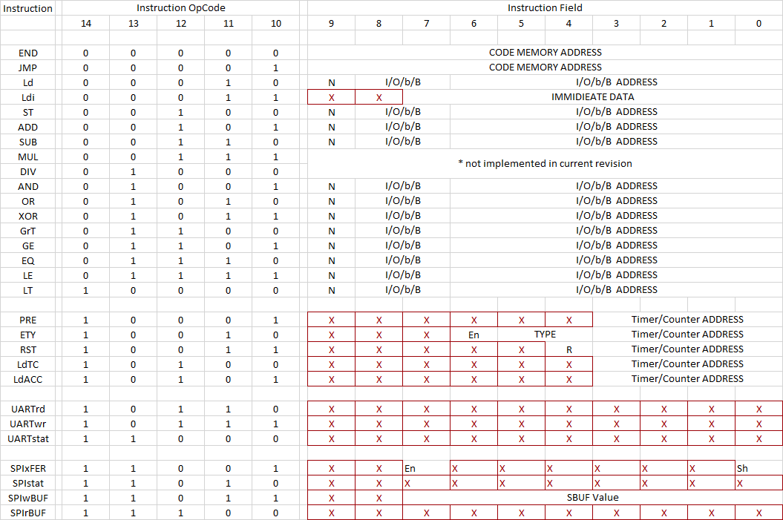

___________________________________________________________________________________________________________________________________________
X don’t care
___________________________________________________________________________________________________________________________________________
I/O/b/B 00 – input, 01 – output, 10 – bit RAM, 11 – Byte RAM
____________________________________________________________________________________________________________________________________________
TYPE (related to timer/counter) 00 – on-delay timer , 01 – off-delay timer, 10 – retentive-on-delay-timer, 11 – not used for timer
01 – up counter, 10 – down counter, 00 & 11 not used for counter
_____________________________________________________________________________________________________________________________________________
R (related to timer/counter) 1 – assert reset signal, 0 – de-assert reset signal
_____________________________________________________________________________________________________________________________________________
Timer addresses range from 0000 to 0111
Counter addresses range from 1000 to 1111
Inputs, outputs and both RAMs have addresses from 0000000 to 1111111 (0 to 127 decimal)
Code memory (ROM) address range 0 to 1023
_____________________________________________________________________________________________________________________________________________

