
nova:a H.264/AVC Baseline Decoder
Specification

Author: Ke Xu
eexuke@yahoo.com

Rev. 0.1

This page has been intentionally left blank.
Revision History
Rev. | Date | Author | Description
0.1 | 30/04/08 | Ke Xu | First Draft

Contents
Introduction 1
Architecture 3
Operation 5
On-chip memories 6
Clocks 8
IO Ports 9
Appendix A 10
Appendix B 12
Index 13

Introduction
Nova is a low-power H.264/AVC baseline decoder targeting mobile applications. It is a dedicated, full hardwired ASIC design without utilizing any GPP/DSP cores.
Features:
- RTL coded in Verilog-HDL.
- Support real-time H.264/AVC baseline decoding of QCIF resolution. Can be extended to higher resolutions via minor modifications.
- Extensively pipelining & parallelism are utilized to improve the performance and reduce power.
- Hybrid and self-adaptive pipeline architecture to avoid unnecessary stall cycles and to improve performance:
  - Self-adaptive pipeline for both intra and inter prediction.
  - 4×4/16×16 hybrid pipeline.
  - 1×4 pixel column-level parallelism.
- Low cost intra prediction unit:
  - Self-adaptive pipeline.
  - Hierarchical memory organization to reduce external memory access.
  - “Seed” method for plane mode computation.
  - Exploring data reuse between 1×4 columns.
  - Multi-function Processing Elements for all intra prediction modes processing.
- Optimized motion compensation (inter prediction) unit:
  - Self-adaptive pipeline.
  - Hierarchical memory organization to reduce external memory access.
  - “Variable-block-shape” to reduce redundant memory access and improve throughput.
  - On-chip reference pixel buffer to explore reference pixel reuse.
  - Pipelined and parallelized luma interpolator, consisting of 9 horizontal 6-tap filters, 4 vertical 6-tap filters, and 4 bilinear filters.
  - Innovative chroma interpolator utilizing smallest number of adders.
- High performance deblocking filter.
  - Innovative 5-stage pipeline architecture with data/structure hazards carefully managed.
  - Single-port SRAM based, no dual/two-port SRAM required.
  - 204cycles/MB throughput with max. frequency of 200MHz (0.18µm process). Can deliver up to 980kMB/s throughput.
- Manually inserted latch-based clock gating to reduce power.
- Low-power, low-cost design.
  - Requires only ~1.5MHz for QCIF 30fps real time decoding.
  - Only 169k logic gates.
  - Measured power consumption as low as 293µW.

Nova has been proved on both FPGA environment and on real silicon:
- The FPGA implementation results are listed below:
Table 1 FPGA implementation
Device | Virtex-4 xc4vlx200-10ff1513
Number of slices | 18,377 (utilization 20%)
Number of 4-input LUTs | 32,711 (utilization 18%)
Total equivalent gate count | 10,405,748
- The ASIC implementation results are shown below:
Table 2 ASIC implementation
Technology | 0.18µm CMOS 1P6M
Supply Voltage | 1.8V core, 3.3V I/O
Size (pad limited design) | 3.8×3.8mm² core, 4.4×4.4mm² with pad
Package | CQFP 208
Design Cost | Logic Gates | 169K (in NAND2)
Design Cost | Memory | 2.5K byte SRAM
Operating Frequency | 1.5MHz for QCIF @ 30fps
Measured Power | 293µW @ 1.0V, 973µW @ 1.8V

Architecture
1. Nova is divided into two parts, bitstream parser (also called bitstream controller), and reconstruction datapath, as shown below.
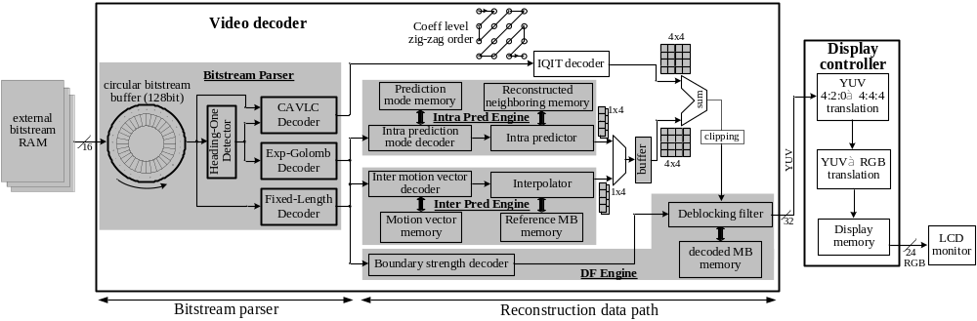
Fig. 1 System architecture

The proposed 4×4/16×16 hybrid pipeline is depicted below:
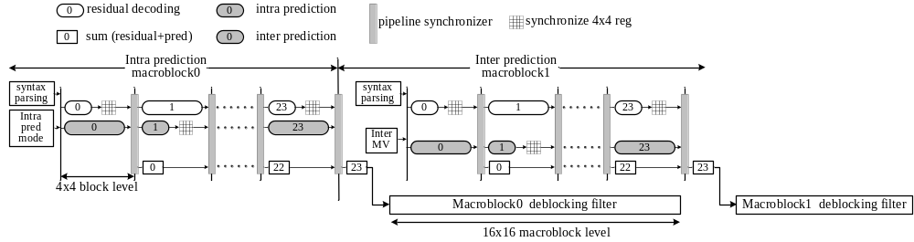
Fig. 2 Hybrid pipeline architecture

The RTL verilog-HDL code structure is illustrated below:
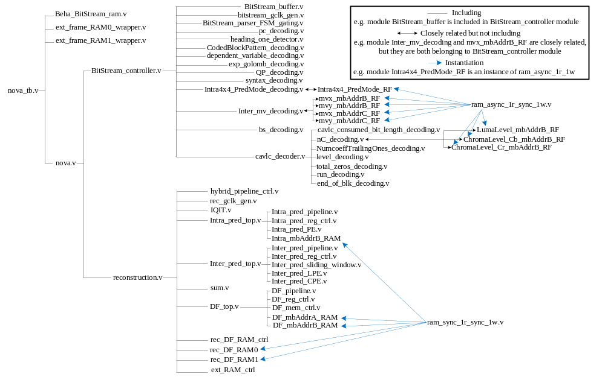Fig. 3 Verilog-HDL code structure

Operation
This section describes the operation of the core:
- After system reset, the BitStream_buffer starts to fetch bitstream from Beha_BitStream_ram via 16bit width data bus (BitStream_buffer_input).
- After 4 clock cycles when half of the 128bit BitStream_buffer is filled, it sends the bitstream to the following decoder via 16bit width data bus (BitStream_buffer_output). The BitStream_buffer acts as an interface between off-chip BitStream_ram and on-chip decoder. An automatically-refill mechanism is employed to refill the buffer if half of its stored bitstream (>=64bit) is consumed.
- The BitStream_controller starts decoding when BitStream_buffer_valid_n = 1’b0. It generates control parameters and control signals for reconstruction datapath.
- The reconstruction datapath is mainly consisted of intra prediction, inter prediction, and deblocking filter. Either intra or inter prediction block is invoked according to current macroblock type. The output of intra/inter block is sent to deblocking filter if required.
- The deblocking filter output is sent to external memory. There are two memories, ext_frame_RAM0_wrapper & ext_frame_RAM1_wrapper. If one is acting as reference memory (providing reference pixels for the decoder), the other is acting as display memory (the decoder is writing decoded pixels to this memory). After 1 frame is decoded, RAM0 and RAM1 exchange their functions.

On-chip memories
There are two types of on-chip memories, register file (RF) and SRAM. In RTL coding, all the RFs are instantiated from behavior module ram_async_1r_sync_1w, while all the SRAMs are instantiated from behavior module ram_sync_1r_sync_1w. During ASIC implementation, all the RFs are synthesized from Synopsys DesignWare and all the SRAMs are provided by the foundry.

List of RF
Table 3 RF usage
Name | Depth | Width | Access
Intra4x4_PredMode_RF | 11 | 16 | Async read, sync write
LumaLevel_mbAddrB_ RF | 11 | 20 | Async read, sync write
ChromaLevel_Cb_mbAddrB_ RF | 11 | 10 | Async read, sync write
ChromaLevel_Cr_mbAddrB _RF | 11 | 10 | Async read, sync write
mvx_mbAddrB_RF | 11 | 32 | Async read, sync write
mvy_mbAddrB_RF | 11 | 32 | Async read, sync write
mvx_mbAddrC_RF | 10 | 8 | Async read, sync write
mvy_mbAddrC_RF | 10 | 8 | Async read, sync write

List of SRAM
Table 4 SRAM usage
Name | Depth | Width | Access
Intra_mbAddrB_RAM | 88 | 32 | Sync read, sync write
DF_mbAddrA_RAM | 32 | 32 | Sync read, sync write
DF_mbAddrB_RAM | 352 | 32 | Sync read, sync write
rec_DF_RAM0 | 96 | 32 | Sync read, sync write
rec_DF_RAM1 | 96 | 32 | Sync read, sync write

Clocks
Nova is a full synchronous design with only one clock input which drives all the DFFs and on-chip SRAMs.
Table 5: List of clocks
Name | Source | Rates (MHz) |  |  | Remarks | Description
Name | Source | Max | Min | Resolution | Remarks | Description
clk | Input | 10 | 1 | NA | Duty cycle 50/50. | Single clock for the entire design

The final layout clock tree is illustrated below:
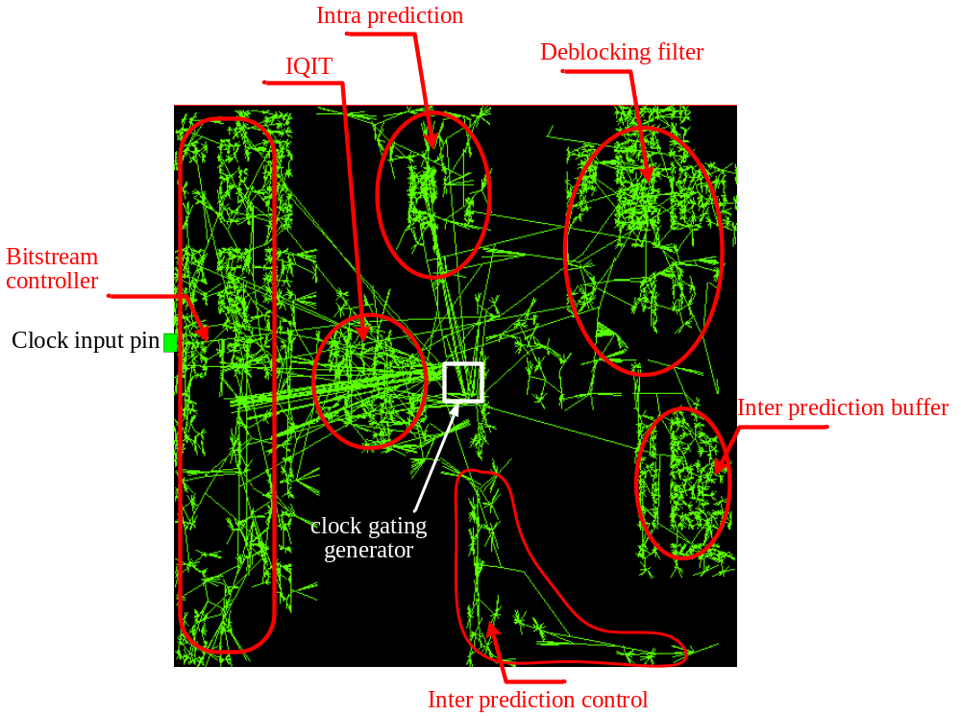
Fig. 4 Clock tree layout

IO Ports
This section specifies the core IO ports.
Table 6 IO ports
Port | Width | Direction | Description
clk | 1 | Input | System clock
reset_n | 1 | Input | System reset, low active
BitStream_buffer_input | 16 | Input | BitStream_buffer data input
BitStream_ram_ren | 1 | Output | BitStream_buffer read enable, low active
BitStream_ram_addr | 17 | Output | BitStream_buffer address
pin_disable_DF | 1 | Input | Externally enable/disable deblocking filter.  =1 deblocking filter is disabled  =0 the decoded bitstream will decide whether to enable/disable deblocking filter
freq_ctrl0 | 1 | Input | Frequency control input
freq_ctrl1 | 1 | Input | Frequency control input
pic_num | 6 | Output | The low 6 bit of current decoding picture number. For debug purpose
ext_frame_RAM0_data | 32 | Input | External RAM0 data
ext_frame_RAM0_cs_n | 1 | Output | External RAM0 chip select, low active
ext_frame_RAM0_wr | 1 | Output | External RAM0 write control, high active
ext_frame_RAM0_addr | 14 | Output | External RAM0 address
ext_frame_RAM1_data | 32 | Input | External RAM1 data
ext_frame_RAM1_cs_n | 1 | Output | External RAM1 chip select, low active
ext_frame_RAM1_wr | 1 | Output | External RAM1 write control, high active
ext_frame_RAM1_addr | 14 | Output | External RAM1 address

Software Simulation
- Ten 300frames QCIF video sequences are used for testing. They are encoded by JM94 software (http://iphome.hhi.de/suehring/tml/)
Table 7 QCIF test sequences
 | QP | Bitrate  (kb/s) | Bits/frame  (Intra) | Bits/frame  (Inter) | SNR  Y (dB) | SNR  U (dB) | SNR  V(dB)
Mother & daughter | 24 | 78.92 | 24,215 | 2,512 | 40.03 | 43.37 | 43.94
News | 26 | 94.8 | 32,161 | 3,018 | 38.05 | 40.97 | 41.56
Akiyo | 28 | 24.83 | 19,005 | 721 | 38.03 | 40.82 | 41.68
Claire | 28 | 30.68 | 12,939 | 937 | 39.6 | 39.4 | 42
Foreman | 28 | 130.24 | 21,911 | 4,177 | 36.16 | 40.54 | 41.64
Silent | 30 | 65.06 | 21,350 | 2,058 | 34.19 | 37.7 | 38.99
Container | 30 | 28.65 | 20,768 | 843 | 34.36 | 39.93 | 39.64
Hall | 32 | 30.75 | 15,644 | 931 | 34.44 | 37.97 | 40.17
Coastguard | 34 | 65.39 | 13,107 | 2,097 | 29.7 | 39.8 | 42.14
Carphone | 36 | 45.19 | 10,418 | 1,431 | 30.69 | 36.635 | 37.135

- JM94 outputs binary .264 files which can not be read directly into verilog (Maybe it can but I don’t know?). A format conversion file, bin2hex.pl, is provided in test directory. Usage (under unix environment):
bin2hex.pl akiyo300_1ref.264
where akiyo300_1ref.264 is the JM encoder output. The name of the converted text file should be specified in line 8 of bin2hex.pl.
- The text file would be read via Beha_BitStream_ram by:
$readmemh("C:/nova/test/bitstream/akiyo300_1ref.txt",BitStream_ram);
Modify the location of the file if pointing to other paths.
- The decoded outputs are generated from ext_frame_RAM0_wrapper and ext_frame_RAM1_wrapper. The “nova_display.log” is used for display while “nova_MB_output.log” is used for debug.
- The software I used, YUVViewer, does not properly display the text format input frame. Therefore, a C program is provided in test directory to convert the text back to binary. Remember, we first converted the input bitstream from binary to text, now we are converting the decoded frame from text back to binary.
- Now you should get “nova300.yuv” somewhere, put it into YUVViewer and good luck!

FPGA Verification
To be added later.

This section contains a list of helpful document entries with their corresponding page numbers.
- Ke Xu, “Power-efficient Design Methodology for Video Decoding”, PhD thesis, 2007.
- Ke Xu, etc., “A 5-stage Pipeline, 204 Cycles/MB, Single-port SRAM Based Deblocking Filter for H.264/AVC”, IEEE Transactions on Circuits and Systems for Video Technology, vol. 18, issue 3, pp. 363 – 374, 2008.
- Ke Xu, etc., “A Power-efficient and Self-adaptive Prediction Engine for H.264/AVC Decoding”, IEEE Transactions on VLSI Systems, vol. 16, issue 3, pp. 302 - 313, 2008.
- Ke Xu, etc., “Power Efficient VLSI Realization of Complex FSM for H.264/AVC Bitstream Parsing”, IEEE Transactions on Circuits and Systems, Part II, vol. 54, issue 11, pp. 984 – 988, 2007.
- Ke Xu, etc., “Priority-based Heading One Detector in H.264/AVC Decoding”, EURASIP Journal on Embedded Systems, vol. 2007, Article ID 60834.
- Ke Xu, etc., “Low-power H.264/AVC Baseline Decoder for Portable Applications”, International Symposium on Low Power Electronics and Design, pp. 256 - 261, Sept. 2007.
- Ke Xu, etc., “A Low-power BitStream Controller for H.264/AVC Baseline Decoding”, 32nd European Solid-State Circuits Conference, pp. 162- 165, Sept 2006.
- Ke Xu, etc., “Power-efficient VLSI Implementation of BitStream Parsing in H.264/AVC Decoder”, IEEE International Symposium on Circuits and Systems, pp. 5339 - 5342, May 2006.

