Versatile counter
A reconfigurable binary, gray or LFSR counter
Brought to You By ORSoC / OpenCores

Legal Notices and Disclaimers
Copyright Notice
This ebook is Copyright © 2009 ORSoC
General Disclaimer
The Publisher has strived to be as accurate and complete as possible in the creation of this ebook, notwithstanding the fact that he does not warrant or represent at any time that the contents within are accurate due to the rapidly changing nature of information.
The Publisher will not be responsible for any losses or damages of any kind incurred by the reader whether directly or indirectly arising from the use of the information found in this ebook.
This ebook is not intended for use as a source of legal, business, accounting, financial, or medical advice. All readers are advised to seek services of competent professionals in the legal, business, accounting, finance, and medical fields.
No guarantees of any kind are made. Reader assumes responsibility for use of the information contained herein. The Publisher reserves the right to make changes without notice. The Publisher assumes no responsibility or liability whatsoever on the behalf of the reader of this report.
Distribution Rights
The Publisher grants you the following rights for re-distribution of this ebook.
[YES] Can be given away.
[YES] Can be packaged.
[YES] Can be offered as a bonus.
[NO] Can be edited completely and your name put on it.
[YES] Can be used as web content.
[NO] Can be broken down into smaller articles.
[NO] Can be added to an e-course or auto-responder as content.
[NO] Can be submitted to article directories (even YOURS) IF at least half is rewritten!
[NO] Can be added to paid membership sites.
[NO] Can be added to an ebook/PDF as content.
[NO] Can be offered through auction sites.
[NO] Can sell Resale Rights.
[NO] Can sell Master Resale Rights.
[NO] Can sell Private Label Rights.
Table of Contents
Chapter 1 Linear Feedback Shift Registers 4
Chapter 2 Implementation 5
Usage notes 8
Appendix A:
excel2csv 9
Recommended Resources 10

Chapter 1 Linear Feedback Shift Registers

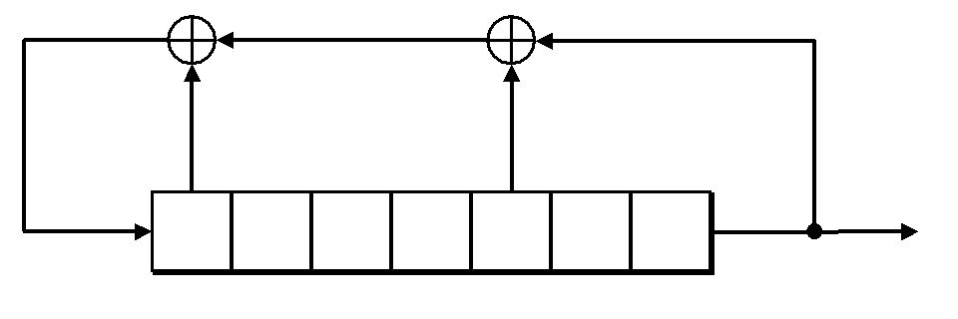

A linear feedback shift register (LFSR) is a shift register whose input bit is a linear function of its previous state.
The only linear functions of single bits are xor and inverse-xor; thus it is a shift register whose input bit is driven by the exclusive-or (xor) of some bits of the overall shift register value.
The initial value of the LFSR is called the seed, and because the operation of the register is deterministic, the stream of values produced by the register is completely determined by its current (or previous) state. Likewise, because the register has a finite number of possible states, it must eventually enter a repeating cycle. However, an LFSR with a well-chosen feedback function can produce a sequence of bits which appears random and which has a very long cycle.
Linear Feedback Shift Registers sequence through (2n - 1) states, where n is the number of registers in the LFSR. At each clock edge, the contents of the registers are shifted right by one position. There is feedback from predefined registers or taps to the left most register through an exclusive-NOR (XNOR).

Chapter 2 Implementation

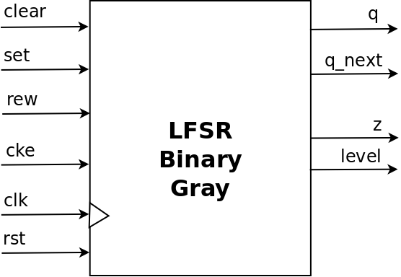

Top level module input and output signals

Signal |  | Function
clear | Optional | Synchronous clear, set output to zero
set | Optional | Synchronous set, set output to predefined value
rew | Optional | Count backwards, rewind
cke | Optional | Clock enable
clk | Mandatory | Clock signal
rst | Mandatory | Asynchronous reset
q | Optional | State of internal shift register
q_next | Optional | Next state of internal shift register
z | Optional | Zero flag
zq | Optional | Zero flag, clocked output
level1 | Optional | Programmable level flag
level2 | Optional | Programmable level flag

The counter is defined by updating a spreadsheet (vc.xls):

From these definitions the design is generated with two scripts. The first converts the excel file into a CSV file and the second script generates the verilog module based on the CSV file.
A Makefile, included in the project, can be used for this.
Makefile:
all:
excel2csv vc.xls -S ,
./versatile_counter_generator.php Versatile_counter.csv > vc.v
Note:
The name of the generated CSV file is defined in the excel tab.
This design is done in Verilog RTL. The design is as a generic module.
The following options are present in the application specific define file:
parameters | Valid options | Comment
Length | 2-32 | Length of counter state vector
clear_value | Any counter value | Default value from excel sheet
set_value | Any counter value | Default value from excel sheet
wrap_value | Any counter value | Default value from excel sheet
level1_value | Any counter value | Default value from excel sheet
level2_value | Any counter value | Default value from excel sheet

Note:
For gray type counters output q_next is next binary value

Usage notes
- All control signals are active high. To change this behavior use the following method for individual signals
.clear(~clear)
- Signal clear has priority over signal set.
The user can change this behavior with the following instantiation method
.clear(clear & ~set)
.set(set)
- Both CNT_SET_VALUE and CNT_WRAP_VALUE are implemented as parameters and can be changed per instance with defparam Verilog statements
- LEVEL1 and LEVEL2 should be used in implementations with REW function implemented. The levels can be changed per instance with defparam Verilog statements
- To construct an up / down counter enable CNT_REW and use inputs as below
 | rew | cke
up | O | 1
down | 1 | 1
- | X | O

- If CNT_REW is enabled for a down counter wrap will occur when current state is CNT=0, next state will be CNT_WRAP_VALUE.

Appendix A:
excel2csv
This projects uses a script to convert excel spreadsheet(s) into comma separated value file(s) (csv files).
This program is available from CPAN:
http://search.cpan.org/~leocharre/excel2csv-1.01/

excel2csv - dump all worksheets from an Excel file to CSV files
===============================================================

The original script was written by Drew Broadley, with contributions from Aristotle Pagaltzis.
Packaged by Leo Charre leocharre at cpan dot org.

excel2csv takes any number of Excel files on the command line, reads them, and dumps each worksheet therein to a separate CSV file, named after the worksheet.

INSTALLATION

perl Makefile.PL
make install

DEPENDENCIES

Getopt::Long
Pod::Usage
Spreadsheet::ParseExcel

LICENCE

This library is free software; you can redistribute it and/or modify
it under the same terms as Perl itself, either Perl version 5.8.8 or,
at your option, any later version of Perl 5 you may have available.

Appendix B
Versatile LFSR counter PHP scripts
To ease the usage of the LFSR type counter a script can be used. The script, VersatileCounter, is written in PHP and can be found in the SW directory.
The script takes two or three argument
- length of LFSR polynom
- number of increments
- optional verbose flag
Example
To see state after 14 increments of a 4 bit counter
./VersatileCounter.php 4 14
1000
The verbose flag gives a more detailed output
./VersatileCounter.php 4 15 v
0: 0000
1: 0001
2: 0011
3: 0111
4: 1110
5: 1101
6: 1011
7: 0110
8: 1100
9: 1001
10: 0010
11: 0101
12: 1010
13: 0100
14: 1000
15: 0000

Recommended Resources
ORSoC – http://www.orsoc.se
ORSoC is a fabless ASIC design & manufacturing services company, providing RTL to ASIC design services and silicon fabrication service. ORSoC are specialists building complex system based on the OpenRISC processor platform.
Open Source IP – http://www.opencores.org
Your number one source for open source IP and other FPGA/ASIC related information.
XILINX – http://www.xilinx.com
http://www.xilinx.com/support/documentation/application_notes/xapp052.pdf

