

10GE MAC Core Specification

Author: A. Tanguay
antanguay@opencores.org

Rev. 0.2
June 6, 2008

This page has been intentionally left blank.
Revision History
Rev. | Date | Author | Description
0.1 | 5/30/2008 | A.Tanguay | Draft
0.2 | 6/6/2008 | A.Tanguay | Added block diagram. Added mod[2:0] signals.

Contents
Introduction 1
Architecture 2
Operation 4
Registers 5
Register List 5
Configuration Register 0 – 0x00 5
Interrupt Pending Register – 0x08 6
Interrupt Status Register – 0x0C 6
Interrupt Mask Register – 0x10 7
Clocks 8
Resets 9
IO Ports 10
Wishbone Interface 10
Packet Receive Interface 10
Packet Transmit Interface 11
XGMII Receive Interface 12
XGMII Transmit Interface 13
Waveforms 14
Wishbone Interface 14
Packet Receive Interface 14
Packet Transmit Interface 15
XGMII Receive Interface 15
XGMII Transmit Interface 15

Table 1: Configuration Register 0 4
Table 2: List of clocks 6
Table 3: List of clocks 7
Table 4: List of IO ports 8
Table 5: List of IO ports 9
Table 6: List of IO ports 9
Table 7: List of IO ports 9
Table 8: List of IO ports 9

Introduction
The 10GE MAC core is designed for easy integration with proprietary custom logic. It features a POS-L3 like interface for the datapath and a Wishbone compliant interface for management. The core was intentionally designed with a limited feature set for a small gate footprint.

Architecture
A block diagram of the core is presented in the figure below.
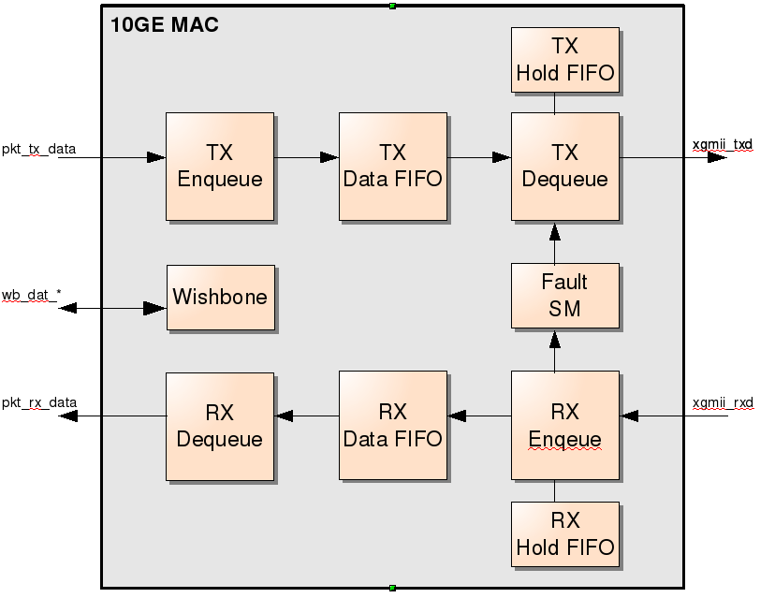Figure 1: Block Diagram

Operation
Operation. TBD.

Registers

Register List
Name | Address | Width | Access | Description
Configuration  Register 0 | 0x00 | 32 | R/W
Interrupt Pending  Register | 0x08 | 32 | COR
Interrupt Status  Register | 0x0c | 32 | RO
Interrupt Mask  Register | 0x10 | 32 | R/W

Configuration Register 0 – 0x00
The registers of the WISHBONE slave unit start at offset 0x180.
RESET VALUE: 0x00000001
Bit # | Name | Description
31 - 1 | Reserved | Reserved field. Reading returns zeros.
0 | TX Enable | When set, transmission of frames is enabled. This bit is set by default.
Table 1: Configuration Register 0

Interrupt Pending Register – 0x08
This register is clear-on-read and provides an indication of pending interrupts.
RESET VALUE: 0x00000000
Bit # | Name | Description
31 - 9 | Reserved | Reserved field. Reading returns zeros.
8 | RX Fragment Error | When set, indicates that a fragment was received. A fragment is a frame that has a start of frame delimiter but no end of frame. Typically it is immediately followed by a new start of frame.
7 | RX CRC Error | When set, indicates that a frame was received with invalid CRC.
6 | RX Pause Frame | When set, indicates that a pause frame was received. Pause frames are discarded.
5 | Remote Fault | When set, indicates that the fault state-machine has transitioned in or out of remote fault condition.
4 | Local Fault | When set, indicates that the fault state-machine has transitioned in or out of local fault condition.
3 | RX Data Fifo Underflow | When set, indicates that the receive data FIFO has experienced underflow. This may occur if “pkt_rx_ren” is asserted when no data is available in the receive FIFO.
2 | RX Data Fifo Overflow | When set, indicates that the receive data FIFO has experienced overflow. This may occur if “pkt_rx_ren” remains de-asserted for a too long period while data is present in the receive FIFO.
1 | TX Data Fifo Underflow | When set, indicates that the transmit data FIFO has experienced underflow. This situation should never occur.
0 | TX Data Fifo Overflow | When set, indicates that the transmit data FIFO has experienced overflow. This may occur if “pkt_tx_val”is asserted and no room is left in the transmit FIFO.
Table 2: Interrupt Pending Register

Interrupt Status Register – 0x0C
This register is read-only and provides a direct status of interrupt lines used to set bits in the Interrupt Pending Register.
RESET VALUE: 0x00000000
Bit # | Name | Description
31 - 0 | Interrupt Status | Each bit corresponds to an interrupt in the Interrupt Pending Register.
Table 3: Interrupt Status Register

Interrupt Mask Register – 0x10
This register is read/write and can be used to enable individual interrupts. By default all interrupts are disabled.
RESET VALUE: 0x00000000
Bit # | Name | Description
31 - 0 | Interrupt Mask | Each bit corresponds to an interrupt in the Interrupt Pending Register. Setting a bit enables the interrupt.
Table 4: Interrupt Mask Register

Clocks
This section describes the various clocks required by the 10GE MAC core.

Name | Frequency | Description
wb_clk_i | 30 - 156Mhz | Wishbone interface clock.
clk_156m25 | 156.25Mhz | Clock for transmit and receive packet interfaces towards user's core logic. “pkt_tx_*” and “pkt_rx_*” signal are timed to this clock.
clk_xgmii_rx | 156.25Mhz | Clock for XGMII receive interface between 10GE MAC core and XAUI/PCS macro.
clk_xgmii_tx | 156.25Mhz | Clock for XGMII transmit interface between 10GE MAC core and XAUI/PCS macro.
Table 5: 10GE MAC Clocks

Resets
This section describes the various resets required by the 10GE MAC core. The user must ensure that each reset is synchronously de-asserted with it's corresponding clock. To ensure that transmit and receive FIFO's are initialized correctly, “reset_156m25_n”, “reset_xgmii_rx_n” and “reset_xgmii_tx_n” must be de-asserted within 2-cycles of each other.

Name | Description
wb_rst_i | Wishbone interface reset. Active high. Must be de-asserted synchronous to wb_clk_i.
reset_156m25_n | Core packet interfaces clock domain reset. Active low. Must be de-asserted synchronous to clk_156m25.
reset_xgmii_rx_n | XGMII receive clock domain reset. Active low. Must be de-asserted synchronous to clk_xgmii_rx.
reset_xgmii_tx_n | XGMII transmit clock domain reset. Active low. Must be de-asserted synchronous to clk_xgmii_tx.
Table 6: 10GE MAC Resets

IO Ports
This section specifies the 10GE MAC core IO ports.

Wishbone Interface
Refer to Wishbone interface specification for more details on these signals.
Port | Direction | Description
wb_adr_i [7:0] | Input | Address input. All accesses to core must be 32-bit. Bits 0 and 1 are not used.
wb_cyc_i | Input | Wishbone cycle.
wb_dat_i [31:0] | Input | Wishbone data input.
wb_stb_i | Input | Wishbone strobe.
wb_we_i | Input | Wishbone write enanle.
wb_ack_o | Output | Wishbone acknowledge.
wb_dat_o [31:0] | Output | Wishbone data output.
wb_int_o | Output | Wishbone interrupt signal. Active high.
Table 7: List of IO ports

Packet Receive Interface
This interface is used to transfer received packets to the FPGA/ASIC core logic.
Port | Direction | Description
pkt_rx_ren | Input | Receive Read Enable: This signal should only be asserted when a packet is available in the receive FIFO. When asserted, the 10GE MAC core will begin packet transfer on next cycle. Signal should remain asserted until EOP becomes valid.
pkt_rx_avail | Output | Receive Available: Indicates that a packet is available for reading in receive FIFO.
pkt_rx_data [63:0] | Output | Receive Data: Little-endian format. First byte of packet will appear on pkt_rx_data[7:0].
pkt_rx_eop | Output | Receive End of Packet: Asserted when the last word of a packet is read from receive FIFO.
pkt_rx_val | Output | Receive Valid: Indicates that valid data is present on the bus. This signal is typically asserted one cycle after pkt_rx_ren was asserted unless FIFO underflow occurs.
pkt_rx_sop | Output | Receive Start of Packet: Indicates that the first word of a frame is present on the bus.
pkt_rx_mod [2:0] | Output | Receive Packet Length Modulus: Valid during EOP. Indicates valid bytes during last word:  0: pkt_rx_data[63:0] is valid  1: pkt_rx_data[7:0] is valid  2: pkt_rx_data[15:0] is valid  3: pkt_rx_data[23:0] is valid  4: pkt_rx_data[31:0] is valid  5: pkt_rx_data[39:0] is valid  6: pkt_rx_data[47:0] is valid  7: pkt_rx_data[55:0] is valid
pkt_rx_err | Output | Receive Error: When asserted during a transfer, indicates that current packet is bad and should be discarded by user's logic. This signal is most likely asserted as the result of a CRC error.
Table 8: List of IO ports

Packet Transmit Interface
This interface accepts packets from the FPGA/ASIC core logic.
Port | Direction | Description
pkt_tx_data [63:0] | Input | Transmit Data: Little-endian format. First byte of packet must appear on pkt_rx_data[7:0].
pkt_tx_val | Input | Transmit Valid: This signal must be asserted for each valid data transfer to the 10GE MAC.
pkt_tx_sop | Input | Transmit Start of Packer: This signal must be asserted during the first word of a packet.
pkt_tx_eop | Input | Transmit End of Packet: This line must be asserted during the last word of a packet.
pkt_tx_mod [2:0] | Input | Transmit Packet Length Modulus: Valid during EOP. Indicates valid bytes during last word:  0: pkt_tx_data[63:0] is valid  1: pkt_tx_data[7:0] is valid  2: pkt_tx_data[15:0] is valid  3: pkt_tx_data[23:0] is valid  4: pkt_tx_data[31:0] is valid  5: pkt_tx_data[39:0] is valid  6: pkt_tx_data[47:0] is valid  7: pkt_tx_data[55:0] is valid
pkt_tx_full | Output | Transmit Full: This signal indicates that transmit FIFO is nearing full and transfers should be suspended at the end of the current packet. Transfer of next packet can begin as soon as this signal is de-asserted.
Table 9: List of IO ports

XGMII Receive Interface
This interface accepts data or control character from XAUI/PCS macro. A normal XGMII interface is made of a 32-bit data bus clocked on rising and falling edges of the clock. For simplicity the 10GE MAC uses a 64-bit interface clocked on the rising edge only.
Port | Direction | Description
xgmii_rxc [7:0] | Input | XGMII Receive Control: Each bit corresponds to a byte on the 64-bit interface. When high, indicates that the byte is a control character. When low, indicates that the byte carries data.
xgmii_rxd [63:0] | Input | XGMII Receive Data: When interfacing with 32-bit devices, xgmii_rxd[31:0] should be mapped to the rising edge of the clock and xgmii_rxd[63:32] should be mapped to the falling edge.
Table 10: List of IO ports

XGMII Transmit Interface
This interface transmits data and control character towards the XAUI/PCS macro. A normal XGMII interface is made of a 32-bit data bus clocked on rising and falling edges of the clock. For simplicity the 10GE MAC uses a 64-bit interface clocked on the rising edge only.
Port | Direction | Description
xgmii_txc [7:0] | Output | XGMII Transmit Control: Each bit corresponds to a byte on the 64-bit interface. When high, indicates that the byte is a control character. When low, indicates that the byte carries data.
xgmii_txd [63:0] | Output | XGMII Transmit Data: When interfacing with 32-bit devices, xgmii_txd[31:0] should be mapped to the rising edge of the clock and xgmii_txd[63:32] should be mapped to the falling edge.
Table 11: List of IO ports

Waveforms

Wishbone Interface
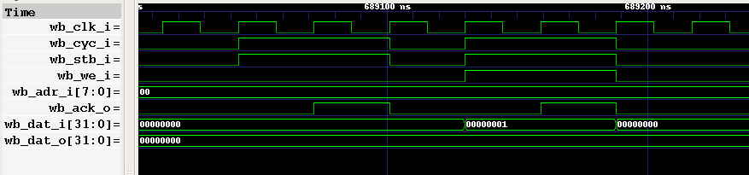Figure 2: Wishbone Waveforms

Packet Receive Interface
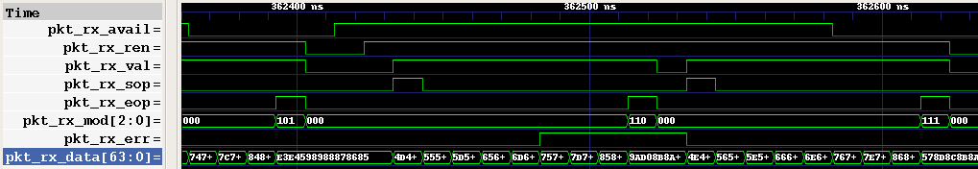Figure 3: Packet Receive Interface Waveforms

Packet Transmit Interface
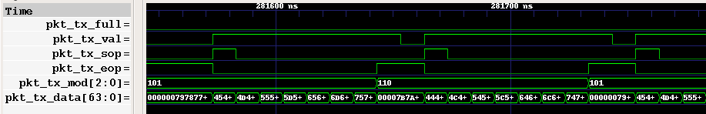Figure 4: Packet Transmit Interface Waveforms

XGMII Receive Interface
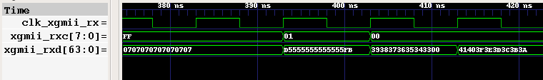Figure 5: XGMII Receive Interface Waveforms

XGMII Transmit Interface
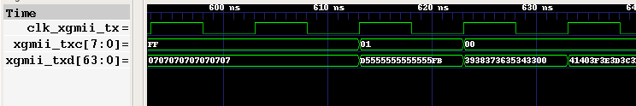Figure 6: XGMII Transmit Interface Waveforms

