IOT(INTERNET OF THINGS)

WHAT IS IOT?

# The internet of things, or IoT, is a system of interrelated computing devices, mechanical and digital machines, objects, animals or people that are provided with unique identifiers ([UIDs](https://internetofthingsagenda.techtarget.com/definition/unique-identifier-UID)) and the ability to transfer data over a network without requiring human-to-human or human-to-computer interaction.

# A [*thing*](https://internetofthingsagenda.techtarget.com/definition/thing-in-the-Internet-of-Things) in the internet of things can be a person with a heart monitor implant, a farm animal with a [biochip transponder](https://internetofthingsagenda.techtarget.com/definition/injectable-ID-chip-biochip-transponder), an automobile that has built-in [sensors](https://www.techtarget.com/whatis/definition/sensor) to alert the driver when tire pressure is low or any other natural or man-made object that can be assigned an Internet Protocol (IP) address and is able to transfer data over a network.

# Increasingly, organizations in a variety of industries are using IoT to operate more efficiently, better understand customers to deliver enhanced customer service, improve decision-making and increase the value of the business.

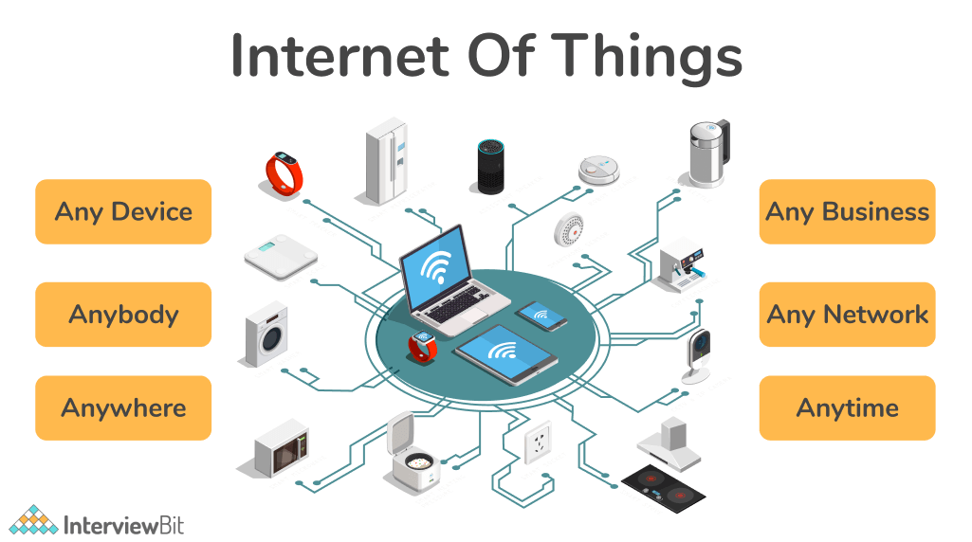

HOW IOT WORKS ?

# An IoT ecosystem consists of web-enabled smart devices that use embedded systems, such as processors, sensors and communication hardware, to collect, send and act on data they acquire from their environments. [IoT devices](https://internetofthingsagenda.techtarget.com/definition/IoT-device) share the sensor data they collect by connecting to an IoT gateway or other edge device where data is either sent to the cloud to be analyzed or analyzed locally.

# Sometimes, these devices communicate with other related devices and act on the information they get from one another. The devices do most of the work without human intervention, although people can interact with the devices -- for instance, to set them up, give them instructions or access the data.

# The connectivity, networking and communication protocols used with these web-enabled devices largely depend on the specific IoT applications deployed.

# IoT can also make use of artificial intelligence (AI) and machine learning to aid in making data collecting processes easier and more dynamic.

# how-iot-works.jpg

# 

WHY IOT IS IMPORTANT?

# The internet of things helps people live and work smarter, as well as gain complete control over their lives. In addition to offering smart devices to automate homes, IoT is essential to business. IoT provides businesses with a real-time look into how their systems really work, delivering insights into everything from the performance of machines to supply chain and logistics operations.

# IoT enables companies to automate processes and reduce labor costs. It also cuts down on waste and improves service delivery, making it less expensive to manufacture and deliver goods, as well as offering transparency into customer transactions. As such, IoT is one of the most important technologies of everyday life, and it will continue to pick up steam as more businesses realize the potential of connected devices to keep them competitive

BENEFITS OF IOT:-

- Efficient resource utilization

- Save time and money

- Human efforts and errors

- SECURITY

- User friendly and easy to use

IOT BENEFITS TO ORGANISATION

# The internet of things offers several benefits to organizations. Some benefits are industryspecific, and some are applicable across multiple industries. Some of the common benefits of IoT enable businesses to:

* UNPRECENTED POSSIBILITIES
* IMPROVED CUSTOMER EXPERIENCE
* REDUCED OPERATIONAL COST
* ELEVATE PRODUCTIVITY
* BETTER ASSET UTILIZATION
* REAL TIME ANALYTICS
* IMPROVED SAFETY AND SECURITY
* ADVANCE COST OPTIMIZATION

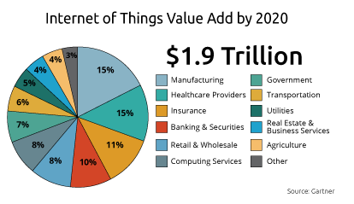

Wireless Technologies

**• Telecommunication systems**

– Initial/primary service: mobile voice telephony

– Large coverage per access point (100s of meters – 10s of kilometers)

– Low/moderate data rate (10s of kbit/s – 10s of Mbits/s)

– Examples: GSM, UMTS, LTE

**• WLAN**

– Initial service: Wireless Ethernet extension

– Moderate coverage per access point (10s – 100s meters)

– Moderate/high data rate (Mbits/s – 100s)

– Examples: IEEE 802.11(a-g), Wimax

**• Short range**

– Direct connection between devices

– sensor networks

– Typical low power usage

– Examples: Bluetooth, Zigbee, Z-wave (house products)

**• Other examples**

– Satellite systems

• Global coverage

• Applications: audio/TV broadcast, positioning, personal communications

– Broadcast systems

• Satellite/terrestrial

• Support for high speed mobiles

– Fixed wireless access

`• Several technologies including DECT, WLAN, IEEE802.16, etc.

PROS AND CONS OF IOT

**ADVANTAGES OF IOT:-**

* **SAVE TIME**
* **MINIMIZE HUMAN EFFORT**
* **ENHANCED DATA COLLECTION**
* **IMPROVED SECURITY**
* **EFFICIENT RESOURCE UTILIZATION**
* **USEFUL IN HEALTHCARE INDUSTRY**

**DISADVANTAGES OF IOT:-**

* **SECURITY ISSUES**
* **PRIVACY CONCERN**
* **INCREASED UNEMPLOYMENT**
* **REDUCED MENTAL AND PHYSICAL ACTIVITY**
* **HIGH DEPENDENCY ON THE INTERNET**
* **THE COMPLEXITY OF THE SYSTEM**

IoT standards and frameworks

**There are several emerging IoT standards, including the following:**

* [IP**v6**](https://www.techtarget.com/searchnetworking/definition/IPv6-Internet-Protocol-Version-6)**over Low-Power Wireless Personal Area Networks (6LoWPAN)** is an open standard defined by the Internet Engineering Task Force ([IETF](https://www.techtarget.com/whatis/definition/IETF-Internet-Engineering-Task-Force)). The 6LoWPAN standard enables any low-power radio to communicate to the internet, including 804.15.4, Bluetooth Low Energy ([BLE](https://internetofthingsagenda.techtarget.com/definition/Bluetooth-Low-Energy-Bluetooth-LE)) and [Z-Wave](https://internetofthingsagenda.techtarget.com/definition/Z-Wave) (for home automation).
* [**ZigBee**](https://internetofthingsagenda.techtarget.com/definition/ZigBee) is a low-power, low-data rate wireless network used mainly in industrial settings. ZigBee is based on the Institute of Electrical and Electronics Engineers (IEEE) 802.15.4 standard. The ZigBee Alliance created Dotdot, the universal language for IoT that enables smart objects to work securely on any network and understand each other.
* [**LiteOS**](https://www.techtarget.com/whatis/definition/LiteOS) is a Unix-like operating system (OS) for wireless sensor networks. LiteOS supports smartphones, [wearables](https://www.techtarget.com/searchmobilecomputing/definition/wearable-technology), intelligent manufacturing applications, [smart homes](https://internetofthingsagenda.techtarget.com/definition/smart-home-or-building) and the internet of vehicles (IoV). The OS also serves as a smart device development platform.
* **OneM2M** is a machine-to-machine service layer that can be embedded in software and hardware to connect devices. The global standardization body, OneM2M, was created to develop reusable standards to enable IoT applications across different verticals to communicate.
* [Data Distribution Service (DDS)](https://internetofthingsagenda.techtarget.com/definition/Internet-of-Things-IoT) was developed by the Object Management Group (OMG) and is an IoT standard for real-time, scalable and high-performance [M2M](https://internetofthingsagenda.techtarget.com/definition/machine-to-machine-M2M) communication.
* **Advanced Message Queuing Protocol (**[**AMQP**](https://www.techtarget.com/whatis/definition/Advanced-Message-Queuing-Protocol-AMQP)**)** is an open source published standard for asynchronous messaging by wire. AMQP enables encrypted and interoperable messaging between organizations and applications. The protocol is used in [client-server](https://www.techtarget.com/searchnetworking/definition/client-server) messaging and in IoT device management.
* **Constrained Application Protocol (**[**CoAP**](https://www.techtarget.com/whatis/definition/Constrained-Application-Protocol)**)** is a protocol designed by the IETF that specifies how low-power, compute-constrained devices can operate in the internet of things.
* **Long Range Wide Area Network (LoRaWAN)** is a protocol for WANs designed to support huge networks, such as smart cities, with millions of low-power devices.

**IoT frameworks include the following:-**

• Amazon Web Services (AWS) IoT is a cloud computing platform for IoT released by Amazon. This framework is designed to enable smart devices to easily connect and securely interact with the AWS cloud and other connected devices.

• Arm Mbed IoT is a platform to develop apps for IoT based on Arm microcontrollers. The goal of the Arm Mbed IoT platform is to provide a scalable, connected and secure environment for IoT devices by integrating Mbed tools and services.

• Microsoft's Azure IoT Suite is a platform that consists of a set of services that enables users to interact with and receive data from their IoT devices, as well as perform various operations over data, such as multidimensional analysis, transformation and aggregation, and visualize those operations in a way that's suitable for business.

• Google's Brillo/Weave is a platform for the rapid implementation of IoT applications. The platform consists of two main backbones: Brillo, an Androidbased OS for the development of embedded low-power devices, and Weave, an IoT-oriented communication protocol that serves as the communication language between the device and the cloud.

• Calvin is an open source IoT platform released by Ericsson designed for building and managing distributed applications that enable devices to talk to each other. Calvin includes a development framework for application developers, as well as a runtime environment for handling the running application.

**CONSUMER AND ENTERPRISE IOT APPLICATIONS :-**

There are numerous real-world applications of the internet of things, ranging from consumer IoT and enterprise IoT to manufacturing and industrial IoT (IIoT).

IoT applications span numerous verticals, including automotive, telecom and energy. In the consumer segment, for example, smart homes that are equipped with smart thermostats, smart appliances and connected heating, lighting and electronic devices can be controlled remotely via computers and smartphones.

Wearable devices with sensors and software can collect and analyze user data, sending messages to other technologies about the users with the aim of making users' lives easier and more comfortable.

Wearable devices are also used for public safety -- for example, improving first responders' response times during emergencies by providing optimized routes to a location or by tracking construction workers' or firefighters' vital signs at lifethreatening sites.

In healthcare, IoT offers many benefits, including the ability to monitor patients more closely using an analysis of the data that's generated. Hospitals often use IoT systems to complete tasks such as inventory management for both pharmaceuticals and medical instruments

WHAT IS THE FUTURE OF IOT :-