Node.js :

notes.txt file will create

App.js

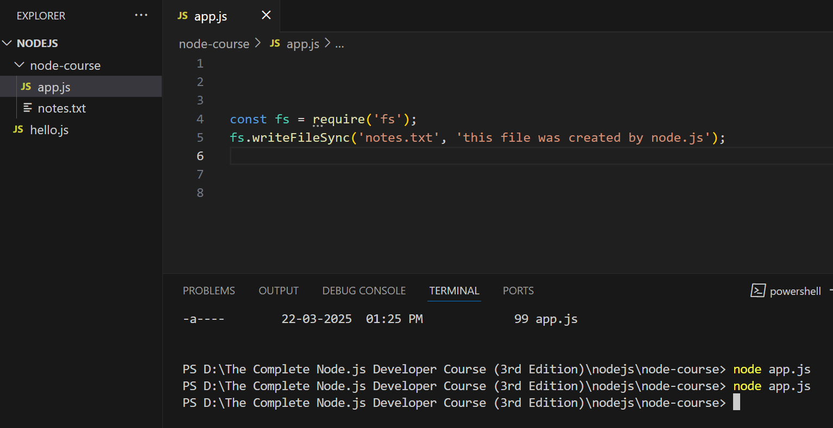

const fs = require('fs');

//fs.writeFileSync('notes.txt', 'this file was created by node.js');

fs.appendFileSync('notes.txt', ' I live in philadelphia.')

appending file

const fs = require('fs');

//fs.writeFileSync('notes.txt', 'this file was created by node.js');

fs.appendFileSync('notes.txt', ' I live in philadelphia.')

notes.txt ->

this file was created by node.js I live in philadelphia.

