Phoenix Quiz Web Application Flowchart and Storyboard

Final project

php+jAVASCRIPT+HTML+CSS

Zhilin Lin, Zhaosheng Liu, Peng Gao | 420-P75-AB PHP Programming | 2020-04-04

# Web pages we need build in this web site

The user can be either teachers or students. Teachers’ login information is written at the backend database by administrator for security reasons. Any user logged in from the web site by default is a student. Because of the functionality and authorization difference, teacher and student will need to have the following web pages designed in this website:

* Teacher mode:
  + Home page: index.php
  + Login page: login.php (teacher’s credentials have been saved in database already by database admin, no teacher registers available on the website)
  + Question page: question.php
* Student mode:
  + Home page: index.php
  + Register page: register.php
  + Login page: login.php
  + Quiz page: quiz.php
  + Result page: summary.php (print button designed in this page for student to generate result in PDF file for printing)

# Flowchart of the webpages

The relationships and interactions between the pages are shown in the following flow chart.

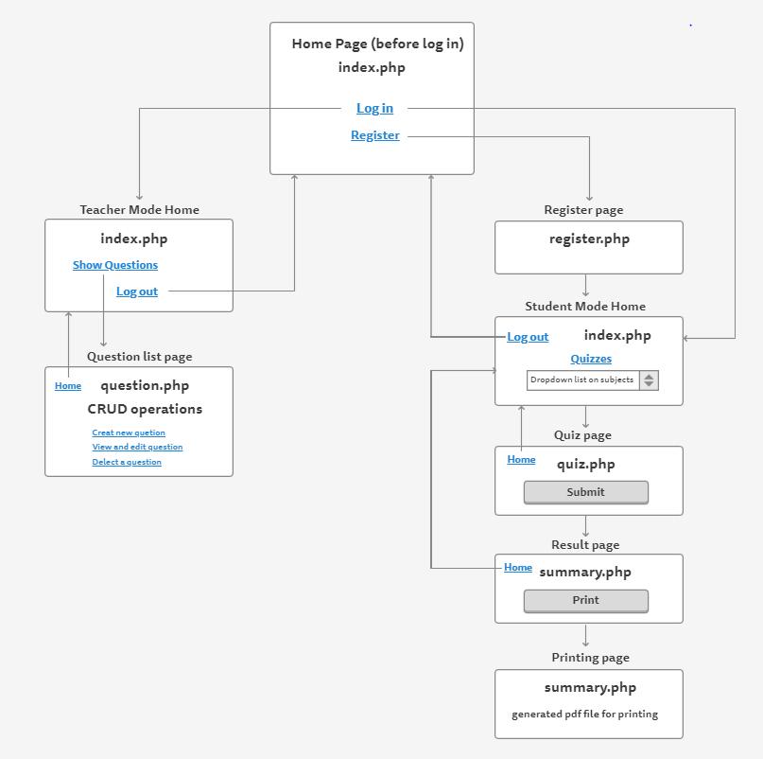

The flowchart is made from the following URL:

<https://www.gomockingbird.com/projects/0f81m4s/4gXVnC>

We designed our website wire frame at the following URL:

<https://www.gomockingbird.com/projects/tjw0jsu/4gXVnC>