Freedom Fone


Non-technical
User Guide
Freedom Fone Pictus Lupinus 1.5.2

March 2010
Author: IT46
Version 1.5.2

The Poll Service
Functionality
The Poll service allows end users to participate in polls by sending SMSs to Freedom Fone.
The Freedom Fone administrator has the ability to create, edit and delete polls. A poll is composed using the following parameters:
- Question: The question you want your audience to answer
- Code: The poll code to be included as the first word in an SMS vote participating in the poll
- Answers: Two or more answers to the question.
- Start time: Date and time when the poll opens for submission
- End time: Date and time when the poll closes for submission
Poll details can be communicated with the public via any means, including website, email and printed materials. Remember to share the above details and include the phone number or short code to which participants should send their SMS replies.
The administrator can at any time edit the above listed fields. Of course, it is not recommended to change the question, code or answers to a poll once it has been opened to the public. Before a poll is opened, and after it has been closed, no poll votes are registered for the poll.
For each poll, once it has started, the administrator can at anytime, view the interim or final result in terms of number of votes per answer, and percentage of total votes per answer.
The system classifies all incoming votes as valid, invalid, or incorrect:
Valid vote: correct poll code, and correct poll option
  - Early: Received before the poll opened.
  - In time Received while the poll was open.
  - Late: Received after the poll was closed.
Early votes will be registered as ”Valid, early”. The number of early votes per poll option is presented in a separate column under the View poll page. Early votes will not be added to the Total votes accepted for the poll.
Late votes will be registered as “Valid, late”. The number of late votes per poll option is presented in a separate column under the View poll page. Late votes will not be added to the Total votes accepted for the poll.
The Early and Late vote classifications are summarised separately to provide a complete view of votes submitted to the poll concerned.

Invalid vote: correct poll code, but a non-matching poll option
Invalid votes are registered as votes, but classified as “invalid”. “Early”, “late” and “on-time” invalid votes are registered.
Only “on-time” invalid votes are incorporated into the Total number of votes (in time) summary.
Invalid vote totals are provided to give deployers an idea of how SMS errors might impact on poll results.
Incorrect vote: Non-matching poll code
Incorrect votes that cannot be matched to any existing poll, will be classified as an incoming SMS and will be stored under “Other SMS”. The SMS will be classified as “Unclassified”.
The poll is not sensitive to casing, so 'yes' ,'Yes', 'YES', 'yEs' will all be interpreted as a YES. The same logic applies to the SMS code. More than one poll can be active at the same time. Incoming SMS are identified by the SMS code used and matched with existing polls.
The timestamp used to determine whether or not a vote is in time for a poll, is the time of arrival to the Freedom Fone platform. Hence, if an SMS gets delayed in the GSM network, it will be classified as late even if it was sent before the poll deadline.

Example: The administrator creates a poll with the following parameters:
Question: Would you like to deploy Freedom Fone in your organization?
Code: freedomfone
Answer: Yes/No/Maybe
Start time: 08:00 AM, January 1, 2010
End time: 08:00 AM, Jan 31, 2010
To participate in the poll, the end user needs to send an SMS that arrives after 08:00 AM the 1st of January, and before 08:00 AM the 31st of January 2010 with one of the following messages:
freedomfone yes
freedomfone no
freedomfone maybe

The Leave-a-message service
Functionality
The Leave-a-Message service offers callers the option to call into Freedom Fone, and leave their personal message. This may be a report, feedback, tip-off, response to a question, or perhaps a job application.
A caller using the Leave-a-message service is connected to a voice menu created by the Freedom Fone administrator. The voice menu greets the caller and provides instructions as to how to use the service. The Leave-a-message service allows the caller to
- Record a message
- Listen to their recorded message
- Delete and record a new message OR
- Save their message and exit

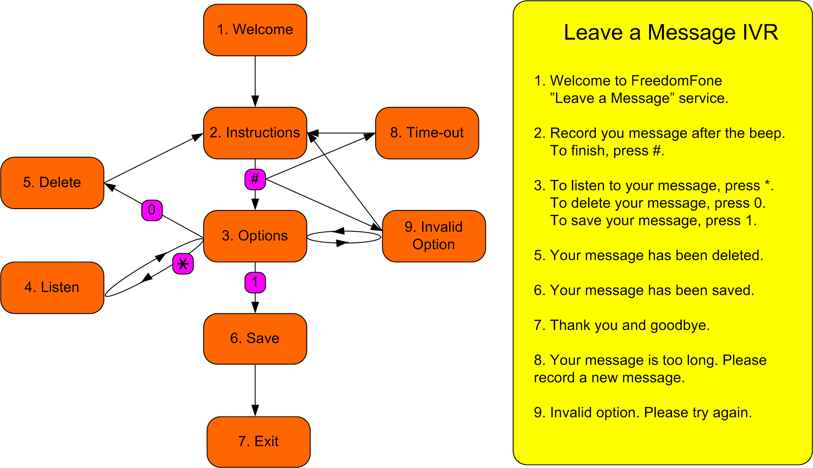

By using the buttons # (hash), * (star), 0 (zero) and 1 (one), the user is able to navigate through the menu according to the illustration above.

The Leave-a-message Voice Menu
The Leave-a-message voice menu is created by the administrator. The menu consists of eight different messages. Each message can be generated in three different ways:
- Customised audio files
- Customised text to speech
- Default text to speech

If the administrator associates an audio file with a message, that file will be played to the caller when she enters the voice menu.
If no audio file is provided for a message, but a customised text message exists, the text message will be synthesized and played to the caller.
If neither an audio file, nor a customised text is provided, the default text will be synthesized and played to the caller.
The audio files must be uploaded in either .mp3 or .wav format through the user interface. Once uploaded, they can be listened to from the administration GUI via the built-in Flashplayer. Audio files can at any time be overwritten with a new audio file.

Received voice messages
The Freedom Fone administrator receives all incoming messages to the “Inbox”. For each message, the administrator can
- listen to it (with a built-in Flashplayer)
- name it (give the message a title)
- assign a category
- associate the message with one or more tags
- give the message a rating (1-5)
The administrator can also choose to delete a message, or to archive it for future use.

Voice Menus
Functionality
The administrator is able to build a variety of Voice Menus based on customised audio files and synthesized text messages.
A voice menu consists of:
- Menu Instructions: a set of mandatory voice messages, such as a Welcome message, and instructions on how to navigate through the menu.
- Menu Options: audio files or components associated with telephone keypad selections.

A Menu Instruction can either be a text message (that is automatically synthesized) or an uploaded audio file. If an audio file is to be used it must be uploaded from your local computer by either clicking in the relevant Audio file text box or clicking the associated ‘Browse’ button. You can revert to using a synthesized text message by “un-associating” the uploaded file. The audio file is not deleted and can be used in the Voice Menu at a later stage, by “associating” the file with the Menu Instruction once again.
A Menu Option can either be
- an audio file previously uploaded through the Menu option files screen, or
- a Leave-a-Message service
The administrator can at any time add, edit, listen to or delete existing Menu Options.
Menu option files can be .mp3 or .wav audio files. When they are uploaded into the system they are associated with a Title to help you manage your audio files.
A Menu option file can be used in one or more different Voice Menus. These files cannot be deleted if they are currently associated with a Voice Menu.
Freedom Fone v.1.5 offers the possibility to assign eight Menu Options to a Voice Menu.
Note that digits 0 and 9 are reserved for future use. They will be used as navigation keys once nested voice menu functionality has been added.
The design of a Voice Menu is illustrated below.
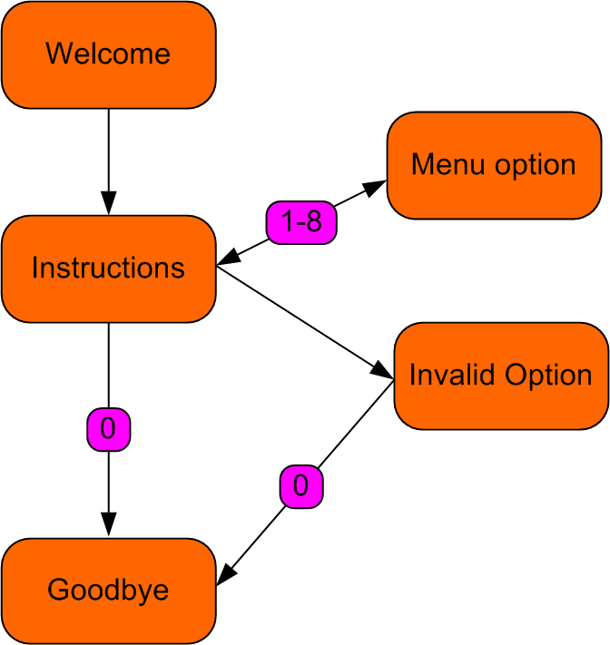
The administrator can create multiple Voice Menus, but only one can be active at a time (marked as Default). The administrator can at any time edit or delete a Voice Menu. If the default Voice menu is deleted, the oldest existing Voice Menu will automatically become the new default.
The administrator can at any time change the default Voice Menu.

Monitoring
Freedom Fone offers the administrator a means to monitor the features and audio files accessed by callers via a voice menu. For each incoming call to a Voice Menu, the caller's options are recorded (time, ivr, digit pressed, menu option, caller number).
These call records can be exported to a CSV file. The administrator can choose to export All entries, or a range of entries using a start and end time.
Where privacy is a concern, the administrator can choose to delete all monitoring data from the system (using start and end time).

Dashboard
The Dashboard gathers useful information about the system’s software and hardware and offers the opportunity to start and stop major components.

System Health
The System Health page displays the current status of the telephony application – FreeSWITCH - and the incoming and outgoing dispatchers handling the calls and SMSs. The dispatchers can be stopped and started by the administrator.

Software
Software versions of database, web server, FreeSWITCH and dispatcher are displayed. The versions are dynamically updated when software updates take place.

Hardware
A list of connected GSM gateways are displayed with relevant information.

Call Data Records (CDR)
Call data records (CDR) of all incoming calls (from Leave-a-message and Voice Menus) are displayed with the following parameters: unique call id, start time, end time, caller number, application
CDR can be exported to a CSV file. The administrator can choose to export All entries, or a range of entries using a start and end time.

