The Poll Service
Functionality
The Poll service allows end users to participate in polls by sending SMSs to Freedom Fone.
The Freedom Fone administrator has the ability to create, edit and delete polls. A poll is composed using the following parameters:
- Question: The question you want your audience to answer to
- Code: The SMS code to use, to associate an incoming SMS with your poll
- Answers: Two or more answers to the question.
- Start time: Date and time when the poll opens for submission
- End time: Date and time when the poll closes for submission
Poll details can be communicated with the public via any means, including website, email and printed materials. Remember to share the above details and include the phone number or short code to which participants should send their SMS replies.
The administrator can at any time edit the above listed fields. Of course, it is not recommended to change the question, code or answers to a poll, once it has been opened to the public.
Before a poll is opened, and after it has been closed, no poll votes are registered for the poll.
For each poll, the administrator can view the result in terms of number of votes per answer, and percentage of total votes per answer.
The poll is not sensitive to casing, so 'yes' ,'Yes', 'YES', 'yEs' will all be interpreted as a YES! The same logic applies to the SMS code.
More than one poll can be active at the same time. Incoming SMS are identified by the SMS code in use.

Example: The administrator creates a poll with the following parameters:
Question: Would you like to deploy Freedom Fone in your organization?
Code: freedomfone
Answer: Yes/No/Maybe
Start time: 08:00 AM, January 1, 2010
End time: 08:00 AM, Jan 31, 2010

To participate in the poll, the end user needs to send an SMS (after 08:00 AM the 1st of January, and before 08:00 AM the 31st of January 2010) with the following message:
freedomfone yes

The Leave-a-message service
Functionality
The Leave-a-Message service offers callers the option to call into Freedom Fone, and leave their personal message. This may be a report, feedback, tip-off, response to a question, or perhaps a job application.
A caller using the Leave-a-message service is connected to a voice menu created by the Freedom Fone administrator. The voice menu greets the caller and provides instructions as to how to use the service. The Leave-a-message service allows the caller to
- Record a message
- Listen to their recorded message
- Delete and record a new message OR
- Save their message and exit
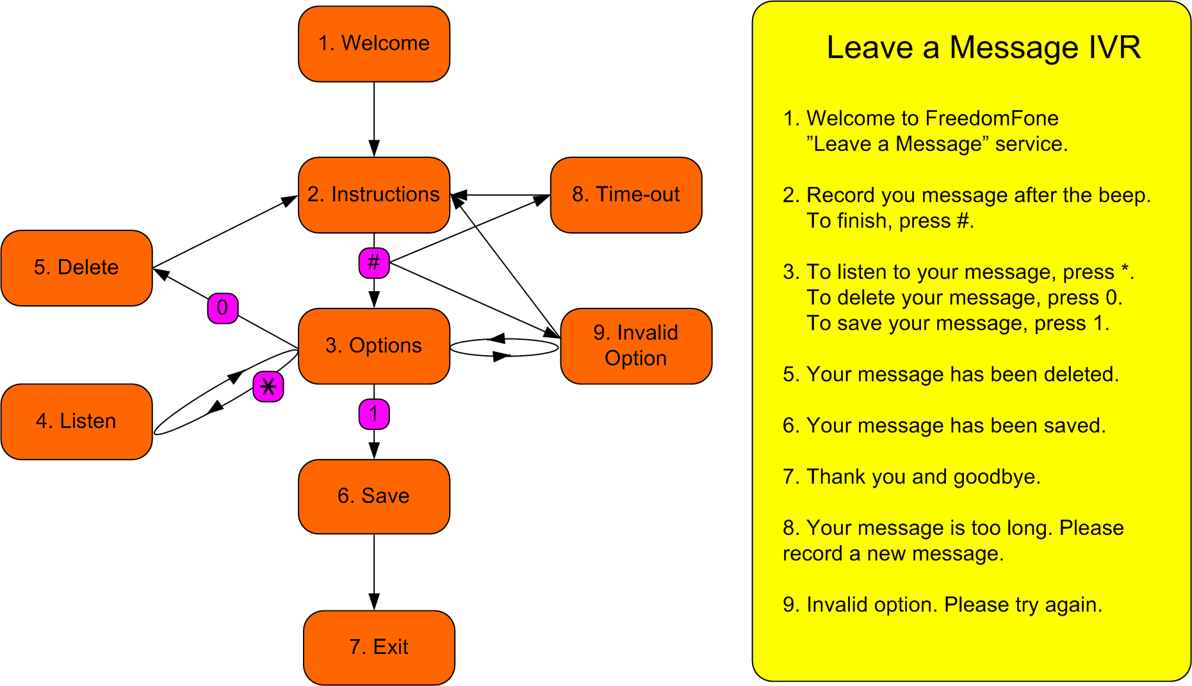

By using the buttons # (hash), * (star), 0 (zero) and 1 (one), the user is able to navigate through the menu according to the illustration above.

The Leave-a-message Voice Menu
The Leave-a-message voice menu is created by the administrator. The menu consists of eight different messages. Each message can be generated in three different ways:
- Customized audio files
- Customized text to speech
- Default text to speech

If the administrator associates an audio file with a message, that file will be played to the caller when she enters the voice menu.
If no audio file is provided for a message, but a customized text message exists, the text message will be synthesized and played to the caller.
If neither an audio file, nor a customized text is provided, the default text will be synthesized and played to the user.
The audio files must be uploaded in .wav format through the user interface. Once uploaded, they can be listened to from the administration GUI via the built-in Flashplayer. Audio files can at any time be overwritten with a new audio file.

Received voice messages
The Freedom Fone administrator receives all incoming messages to the “Inbox”. For each message, the administrator can
- listen to it (with a built-in Flashplayer)
- name it (give the message a title)
- assign a category
- associate the message with one or more tags
- give the message a rating (1-5)
The administrator can also choose to delete a message, or to archive it for future use.

Voice Menus
Functionality
The administrator is able to build personal Voice Menus based on customized audio files, or synthesized text messages.
A voice menu consists of:
- a set of mandatory voice messages, such as a Welcome message, and instructions on how to navigate through the menu,
- pointers to so called nodes, that contain the actual content.
A node is the combination of a customized audio file, with a text based title. A node can be used in one or more Voice Menus. The administrator can at any time add, edit, listen to or delete existing nodes.
Freedom Fone v.1 offers the possibility to assign five nodes to a Voice Menu. The design of a Voice Menu is illustrated below.
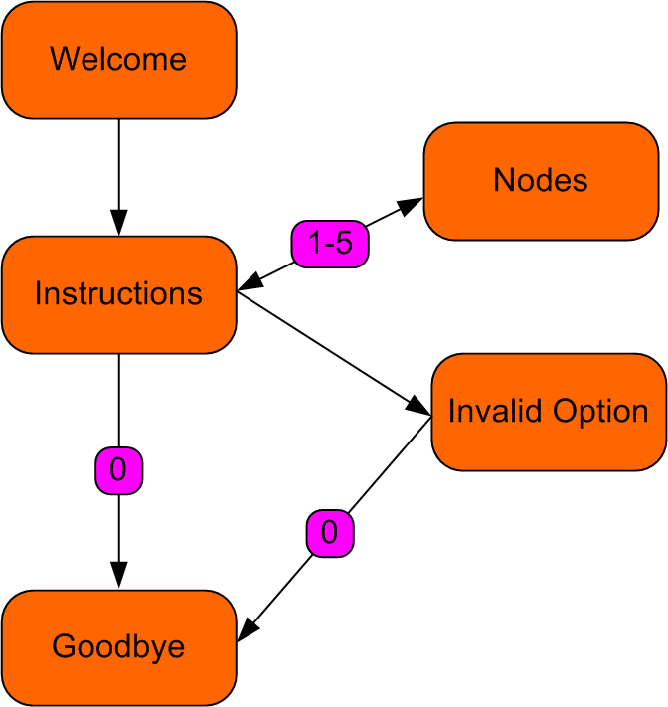

The administrator can create multiple Voice Menus, but only one can be active at a time (marked as Default). The administrator can at any time edit or delete a Voice Menu. If the default Voice menu is deleted, the oldest existing Voice Menu will automatically become the new default.
The administrator can at any time change the default Voice Menu.

Callback
Functionality
The Callback service offers callers a means to access audio content from Freedom Fone at a low cost, or at no cost at all. As the name suggests, the Callback service establishes outgoing phone calls from Freedom Fone to a caller, with the Freedom Fone deployer carrying the cost of the call.
To request a Callback from Freedom Fone, the caller can either
- send an SMS to a designated number with the text “callback”, or
- tickle a designated number (ring once and hang up)
The cost to the caller will either be the cost for an SMS, or nothing (if you hang up after the first ring).

Administration settings
The administrator can choose which content to connect with the Callback service. The options for Freedom Fone v.1 are
- Leave-a-message menu OR
- Default Voice Menu

To limit the risk of abuse of the Callback service, the administrator can limit the maximum number of Callbacks for a unique GSM number for a certain period of time.
- Max Calls: 10, 25, 50, 100, no limit
- Period : 12h, 24h, 2d, 4d, 1 week

The administration parameters can be found under Settings.

