EAST WEST INSTITUTE OF TECHNOLOGY
Department of CSE (IoT and Cyber Security including Blockchain Technology)
Academic Year 2026-27 | 7th Semester
Machine Learning [BIC703]
PHASE 1 EVALUATION REPORT (40 MARKS)
EMPLOYEE ATTRITION PREDICTION USING MACHINE LEARNING
Course Instructor: P Bharath Krishna
Team Members: Student Project Team (USN: 1EW23CS001, 1EW23CS002)
Phase 1 Timeline: Weeks 1 to 5 (17th Aug 2026 – 14th Sep 2026)

1. Problem Statement & Objectives
Voluntary employee attrition creates significant costs and operational disruptions for organizations. The objective of this project is to build an explainable binary classification model to predict whether an employee will leave the company based on demographic, compensation, tenure, and satisfaction features.

2. Problem Formulation
This task is formulated as supervised binary classification. Target variable: Attrition ∈ {No: 0, Yes: 1}. Due to the 83.9% / 16.1% class imbalance, model performance must be evaluated via F1-score, Precision, Recall, and ROC-AUC.

3. Dataset Description & Data Quality
The IBM HR Analytics dataset contains 1,470 records and 35 features. Data quality assessment reveals 0 missing values and 0 duplicate rows. Four non-informative columns were removed (EmployeeNumber, EmployeeCount, Over18, StandardHours).

4. Exploratory Data Analysis (EDA Visualizations)
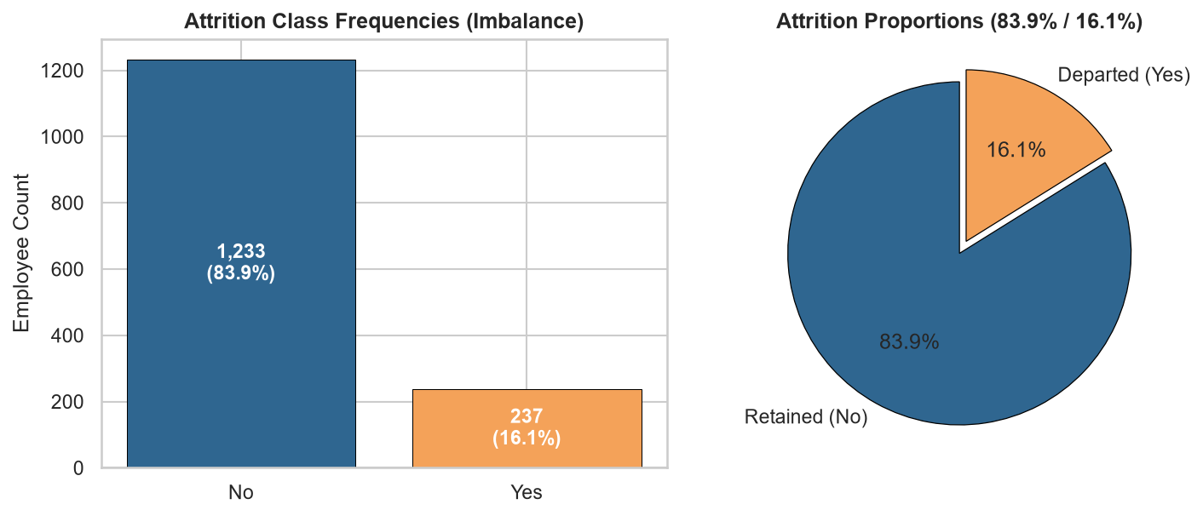
Figure 1: Attrition Target Class Imbalance (83.9% / 16.1%)

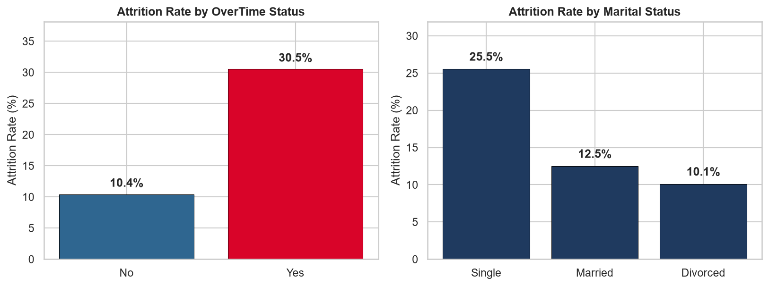
Figure 2: OverTime & Marital Status Attrition Disparities

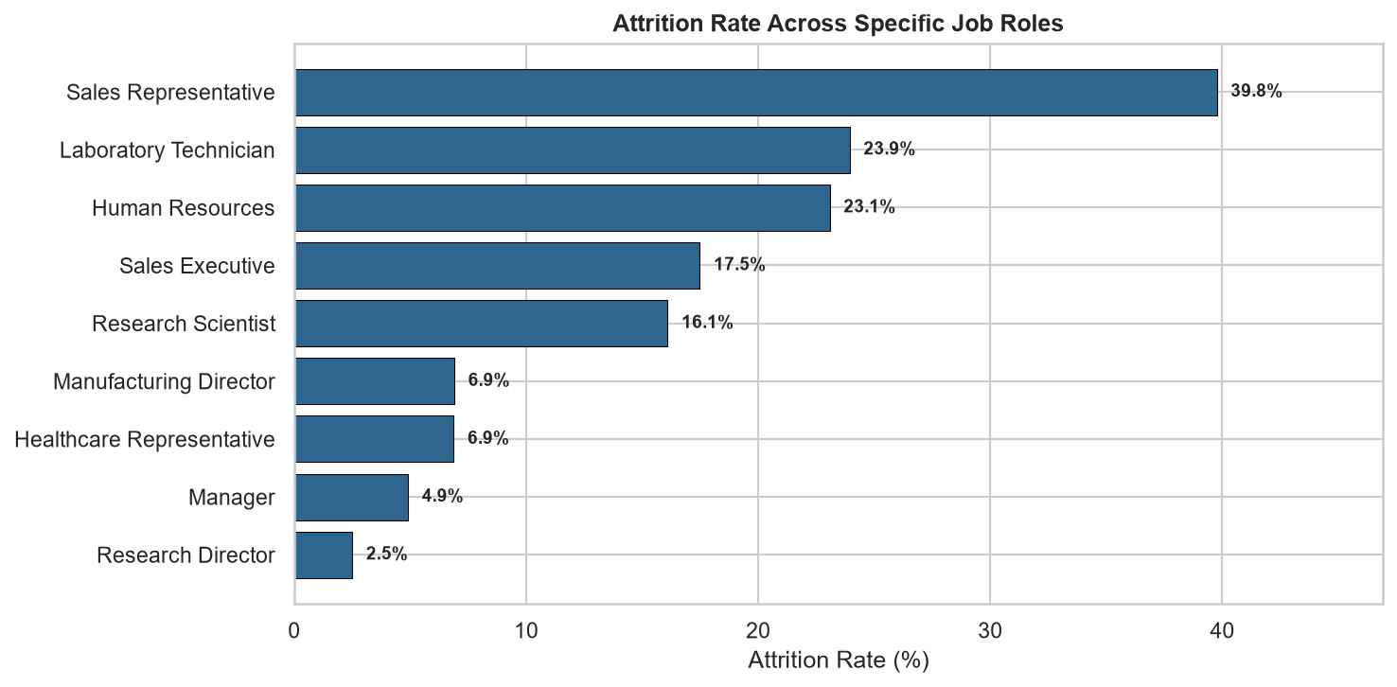
Figure 3: Attrition Rates Across Specific Job Roles

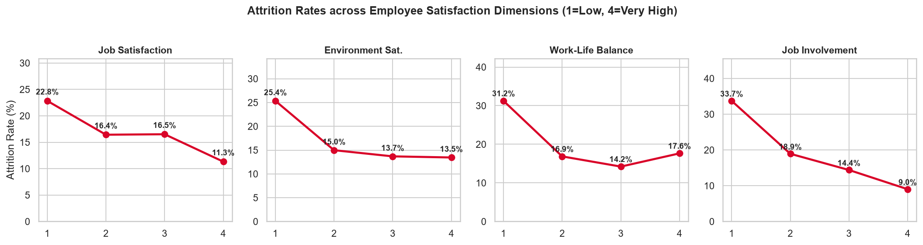
Figure 4: Monotonic Churn Trends Across Satisfaction Dimensions

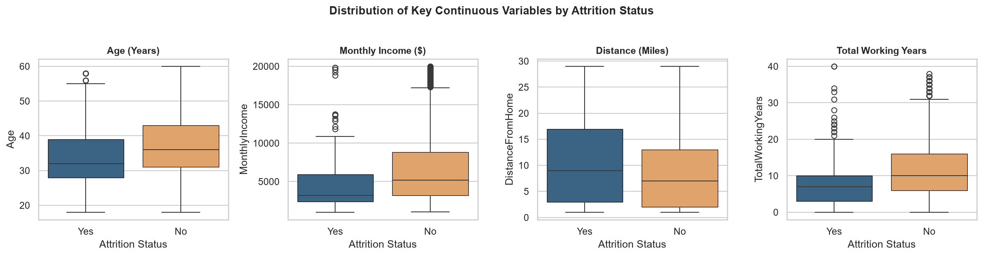
Figure 5: Age, Monthly Income, and Tenure Distributions

5. Data Cleaning & Preprocessing
A ColumnTransformer encapsulates StandardScaler on 23 numerical features and OneHotEncoder on 7 categorical features. Stratified 70/30 train/test splitting guarantees that training fold statistics never leak into the test evaluation.

6. Initial ML Models & Preliminary Results
Initial baseline pipelines were evaluated with balanced class weights:
• Support Vector Machine: Test F1 = 0.539, ROC-AUC = 0.817, 5-Fold CV F1 = 0.553
• Logistic Regression: Test F1 = 0.480, ROC-AUC = 0.816, 5-Fold CV F1 = 0.512
• Random Forest: Test F1 = 0.455, ROC-AUC = 0.780, 5-Fold CV F1 = 0.514
• Decision Tree: Test F1 = 0.414, ROC-AUC = 0.698, 5-Fold CV F1 = 0.408
• K-Nearest Neighbors: Test F1 = 0.286, ROC-AUC = 0.611, 5-Fold CV F1 = 0.284

7. Challenges & Observations
1. Class Imbalance: Tackled via cost-sensitive learning ('class_weight=balanced') and threshold tuning.
2. Dimensionality: One-hot encoding expanded feature space to 51 dimensions, favoring RBF SVM margins over distance-based KNN.

8. Phase 2 Plan
Phase 2 will implement comprehensive hyperparameter tuning, optimal threshold calibration, dual-layer XAI explainability (Permutation Importance + SHAP), an interactive Streamlit web dashboard with batch workforce scoring, automated test suites, and final project defense.

9. Guide Evaluation Comments
Phase 1 Marks Awarded: ________ / 40 Marks
Guide Signature: __________________________ Date: ______________

