Reproducible Research: Peer Assessment 1

## Loading and preprocessing the data

unzip('activity.zip')  
ori_data<- read.csv(file = 'activity.csv')  
head(ori_data)

## steps date interval  
## 1 NA 2012-10-01 0  
## 2 NA 2012-10-01 5  
## 3 NA 2012-10-01 10  
## 4 NA 2012-10-01 15  
## 5 NA 2012-10-01 20  
## 6 NA 2012-10-01 25

## What is mean total number of steps taken per day?

Calculate the total number of steps taken per day and visualize the data by generating a histogram.

step_per_day<-with(ori_data,tapply(steps,date,sum,na.rm=TRUE))  
hist(step_per_day, breaks=20,density = 10)

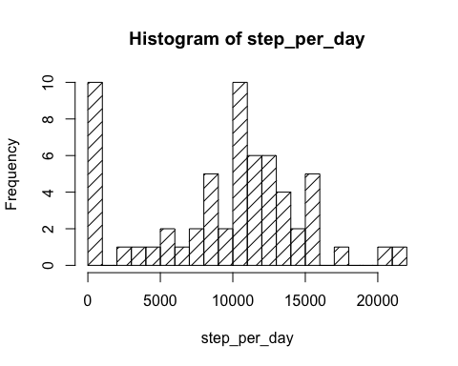 Get the median of total number of steps taken per day.

median(step_per_day)

## [1] 10395

Get the mean of total number of steps taken per day.

mean(step_per_day)

## [1] 9354.23

## What is the average daily activity pattern?

## Imputing missing values

## Are there differences in activity patterns between weekdays and weekends?