♦ Overview
- Memory Controller(3EA: SMC[PL092])
- Flash Memory Write protection
Sector Area : 2-Page[512 Area]
PROT[15:0]
Arbiter: TIC,ARM7TDMI,Remap/Pause,I2C
-Special Function Register
Gpio Address[4EA]
Push-pull output mode[pin들에 대한 PAD 정보:Open Drain??]

-Vectored Interrupt Controller
AHB base 가 아님[SDI는 APB base]
Trigger Level Control Register

-ADC Converter
FLASH

-Clock & Power Management
-PLL??(존재유무)
CLKSRC??

Figures 10 and 11 show mirror topologies of the Figures 8 and 9 circuits with PNP pass transistors replacing the NPNs. Now the LEDs are referred to a negative supply instead of a higher voltage positive supply. LED current is supplied from the port expander's positive supply and returned into the negative supply.
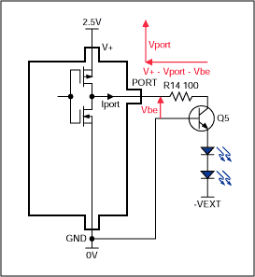
Figure 10. Active-High, Constant Current Source LED Drive.
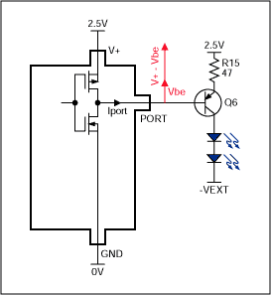
Figure 11. Active-Low, Constant Current Source LED Drive.

