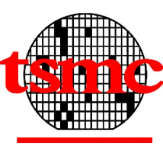

Application Note of 0.18um testchip TMC875_1 512KX16

Rev 0.1

Date : 12/28/2004

Writer : Shang-Hsuan Liu

Block Diagram

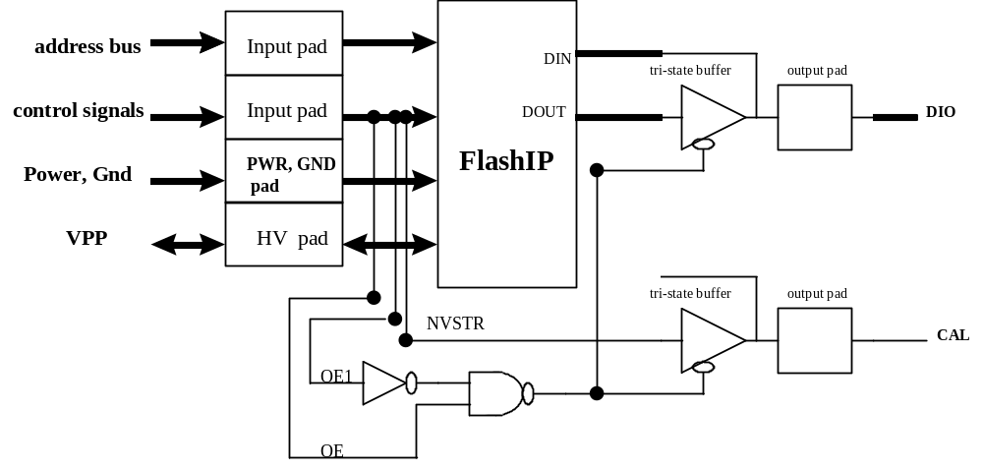

An Alternative Access Time Measurement Method by Latching Input Address and Data Output:

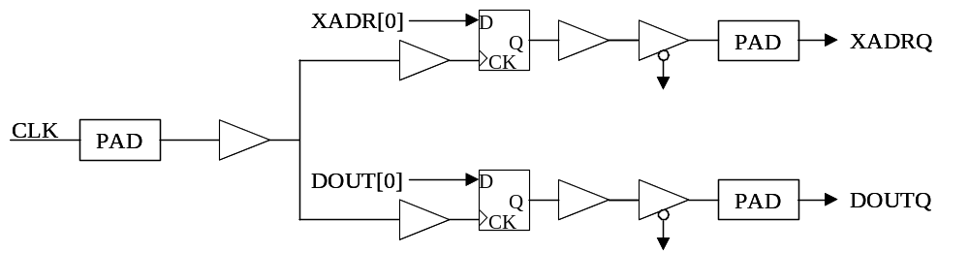

The measurement steps are listed below:
- Use CLK to latch XADR[0] at time T₀.
- Use CLK to latch DOUT[0] at time T₁.
- The access time for DOUT[0] = T₁ - T₀.

Pin Diagram:
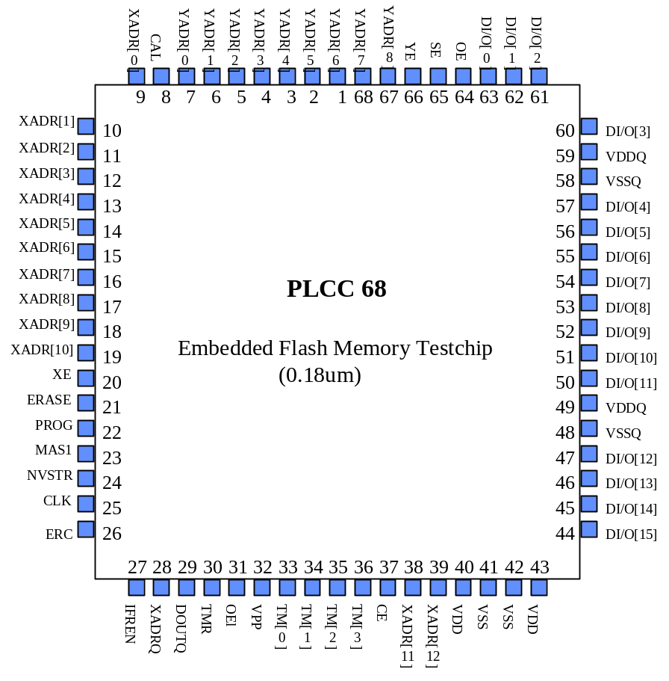
Bonding Diagram:
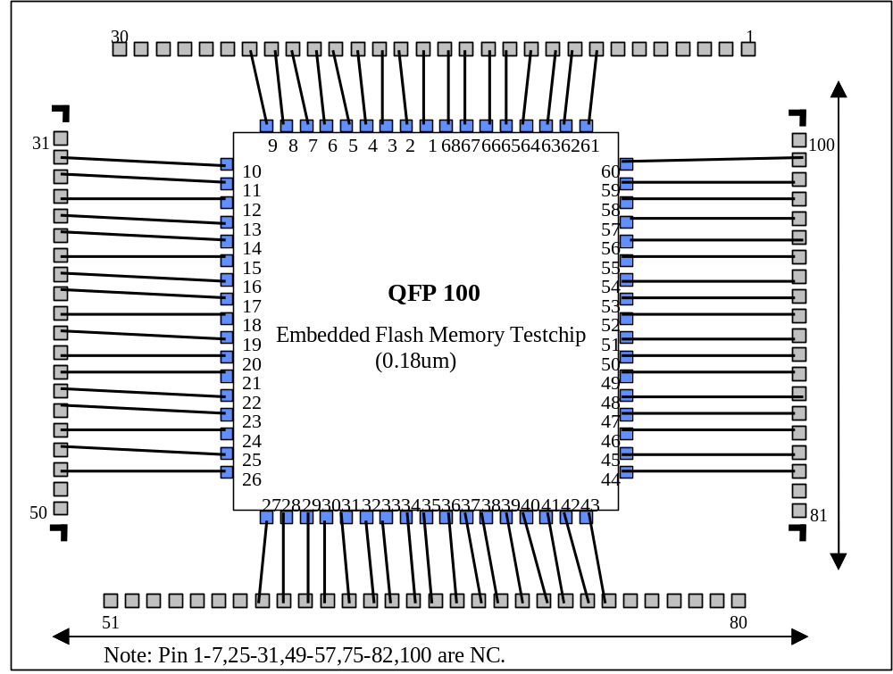
Pin Description

Pin Name | Direction | Description
XADR[12:0] | I | X address input, access rows. XADR[2:0] select one raw within a page of main memory block and information block. XADR[12:11] was not used, connect to GND.
YADR[8:0] | I | Y address input, access a word within a row. YADR[8] was not used, connect to GND.
DI/O[15:0] | I/O | Data I/O bus.
XADRQ | O | Latched data of XADR[0].
DOUTQ | O | Latched data of DOUT[0].
CE | I | Chip enable. If CE is low, all the control signals will be in standby state.
XE | I | X address enable, all rows are disabled when XE=0.
YE | I | Y address enable, YMUX is disabled when YE=0.
OE | I | Test chip output enable. output pad of testchip will be in tri-state when OE1=0
OE1 | I | Testchip output enable, output pad of testchip will be in tri-state when OE1=1
SE | I | Sense amplifier enable.
CLK | I | The clock signal to latch DOUT[0] and XADR[0].
ERC | I | NC pin, Connect to GND.
IFREN | I | Information block enable.
MAS1 | I | Define mass erase cycle, erase whole block.
PROG | I | Define program cycle.
ERASE | I | Define erase cycle.
NVSTR | I | Define non-volatile store cycle.
VPP | I/O | High voltage input/output pin¹.
TMR | I | Register reset for test mode. In user mode, it should be connected to VDD¹.
TM[3:0] | I/O | Analog pins used in test mode¹.
CAL | O | Used to measure the delay from output of FlashIP to testchip.
VDDQ | I | External power supply for I/O
VSSQ | I | External Ground for I/O
VDD | I | Power supply for IP
VSS | I | Ground for IP
note:
- Please refer to the specification of FlashIP and 0.18um test mode document for detail.

Revision history:
Date | Rev | What | Who
12/29/2004 | 0.1 | New create | SSLiu

