

SPECIFICATIONS OF SFD32KX8M64P4

Rev 010C

Date : 4/20/2004

Writer : Shang-Hsuan Liu

TSMC SFD32KX8M64P4
32K x 8 Embedded Flash Memory

General Description

The SFD32KX8M64P4 is a CMOS page erase, byte (8-bit) program Embedded Flash Memory which is partitioned into two memory blocks. One is the main memory block, the other is the information block .The main memory block is organized as 32,768-word by 8-bit. The information block is organized as 512-word by 8-bit. The information block can be used for the storage of device information. The page erase operation erases all bytes within a page. A page is composed of four adjacent rows for main memory block and information block .The split gate cell design and thick oxide tunneling injector attain better reliability and manufacturability compared with alternative approaches. The SFD32KX8M64P4 erases and programs with a 1.8-volt only power supply.

Features
Single 1.8-volt power supply
Endurance: 1000 cycles (min) with 20ms erase and 20us program time at 1.8Vcc
Memory Organization 32Kx8 + 512x8 Greater than 100 years Data Retention under
Room Temperature
Page Erase Capability: 256 bytes per page Fast Page Erase/Word Program Operation
Access Time : 25ns(max) Word Program Time: 20us(min)
Current Page Erase Time: 20 ms(min)
Operating : 13mA(max) Mass Erase Time: 20 ms(min)
Standby : 80uA(max)

Block Diagram

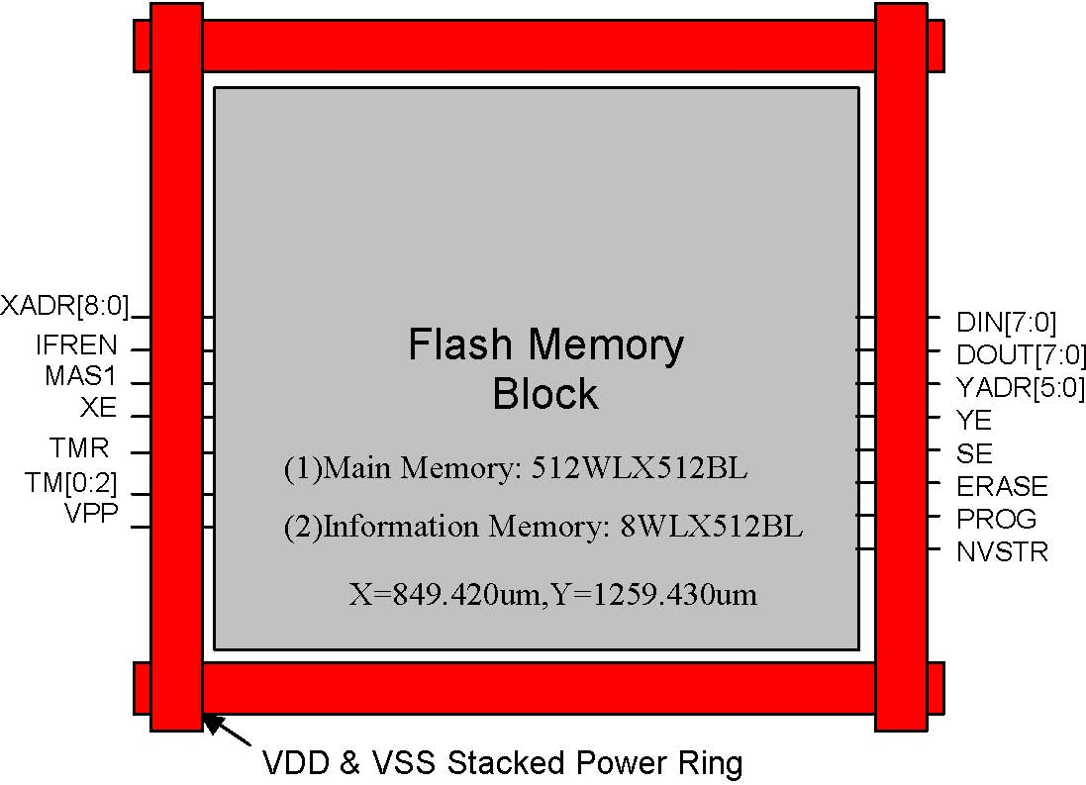

Connector Description

User Mode1
Connector name | Direction | Description
XADR[8:0] | I | X address input, access rows, XADR[1:0] select one row within a page  of main memory block or information block.
YADR[5:0] | I | Y address input, access a byte within a row.
DIN[7:0] | I | Data input bus.
DOUT[7:0] | O | Data output bus.
XE | I | X address enable, all rows are disabled when XE=0.
YE | I | Y address enable, YMUX is disabled when YE=0.
SE | I | Sense amplifier enable.
IFREN3 | I | Information block enable
ERASE | I | Defines erase cycle.
MAS1 | I | Defines mass erase cycle, erase whole block.
PROG | I | Defines program cycle.
NVSTR | I | Defines non-volatile store cycle.
VDD2 | I | Power supply
VSS2 | I | Ground

Notes:
- 1. Need to multiplex all control, address and data signals to package pins to facilitate direct memory test.
- 2. If routing power width is as wide as 30um, connecting only one set of VDD/VSS is allowable. If not, the total width of power line connecting to two sets or three sets of VDD/VSS should not be less than 30um .

3. When access the information block, the XADR[1:0] select one row within a page and XADR[8:3] are don’t care.

Test Mode1
Connector name | Direction | Description
TMR2 | I | Register reset for test mode. In user mode, it should be connected to  VDD.
VPP | I/O | High voltage pin used in test mode and operating in 0~13V. A high voltage pad with a I/O path for VPP pin will be provided by TSMC.
TM[1:0] | I/O | Analog pins used in test mode and operating in 0~VDD. These analog pins are high impedance in user mode.
TM[2]3 | I/O | Analog pins used in test mode and operating in 0~3V. Since the operation voltage is higher than VDD, the high voltage pad is recommended to use for this pin.

Notes:
- 1. Need to multiplex the test mode related signals to package pins for memory testing.
- 2. TMR is a digital pin and operating in 0~VDD.

3. TM[2] is used for debugging and will not be used in testing flow and user mode.

Recommended DC Operating Conditions
(TJ = 0 oC to 125 oC | )
Parameter | Symbol | Min. | Typ. | Max. | Unit
Supply Voltage | VDD | 1.62 | 1.8 | 1.98 | V
Ground | VSS | 0 | 0 | 0 | V

DC Electrical Characteristics (TJ = 0 oC to 125 oC, VDD = 1.62 V to 1.98 V, VSS = 0V)
Parameter | Symbol | SFD32KX8M64P4 |  | Unit | Condition
 |  | Min. | Max.
Operating Current |  |  |  |  | Min.Cycle,Duty= 100%
Read | IDD1 | - | 13 | mA | VIN = VDD or VSS
Program |  | - | 5 |  | II/O = 0mA
Erase |  | - | 7
Mass erase |  | - | 5
Static Read Current | IDD2 | - | 5 | mA | XE=YE=SE =VDD  II/O = 0mA
Standby Power Supply Current | ISB | - | 80 | uA | XE, YE, SE, PROG,
 |  |  |  |  | ERASE, and MAS1 are
 |  |  |  |  | all VSS. Other VIN = VDD or VSS

Truth Table
Mode | XE | YE | SE | PROG | ERASE | MAS1 | NVSTR
Standby | L | L | L | L | L | L | L
Read | H | H | H | L | L | L | L
Byte Program | H | H | L | H | L | L | H
Page Erase | H | L | L | L | H | L | H
Mass Erase | H | L | L | L | H | H | H

IFREN Truth Table
Mode | IFREN=1 | IFREN=0
Read | Read information block | Read main memory block
Byte program | Program information block | Program main memory block
Page erase | Erase information block | Erase main memory block
Mass erase | Erase both block | Erase main memory block

Test Mode Decoder Truth Table
Mode | CODE
 | ERASE | YE | XE | IFREN | MAS1
Test mode 1 | L | H | L | L | H
Test mode 2 | L | H | L | H | L
Test mode 3 | H | H | H | L | L
Test mode 4 | H | H | H | L | H
Test mode 5 | H | H | H | H | L

Capacitance
Parameter | Symbol | Min. | Max. | Unit
Address & Control Input pin Capacitance | CIN | - | 0.3 | pF
Data Input pin Capacitance | CDIN | - | 0.3 | pF
Data Output pin Capacitance | CDOUT | - | 0.1 | pF

Timing Parameters 1(TJ = 0 oC to 125 oC, VDD = 1.62 V to 1.98 V, VSS = 0V,CLOAD=1pF)

User mode
Parameter | Symbol | SFD32KX8M64P4 |  | Unit
 |  | Min. | Max.
X address access time | Txa | - | 25 | ns
Y address access time | Tya | - | 25 | ns
PROG/ERASE to NVSTR set up time | Tnvs | 5 | - | us
NVSTR hold time | Tnvh | 5 | - | us
NVSTR hold time(mass erase) | Tnvh1 | 100 | - | us
NVSTR to program set up time | Tpgs | 10 | - | us
program hold time | Tpgh | 20 | - | ns
program time | Tprog | 20 | 40 | us
address/data set up time | Tads | 20 | - | ns
address/data hold time | Tadh | 20 | - | ns
recovery time | Trcv | 1 | - | us
cumulative program HV period2 | Thv | - | 8 | ms
Erase time | Terase | 20 | 40 | ms
Mass erase time | Tme | 20 | 40 | ms

Notes:
- 1. All timing numbers are pre-simulation and subject to change before silicon verification.
- 2. Thv is the cumulative high voltage programming time to the same row before next erase and the same address can’t be programmed more than twice before next erase.
- 3. All signals that align together in the timing diagrams should be derived from the same clock edge. Set up and hold times are not critical if they are within 10ns.
- 4. Reading operation is combinatorial. Sequences of timing edges are not important. The latest valid signal determines the access time.
- 5. All timing measurements are from the 50% of the input to 50% of the output.
- 6. All input waveforms have rising time(tr) and falling time(tf) of 1ns.
- 7. For capacitive loads greater than 1pF, access time will increase by 1ns per pF of additional loading.

.

Test mode
Parameter | Symbol | Value |  | Unit
 |  | Min | Max
TMR pulse width | Ttmr | 20 | - | ns
TMR to internal TMSE set up time | Trses | 10 | - | ns
Internal TMSE to data set up time | Tseds | 10 | - | ns
Data set up time for latch | Tlds | 10 | - | ns
Set latch pulse width | Tlpw | 20 | - | ns
Data hold time for latch | Tldh | 10 | - | ns
Data to internal TMSE hold time | Tdseh | 10 | - | ns

Timing Waveforms

Read Cycle

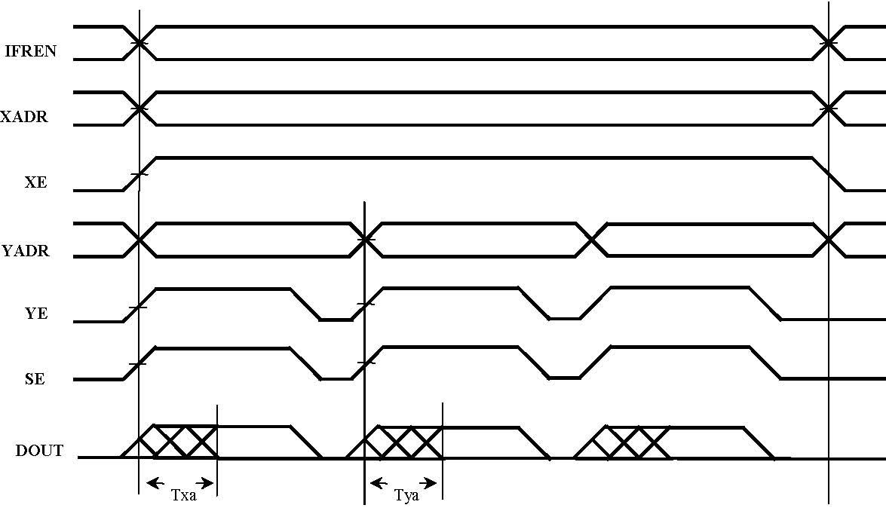

Program Cycle

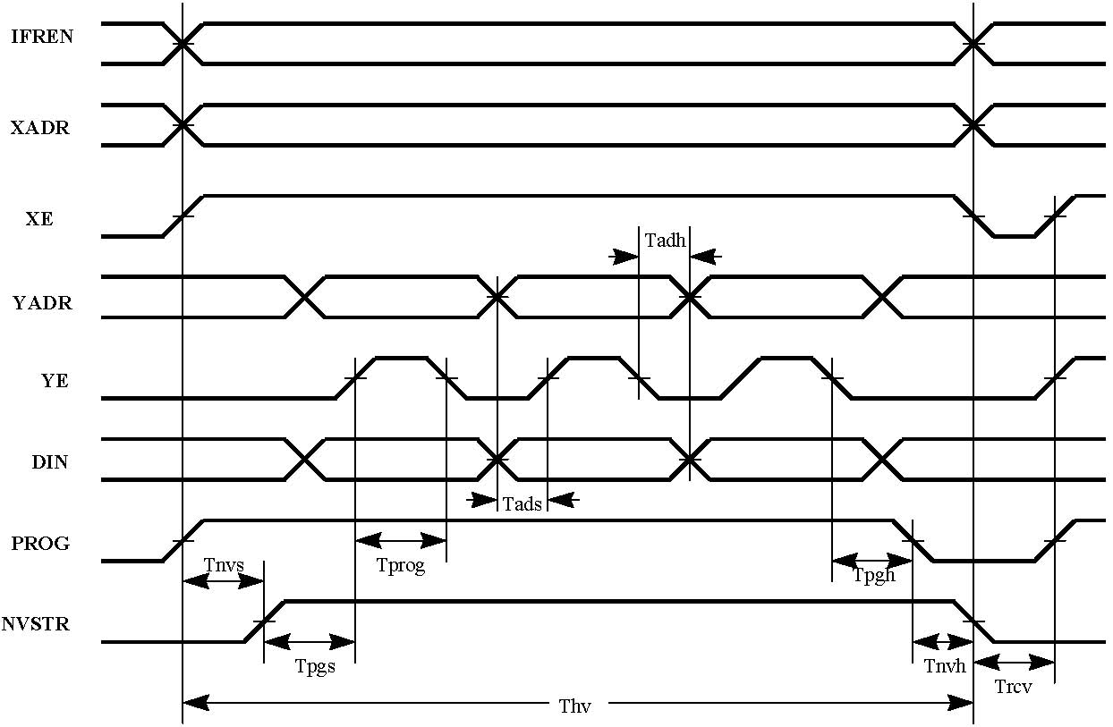

Erase Cycle

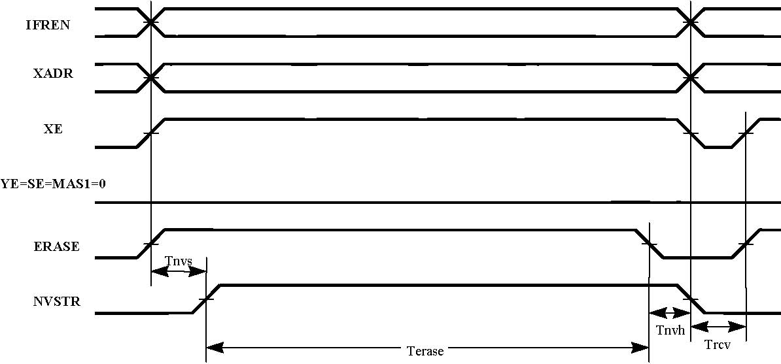

Mass Erase Cycle

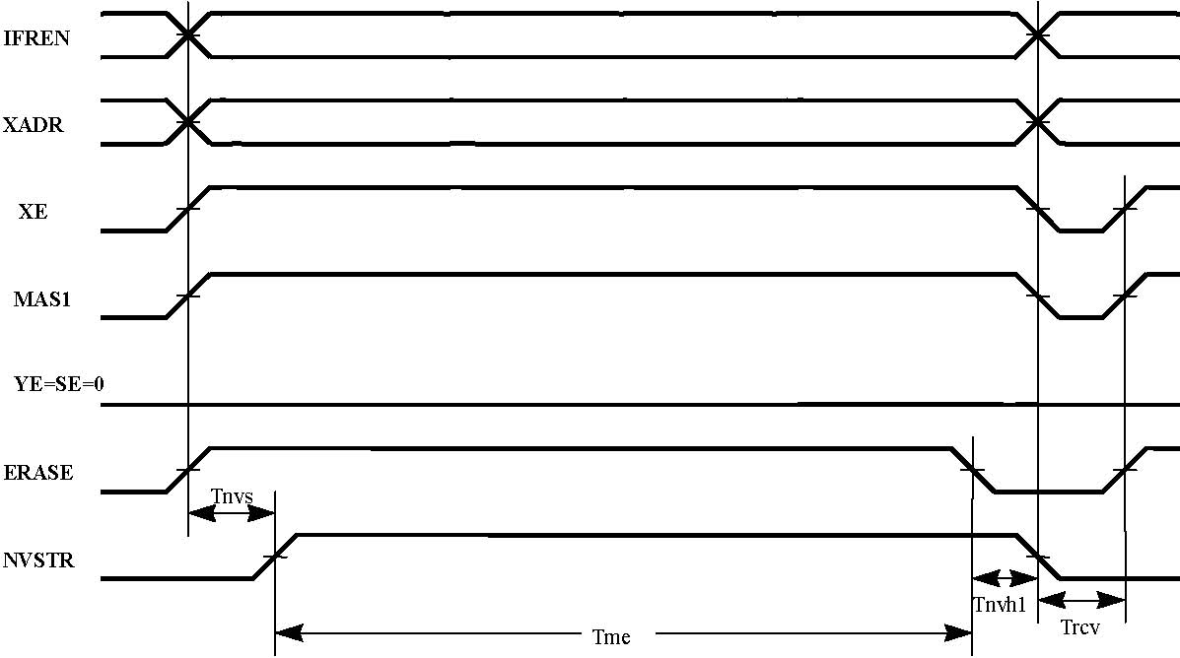

Test mode

Update history:
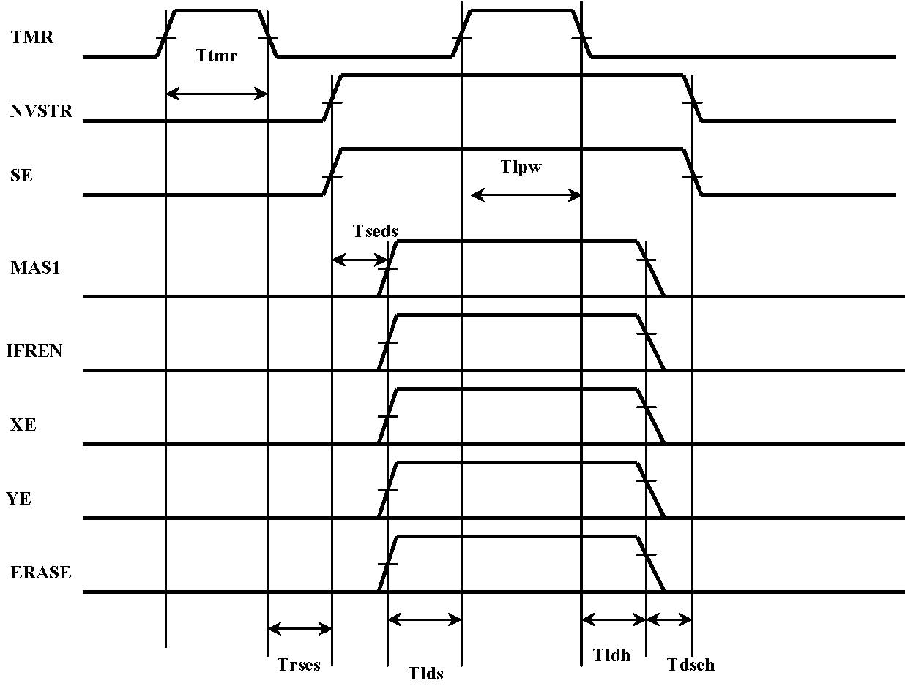
Date | Rev | What | Who
12/10/2003 | 010A | New created. | SSLiu
04/20/2004 | 010B | Change endurance spec, mass erase time, access time, read operation current and test mode pin number TM[2]. | SSLiu
05/21/2003 | 010C | - 1. Add qualification condition for 1K endurance  - 2. Update Terase,Tme | HHCHENA

