

♦ Block Diagram

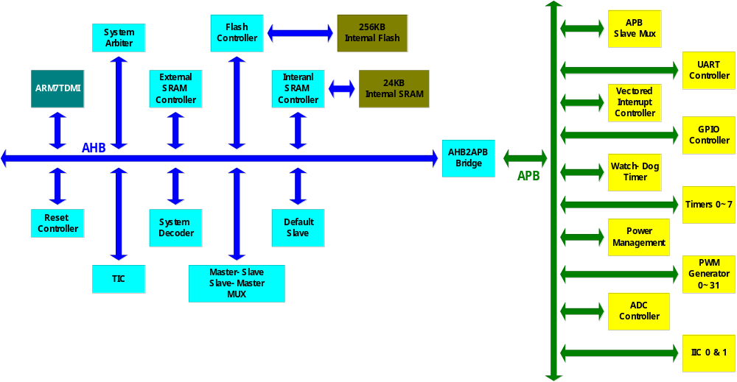
Fig. DTSDI003 Block diagram

