【1】Serial OTP/Flash Protocol.
1. Protocol Introduction
. From the I²C Bus, Conditions for start and stop has changed and the address field has become
wider.
. No arbitration : Slave mode only
. Signal format
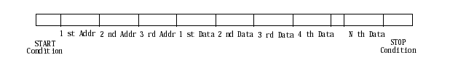

. Data valid period : SCLK = "High"
. Data invalid period : SCLK = "Low"
. Start condition : SCLK = "High" and SDAT = Positive Edge
. Stop condition : SCLK = "High" and SDAT = Negative Edge

[Composition of basic transmitting and receiving bit]
Transmitting and receiving data is composed of 8-bit.
Serial clock is composed of eight clocks and one dummy clock to transmitting/receiving.

[Start condition]
It means the start of protocol. It always has 3-Byte address field and 1- or more byte data field.

[Address field]
It is the data up to 3rd byte after start condition. Address field is composed of 1st, 2nd, 3rd address byte.
[Data field]
The address does auto-increment after the data is transmitting/receiving to/from Memory Cell to Read/Write.

[Stop condition]
Stop transmitting/receiving. Data transfer can be resumed by start condition sequence once stop condition is asserted

[Others]
Dummy clock
A master generates the dummy clock at 9th clock after a byte is transferred and a slave (Flash/ MTP/OTP) internally generates pulse corresponding to the dummy clock generated by the master for PGM or OE.
In the mean time, the SDA has to set and remain High to detect Stop condition.

◆ Rx mode (during Write mode)
→ After receiving each byte, the MTP/OTP start write operation during the dummy pulse.
After all data are transferred, the Transmitter finishes the write operation by generating the stop condition.

◆ Tx mode (during Read mode)
→ MTP/OTP transmits every byte. If the receiver wants to finish read, the master Rx generates the stop
condition.

【2】The Operation Command of Flash Chip

Byte | 1'st Byte |  |  |  | 2'nd Byte | 3'rd Byte | - | - | - | -
Mode | REG/MEM | Mode  (M1-M0) | Address2  (A19-A16) | R/W | Address1  (A15-A8) | Address0  (A7-A0) | Data  (D7-0)  (D31-24) | Data  (D23-16) | Data  (D15-8) | Data  (D7-0)
Bit n | B23 | B22-B21 | B20-B17 | B16 | B15-B8 | B7-B0
Read | 0 | 11b | xxxxb | 1 | Xxh | xxh | xxh
Program | 0 | 11b | xxxxb | 0 | Xxh | xxh | xxh
Verify1 | 0 | 11b | xxxxb | 1 | Xxh | xxh | xxh
Chip Erase | 1 | 11b | 0000b | 0 | ---1,0101b | ----,----b | ----,----b
Smart Option | 1 | 11b | 0000b | 0/1 | ---0,1110b | zz 11,1000b | 00h | 00h | ----,----b | ----,----b
LDC Protection | 1 | 11b | 0000b | 0/1 | ---0,1110b | zz 11,1100b | ffh | feh | ffh | ffh
Hard Lock | 1 | 11b | 0000b | 0/1 | ---0,1110b | zz 11,1100b | ffh | ffh | fdh | ffh
Read Protection | 1 | 11b | 0000b | 0/1 | ---0,1110b | zz 11,1100b | ffh | ffh | ffh | f7h
Verify2 | 0 | 00b | xxxxb | 1 | xxh | xxh | xxh
Verify3 | 0 | 01b | xxxxb | 1 | xxh | xxh | xxh

1. zz → >= 256K Bytes '00'
>= 128K Bytes 'x0'
< 128K Bytes 'xx' ('x' is don't care)
2. '-' : not decoded ( don't care. but, recommended "0" in address byte field, "1" in data byte field )
3. When user writes to Protection Option or Smart Option, user has to send 4-byte data.

* Erase
There are two kinds of erase, one is chip erase and the other is sector erase.
When the chip erase command is asserted, the erase and mas signal become active internally.
When the sector erase command is asserted, only the sector which is addressed by the active erase signal will be erased(sector erase is test usage only).

* Option sector program/read
The start address of the smart option is 0e38h, only the lower 16-bit out of 32-bit is used.
Thus, the form of the data for program is 32'hffff0000 and among the lower 16-bit, set the bit which user want to write to '0'. The Smart option program/read is distinguished with the bit-16 ; 0(program)/1(read).

【3】SERIAL INTERFACE PROTOCOL

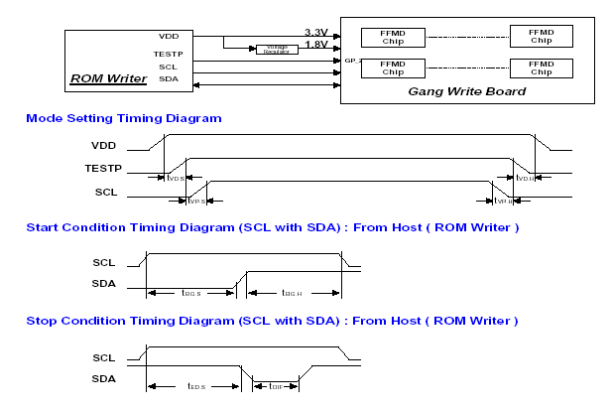

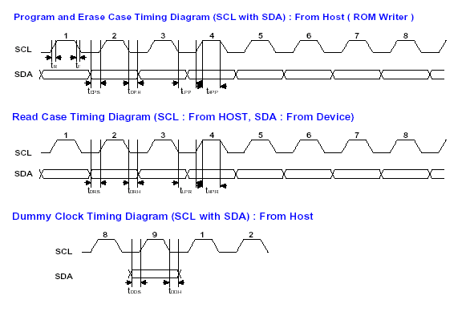

Electrical Characteristics
Symbol
Parameter
Min
Typ
Max
Unit
t
VD.S
/
t
VD.H
VDD
Setup
and
Hold
Time
1
0
us
t
/
t
Test
Setup
and
Hold
Time
1
0
us
VP.S
VP.H
t
t
Begin
Setup
and
Hold
Time
5
0
0
ns
BG.S
/
BG.H
t
ED.S
End
Setup
Time
5
0
0
ns
t
DIF
Time
Interval
for
new
transmission
start
1
0
us
t
R
/
t
F
Rising
and
Falling
time
of
SCL
and
SDA
5
ns
t
Data-Out
Setup
Time
5
0
ns
DP.S
t
Data-Out
Hold
Time
DP.H

2
0
ns
t
LP.P
/
t
HP.P
High
and
Low
Period
of
SCL
in
Program
2
us
t
DR.S
Data-In
Setup
Time
1
0
ns
t
DR.H
Data-In
Hold
Time
1
0
ns
t
LP.R
/
t
HP.R
High
and
Low
period
of
SCL
in
Read
2
5
0
ns
t
DD.S
Dummy
Data-Out
Setup
Time
5
0
ns
t
DD.H
Dummy
Data-Out
Hold
Time
1
0
2
0
ns
t
PGM
Programming
Cycle
Time
6
0
us
t
CED
Chip
Erase
Delay
Time
5
0
ms

- The minimum SCLK period becomes 4us, and it is advisable that High and Low duty is 50:50.

2
0
ns
t
LP.P
/
t
HP.P
High
and
Low
Period
of
SCL
in
Program
2
us
t
DR.S
Data-In
Setup
Time
1
0
ns
t
DR.H
Data-In
Hold
Time
1
0
ns
t
LP.R
/
t
HP.R
High
and
Low
period
of
SCL
in
Read
2
5
0
ns
t
DD.S
Dummy
Data-Out
Setup
Time
5
0
ns
t
DD.H
Dummy
Data-Out
Hold
Time
1
0
2
0
ns
t
PGM
Programming
Cycle
Time
6
0
us
t
CED
Chip
Erase
Delay
Time
5
0
ms

A7~A0
Dummy
Clk
D7~D0
D7~D0
Dummy
Clk
~
7
8
9
1
2
~
7
8
9
1
2
~
7
8
9
1
2
~
7
1
2
1
2
~
7
8
9
S
~
7
9
P
SDAT
SCLK
[Programming]
A23
A22~A17
A16
Dummy
Clk
A15~A8
Dummy
Clk
Data
Data
+
3
1st-3rd Byte(Address Field)
D7~D0
Dummy
Clk
D7~D0
Dummy
Clk
1
2
~
7
8
9
1
2
Data
+
(
n%4)
Data
=
FFFFh
In the case of 32bit Product,
2byte Dummy Data 0xFFFF
should be Inserted to avoid
the timing violation
t
PGM
Word
T
prog
T
nvh
PROG
zone
At
least,
PROG
zone
>
T
prog
+
T
nvh
Data
+
4
Disable Timing of this signal is controlled by Internal Counter of FMC
T
prog
NVSTR timing diagram of F/M Core, when user programs last data to F/M
PROG timing diagram of F/M Core, when user programs last data to F/M
Note: Timing diagram of [Protection] and [Smart Option] is the same as this one.

[
Erase]
SDAT
SCLK
A23
A22~A17
A16
Dummy
Clk
A15~A8
Dummy
Clk
A7~A0
Dummy
Clk
D7~D0
Dummy
Clk
D7~D0
Dummy
Clk
~
7
8
9
1
2
~
7
8
9
1
2
~
7
8
9
1
2
~
7
8
9
1
2
1
2
S
~
7
8
9
P
Data
-
FFH
Chip Erase Delay
Data
=
FFFFFFFFh
1st-3rd Byte(Address Field) – E0H,
55H,
FFH
t
CED
Don't Care of this Value
This canbeH/35H/75H/95H/B5H/D5H/F5H
Don't care of this value
T
nvhl
ERASE
zone
T
cers
At
least,
ERASE
zone
>
T
nvhl
MAS timing diagram of F/M Core
Disable Timing of this signal is controlled by Dummy clock
ERASE timing diagram of F/M Core
NVSTR timing diagram of F/M Core
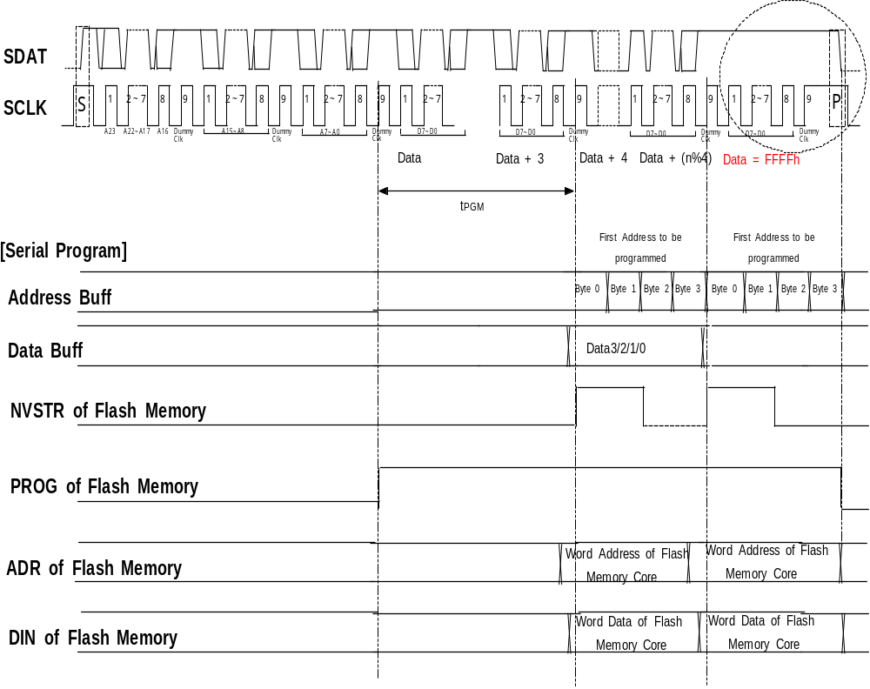

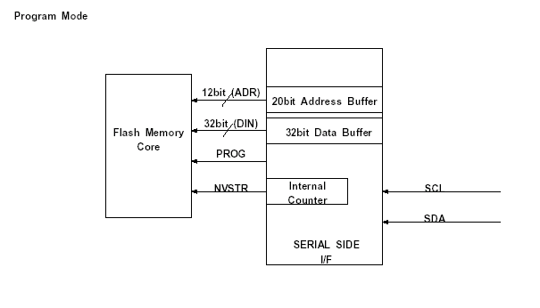

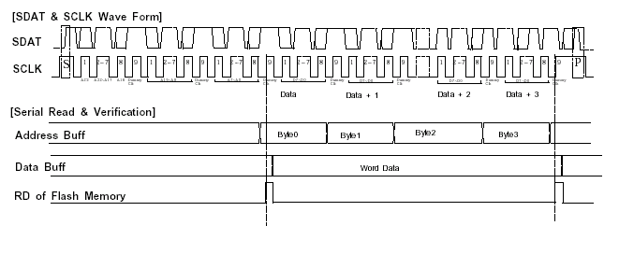

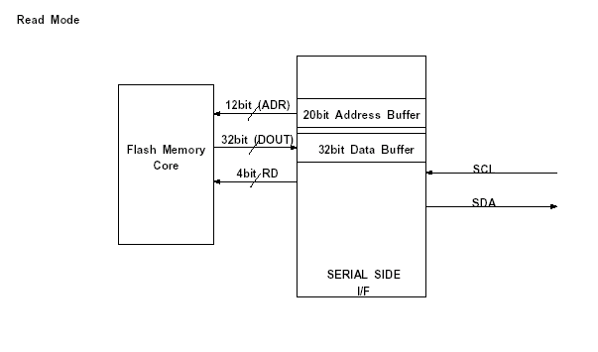

【4】Serial Interface Protocol Format - See Timing Diagram in above pages -
Serial Interface Protocol is composed of 3-byte Address Field and 1 or more -byte Data Field.
In the Address Field, 4-bit of the first byte is used for the Serial Interface Mode and the rest of 4-bit is used for upper Address bits.
The bit16 of 4-bit, used for the Serial Interface Mode, is for the Cell Read/Write Control: "1”is for Cell Read Mode and "0" is for Cell Write Mode(programming).
Bit23 is the control bit for Normal and test operation. When it is set to "1", it is used as Cell Test Mode for the Protection and the each Test Mode. When it is“0", it is used as Cell Normal Mode to access the Main Cell.
Bit22 and Bit21 are used to select the each mode more specifically.

. Address counter
Address Counter is composed of 20 registers and the registers has to be added when the address extends. Start Address is given after the Start Condition is set, and the Address increases automatically according to data transfer after the Start Address is stored in the Address Register.
Address increment method for the program/read is that the address increase by one from the Start Address. For Cell Test Mode, the address increment method can different from one for the program/read.
Currently, there is no different address increment method for Flash module since the Flash module does not have gang write and column/row read/write like the OTP.

. Read operation
When the LSB (Bit16, R/W) of the first byte of Address Field is "1" after Start condition, it becomes Read Mode.
The Read operation corresponding to each Mode is initialized by Bit23, Bit22, Bit21 and Start Address.

After the Start Address is transferred, a data is read from the EPROM/Flash Cell and is written to the Data Shift Register while the Dummy Clock stays high.
The Shift Register's Data is transferred with the SCL. The Address increases automatically at 8th clock of Dummy Clock for the Data Byte transfer.
When the data read is finished, the master extends the dummy clock.
During the extended dummy clock cycles the master makes SDA transition from High to Low which generate stop condition and as a result, the read operation stops.

. Programming operation
When the LSB (Bit 16, R/W) of the first byte of the address field is "0", it becomes write mode (program).
The write operation corresponding to each Mode is initialized by Bit 23, 22, 21 (Mode), and start address.
After the address and the data are transferred, the write operation starts at on the falling edge of the dummy clock. While it is writing, the next write-data is transferred and the current write is finished on the falling edge of the 8th clock of data transfer clock.
Two separate registers, Buffer Register for writing to EPROM/Flash Cell and Shifter Register for Serial Transfer, made transfer of next write-data possible during the writing current data.
The address for the next write is automatically increased by dummy clock after the current data transfer.
After the last data is transferred, additional time is needed to write the data on the EPROM/Flash Cell.
For this additional time required, the dummy data (= FFh) is transferred before it finished the write operation.

. Read Protection
Read Protection prohibits program code in Flash from being read. This feature is used to prohibit the illegal copy of

program code.
Protection is done by writing 00h at Bit 23= 1, Bit [22:21](Mode)= 11b, Start Address 00E3Fh = 00h.
To disable the read protection, Chip Erase is needed. In this case, the program contents will be erased also.

.Chip Erase
It is the operation that erase all flash cell area of the flash memory cell and option cell.

. Additional Feature
Protection
.Read Protection : Prohibits program code from being read by TOOL(MDS or ROM writer) to prohibit the illegal copy of
program code.
.LDC Protection : Even if Read protection is done, the code can be read by LOAD instruction of JTAG based ICE and in
ROMLESS mode.
The LDC protection disables reading the program code by LOAD instruction. So, the LDC protected code
cannot be read by JTAG based ICE and in ROMLESS mode.
.HardLock Protection : while Hardlock is active, User Program or Sector Erase can't be done. The hardlock protection will
be disabled by only chip erase by tool.
Smart Option
The start address of the smart option is 0e38h, only the lower 16-bit out of 32-bit is used.

Verify
The verify command is used to verify the Written data on memory cell.(ln Tool(MDS), the read command isn't used
instead of verify command). In Flash(EPROM Cell), only Verify1 command is used. In MTP(Flash Cell), Verify1,
Verify2, Verify3 command is used.

In this case, The different Vth level can be used into On Cell and Off Cell.
(Verify 1 : 50% Vth, Verify 2 : 25% Vth, Verify 3 : 75% Vth).
Using these versatile Vth level, Flash Cell will be verified more heavily.

- Please refer to the timing diagram for above commands (Chip Erase, Verify)

【5】Flash ROM Program/Erase Sequence
1. Byte Programming Sequence
- Tool Mode : In successive programming, the time gap between two successive data writes must be greater than 40us.
(A ring oscillator on chip makes it possible automatically.)

2. Option Sector Programming Sequence
- Tool Mode : refer to 1.
- Full Flash Mode(User PGM Mode) : refer to 1.
- In option sector programming, Address is incremented automatically, and Not used bytes in 32-bit word must be written by FFH.

3. Chip Erase Sequence
- Tool Mode : Start - Address - Data - Erase Delay - Data - Stop
.Erase delay time from erase start to erase stop is needed. Chip Erase Delay Time. refer to the flash memory spec sheet
.Protection bits and Smart Option bits are all erased.

4. Verify Sequence
- Tool Mode : Blank test after chip Erase - If data FFH be read In Verify 3 (75% Vth), erasing will be completed.
Verify test after write - if written data be read in Verify 3 (75% Vth) and Verify 2 (25% Vth), programming will be
completed.
* Only Verify 1 test is applicable for erasing/programming verify, when Verify 1 (50% Vth) guarantees good operation.
- User program Mode : Verify test is covered by normal memory Read.

