USB 2.0 IP

(MOON)

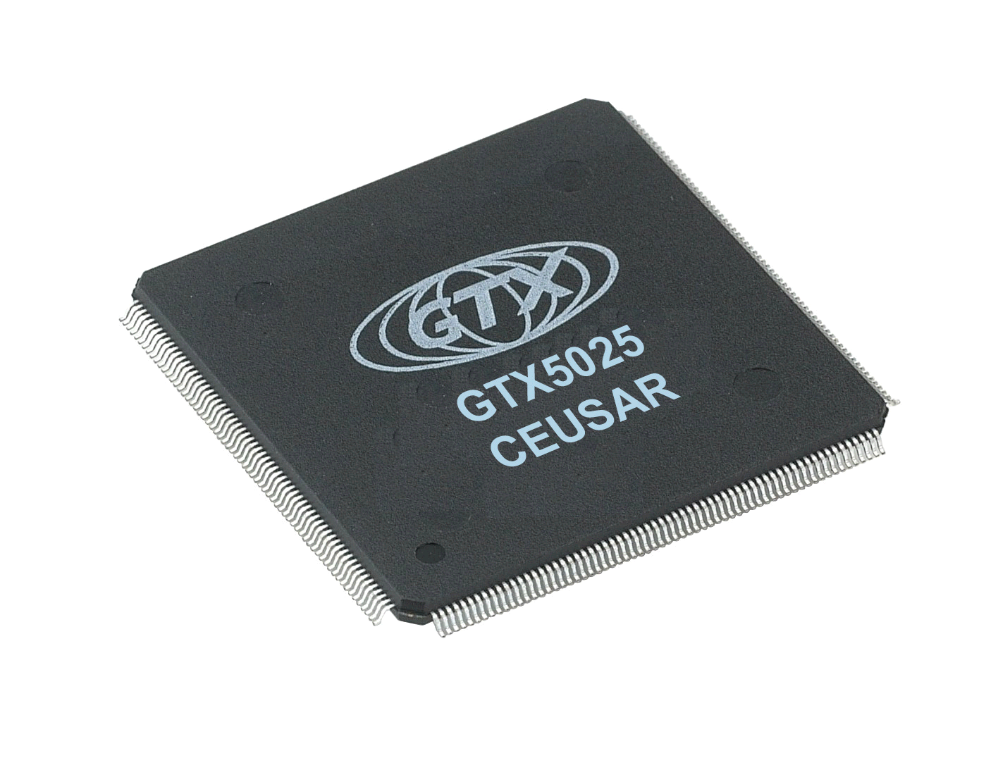

UTMI for USB 2.0

Tranceiver for USB1.1

AHB interface for internal register access

AHB interface for high performance DMA

Configurable Endpoints

Moon is a USB 2.0 device controller. Moon operates at either Full-speed device or High-speed device. In full-speed, the controller supports USB 1.1 specification device controller. In high-speed, it supports USB 2.0 specification device controller with UTMI.
Moon’s SIE supports UTMI and AHB for host interface and the DMA. The SIE consists of protocol layer and a number of command, status and error counter registers.
Moon has a control endpoint, an interrupt endpoint and two bulk endpoints for TX and RX. The number and size of bulk endpoint is configurable.
Moon has AHB for host and DMA interface.

Silicon Proven IP

Specifications

Process : 0.25 um Samsung
Performance : 100 MHz
Gate Count : 90 K
Operational Voltage : 2.5V
Design with RMM rule

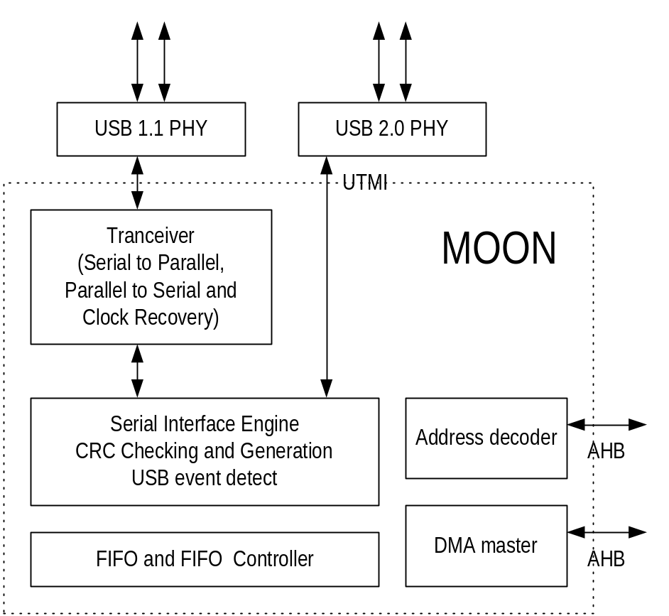

FEATURES

- USB 2.0 and USB 1.1 compliant
- UTMI to external PHY
- 16-bit and 8-bit UTMI
- AHB interface for DMA
- AHB interface to internal registers and management counters
- A control endpoint (64bytes buffer)
- A interrupt endpoint (1Kbytes buffer)
- Two bulk endpoint (1Kbytes buffer)
- Configurable bulk endpoints
- Automatic CRC generation and checking
- Automatic packet error discarding
- Scatter and gather capabilities
- Chain descriptor structures
138 - 160 6th fl, IT Venture Tower, #78, Garak-dong, Songpa-gu, Seoul, Korea
TEL : 02) 2142 – 1700, FAX : 02) 2142 – 1710, URL : www.glotrex.co.kr
INFORMATION

