Preliminary Information
This document contains information on a product under
Development. The parametric information contains target
Parameters that are subject to change.

Moon
(USB 2.0 device controller)
User Guide

VER 1.0

GLOTREX
Communication & Network

Venture Tower, #78, Garak-Dong Songpa-Gu Seoul, Korea
http://www.glotrex.co.kr

Contents

1. About this Documents 3
2. Directory Structures 4
2.1 Fast Ethernet directory structures 4
2.2 Simulation Environment 5
2-3 Synthesis Environment 6

1. About this Documents

This document gives instructions for the installation and use of the simulation environment or synthesis environment.

2. Directory Structures

The file offered to customers is compressed format, so it should be released in the destination directory.

Example > gzip –d Usb.tar.gz
Example > tar xcv Usb.tar

2.1 Usb directory structures

Figure 2-1 illustrates the directory structures for Usb:

(Destination Directory) RTL (RTL source code)

USB_HOST

USB

DMA
MACRO

ARM
FPGA_TOP

TOP

RTL_encrypt (encrypted RTL Code)

sim (Simulation environment)

sim_encrypt (encrypted simulation environment)

syn (Synthesis Script)

Demo ( Documents, Driver, NDIS, Board)

Figure 2-1 Directory structures for Usb

For more detail in RTL directory structures, please refer to the “README”

2.2 Simulation Environment

In sim directory, there is several files for simulation as follow;

Table 2-1 Files in sim directory
File Name | Description
TB_MOON.v | Test bench
ahbtask.v | Tasks for AMBA bus
Infile.mst | Configuration & Interrupt Service
infile_usb | Usb Configuration
usb_model/usb_host_model.v | Usb modeling
usb_model/urx_dcompare.task | Task for RX data compare
usb_model/utx_dcompare.task | Task for TX data compare
usb_model/usb_test.task | Task for RX data generation
usb_model/read_iqueue.task | Task for interrupt queue reading
usb_model/write_txdesc.task | Task for TX descriptor generation
usb_model/write_txpque.task | Task for TX packet queue writing
reg_define.v | Variable is defined
flist_moon.f | RTL file list for moon simulation

Nc-verilog simulation performs with plus arguments.

ncxlmode +access+rwc +unbuffered –f ncrun_script/run_RTL_HIGH_USB +DUMP

For more plus arguments please refer to ncrun_script.

Figure 2-2 shows the test-bench’s block diagram

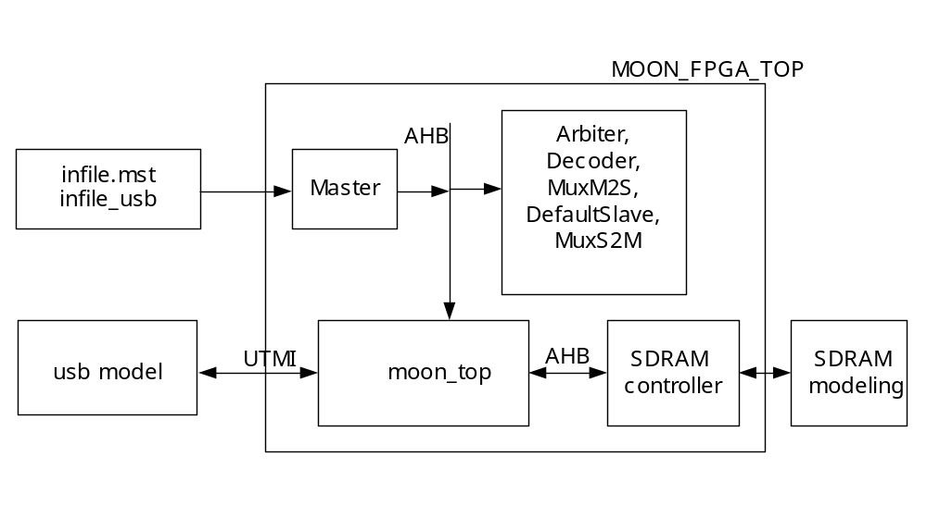

Figure 2-2 Test-bench’s block diagram

2-3 Synthesis Environment

Figure 2-3 shows the structure of syn directory

syn
db (compiled DB)

Constraint (constraint & Synthesis Script)

Report (Violation, Timing, Area Report)

WORK (Working Design Library)

Budget_Result (Budgeted Constraint)

Log (Log Files)

Netlist (Netlist)

Figure 2-3 structure of syn directory

There are the synthesis script and constraint files in Constraint directory.
Synthesis script is made in TCL.

Synthesis may be run in syn directory as followings.

dc_shell-t –f moon_pre.compile
dc_shell-t –f moon.compile

