BI-linear Scaler .
- specification

- register block

Register | Address | R/W | Description | Reset Value
Src_size |  | R/W
New_size |  | R/W
Src_addr |  | R/W
Dst_addr |  | R/W

Src_size | Bit | R/W | Discription | Reset Value
Ready | [31] | R | Scale 중이면 low  Idle 이면 high | 1
start | [30] | R/W | Scaler start signal active high  High를 쓰면 한 clk후 0로 리셋됨. | 0
Src_width | [27:16] | R/W | Source image width | 0
Src_height | [11:0] | R/W | Source image height | 0
New_size | Bit | R/W | Discription | Reset Value
bpp | [31:29] | R/W | 이미지 bpp를 나타냄  001 : 1555 (unused R G B)  010 : 565 (RGB)  011 : 888 (BGR)  100 : 8888 (unused BGR)  101 : 8888 (ARGB) | 0
New_width | [1 : 0] | R/W | New image width(max 2048) | 0
New_height | [1 : 0] | R/W | New image width(max 2048) | 0
New_size | Bit | R/W | Discription | Reset Value
Src img addr | [31 : 0] | R/W | Source image address | 0
Dst img addr | [31 : 0] | R/W | Destination image address | 0

- 블록도

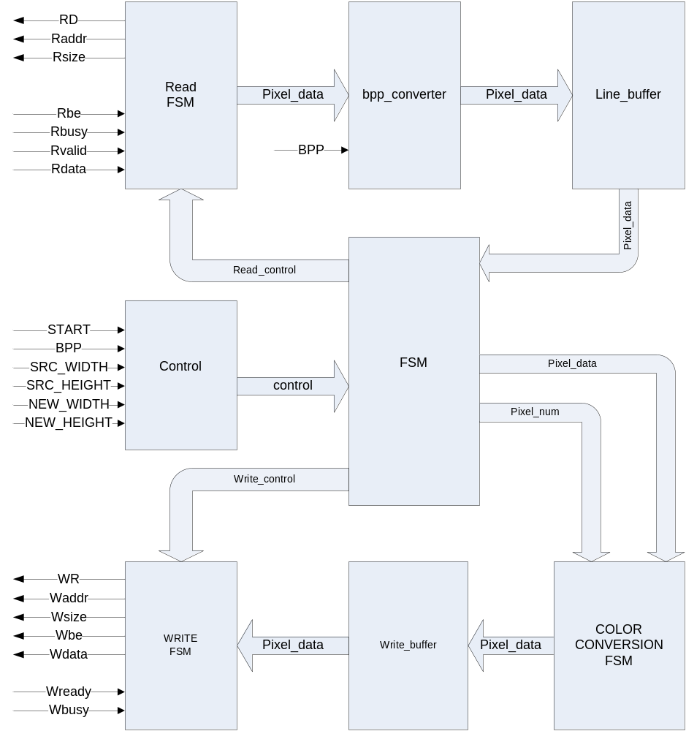4. 픽셀 생성
Up_Up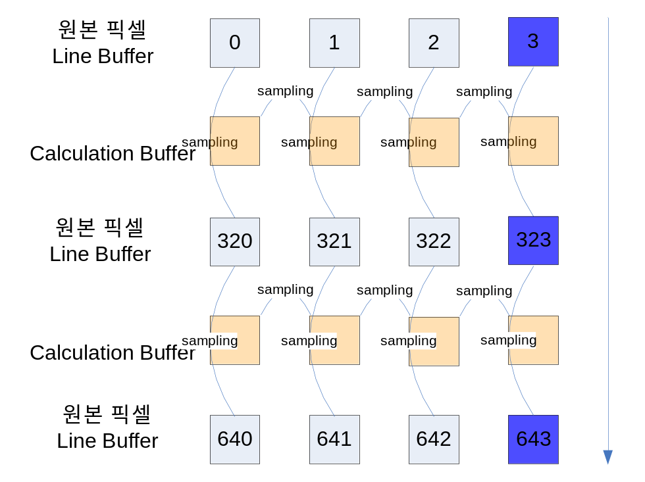
Up_Down
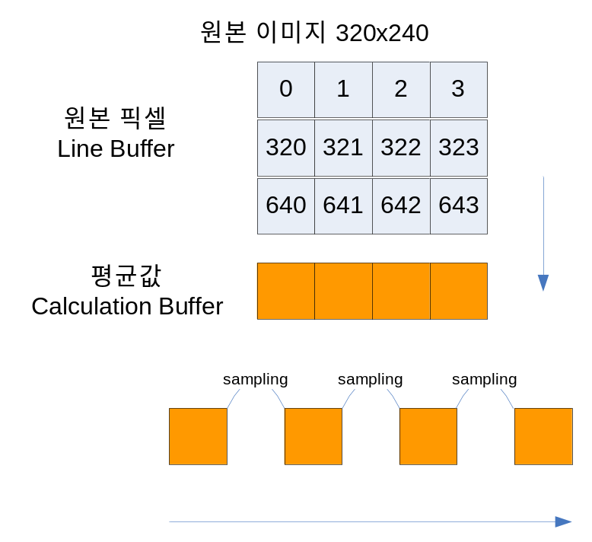

Down_up
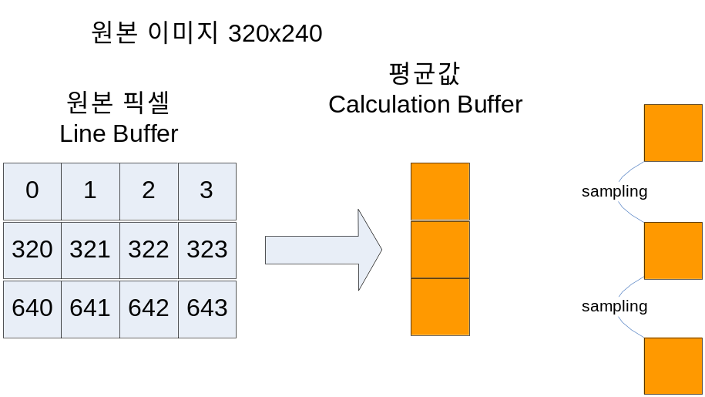

Down_Down
