Project | AXI Bux
Date | 2006 년 4월 14일
Description | WRITE Channel ( Simple mode )

- MUX / DEMUX 설계

설정 하는 목록 :
BUSWID : BUS bit width
IDWID : ID bit width
SLAVENUM : Slave 개수
SLAVE0SartAddress : SLAVE0에 시작 번지
SLAVE0Size : SLAVE0에 끝 번지. (4K이상)
(총 SLAVE 수 만큼 지정해야 한다 :: Memory map)

ADDRWID : Address bit width

꼬리말 :
AWIDm2si ( AWID signal Master to Slave Interface)
AWADDRm2si (AWADDR Master to signal Slave Interface)
AWREADYsi2m (AWREADY Slave Interface to Master)

si (slave interface)
m (master)
s (slave)
mi (master interface)

- Write channel slave interface

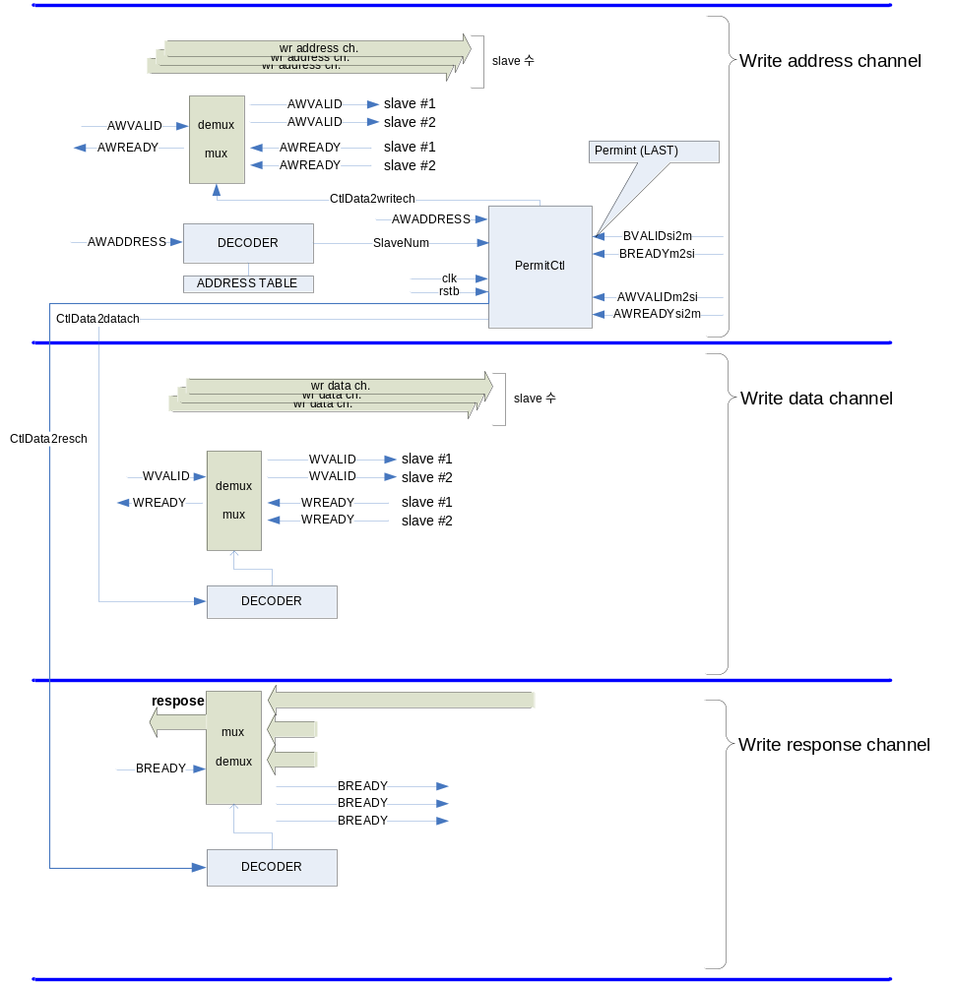

  - PermitCtl.v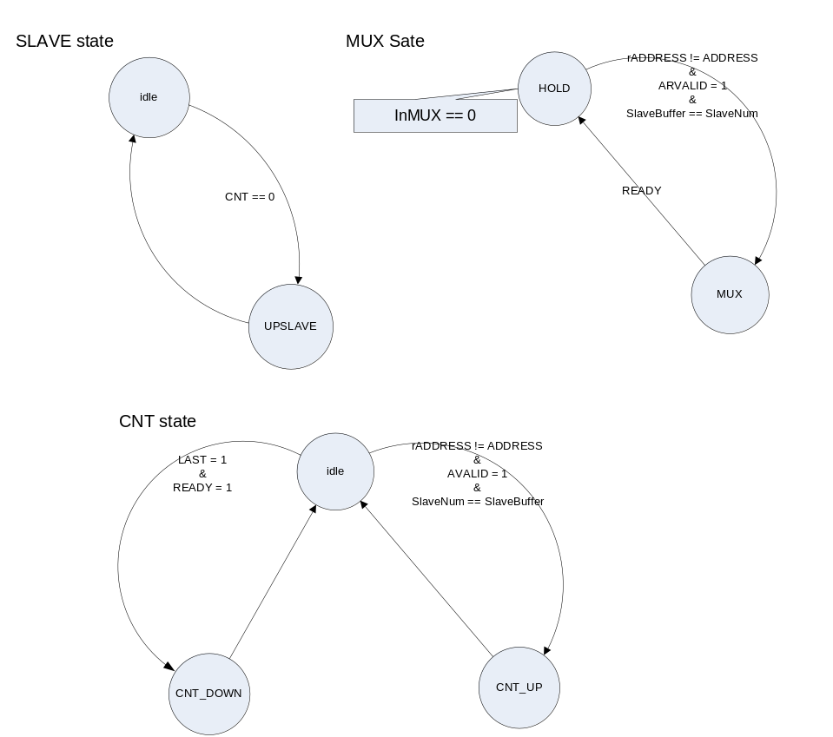

- Write channel master interface

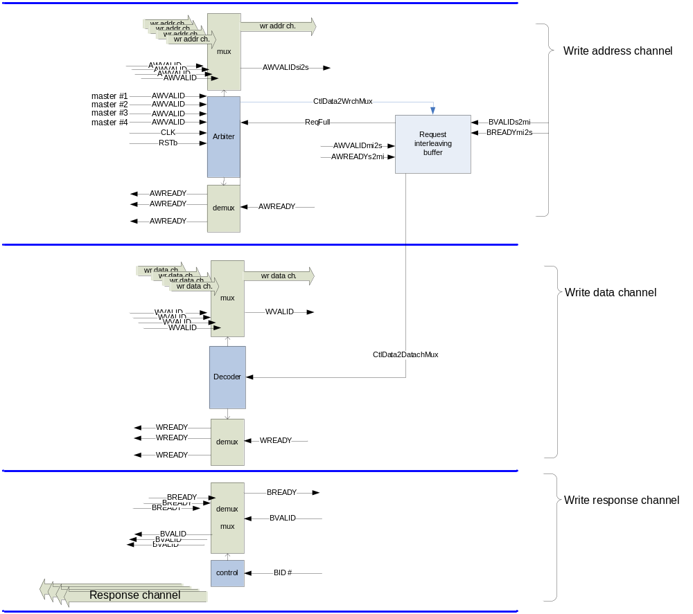

- Read channel slave interface

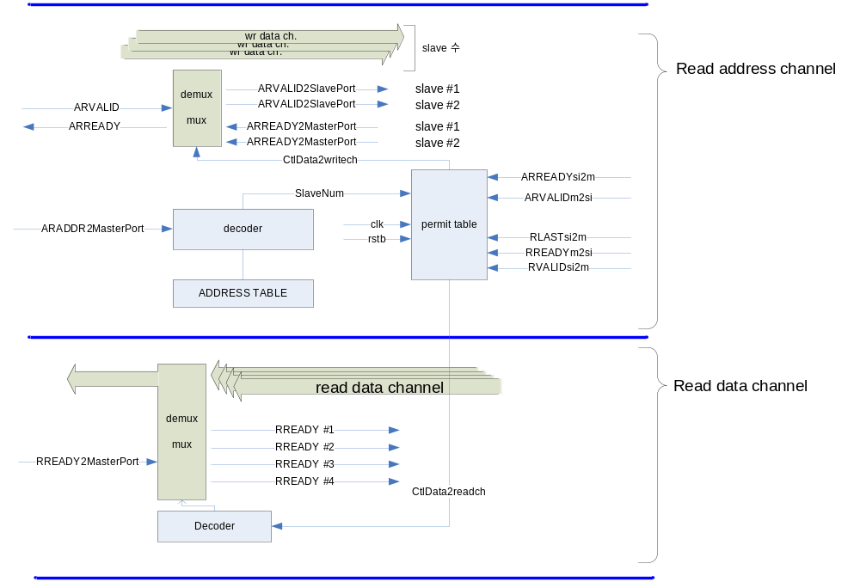

- Read channel master interface

