AHB 32bit to AXI 64bit Bridge

Version 1.0

SHMT Co., Ltd.(Verdana 18pt bold)

REVISION HISTORY
Version | Detail | Name | Date
V1.0 | Created | kwoly | 2007-07-10

Technical documents
Copyright © 2006 Shmt Limited. All rights reserved.

Confidentiality Status
This document is NOT OPEN ACCESS. The distribution is restricted to certified company.
This document is CONFIDENTIAL.

Feedback on this document
If you have any comments on this document, please contact your channel to our company.

Shmt Web address
http://www.shmt.com

Contents

1. AHB32bit to AXI64bit bridge 7
1.1. Overview 7
1.1.1. Feature 7
1.1.2. Block Diagram 7
1.2. Operation 8
1.2.1. HCLK/ACLK clock 8
1.3. Signal Description 9
1.3.1. AHB2AXI Bridge Signal 9

Figures
Figure 1-1 Block Diagram 7

Tables

Table 1-1 Bridge Signal 9

AHB32bit to AXI64bit bridge

Overview

Feature

- AHB interface / AXI interface support
- Clock enable support (AHB : 1x clock and AXI : 2x clock)

Block Diagram

Figure 1-1 Block Diagram

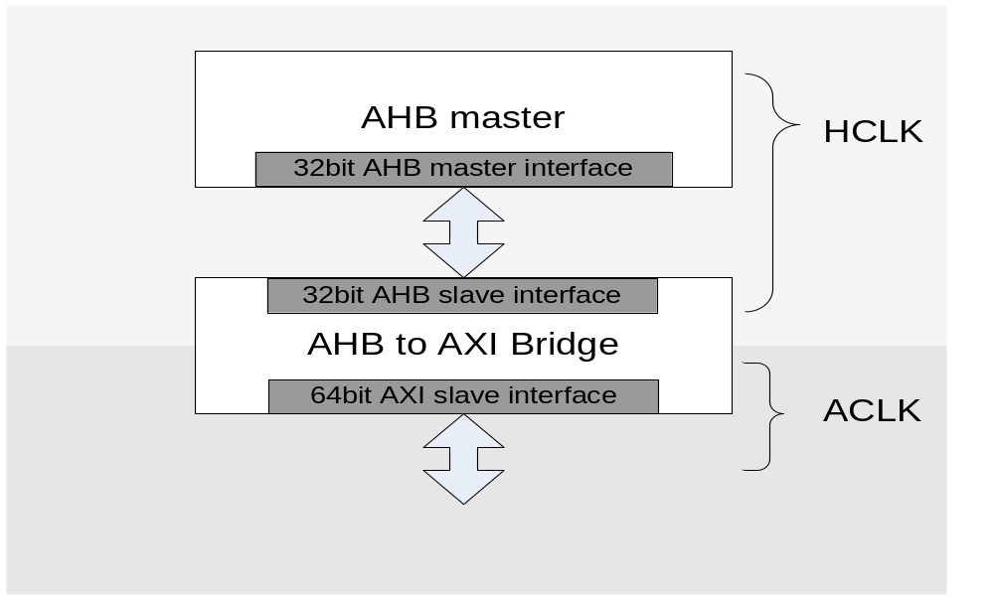

Operation

32bit AHB interface / 64bit AXI interface 연결하도록 구성 되어있음. AHB 측에서 byte/halfword/word로 접근할 수 있으며, wrap burst를 지원합니다.

HCLK/ACLK clock

HCLK를 기본으로 하고, ACLK를 배수로 사용 할 경우 Clock 변경에 순서를 보면.
첫째로 외부에서 IDEL == 1’b0 일 때, HOLDBride 신호를 ‘High’로 고정합니다.
둘째, IDEL == 1’b1 이면, 이때 ACLK를 변경합니다
셋째, HOLDBridge 신호를 ‘Low’로 변경합니다.

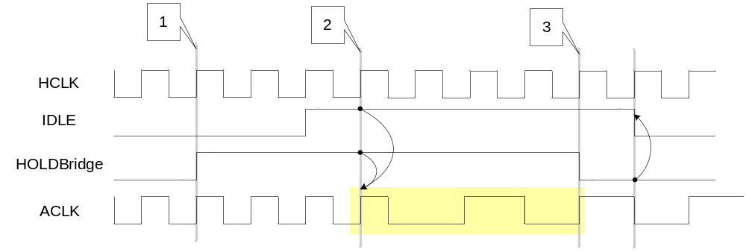

HOLDBridge를 ‘LOW’ 이면, IDLE이 ‘LOW’ 되고 동작이 진행됩니다. ACLK가 변경됨에 따라 ClockEn도 변경 되어야 합니다.

Signal Description

AHB2AXI Bridge Signal

Table 1-1 Bridge Signal
Signal Name | Direction | Description | Init. value
HCLK | Input | AHB interface clock
ACLK | Input | AXI interface clock
RESETn | Input | Reset
ClockEn | Input | Clock enable
IDLE | Output | Status output
HOLDBridge | Input | Holding bridge(Clock 변경할 때)
HADDR | Input | AHB interface address
HTRANS | Input | AHB transfer type
HWRITE | Input | AHB write or read
HSIZE | Input | AHB transfer size
HBURST | Input | AHB burst mode and size
HPROT | Input | AHB protect
HWDATA | Input | AHB write data
HRDATA | Output | AHB read data
HREADY_IN | Input | AHB transfer signal
HREADY_OUT | Output | AHB transfer signal
HRESP | Input | AHB response
HSEL | Input | AHB selection
HMASTLOCK | Input | AHB lock transfer
AWADDR | Output | AXI Write address
AWLEN | Output | AXI Write length
AWSIZE | Output | AXI Write size
AWBURST | Output | AXI Write burst type
AWLOCK | Output | AXI Write lock
AWCACHE | Output | AXI Write cache
AWPROT | Output | AXI Write protect
AWVALID | Output | AXI Write address valid
AWREADY | Input | AXI Write address ready

Signal Name | Direction | Description | Init. value
WDATA | Output | AXI write data
WSTRB | Output | AXI write strobe
WLAST | Output | AXI write last valid
WVALID | Output | AXI write data valid
WREADY | Output | AXI write data ready
BRESP | Output | AXI write data response
BVALID | Output | AXI write response valid
BREADY | Input | AXI write response ready
ARADDR | Output | AXI Read address
ARLEN | Output | AXI Read length
ARSIZE | Output | AXI Read size
ARBURST | Output | AXI Read burst type
ARLOCK | Output | AXI Read lock
ARCACHE | Output | AXI Read cache
ARPROT | Output | AXI Read protect
ARVALID | Output | AXI Read address valid
ARREADY | Input | AXI Read address ready
ARADDR | Output | AXI Read address
ARLEN | Output | AXI Read length
ARSIZE | Output | AXI Read size
ARBURST | Output | AXI Read burst type
ARLOCK | Output | AXI Read lock
ARCACHE | Output | AXI Read cache
ARPROT | Output | AXI Read protect
ARVALID | Output | AXI Read address valid
ARREADY | Input | AXI Read address ready
RDATA | Input | AXI Read data
RRESP | Output | AXI Read data response
RLAST | Input | AXI Read data last valid
RVALID | Input | AXI Read data valid
RREADY | Output | AXI Read data ready

