CEVA-X1622™ |  | 
Product description  The CEVA-X family of cores is based on CEVA's latest pioneering DSP architecture. This architecture offers best-in-class performance, scalability, and lowest cost-of-development for DSP deployment.  CEVA-X1622 is a member of the CEVA-X DSP family consisting of 16-bit data width and two MAC units. CEVA-X1622 target markets include 3G/3.5G cellular handsets and Software radio, multimode terminals, smartphones, and VoIP Gateways & broadband modems..
  CEVA-X1622 Target Markets
  3G/3.5G/HSDPA cellular
  handsets and Software Radio
  Multimode terminals and smartphones
  VoIP Gateways & broadband modems
High Performance at Low Power Consumption
CEVA-X1622 is a high-performance, low-power, fully synthesizable DSP with enhanced memory architecture including configurable memory size (64KB or 128KB), and configurable memory bank organizations in 2 or 4 blocks. The flexible memory architecture allows the customer to make an optimal cost /performance selection in line with market needs In addition, the CEVA-X1622 core offers a reduced gate count compared to other CEVA-X family members.
The CEVA-X1622 DSP has a unique mix of Very Long Instruction Word (VLIW) and Single Instruction Multiple Data (SIMD) architectures. The VLIW architecture allows a high level of concurrent instructions processing thus providing extended parallelism, as well as low power consumption.
Using an area-optimized implementation and On-chip Emulation Module (OCEM) enhancements, the core achieves a significant area reduction compared to the CEVA-X1620, making it ideal for advanced baseband and other mobile applications.
High-level Programming
CEVA-X1622 architecture is compiler-driven, implementing orthogonal instruction set and operands, load/store architecture, byte addressing and simple memory configuration (no X/Y partitioning).
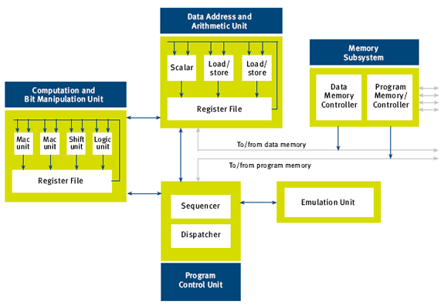
CEVA-X1622 Block Diagram
The Computation and Bit Manipulation Unit is responsible for all DSP computations, and includes four independent functional units: Two 16x16-bit MAC units, 40-bit Shift unit and 40-bit Logical unit.  The Data Address and Arithmetic Unit includes two identical Load/Store Units, responsible for generating all data memory accesses. The Scalar Unit is a 32-bit integer CPU block, supporting arithmetic, shift and bit manipulation operations on 32-bit data types.  The Program Control Unit is responsible for the code flow, including sequential flow, branches, loops and interrupts. The Dispatch Unit analyses instruction packets and dispatches single instructions to the different functional units.
  Technical Highlights
  Dual MAC 16-bit fixed point DSP
  Combination of VLIW and SIMD architecture concepts
  Up to 8 instructions issued simultaneously
  Variable instruction width (16/32-bit) and variable length of instruction packets
  Two level memory architecture
  Up to 4G byte addressable memory space
  64K byte L1 program memory and cache
  64K/128K byte L1 data memory
  Program and data DMAs
  Nine stage pipeline
  All instructions can be conditionally executed
The data memory subsystem supports configurable 64K/128K byte of L1 memory and up to 4G byte of L2 memory, through an AHB-Lite system bus and a programmable DMA. The program memory subsystem supports 64K byte of L1 memory, or 32K byte L1 memory and 32K byte cache. Using a separate AHB-Lite system bus and a programmable DMA, these can be extended up to 4G byte in L2.
A separate IO space is used for peripherals and slow devices built around the DSP.
Soft Core
CEVA-X1622 design implementations are Soft Core based, allowing the customer to select the optimal operating point in terms of die size, power consumption and performance. In addition, the customer has complete flexibility in selecting the foundry, process (e.g. 0.13µ, 90nm, 65nm) and complementary IPs.
CEVA-X1622 IP incorporates fully automated design flow supporting mainstream EDA tools, significantly shortens time-to-market. CEVA-X1622 design can be ported to an FPGA that can be used for product prototype, system integration, design acceleration and clarification

CEVA-X1641™
Product description  The CEVA-X family of cores is based on CEVA's latest pioneering DSP architecture. This architecture offers best-in-class performance, scalability, and lowest cost-of-development for DSP deployment.  CEVA-X1641 is a quad-MAC member of the CEVA-X DSP family consisting of 16-bit data width and four MAC units. CEVA-X1641 target markets include 4G (WiMAX, WiBro) cellular handsets and Software radio, smart phones / PDAs, Video & Audio processing for mobile devices, VoIP Gateways & broadband modems, and home entertainment (Digital TV, HDTV, PVR, HD-DVD).  CEVA-X1641 is fully compatible to existing CEVA-X family members, the CEVA-X1620 and CEVA-X1622.
  CEVA-X1641 Target Markets
  4G and WiMAX cellular handsets and Software Radio SmartPhones / PDAs
  Video & Audio processing for mobile devices
  VoIP Gateways & broadband modems
  Home entertainment (Digital TV, HDTV, PVR, HD-DVD)
High Performance at Low Power Consumption
The CEVA-X1641 architecture has a unique mix of Very Long Instruction Word (VLIW) and Single Instruction Multiple Data (SIMD) architectures. The VLIW architecture allows a high level of concurrent instructions processing thus providing extended parallelism, as well as low power consumption.
SIMD architecture allows single instructions to operate on multiple data elements resulting in code size reduction and increased performance. Low power consumption is also achieved in the CEVA-X1641 by its instructions and dedicated mechanisms such as dynamic and selective units shutdowns and clock slow downs.
High-level Programming
CEVA-X1641 architecture is compiler-driven, implementing orthogonal instruction set and operands, load/store architecture, byte addressing and simple memory configuration (no X/Y partitioning).
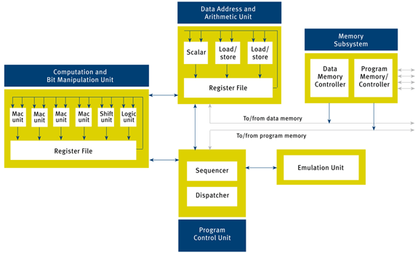
CEVA-X1641 Block Diagram
The Computation and Bit Manipulation Unit is responsible for all DSP computations, and includes four independent functional units: Four 16x16-bit MAC units, 40-bit Shift unit and 40-bit Logical unit.  The Data Address and Arithmetic Unit includes two identical Load/Store Units, responsible for generating all data memory accesses. The Scalar Unit is a 32-bit integer CPU block, supporting arithmetic, shift and bit manipulation operations on 32-bit data types.  The Program Control Unit is responsible for the code flow, including sequential flow, branches, loops and interrupts. The Dispatch Unit analyses instruction packets and dispatches single instructions to the different functional units.
  Technical Highlights
  Quad MAC 16-bit fixed point DSP
  Combination of VLIW and SIMD architecture concepts
  Up to 8 instructions issued simultaneously
  Variable instruction width (16/32-bit) and variable length of instruction packets
  Two level memory architecture
  Up to 4G byte addressable memory space
  64K/96K/160K byte L1 program memory and cache
  64K/128K byte L1 data memory
  Program and data DMAs
  Nine stage pipeline
  All instructions can be conditionally executed
The data memory subsystem supports a user configurable size L1 memory and up to 4G byte of L2 memory, through an AHB-Lite system bus and a programmable DMA. The program memory subsystem supports a user configurable size of L1 memory, with or without a 32KB program cache. Using a separate AHB-Lite system bus and a programmable DMA, these can be extended up to 4G byte in L2.
A separate IO space is used for peripherals and slow devices built around the DSP.
The CEVA-X1620 achieved the highest score for a licensable dual MAC DSP from BDTI (as measured by BDTIsimMark2000™), and the CEVA-X1641 is reaching even higher performance levels. To accomplish that, dedicated instructions and mechanisms were built into the architecture, supporting 1-cycle Viterbi butterfly (two ACS), 1.2-cycles FFT butterfly and various functions accelerating multimedia kernels.
Soft Core
CEVA-X1641 design implementations are Soft Core based, allowing the customer to select the optimal operating point in terms of die size, power consumption and performance. In addition, the customer has complete flexibility in selecting the foundry, process (e.g. 0.13µ, 90nm, 65nm) and complementary IPs.
CEVA-X1641 IP incorporates fully automated design flow supporting mainstream EDA tools, significantly shortens time-to-market. CEVA-X1641 design can be ported to an FPGA that can be used for product prototype, system integration, design acceleration and clarification.

