Video Interface Controller WorkBook

Created By East

Table of contents
Chapter 1 Function Description 3
1.1 General Features 3
1.2 Top Block Diagram 4
1.3 Detailed Function Description 5
1.3.1 Register Interface 5
1.3.2 BT656 Interface 5
1.3.3 AXI Interface Write DMA 5
Chapter 2 Register Description 6
2.1 Global Control Register 7
2.1.1 VIF Control Register 7
2.1.2 VIF Interrupt Status Register 7
2.1.3 Video XY Position Register 8
2.1.4 Video XY Size Registers 8
2.1.5 VIF Write DMA Address Registers 8
2.1.6 VIF Write DMA XY Size Registers 9
2.1.7 VIF Down Scale Control Registers 9
2.1.8 VIF Down Scale Ratio Registers 9

Chapter 1 Function Description

1.1 General Features

- CCIR656 Video Interface 지원
- AXI Write Interface 지원
- External Video Bypass Mode 지원(Display Module과 연동)
- Down Scale 지원(CT500에는 지원 안 함)

1.2 Top Block Diagram

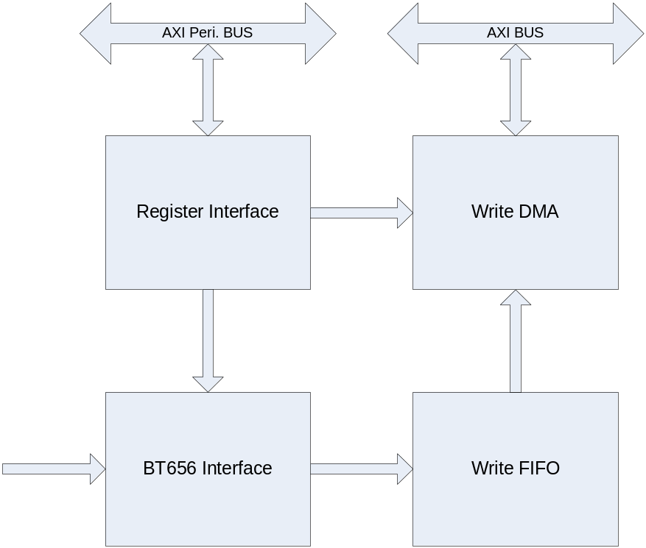

- Register Interface
- BT656 Interface
- AXI Interface Write DMA
1.3 Detailed Function Description

1.3.1 Register Interface
BT656 Control Register는 Metastability를 고려해서 FlipFlop 2개를 사용한다.

1.3.2 BT656 Interface
Video Clock과 Data를 이용하여 Field, VSync, HSync를 만들고 Register Block의 Mask 정보를 가지고 Active Video Data를 걸러낸다.

1.3.3 AXI Interface Write DMA
AXI의 Write Channel의 Timing에 맞게 FIFO에서 Video Data를 설정된 개수만큼 읽어 Main Memory에 Write 한다.
External Bypass Mode에서는 DMA는 FIFO에서 데이터를 읽지 않고, Display Module의 Video Plane에서 Data를 읽어 간다.

Chapter 2 Register Description

Register | Address | R/W | Description | Reset Value
VIFCON | 0x00 | RW | VIF Control Register | 0
VIFSTS | 0x04 | R | VIF Interrupt Status Register | 0
VIFPOS | 0x08 | RW | Video XY Position Register
VIFSIZ | 0x0C | RW | Video XY Size Register
VIFADDR | 0x10 | RW | VIF Write DMA Address Register
VIFDSIZ | 0x14 | RW | VIF Write DMA Size Register | 0
VIFSCON | 0x18 | RW | Video Down-Scale Control Register | 0
VIFSRAT | 0x1C | RW | Video Down-Scale Ratio Register

2.1 Global Control Register

2.1.1 VIF Control Register

Register | Address | R/W | Description | Reset Value
VIFCON | 0x00 | RW | VIF Control Register | 0

Register | Bit | Description | Reset Value
 | 31:8 | Reserved | 0
SWReset | 7 | Reset LCD Controller  1 : Reset  0 : Set | 0
YCOrder | 5:4 | 0b00 : {Cr0, YY1, Cb0, YY0};  0b01 : {Cb0, YY1, Cr0, YY0};  0b10 : {YY1, Cb0, YY0, Cr0};  0b11 : {YY1, Cr0, YY0, Cb0};
 | 3 | Reserved | 0
StartIntEn | 2 | Frame의 전송이 시작되면 인터럽트를 걸지 여부를 결정한다
EndIntEn | 1 | Frame의 전송이 종료되면 인터럽트를 걸지 여부를 결정한다 | 0
DmaEn | 0 | DMA Enable | 0

2.1.2 VIF Interrupt Status Register

Register | Address | R/W | Description | Reset Value
VIFSTS | 0x04 | R | VIF Interrupt Status Register | 0

Register | Bit | Description | Reset Value
 | 31:2 | Reserved | 0
StartFrame | 1 | Start of Frame  When Read, Auto Cleared | 0
EndFrame | 0 | End of Frame  When Read, Auto Cleared | 0

2.1.3 Video XY Position Register

Register | Address | R/W | Description | Reset Value
VIFPOS | 0x08 | RW | Video XY Source Position Register | 0

Register | Bit | Description | Reset Value
 | 31:22 | Reserved
VIFXPos | 21:11 | X Position Start : X position of top left corner of Source
VIFYPos | 10:0 | Y Position Start : Y position of top left corner of Source

2.1.4 Video XY Size Registers

Register | Address | R/W | Description | Reset Value
VIFSIZ | 0x0C | RW | Video Source Size Register | 0

Register | Bit | Description | Reset Value
 | 30:29 | Reserved
VIFXSize | 20:11 | Video Surface Width
VIFYSize | 10:0 | Video Surface Height

2.1.5 VIF Write DMA Address Registers

Register | Address | R/W | Description | Reset Value
VIFADDR | 0x10 | RW | VIF Write DMA Address Register | 0

Register | Bit | Description | Reset Value
VIFADDR | 31:0 | VIF Write DMA Address

*** Not used EnterTech Chip

2.1.6 VIF Write DMA XY Size Registers

Register | Address | R/W | Description | Reset Value
VIFDSIZ | 0x14 | RW | VIF Write DMA Size Register | 0

Register | Bit | Description | Reset Value
 | 30:29 | Reserved
VIFDmaXSize | 20:11 | VIF Write DMA Width
VIFDmaYSize | 10:0 | VIF Write DMA Height

2.1.7 VIF Down Scale Control Registers

Register | Address | R/W | Description | Reset Value
VIFSCON | 0x18 | RW | VIF Down Scale Control Register | 0

Register | Bit | Description | Reset Value
 | 31 | Reserved
PreFilterEn | 30 | Pre-Filter Enable
 | 29:1 | Reserved
DnScaleEn | 0 | Down Scale Enable

2.1.8 VIF Down Scale Ratio Registers

Register | Address | R/W | Description | Reset Value
VIFSRAT | 0x1C | RW | VIF Down Scale Ratio Register | 0

Register | Bit | Description | Reset Value
DnScaleXRatio | 31:16 | Down Scale X Ratio | ffff
DnScaleYRatio | 15:0 | Down Scale Y Ratio | ffff

